
CEPI Newsletter
September 2021

Dear CEPI members,

After a not so quiet summer break, it is now time for “la rentrée”. CEPI kick started it with the Series Mania festival in Lille which took place on the last week of August. We had the great opportunity to chair a panel of great producers, all discussing what the Audiovisual Media Services Directive is changing in their daily business, and whether more is needed to support them. CEPI also participated to the international panel organised by USPA.
Continuing our work to communicate to the European Commission on the challenges of audiovisual producers across Europe, CEPI has send a new letter to both Commissioners Gabriel and Breton, raising the question of UK productions after Brexit, as well as questioning whether the definition of European work remains relevant. We’ve asked the Commission to ensure that an assessment of these issues will soon start.
With the end of the summer break for the European Commission, were are expecting several work tracks from in the European Media and Audiovisual Action Plan to resume, and for some to start. The stakeholder consultation on cross border access to content should be announced soon, as well as the consultation of stakeholders for the Media outlook study. The result for the Media Outlook study will be expected for the second half of 2022, nonetheless CEPI will make sure to provide the Commission with relevant input as early as possible. The ongoing stakeholders dialogue on sustainable production should also resume with a next meeting expected in November. Meanwhile the European Commission has mandated 2 studies on CO2 carbon calculators and on green labels.
This last work track is particularly interesting as it echoes CEPI’s ongoing project on sustainable production. This project second meeting of the steering group took place this week. In the context of the social dialogue committee, CEPI has also been invited to exchange with the social partners on the issues of prevention of violence and sexual harassment, to rconsider the possibility to review the audiovisual social dialogue committee framework of action on gender equality.
On the legislative front, discussion on the Digital Services act are progressing at the European parliament. CEPI’s position is defended through the work of different industry coalitions such as the Audiovisual coalition, the Creativity work coalition and the Know Your Business Customer coalition. Our latest joint letter encourages MEPs to consider eliminating specific time limits criteria and instead support expeditious platforms’ action to remove copyright infringing content after notification.
Finally, we are preparing the next CEPI General Assembly to take place on the 25th and 26th of November in Madrid. You should already have received information to book your hotel. We are looking forward to see you there!
We hope you will find this newsletter informative,
Best regards,
The CEPI secretariat

Sections in this newsletter:
- Latest from the EU
- COVID 19: Impact on the sector
- Latest on the AV industry
- Copyright
- Digital Services Act (DSA) & Digital Platform Regulation
- Piracy

- Audiovisual platforms
- Film and TV
- Festival
- Recent studies
- Events
- Interesting links

Latest from the EU

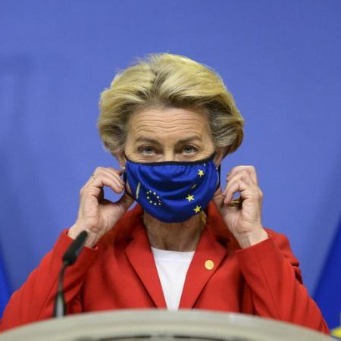
Summary of Ursula Von der Leyen's State of the Union address 2021
European Commission’s President Ursula von der Leyen began her speech by stressing the importance of the digital single market for the future of the European Union. In this regard, she promised that the EU will continue to work to contain the gatekeepers' power in major platforms while channeling the power of AI to increase the efficiency of the market and promote prosperity through the digital space.
The initiative would be accompanied by a significant increase in digital spending sourced from 20% of the investments foreseen in the Next Generation EU program.
After explaining how the EU will continue to find new ways to fight climate change and support its youth, the President also touched upon the issues of misinformation and cybersecurity. With regards to the former, she expressed the Commission’s intention to tackle down on the spread of disinformation and online threats coming from abroad while ensuring media freedom all over the continent through the new Media Protection Act. With regard to the latter, she pointed to the Commission’s intention to turn the EU into a leader in the realm of cybersecurity. She announced the launch of a new European Cyber Resilience Act to promote new cyber standards and converge technological synergies at the European level.
See the Commission’s Press Release on the State of the Union Speech here.

New French presidency of the Council of the EU already speeding up on tech issues
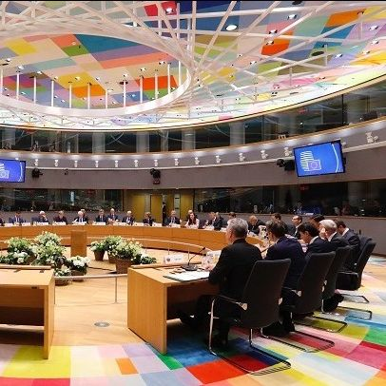
Despite being months away from the beginning of France’s presidency of the Council of the European Union (January 2022), French ambassadors and other French diplomats have already started to meet with key ministers of Europe’s Member States to discuss how the French Presidency can facilitate discussion on key files.
According to French EU Affairs Minister Clément Beaune, they were asked to provide a “more detailed position of each of their countries on legislative issues such as the DSA and the DMA even though we can see a consensus shaping up on tech files”.
The effort can be framed in Paris’ effort to devise a consensual roadmap to guide its take on technological issues when it takes on the presidency in January 2022. France will make its priorities and overall program on December 1st. However, the main lines have already been decided and will be unveiled in the coming weeks, as stated by the French foreign affairs ministry.

The G7 declares war on the spread of illegal content online
The G7 and Interpol got together last September to tackle the spread of harmful and illegal content online. The topics that they will cover include child abuse, violence against women and girls, and the spread of online extremism and terrorism. This time, all the attention will be put on online platforms, especially big tech giants such as Facebook and Alphabet.
One of the most innovative proposals that will be put up on the G7 table is the launch of a fund to develop technologies that can detect child abuse images in end-to-end encrypted messaging services. Other proposals include inviting facebook to abandon its plan to roll out encryption to all of its platforms and push for an improved age verification system.

Covid-19: Impact on the sector


British Box Office results are now back to 50% of their pre-pandemic levels
The Box office tracker Comscore just released the results of the first month since the Covid restrictions were lifted in the UK. It states that £65.7m were spent by cinema goers in July, only 50% of the total £129m that were spent in the corresponding weeks of 2019.
The figure stands close to that of the US and has been received by cinemas with excitement as a potential sign that sales levels may be in their way back to pre-pandemic levels soon.
However, this does not mean that the pandemic will not continue to disrupt releases in the coming months. As the Delta variant continues to ravage the United States, movies like Clifford the Big Red Dog, the Venom sequel and Hotel Transylvania 4 have either been pushed back or moved to streaming. Older audiences in particular, seem to be reluctant about returning to the cinema rooms, but companies all through the industry are adapting to their new demands. Although the industry is recovering, it is already introducing previously unseen practices and strategies, with distributors realising their films in both cinemas and online streaming services.


French Cinema Admissions weakened by the new Pass Sanitaire
Despite reopening their doors in mid May after a 6 month shutdown due to the Pandemic, French cinemas still struggle to adapt to the complexity incurred in the market by the Covid Pandemic.
Over the week from the 11th to the 18th of August, just after the introduction of a compulsory COVID health pass by the government, ticket sales fell by 41%.
Members of the industry noted that the expansion of the so-called “pass sanitaire” to every single cinema in the country may plunge the entire sector into an even deeper crisis. Films ranging from global blockbusters to prestige auteur films felt the blow, although those targeting demographic market segments with lower vaccination rates were particularly impacted. In spite of these discouraging results, most distributors have chosen to stick to their release schedule counting on the expansion of the vaccination campaign to soon cover the vast majority of the population.

Latest on the AV industry


European indie producers struggling to retain IP and revenues during streaming boom
Europe’s entire independent film and TV production sector faces faces a period full of challenges brought up by the pandemic. While streaming platforms boost their numbers and variety, cinema closures resulted in a 70% fall in admissions in Europe to 300 million tickets sold in 2020, against nearly a billion in 2019, according to data released by the Strasbourg-based European Audiovisual Observatory (EAO) in July.
In response to these structural changes, European independent producers are adapting to the demands of the now dominant streaming services.
This includes focusing their efforts on producing drama series, but also incurs some risks. Several producers have pointed to a trend by which streaming platforms demand complete control over additional seasons or feature sequels and other potential spin-offs. Even when a platform decides to abandon a production, independent producers find it difficult to extract the IP from the cancelled development deals. Another worrisome trend is the unbalanced share of rights that production companies obtain after launching their content, which threatens their capacity to operate in the market altogether. As a response, local producers are starting to voice their concerns via festivals or events to raise awareness among EU and member state regulators around the challenges facing the region’s independent producers.They hope that the EU will develop a new pan European regulation modelled by teh French example, which forced treamers operating in the territory need to invest 20%-25% of their turnover in French local content, of which 85% needs to be in the French language. Within this 85% tranche, 66% of TV investment needs to be with independent producers who get the rights back after 36 months in the cases of an exclusive deal, rising to 75% for feature film with rights reverting to the producer after 12 months.


Sustainability debate arrives to TV industry
TV industry’s leaders discussed back in September how to adapt to the decarbonization efforts of the century. They highlighted the role of engineers, the transformative potential of energy transport technologies and the role of broadcasters to use their ability to influence the public through the products and services they provide.
Other challenges mentioned in the talk included promoting products with longer life cycles, the importance for operators to work with Original Equipment Manufacturer (OEMs) and streaming services making sure that they deliver the video quality suitable for the devices on which content is received.

The question of ownership of rights in Spain
During Summer 2021, the Spanish government unveiled a draft of the new Audiovisual Communication Services Law to translate EU directives to the Spanish legal and market context. The new law includes a quota of 3,5% of global platforms annual revenues to be invested back in the local industry. However, it is expected that the law will evolve before the final draft is published and is likely to change important aspects like rights ownership and co-finance mechanisms that will ensure that local producers can profit from and retain their IPs. Among all the new insights to this move, producers may be happy to hear that publishing rights will be reverted to independent producers after 36 months to be jointly exploited with the plattform. However, simultaneously, platforms will still be able to to 100% finance a number of high-end drama series with producers working for hire, paid by a fee calculated as a fixed percentage of the series’ budget, currently around 7%-10% of budgets.
The mixed model is supposed to strike a balance between independent producers and streaming giants, but there are still a lot of questions regarding how this equilibrium will finally look like. In any case, the law is expected to pass the legislative process and be published in the statue books by the end of the year.

Greening local production in Finland
Anni Wessman, head of International at APFI, the film and TV Producers' association in Finland, announced a new initiative with the Albert international environmental nonprofit to give producers a set of tools and metrics and help them reduce their production’s carbon footprint. The new tools are supposed to make it clearer for companies to find out how to reduce their footprint in a practical rather than policy means.
The initiative is said to have grown organically from local producers worried about achieving a considerable level of sustainability in their activities. In fact, movies like the upcoming children’s feature “Detective Agency Henkka & Kivimutka,” already followed green standards during their production process. The move is also thought to adjust to wider international trends like new mandatory diversity quotas and standards that Finish filmmakers must integrate into their international co-productions.

Copyright


Court-ordered site blocking and Internet disconnections for WOW!
A group of filmmakers (“After We Collided”, “Rambo V: Last Blood” among other titles) has filed a lawsuit against Internet provider WOW! for allowing copyright-infringing activities.
Specific cases are cited where the service’s subscribers used YTS torrent site to illegally download content. WOW! has already received several notifications, being now asked to take site-blocking and identification measures for repeat copyright infringers. Sites like The Pirate Bay should also be blocked by the service. Meanwhile, WOW! has not yet responded to the complaint. These demands are a novelty in US courts, going way further than previous repeat infringer cases so far.

Digital Services Act and platform regulation

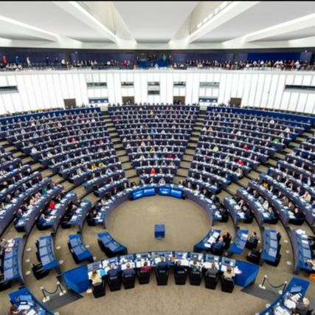
DSA and DMA final vote in the European Parliament scheduled for mid-December
Since most Committees for opinion in the European Parliament have now voted on their reports and amendments, the IMCO committee has the most important role.
The committee is expected to vote on both files on the 8th of November. If they are able to finish the reports at the deadline, the final vote in the European Parliament will likely take place during the last plenary of 2021, between the 13th and 17th of December in Strasbourg.


Leaked compromise amendments from the DSA
Compromise amendments from the Internal Market Committee show that rapporteur Schaldemose is moving further towards adding more obligations for online marketplaces such as Amazon, eBay and AliExpress to halt the sale of illegal products on the internet.
This could be problematic for EPC members’ own marketplaces if they get landed with onerous obligations designed for global marketplaces.
MEPs led by rapporteur S&D Danish MEP Christel Schaldemose, a fierce consumer advocate, added in the definitions of the bill that the Digital Services Act aims to “establish a high level of consumer protection and contribute to increased consumer choice while facilitating innovations, support digital transition, encourage economic growth within the internal market.”
MEPs added safeguards for the removal of specific pieces of content. They want national courts and administrative authorities to respect the EU Charter on Fundamental Rights. They also want the Commission and regulators overseeing the Digital Services Act to be more involved.
In line with EPC’s position MEPs added more obligations for very large platforms on their own terms and conditions. Online platforms would need to “notify expeditiously” their users when they significantly change their own policy rules.
The internal market committee is currently negotiating the whole text and is expected to vote on the draft on November 8.

Slovenian presidency moves forward on DSA
Over the summer, the rotating Council presidency moved over from Portugal to Slovenia which published plans to amend the Digital Services Act here.
The document, dated September 2 recommended including search engines in the list of digital services that should be regulated in the new law, a provision backed by France and Germany. Danish MEP Christel Schaldemose, who is leading in Parliament, also included search engines, despite opposition from Google and Microsoft. Furthermore, the Slovenia Presidency strengthens a provision that prevents member states from implementing their own national content moderation laws once the DSA enters into force.

Busy week in the European Parliament on DSA and DMA
It has been a busy week in the European Parliament. On Monday and Thursday, six of the eight parliamentary committees responsible for the Digital Services Act and Digital Markets Act came together to discuss their amendments and have votes on both files. The committees that have no meetings on the files will have to hurry. The Internal Market Committee (IMCO), which is in the lead on both files, will have a vote on the final reports of the DSA and DMA on 8th November. The lead committee IMCO had a committee meeting in which they discussed the amendments tabled and possible compromise amendments on both files. ITRE, CULT and TRAN met on Monday as well and adopted their reports including compromise amendments. JURI and FEMM met on Thursday.

Piracy


Anti-Piracy Alliance trying to ‘fix’ EU’s Digital Services Act: a ‘Staydown’ requirement as the main priority
The Audiovisual Anti-Piracy Alliance (AAPA) has elaborated a list of amendments to improve the Digital Service Act (DSA) proposal, calling for staydown requirements to keep pirated material offline and for re-offending users to be permanently banned.
On the other hand, the alliance also proposes to terminate the accounts of takedown abusers. Major copyright holders have been calling for stricter measures on online piracy for some time, also given the concerns that fundamental rights are being increasingly put at risk by illegal filtering. For the moment, the DSA proposal doesn’t include ‘staydown’ requirements, even if the AAPA has already submitted their claims to the European Parliament’s IMCO Committee. A more detailed overview of the recommendations can be found on the AAPA’s website.


Funimation anti-piracy campaign forces pirate anime apps to shut down or to consider their future
For some time now, anime has enjoyed a huge growth in the West, in part due to piracy platforms fulfilling the increasing regional demand.
However, strong anti-piracy action has been launched since several companies (Netflix and Disney among others) started investing in the sector. In early September 2021 Funimation deployed a new anti-piracy campaign, causing services like ‘Taiyaki’, ‘Shiro’ or AnimeGlare to shut down or take evasive action to survive. The campaign also involved threats to refer the matter to law enforcement in different EU countries.

Grande Communications sued for allowing piracy-related activities
More than twenty movie studios have launched a lawsuit against American telecommunications company Grande Communications for “turning a blind eye” to customers downloading and sharing movies through BitTorrent and sites like The Pirate Bay. The list of complainants includes names like Voltage Holdings, Millenium Media and LHF Productions. According to the movie companies, Grande allowed the illegal activity because it acted as a draw to subscribers. The complaint alleges that Grande cannot rely on the safe harbor provisions of the U.S. Digital Millennium Copyright Act (DMCA), which means that it is liable as a contributory copyright infringer for the acts of its subscribers. Most of the tracking evidence was supplied by Maverickeye and Torrent giant YTS.

LiquidVPN brought to Court for piracy damages
Movie studios accuse the no-log VPN provider LiquidVPN of encouraging and facilitating copyright infringing activities. The current owner of the service is 1701 Management, run by a U.S. resident called Mr. Muszynski. Despite the serious allegations, the company has already failed to show up in court, which caused the movie companies to request a default judgement in their favor. Since LiquidVPN has failed to implement a repeat infringer policy, the motion argues that it isn’t entitled to a safe harbor defense. The movie companies, makers of films like “Hunter Killer” and “Automata”, claim compensations of $9,000,000 for statutory damages and $1,650,000 for DMCA violations. Additionally, they request LiquidVPN to terminate the accounts of repeat infringers and block access to several pirate sites. Meanwhile, the LiquidVPN website seems to have vanished.

Portugal losing €200 million per year to piracy
Paulo Santos, director of Fevipe and president of anti-piracy movement MAPiNET, cites a report by the British consultancy MUSO (registration required) showing that the audiovisual industry in Portugal is losing around €200 million a year to piracy. Series and films seem to be the most pirated content, closely followed by football. Over 55 million visits to illegal websites were registered following the 2020 lockdown. Santos points out that not only right holders, producers and authors are being harmed, but also televisions and cable operators, since piracy also uses IPTV.

Nearly 250 pirate IPTV subscribers reported for prosecution in Piacenza, Italy
The Italian law enforcement agency Guardia di Finanza has reported 240 subscribers of pirate IPTV services in the city of Piacenza to the prosecutor’s office. The illegal platform offered Sky, Mediaset Premium, Netflix and Amazon Prime content for just 10 euros per month. Italian authorities have been chasing the use of pirate IPTV platforms for some time now. Already in September 2019, a massive operation took down IPTV management service Xtream-Codes. Six months later, the GdF reported 223 IPTV subscribers for “receiving stolen goods”. The current investigation was triggered in early 2020, when the GdF of Rome identified a reseller of pirate IPTV services. If guilty, subscribers now face up to 25,000€ penalties, plus criminal violations relating to the use of equipment designed for the “illegal decoding of conditional access audiovisual broadcasts”.

AVMSD

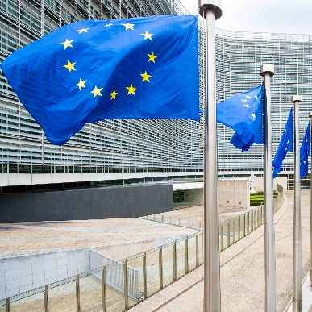
Innovative ‘News Initiative’ launched by the European Commission
The Commission has recently launched a ‘News Initiative’, which supports the news media sector as part of its Media and Audiovisual Plan.
Structured dialogue, enhancing competitiveness, unleashing innovation and nurturing democracy are the main pillars to support news media through this new strategy. A European News Media Forum (ENMF) set to take place twice a year has also been deployed by the Commission to foster dialogue with news media organisations, IOs and civil society. Better access to finance, fostering advanced data strategies and media freedom are just some of the priorities of this initiative. Measures to boost competitiveness will complement existing legal initiatives like the AVMSD, the DSA and the DMA.


Poland implements Audiovisual Media Services Directive: implications for video-sharing platforms
Although one year late, the Sjem (Polish Lower House) has implemented the Audiovisual Media Services Directive (2018/1808).
The Act changes rules governing the jurisdiction over media service providers, their information obligations, regulations concerning placement of ads and protection of consumers, in particular minors. It also introduces new regulations regarding video-sharing platforms.
For video-sharing platforms, the act means that for the first timePoland will have explicit regulations for their sector. When the act enters into force video-sharing platforms will be obliged to: provide their users with easy, direct and constant access to certain information, in particular, the details of the service provider and the list of its services; make available technical measures, including parental control measures, to protect minors; comply with requirements for advertising content; and to provide the users with transparent and friendly mechanisms for reporting illegal content and to respond to the user’s notification within 48 hours deadline.

Spanish regulator reviews draft audiovisual law
The Spanish Markets and Competition Regulator (CNMC) has published a report on a draft for the General Law on Audiovisual Communication. In the report, they explain what the biggest changes will be for financing public broadcasters. The main change that will take place is that public broadcaster’s financing be carried out “with contributions from all the agents present in the audiovisual market that compete for the same audience”. ‘All agents’ in this definition includes providers and video exchange platforms, along with linear FTA and pay-TV

Commission sent reasoned opinion to nine Member States for failing to implement the AVMSD
Last week, the European Commission sent a reasoned opinion to Czechia, Estonia, Ireland, Spain, Croatia, Italy, Cyprus, Slovenia and Slovakia for failing to provide information about the implementation of the EU Audiovisual Media Services Directive (AVMSD) into their national laws. The new rules apply on all audiovisual media, both traditional TV broadcasts and on-demand services, as well as video-sharing platforms.
Member States had until 19 September 2020 to transpose the Directive and communicate their transposition measures to the Commission. In November 2020, the Commission sent letters of formal notice to 23 Member States for not having notified full transposition. The Commission is now taking the second step in the infringement procedure by sending a reasoned opinion to the afore-mentioned nine Member States that have still not notified full transposition. They now have two months to reply to the Commission, or the Commission may decide to refer their cases to the Court of Justice of the European Union.

AV platforms

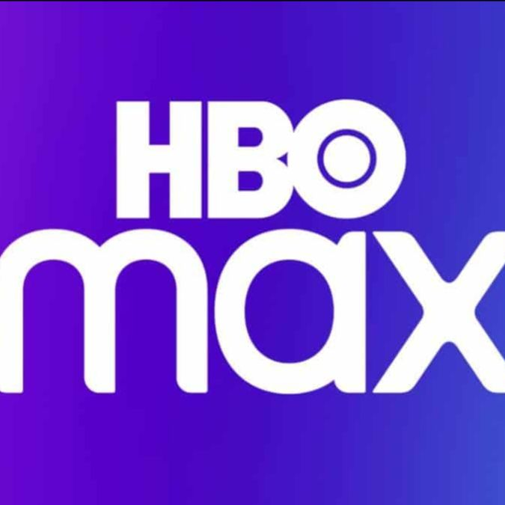
Warner Bros’ HBO Max will arrive to European markets this year
The US streaming platform HBO Max is planned to enter the European market later this year. According to Priya Dogra, the president of parent company WarnerMedia for the Europe, Middle East, Africa and Asia region will launch in Spain and the Nordic countries later this year to later expand to Central and Eastern Europe and Portugal in 2022.
Dogra also claimed that Europe has become a priority for the company, as the natural next step in the company’s geographical expansion after the US and Latin America. However, the European market poses as many challenges as opportunities for the new plattform, including existing competition and EU regulations requiring streaming platforms to invest in local content.


Discovery +, the next streaming champion?
Discovery’s new stream service, Discovery +, is largely to blame for the company’s profit growth for the second quarter of 2021, according to CEO David Zaslav.
The service finished the quarter with 1 million extra subscribers that, according to Zaslav were attracted to the platform due to the Tokyo 2020 Olympic Games coverage.
The results have pushed the company to expand Discovery + to Brazil, Canada, the Philippines and a number of European markets in Q4, with others planned for 2022. The news is also said to be in the process of accelerating its merger with AT&T’s WarnerMedia to create a new proposed company. Warner Bros. Discovery.

The average Briton spends a third of the waking hours watching TV and online videos
According to research from the media regulator Ofcom, Britons spend a third of their waking hours watching multimedia content in the form of either tv or online videos. This amounts to an average of 5 hours and 40 minutes a day, an increase of close to an additional hour in comparison to pre-pandemic levels. The lack of alternative forms of entertainment due to the restrictions of the pandemic are largely to blame, according to the creators of the study.
Most interestingly importantly, the study also revealedreflected on the rapid growth of US-owned streaming services such as Netflix, Amazon Prime and Disney+. More than 60% of UK households had access to at least one paid streaming service, a figure that now includes an increasing number of older Britons that are still to be introduced to new streaming service products and channels.

Paramount + to launch in Europe in the near future
ViacomCBS Networks International and the Comcast-owned Sky have agreed to launch Paramount+, a new streaming platform that will roll out in the UK, Ireland, Italy, Germany, Switzerland and Austria throughout 2022. As part of the agreement, Sky Cinema subscribers will now be able to access more than 10,000 hours of Paramount+ content at no additional cost, including blockbuster franchises like Mission Impossible and Transformers.
The deal also provides a barrier to the rollout of WarnerMedia’s HBO Max, which established a deal with Sky running into 2025 in territories including the UK, Germany and Italy.

SofaVOD, a streaming service for French independent cinema
A new streaming platform to watch French independent cinema has been launched on September 24, 2021. The new service, called SofaVOD, will include films and services covering multiple genres from documentary to animation. An emphasis will be placed on promoting short content made by french professionals and even amateurs that may otherwise find it difficult to promote their creation in other platforms. The subscription will cost €5.99 per month and will include Over 100 titles including 92 films and 11 series at launch. Half of the revenues will be paid directly to the content creators.

The Netflix film catalogue keeps on growing
The American streaming service Netflix will deliver on its promise to provide a new movie every week with 42 movies and documentaries to be released in the four months remaining in the current year. “The films coming this fall include star vehicles such as “Don’t Look Up,” with Jennifer Lawrence and Leonardo DiCaprio, which cost $55 million to make; “Worth,” starring Michael Keaton; “The Starling,” with Melissa McCarthy and Chris Dowd; and “Red Notice,” with Dwayne Johnson, Gal Gadot and Ryan Reynolds”. A similar movie is expected from the company in India where the streaming service will offer a list of 13 new films in March. The staggering amount of new content has raised the eyebrows of critics skeptical with the company’s capacity to maintain a high level of quality among all such releases.

Cinema & TV

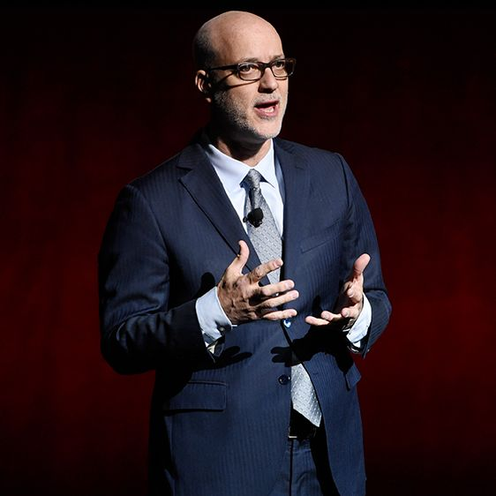
Theatre owners reject simultaneous releases
During this year’s Cinemacon, John Fithian, the chief of the National Association of Theater Owners, declared that his organization would side with the artists and creators that support the moviegoing experience and “refuse to accept the false narrative that movie theaters are a thing of the past”.
Reflecting on the rise of streaming services and the increasingly short theatrical release windows in the industry, Fithian admitted that the sector is going through considerable changes and insisted on the importance of “exclusive release periods … to the survival and success of the theatrical experience”. His statement was backed by the catastrophic release of recent films like Black Widow, whose simultaneous launch in streaming platforms deeply handicpaed its success in theaters. Despite this encouraging message, studio attendance to this year’s edition of Cinemacon has been lower than in previous years, reflecting the overarching crisis that the sector is going through. Time will only tell if his predictions will continue to reflect the reality of the industry in the coming decades.


Warner Bros will continue to support the theatre-going experience
Despite the hugely controversial theatrical-day-and-date release HBO Max model, Warner Bros’ Domestic Distribution president Jeff Goldstein assured his industry colleagues at the Cinemacon in Vegas last year that “Going to the theater is simply in our DNA and that will never change”.
Justifying the company’s aforementioned choices on the ground of its process of adaptation to the challenges of the Covid Era, Andrew Cripps, Warner Bros’ International president, echoed Goldstein’s sentiment and reflected on the company’s innovations over the past year to optimize attendance, implementing cinema safety and their involvement in robust marketing campaigns. Their statements were accompanied by exciting announcements like the trailer for Matrix 4 now known as The Matrix: Resurrections. FInally, Warner also showed the same trailer from DC Fandome for Matt Reeves’ The Batman, which, following with the company’s promises, will be purely theatrical for its release in March 4 2022.

Hollywood’s Sunset Studios to expand to the UK
The company behind cinematic hits like “La La Land”, Sunset Studios, is set to build a new studio facility in Hertfordshire, UK. The owner of the company, Hudson Pacific Properties, has agreed to invest in the creation of new facilities for its productions in film, TV and digital industries in partnership with private equity firm Blackstone Group.
Hertfordshire is an hour’s drive away from Central London and is also home to Elstree Studios, the organization behind the production of “The Crown” or “Star Wars”. The move has been celebrated by UK government officials including Prime Minister Boris Johnson and Culture Secretary Oliver Dowden.

The British Global Screen Fund and the push for UK co-productions
According to Neil Peplow, BFI director of industry and international affairs in the UK, the new UK Global Screen Fund that was launched earlier this year could potentially replace the financial contributions that Creative Europe’s MEDIA program used to provide to British creators before Brexit.
The statement came right in the middle of a discussion of British and Swiss cooperation in the film industry during Locarbo’s Film Festival. Regarding the topic of the debate, some attendees raised the issue of the lack of willingness on behalf of British companies to cooperate with its continental counterparts. According to Peplow, the new Fund will help British companies in this respect by promoting a more international and cooperative outlook.

Times of recovery lie ahead for Europe’s cinema industry
Laura Houlgatte, director of the International Union of Cinemas (UNIC), remains optimistic about the recovery of the sector after the Covid pandemic, despite the changing and sometimes unpredictable health environment. Measures like the imposition of the European health pass have slowed down the recovery, but with vaccination extending to increasing sections of the population, industry leaders expect things to go back to normal in the near future.
Houlgatte pointed to the return to the market of American blockbusters and highly anticipated national films as the main causes for the long awaited recovery. The over reliance on American productions initially hurt theatres due to their seemingly never ending release delays, but their return is also set to lead the recovery. National financial aid packages will also set the tone for the years ahead as they share the burden of aiding the sector along with the 2.4 billion that will be allocated for culture in the EU budget for the period 2021-2027.

Disney justifies the simountenous release of Black Widow on cinemas and Disney +
Disney CEO Bob Chapek has defended the company's streaming release of Black Widow last August, after leading main actress Scarlet Johansson complained that her contract guaranteed an exclusive cinema release. Disney defended its position on the basis of the detrimental conditions imposed in the market due to the Covid pandemic.
In particular, Chapek told investors that the company needed to have a flexible strategy when it came to film releases due to the unpredictable nature of the global health crisis. In this context, according to him, the hybrid release was “the right strategy because it would enable us (Disney) to reach the broadest possible audience." In response to further critics, he also mentioned the potential compensation to actors and actresses like Johansson to make everybody “feel satisfied”.

The ever-increasing demand for Danish TV content is creating serious problems for the industry’s workers
The award-winning makeup artist Bjørg Serup has recently decided to quit his career in the Danish film industry due to stress-related cognitive impairment. Her case is not unique, and reflects a larger trend in the Danish cinema industry. She blamed her case on the tight production schedules and long working hours that the high demand for Danish TV productions has imposed on the industry’s workers. 415 people in the Danish film industry recently signed an open letter to the country’s industry leaders warning about the excessive amount of stress that they are going through at the moment.
The demands reflect the lack of skilled labour to cover the increasing demand and consequent depreciating working conditions for those workers in charge of an increasingly demanding amount of projects. The excessive rise in the demand for new content comes from streaming companies like Netflix, HBO or Amazon that, according to the letter’s authors, are pushing the industry’s workers to breaking point. Adding insult to injury, some workers have also complained about being bullied by such companies.

Will we witness cinema’s post-covid awakening?
Covid and the boom in streaming platforms are putting a lot of pressure on the theatrical release model. We’re currently seeing a mix of new films and pre-covid titles back on offer, the film industry being still wary of a new Covid wave. However, the existing model has proved to be resilient in the past: cinema is not as vulnerable as live music or theatre, since it takes place indoors and physical distance doesn’t pose problems. Moreover, the consumer appetite for intelligent and complex movies on streaming services only increased during lockdown, proving that people may now be even more enthusiastic to go see films on the big screen.

New 45-day window for Warner Bros titles in Asia
Warner Bros titles will be streamed on HBO Go in Asia 45 days after their theatrical premiere in Asian markets, including Southeast Asia, Taiwan and Hong Kong. Some of the first films to benefit from this shortened window are The Conjuring: The Devil Made Me Do It and Space Jam: A New Legacy. This 45-day window is in line with WarnerMedia’s strategy in North America, even though what was first announced is that Warner Bros titles would be released day-and-date in theatres and on HBO Max. Amit Malhotra, managing director for HBO Max and HBO Go in Southeast Asia and India, points out the convenience of this new strategy for fans that aren’t able to see Warner Bros movies in cinemas.

Simultaneous streamer releases to be the future of movie theater business?
Windows matter, at least to the movie theater business. The idea of trying to maximize revenues by releasing movies on streaming at the same time they are offered in theaters, although not particularly appealing to Sony, has convinced other movie studios to get on board. Streaming windows could for sure be taking a sizable piece of business, but they could also end up working well in five years’ time. This year, the movie theater business lost only 50% from 2019, compared to 80% in 2020. Maybe cinemas have some lessons to learn from this experience.

Festivals


Proof of full vaccination will be required at the 2022 edition of the Sundance Festival
Sundance Film Festival will launch a new hybrid approach, combining in-person events with virtual offerings.
This year, a proof of full vaccination will be required to all participants attending the mountain-top gathering, including the artists themselves. The Utah-based festival will have in-person screenings in Park City, Salt Lake City and at the Sundance Mountain Resort. More information about the 2022 edition of the Sundance can be found here.


Smaller European film festival adapting to the future by sticking to the hybrid format
In the post-pandemic scenario, some small European film festivals consider adopting a permanent hybrid format to reach beyond their borders and expand their footprint.
It is the case of the Tallinn Black Nights Film Festival in Estonia, the FilmFestival Cottbus in Germany and the New Horizons in Poland. Marcin Pienkowski, director of this last one, affirms that the festival attracted 15% more new viewers as a result of the virtual format.
In this regard some radical policy changes have already been proposed, like concentrating the funding of the European Union’s Creative Europe MEDIA on festival networks in the future rather than on individual festivals. According to Emmanuel Joly, senior expert at the Commission’s DG for communications, networks, content and technology, the idea behind support for collaboration is to encourage European players to “strengthen their capacity to follow the evolution of the market, to strengthen their capacity to invest in new technology, and to share and exchange best practices”.

Awards season inaugurated in Venice by Netflix’s exclusive party for ‘Power of the Dog’ and ‘Hand of God’
With Campion’s “The Power of the Dog” and Sorrentino’s “The Hand of God”, Netflix made its debut at the Venice International Film Festival the 2nd of September, holding an exclusive reception for their top executives and partners in the afternoon. This was one of the first major events the streaming giant has held at the Italian festival, which will kickstart a busy award season for the service, still chasing a best picture Oscar. More information on the 78th edition of the festival can be found here.

Cinecittà Studios Revamp Plan unveiled at the Venice Film Festival
Dario Franceschini, the Italian culture minister, unveiled the plans to turn Rome’s Cinecittà Studios into the top European filming facility at the Venice Film Festival on the 2nd of September. The studios were visited in June by Ursula von der Leyen and Mario Draghi, who then announced a €300 million investment to “adequately meet the growing international demand”. This could boost Cinecittà at the cutting edge of technology, something fundamental for making international content. The chief of the state entity Istituto Luce-Cinecittà, Nicola Maccanico, claims that “the world of streaming platforms is creating a European industry on a scale that was not conceivable with the traditional film industry”, which creates an opportunity for more production. He also notes Italy’s “competitive edge” thanks to its 40% tax rebate for international productions.

Recent studies


European TV fiction industry still lagging behind on gender-balance
This report analyzes the gender imbalance within six audiovisual professional categories in European TV fiction (including directors, writers, producers, lead roles and so on) made available between 2015 and 2019.
It also identifies the share of TV titles led by female-majority professional teams. The report finds that, beyond obvious inequalities, there are great differences in the audiovisual professional activity depending on the job. Cinematographers and composers in European TV fiction are mainly men, working alone or with other men. Producers seem to work mainly alone as well, but on gender-balanced teams. Women directors were found to collaborate with other colleagues more often than their male counterparts. Find more about this study here.


Have top 3 premium streamers reached saturation point?
The Leichtman Group, the media and entertainment research company, has found that 78% of all U.S. TV households have at least one of the three top premium streaming services – Netflix, Hulu and Amazon Prime Video.
This percentage has not changed since 2020, coming from a 74% in 2019 and a 50% in 2016. 58% of these households currently have more than one of them, compared to 55% in 2020 and 28% in 2016. This indicates that distribution among these services may be slowing down. Find more about this survey here.

Study suggest that big movie franchises are equally popular as Netflix Originals
Ampere Analysis’ findings indicate that a quarter of the titles that were expected to achieve long term popularity during the last five years were Netflix’s Originals, surpassing those of any other streaming platforms and matching Disney and WarnerMedia in producing valuable long-term content. Since 2015, Netflix has ramped up its Original content to over 2.000 titles as of 2020. Find more on this analysis here.

Events


Deadlines still open for the Berlinale Co-Production Market
There is still time to submit feature projects for the Official Selection (until end September) and drama series projects for Co-Pro Series (until mid-October). Applying to participate without a project will be possible in November/December. The 19th Berlinale Co-Production Market will be celebrated from the 12th to the 16th of February 2022.
Please find all the details here.

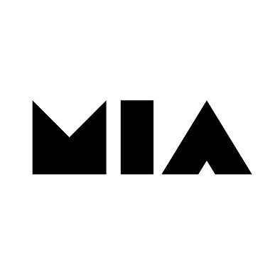
MIA Market 2022: Get your accreditation!
Accreditations are open. MIA market will take place from 13 to 17 October.
Registrations are available both for online (150 euros) and in presence participation (240 euros including online features).
Please find the registration page here.

Manaki Brothers International Cinematographers’ Festival
Date: 16th - 21st September
Find here the Festival's website and programme

Netherlands Film Festival
Date: 24th September - 2nd October
Find here the Festival's website and programme

CineEurope - Convention and Tradeshow
Date: 4th - 7th October
Find here the Festival's website and brochure

London Film Festival
Date: 6th - 17th October
Find here the Festival's website and programme

Film Festival Gent
Date: 12th - 23th October
Find here the Festival's website and programme

Vienna International Film Festival
Date: 21st - 31st October
Find here the Festival's website

Valladolid International Film Festival
Date: 23st - 30th October
Find here the Festival's website and programme

Stockholm International Film Festival
Date: 10th - 21st November
Find here the Festival's website (programme to be released)

Interesting links

- Disney’s Addiction to Subscriber Gains Drives Disruption at the Expense of Theatrical Revenue (Guest Column)
- Movie Theater Business Licks Its Wounds, Given Simultaneous Streamer Releases
- How Europe’s indie producers are fighting to retain IP and revenues amid streaming boom
- Citizen groups urge stop to MGM acquisition by Amazon
- Former Searchlight co-head says festivals more important than ever in streaming age

