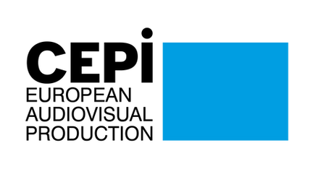
CEPI Newsletter
October 2021

Dear CEPI members,
As usual, October has been a very packed month for CEPI, with many priorities of independent producers high on the agenda. With travels slowly resuming, CEPI has been able to join the EUIPO Observatory plenary meeting in Alicante where stakeholders discussed how to strengthen the global approach to IPR enforcement. We were also present in Ljubljana, for the Slovenian EU Presidency conference on Increasing availability and competitiveness of European audiovisual and media content. You can read more about the outcome of this event in this newsletter.
Progress on the actions of the European Commission Media and Audiovisual Action Plan have also taken place. Most importantly, the long awaited stakeholder dialogue on increasing the availability of audiovisual content across the EU is now officially launched and CEPI has been officially invited by the Commission to contribute. We are preparing our submission as we speak. However, we are still waiting on the Commission to start its work on the media outlook. The ongoing stakeholders dialogue on sustainable production should resume in November, but CEPI already reached out to some of the Commission’s experts to share information on our project on sustainable production with the other social partners. The European parliament also adopted its report on the Commission’s action plan under the leadership of MEP Melbarde. While most of the important issues are covered in the report, it is regrettable that the report does not sufficiently differentiate Audiovidual from news media, despite CEPI and other stakeholder’s effort to communicate the specific needs of our sector. Read more on the report in this newsletter. Going in the same direction, CEPI provided input in the work of the Member States in preparing the Council conclusions on increasing the availability and competitiveness of European audiovisual and media content, which are expected to be adopted at the next Culture Council to take place on the 30th of November.
The Digital Services Act and its key provisions to help producers in their fight against copyright infringement online is progressing in the European Parliament and Council. While the negotiations are going quite fast, the expected voting date of the European parliament, the 8th November, has now been postponed. CEPI together with different industry coalitions such as the Audiovisual coalition, the Creativity work coalition and the Know Your Business Customer coalition continues to make its voice heard collectively on these issues.
Finally, we are preparing the next CEPI General Assembly to take place on the 25th and 26th of November in Madrid. More information on the agenda and the various panels will be circulated soon. If you cannot join us, don’t forget to designate a proxy. We are looking forward to seeing you there!
We hope you will find this newsletter informative,
Best regards,
The CEPI Secretariat

Sections in this newsletter:
- Latest from the EU
- COVID 19: Impact on the sector
- Latest on the AV industry
- Copyright
- Digital Services Act (DSA) & Digital Platform Regulation
- Piracy

- Audiovisual platforms
- Film and TV
- Festival
- Recent studies
- Events
- Interesting links

Latest from the EU


Stakeholder dialogue on access to content across border finally starting: CEPI invited
After a long wait, the Commission is finally launching its stakeholder dialogue increasing the availability of audiovisual content across the EU, but decides to start the discussions with selected CEOs.
.
The Media and Audiovisual Action Plan published by the European Commission last December included the launch of a stakeholder dialogue on increasing the availability of content across the EU. The importance of territorial licensing as the cornerstone of the functioning of the European Audiovisual sector remains a key issue for independent producers. Thus, CEPI has received an invitation to join the first meeting for this stakeholder dialogue to take place in the first half of March.
The Commission‘s objective is to develop and agree with the industry on concrete steps to improve the access to and availability of audiovisual content across borders in the EU. The dialogue should allow identifying, together with the audiovisual sector, pragmatic and innovative solutions to make films, TV series and TV programmes more widely available across Member States and to facilitate consumers’ access to a variety of content. It should also contribute to fostering a common understanding of the EU as a single market for the production and distribution of audiovisual content. It is very likely that the Commission will expect specific targets to be set by the sector.
Surprisingly, Commissioner Breton decided to anticipate the work of the dialogue by organizing a dedicated roundtable last week, with a short list of CEOs from the sector. This approach from the Commissioner created a lot of frustration among stakeholders and industry representatives, which criticized a lack of transparency in the process, and representativity in the discussion, as well as a risk of undermining the actual outcome of the dialogue. However, it seems that the industry forcefully conveyed a coherent message to the Commissioner during the roundtable: the necessity to maintain Territorial exclusivity as the pillar that ensures the viability of the European market. Present in the meeting as detractors, BEUC - The European Consumer Organisation, and MEP Róża Thun (biggest advocate of the removal of geoblocking for the AV in the parliament) raised the issue of geo-blocking calling for removing the AV sector exception from the regulation and expecting a regulatory solution. Commissioner Breton prepared a short article on his first exchange.
CEPI is looking forward to taking part in the stakeholder dialogue and working constructively with the European Commission, while defending the position and interest of independent production. We will report on the development of these discussions in the CEPI newsletters.

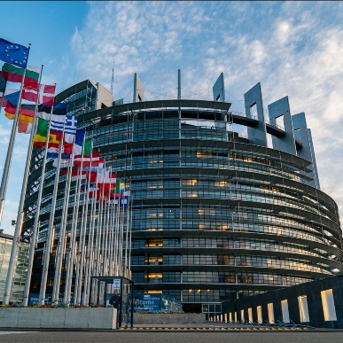
European Parliament on the future of Audiovisual: CEPI key takeaways
The European parliament adopted its report on the European Commission’s communication for Europe’s Media in the Digital Decade: an Action Plan to Support Recovery and Transformation, also called MAAP (Media and Audiovisual Action plan).
Under the leadership of Dace Melbārde, a Latvian MEP from the ECR group, the report touches upon a number of key issues of the audiovisual sector, but, unfortunately, fails at bringing sufficient distinction between the news media and the audiovisual sectors, which implies that both industry are facing the same issues. CEPI’s president was quoted among other industry players on the outcome of this report in Cineuropa.
On financial support and recovery, the report call has properly identified that the audiovisual sector needs for strong and sustainable support via the various EU funding programmes, such as Horizon Europe, the Creative Europe MEDIA strand and the Cohesion Funds, and that access to such funds should be facilitated. While the Commission’s initiative to support the industry with an insurance guarantee for AV co-production fund called MEDIA invest is welcomed, CEPI wants to highlight the importance for this fund to focus specifically to support European independent production, emphasizing the importance of the independence criteria.
On territoriality, CEPI welcomes the report which recalls the importance of territorial licensing as a corner stone of the European audiovisual sector. The report encourage the commission to use the stakeholder dialogue on territoriality, meant to start in the first part of November to to explore alternative funding models while fully respecting copyright rules, territorial exclusivity and the fair remuneration of the rights holders.
CEPI particularly welcomes the report’s repeated call on the commission to launch an assessment of the impact of VOD platforms on the AV European market and its understanding of the impact disproportionate economic powers (such as VOD platforms) can have on independent production. In addition, report shows an understanding of the impact work for-hire practices and buy-out contracts can have on European production and the risk for IP to not remain in Europe. However, CEPI regrets that the European parliament did not go further in asking the Commission to specifically include in its assessment the impact of new business practices on IP and european cultural sovereignty.
Finally, the importance given by the report on transparency of algorithms is welcome, but CEPI regrets that the report does not further emphasize the importance of transparency and access to data for producers, in particular audience data from VOD platforms..

EU officials and AV industry discuss increasing accessibility and competitiveness of the European audiovisual sector in Ljubljana
On 12 and 13 October, CEPI’s Secretariat went to Ljubljana to attend the Slovenian presidency of the European Council holding a conference on Increasing availability and competitiveness of European audiovisual and media content.
The wide presence of European and national institutions but also of industry representative was reflected in the discussions animating the conference.
From the Commission side, Giuseppe Abbamonte - Deputy Director-General in charge of media policy at DG Connect, Anna Herold - Head of Audiovisual and Media Services Policy and Emmanuel Joly - Senior Expert, Audiovisual Industry and Media Support programmes, presented the EU strategy to support the recovery and the transformation of the Audiovisual sector in Europe.
The officials begun by explaining the content of the Media and Audiovisual Action Plan launched in December 2020 and aiming at providing tools to support the industry.
Interestingly, Emmanuel Joly confirmed the view already expressed about MediaInvest considered as a financial instrument that will be accessible by few hence not being a recovery tool but rather an investment strategy for those “big” companies able to work on “big” projects. Indirectly, he concluded, ensuring the viability of large European players will create the right conditions for all the other players of the value chain to flourish.
In a second panel, broadcasters - represented by EBU and ACT, National film funds – represented by EFAD and the CNC, exchanged their views with Anna Herold on catalogues quotas, prominence and investment obligations for VOD platforms within the AVMS directive.
The French implementation of the AVMS was considered ambitious on one hand and risky on the other. Gregoire Polad, director of ACT for instance argued that high catalogue quotas could be an obstacle for small platforms while useless for global streamers as they could easily fulfill obligations with content already owned.
Anna Herold commented on the definition of European works and its possible revision after Brexit. Considering the highly political sensitivity of this issue, the commission has no intention to launch a new discussion on UK content while at the same time rejecting the possibility to reopen the AVMS directive any time soon.
Concerning territoriality and Geoblocking, Commissions officials where clear on the fact that there is no intention to eliminate the industry exception within the geoblocking regulation however, solutions such as increasing coproduction support and promoting content findability might be taken into consideration during the upcoming stakeholder dialogue to be launched this November.
CEPI secretariat had the opportunity to gather industry views that will help our association to drive the future discussions on how to increase availability of content in Europe making sure that the industry pillars will be preserved.

How did the European Union support the AV Sector during the worst months of the Covid Pandemic?
Creative Europe 2020 played an important role in supporting Europe’s cultural and creative ecosystem in its struggle to recover from the detrimental effects of the COvid pandemic in its industries. The two most significant initiatives were the implementation of new flexibility measures and the political agreement between the European Parliament and the Council on the Commission’s 2018 proposal for the new Creative Europe programme.
Beyond that, the effects of the program were felt throughout a diverse set of sectors. The MEDIA sub-programme continued to promote cross border promotion and distribution of films in EUrope and beyond. The MEDIA budget was used to foster talent and skills at the EUropean level, by training more than 2400 AV professionals in high demand skills that will remain at the core of the future of the sector. Half of the Fund was used to support the production of films, short films, serie, and documentaries from the crucial phase when projects are born to their theatrical distribution across borders.The Selective Distribution scheme was particularly helpful for 22 films considered to have the potential to attract wide audiences across borders.
Lastly, 33% of the MEDIA budget was invested in support of Europe’s creative industries in their marketing and portion strategies. MEDIA-funded public events managed to reach almost 2.2 million in audience compared to 3.5 million in 2019 despite the unfavourable conditions. Most importantly, according to Creative Europe’s 2020 Monitoring Report 2 815 SMEs benefited from this scheme in 2020 alone.

CEPI joins a series workshop on how to improve the effectiveness of sectorial Social Dialogue
On the 21st of October CEPI participated in the first of three workshops on how to improve the contribution of the EU sectoral social dialogue to policy-making, organised by the European Social Dialogue Committee. The workshop focused on three main pillars:
- Improving the contribution and participation of social partners
- Improving the impact of the social dialogue
- Improving the structure of the sectoral social dialogue to make it more efficient
The workshop followed the consultation that the European Commission launched to Social Partners on the effectiveness of the sectoral Social Dialogue and possible modernization actions.
During the workshop has been discussed key elements to make the social dialogue more effective such as more targeted consultation and exchange with the Commission, better feedback on how the findings of social partner consultation are used, and the possibility of appointing a Social Dialogue referent person in each DG to facilitate the exchanges with social partners. Participants also discussed how enhancing the involvement of national members, the need for more languages for interpretation and translation, and working more on joint projects and capacity building of social partners. The discussion will continue in two other workshops that will take place on the 18th of November and the 9th of December.

Covid-19: Impact on the sector

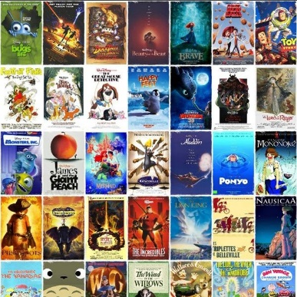
The animation sector adapts well to the pandemic
The animation industry has adapted quickly to the Covid-19 pandemic, mainly due to its capacity to produce remotely.
The sector has also been through unprecedented events due to Brexit: UK production companies were disinvited from French event Cartoon Forum in September for the first time. Nevertheless, it has been a busy year for the industry, with a great number of animated shows launching this fall. London-based distributor Beyond Rights is showcasing Nina & Olga, based on Italian children’s author Nicoletta Costa’s classic book series Olga the Cloud.

Latest on the AV industry

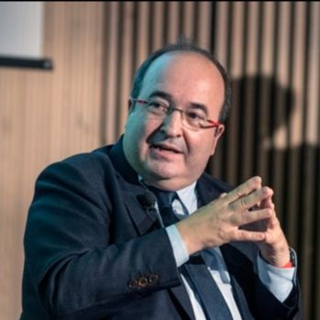
Spain pledges €10 million to help theatres recover from the pandemic
The Spanish Ministry of Culture and Sport has regulated the direct granting of support to film exhibitors for a total amount of €10.2 million.
The announcement comes as part of the aid packages that the Spanish authorities have devised to help the industry in the midst of the Covid pandemic and its detrimental effects for the theatre business and the culture industry as a whole.
The launch of the aid package came along with an announcement on behalf of the Minister for Culture and Sport, Miquel Iceta, to strengthen the Spanish film industry as an integral part of the overarching European One. He also stressed the importance of SMEs but did not announce any specific measures to support them in the short term. All in all though, the measure can better be contextualized as part of an overarching experience to achieve a complete recovery of Spain’s culture industry by 2022, dubbed the year of the Cultural Renaissance.

Copyright

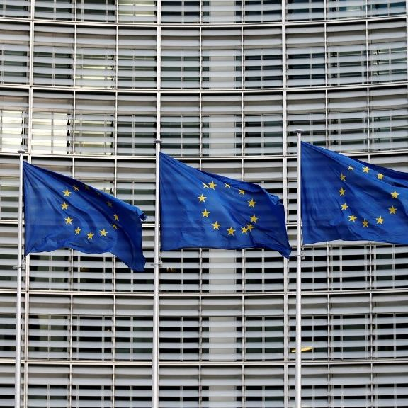
DSA: Time limits for illegal content removal, a step back on copyright protection?
On 26 October, CEPI cosigned a letter addressing the possible detrimental effect of the Digital Service Act (DSA) on the protection of the online environment and copyright protected content online.
The letter sent to the European Commission, DSA rapporteurs at the European Parliament and to some Member States officials, stresses that adopting the DSA as it stands would weaken the current liability regime and have a detrimental impact on the existing standards and good practices for addressing illegal content and activities, including online infringements of copyright and related rights.
Among the three main issues brought to the attention of policy makers, the creative ecosystem pointed out that setting specific time limits for the removal of illegal content online (including copyright infringing content), would weaken the current obligation to act “expeditiously” to remove illegal content as provided in article 17 of the Copyright directive.
MEP Christel Schaldemose, IMCO rapporteur of the DSA announced on 27 October that the vote on the regulation initially set for 8 November will be rescheduled to date to be confirmed soon.


Copyright Directive moving slowly in Member States
Despite the deadline for the implementation of the EU Copyright Directive passed last June, the majority of member states did not yet complete the transposition.
The EU Commission tried to speed up things by opening formal infringement proceedings against 23 member states while asking to provide information on their implementation process by end of September 2021.
Some countries, such as Austria, have published implementation drafts. Germany’s implementation of Article 17 entered into force on 1 August 2021. Nevertheless, in general, stakeholder dialogues are continuing in most countries. There is some hope that upcoming implementation drafts may at least display a more harmonized approach than the differing approaches of Germany, France and other countries.
In June 2021, the Commission published its long-awaited guidance on the interpretation and implementation of Article 17. The guidance gives a more precise outline of the requirements and obligations to be met by online intermediaries and rights holders, and so could well serve as a blueprint for the outstanding national implementations.
However, following the European Court of Justice (CJEU) decision in the YouTube & Peterson and Cyando cases (CJEU, C-682/18, C-683/18), the Commission has already begun to consider whether it should amend its guidance. In that judgment, the CJEU determined the criteria that an online service provider has to satisfy to avoid liability under a pre-Article 17 legal regime. These criteria are less far-reaching than the obligations imposed by Article 17. So, while it’s still an open question if and how this decision will influence the implementation of Article 17, these criteria, in any case, remain relevant for online intermediaries that do not fall under Article 17.

Marco Giorello (DG CONNECT) and Eleonora Rosati speak at the IFIM Conference on “The Making of EU Copyright”
Marco Giorello, acting head of the copyright unit in the European Commission (DG CONNECT), spoke on Monday 18 October at the IFIM Conference “The Making of EU Copyright”. He started by summarizing the state of play regarding the implementation of the Copyright Directive, highlighting the controversial Art. 15 and 17 of the text, and the delays in the transposition of the Directive in several Member States. After that, he gave some reflections on the copyright policy at the European level, stating that the copyright reform of 2019 leaves untouched the original 2001’s Directive, and complements its provisions with a number of rules which bring the copyright law to the European level in the area of market regulation.
Thus, Art. 15 and 17 address the market malfunctioning in the relationship between rights holders and online platforms, a dimension that was not there in the previous copyright legislation. Answering Eleonora Rosati’s questions, he confirmed the unusual character of the Commission’s interpretative communication regarding Art. 17 of the Directive, leaving a reduced room for maneuver to Member States in this regard. Nevertheless, Giorello stated that, in this case, the institution had the mandate to do so coming from the legislation. In his personal opinion, a future intervention to modify the copyright fundamentals (the 2001 Directive) is more likely to happen from the ECJ than from the EU legislator.

Digital Services Act and platform regulation

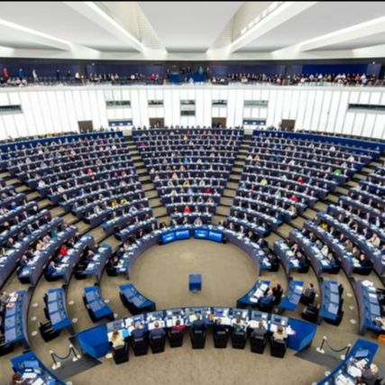
DSA slowly moving towards a committee vote
The Digital Services Act is slowly moving towards its vote in the Internal Markets Committee, still scheduled for November 8. The pace however in IMCO is slower than expected and it is uncertain at this point if the deadlines will be met.
Intelligence suggests that until now, 3 batches of Compromise Amendments have been created and the shadow rapporteurs had one meeting for each. However, there was not even one adoption/agreement on them from the political groups, meaning things are still open.
The new CAs include extended provisions on “online interface design and organisation” (15a) that dictate how online platforms should design their interfaces in order not to manimupate users (the so-called dark patterns), but also their obligations with regard to obtaining consent from the users. Other changes include more oversight on algorithms and guarantees that the operators will reduce the risks that platforms and products pose to society. Under the CAs, NGOs and journalists should also get access to platforms’ data and algorithms. Extensive rules for online marketplace (including even packaging details!). With regard to advertising transparency, a new paragraph has been introduced according to which Member States shall refrain from imposing additional transparency reporting obligations on the online platforms.VLOPs should also maintain an ad repository for seven years, instead of the initial 12m.
On the 27 of October an Exchange of views in the Committee took place, and on the 28 October, IMCO had a technical meeting for the most difficult AMs to agree on.
S&D IMCO's political adviser revealed that Schaldemose – who has also lost her DSA assistant – faces serious delays. Given the situation of no agreement in IMCO until now, it seems that a vote on the 8 November does not look very realistic anymore. Potentially this will be pushed to December or even January, which means that the Plenary will only take place in Jan/Feb 2022.


The JURI committee passes the Digital Service Act (DSA)
The EU’s plans to renew its copyright legislation and combat online piracy continue to move ahead. In this fight, the most significant new tool the EU wants to unleash is the Digital Services Act (DSA).
In this respect, a compromise was recently reached between copyright holders and freedom of speech supporters to improve and adapt the DSA. The updated version of the legislation was adopted by the European Parliament's Committee on LEgal Affairs (JURI) on October 1st.
The new includes a mechanism to take down pirated live streams within 30 minutes and a strict takedown deadline for illegal content that has to be removed within 72 hours.The legal document is not exempted from controversy though. On the one hand, several civil society groups pointed out that the new “trusted flaggers” system, that allows certain content creators to get preferential treatment in the take down process, is unfair. On the other hand, some copyright holders still believe that the text, as it stands,does not go far enough. They want to increase the liability for online service providers to ensure that illegal content does not come up again after being deleted.
To make matters even more complex, some MEPs fear that the algorithms designed to identify pirated content will likely lead to legal content being suppressed. In other words, the adoption of the text by the JURI committee is an important step forward, but there is still a long way before the DSA is finally approved by the EUropean parliament.

Piracy


Nitro TV seeking to have Hollywood lawsuit dismissed
A year ago, a group of entertainment companies members of the ACE filed a lawsuit against pirate IPTV service Nitro TV. Alejandro Galindo, the operator of the service, was accused of massive copyright infringement of the companies’ works, and later of destroying evidence in an effort to hinder the plaintiffs.
He is now asking the court to dismiss the lawsuit. His lawyer argues that the lawsuit should be dismissed without prejudice, since the plaintiffs have unlimited budget and legal team members and are seeking to delay the case. According to Galindo, MPA’s Jan Van Voorn “vigorously advocates” for criminal penalties for IPTV operators.


Movie companies sue several VPNs and hosting partners for piracy
A group of film companies, including the makers of “London Has Fallen”, “Rambo V”, and “Dallas Buyers Club”, is trying to hold VPNs and their hosting partners responsible for piracy. The companies claim that a user used a “hacked” email address to create an account on the YTS site - one of the most popular torrent sites online - and steal money.
YTS had already signed a settlement agreement to share details from its user base with movie companies, providing evidence for follow-up lawsuits against pirate users. UK-based company Datacamp Limited, also known as CDN77 and DataPacket, is one of the largest targets of the lawsuit. It is being accused of contributory copyright infringement, since it failed to terminate the account of several VPN services after being warned on different occasions. The company has yet to respond to the allegations, facing over a million dollars in damages if guilty. The film companies ask the court to require Datacamp to block ports 6881-6889, used for BitTorrent traffic, and to restrain its customers from accessing pirate sites.

MPA sees piracy as the greatest threat to the global audiovisual community
Charles Rivkin, Chair of the Motion Picture Association (MPA), currently sees piracy as a massive threat to the global audiovisual community. Representing major Hollywood studios and Netflix, the MPA and the Alliance for Creativity and Entertainment (ACE) have stepped up their efforts to combat online piracy and copyright violations. Pirate site blocking seems to be working to tackle the problem, particularly in countries like Spain, Italy, France and the Netherlands. Rivkin particularly highlighted the role of the Spanish police. Even if the MPA is pushing for similar powers in the United States, not much progress has been made for the time being. Rivkin is also concerned about the potential competition between legal streaming and the box office through simultaneous releases, but nevertheless claims that “there is no substitute for going to the movies”.

Dozens of pirate IPTV domains forced to submission by ACE anti-piracy coalition
The Alliance for Creativity and Entertainment global anti-piracy coalition has taken down more than three dozen new IPTV-related domains through threats of facing stronger legal action. The ACE coalition is integrated by major Hollywood studios, Netflix, Amazon and the BBC among others. Forcing pirates into submission is one of ACE’s preferred strategies, even if the coalition is not afraid of solving this kind of problems in court. Similar operations have been going on for years now, with ACE taking down over 200 domains. Juice TV has also been affected by this campaign, being transferred over to the Motion Picture Association. Since piracy is currently one of the biggest threats for Hollywood studios, these operations are likely to continue in the long-term.

The global antipiracy coalition achieves a great victory against pirate sites in the US
The war on pirate sites continues with the global anti-piracy coalition obtaining a pair of DMCA subpoenas to compel the Cloudflare platform to hand over information on online pirates. Thousands of pirate sites use Cloudflare to hide information about their platforms, but it seems that this will be no more in the near future.
The subpoena applications were filed by the Motion Picture Association, acting on behalf of the members of the Alliance for Creativity. The first claims that two pirate services were breaching the industry’s copyrights in the movies Jack Reacher and Fast and Furious 9. The second follows a similar format but covers a wider arrange of titles pirated and a larger number of online services were targeted in America and Europe, including Mr Piracy and YGG Torrent. Despite these advances though, the fight is still on, with smaller untouched pirate sites like Watchtvseries.si still untouched by law enforcement in many countries.

Dune is set to become the most pirated movie of the year
The controversy surrounding Dune’s release in HBO MAx was accompanied by its early online leak courtesy of EVO, a hacker group dedicated to leaking streaming platfform’s content online. The group released a file claiming to be a “HDRip” of Dune, before the movie was even released in some European countries.
After the original release, other EVO branded copies of the movie appeared online with lower quality and smaller size fuels. As a result, Dune has become a leading contender to become the most pirated movie of the year.

AVMSD


The AVMSD may bring about a brighter future for Estonia’s film industry
Despite reducing the funding dedicated to film production by almost 30% due to the covid pandemic, the Estonian Film Institute may compensate the losses by negotiating the delivery of further aid packages with the government on the basis of Article 13 of the Audiovisual Media Services Directive (AVMSD).
The article in question relates to the governmental support of companies producing or distributing European works. Edith Sepp, the CEO of the national film agency thinks that in the context of the fundamental market changes brought by the pandemic, the Estonian government could further finance its film industry to support local content production under the label of European works. She is positive about the idea, and thinks the government is listening to the sector’s arguments. The initiative is particularly relevant for the Estonian cultural context, in which Estonian language films play a big role in revinidcating national identity.

AV platforms


Netflix’s originals popularity now measured on number of hours watched
Netflix will from now on report on hours viewed of its originals. The streamer has then detailed its top 10 original productions as of September 27 in this new way.
Bridgerton (625 million hours), Money Heist (619 million hours), Stranger Things (582 million), The Witcher (541 million) and 13 Reasons Why (496 million) meet in the top 5 positions. Previously, Netflix reported on the popularity of its shows through the number of accounts that chose to watch at least two minutes of the programme in its first 28 days on the platform. The service claims that this is a better indicator of the overall success of its original titles. A Netflix spokesperson has also stated that they anticipate a more normalised content slate in 2022, with a greater number of originals and a more balanced schedule than in 2021.


Settlement reached on the “Black Widow” lawsuit
A settlement has been reached between Scarlett Johansson and Disney over her blockbuster lawsuit accusing the studio of disrupting the theatrical release of “Black Widow”.
The studio tried to force the lawsuit into arbitration, arguing that by contract all disputes must be settled in private. Both parties have now expressed their happiness for having resolved these differences.
The actress accused the studio of trying to prop up Disney Plus by launching a simultaneous release of “Black Widow”, instead of the traditional theatrical release that had been agreed in the first place. In March 2021, Disney announced the simultaneous release of the film via Premier Access on Disney Plus on July 9. According to Johansson, the streaming release strongly damaged the theatrical revenues, and violated her contract with the studio. Disney then revealed that the film had grossed $125 million on streaming.

New French SVOD platform Melty+
A new paid subscription SVOD service has been launched by Alchimie and the French Meltygroup, offering premium content to around 10 million users for €4.99 a month. The president of Meltygroup, Bruno Massiet du Biest, speaks of a new stage of development of the entertainment news media group, now offering richer content to meet the expectations of younger audiences. He also mentions the good results of diversifying revenue sources, consolidating a more resilient model. Combined with the SVOD expertise of Alchimie, Melty now offers a reduced subscription fee of €1.99 for the first month, which allows the user to have ad-free access to more than 50 hours of programmes, podcasts and articles.

Higher subscription fees for Netflix in the Netherlands
We are now witnessing Netflix’s first price increase in the Netherlands for four years. With around three million subscribers in the whole country, the service now charges an additional 1€ a month for the Standard package and €2 a month for the Premium one. €7.99 remains the price of the basic package, which offers lower image quality. These measures will have immediate effect in the Netherlands.

Streaming is becoming the norm for TV consumers in the UK across all ages
According to a study produced by online video streaming service and technology provider Roku, British consumers largely prefer TV streaming over pay-TV services. The study found that 9 out of 10 Britons use the former in comparison to 7 out 10 that use the latter. It surveyed 934 18–70-year-olds that consume at least 5 hours of TV and found that the main reason behind streaming’s dominance is its perceived better value, convenience and wider content variety.
Most importantly, the results of the study vary depending on the age of the respondents and the kind of content that is consumed, but the results were reflected across age groups and products. Other interesting findings reported that 68% of consumers use streaming services because it allows them to have early access to film releases and that ad-funded TV (AVOD) services are likely to become increasingly popular.

The Future of Streaming looks bright, specially for Disney
Research firm Digital TV Research recently published a report predicting that three SVOD platforms, Netflix, Disney +and Amazon Prime, will control nearly half of SVOD subscriptions by 2026. The study also projected that Disney + will surpass Netflix in its number of subscribers by 2025, turning into the world’s most popular streaming service, despite the recent speed bump the service is going through at the moment.
Overall, the study predicted that the global subscriber base will increase by close to half a billion between 2021 and 2026, with the CHinese and US markets accounting for 49% of the global total by that date. If compared with the current 56%, this means that much of the space for market growth in the sector will come from smaller and developing countries, according to the report.

How the pandemic has changed the SVOD and AVOD markets
Ampere Analysis just released another report that found that older age groups have been at the core of the increase on Netflix subscriptions during the third quarter of 2021. For the first time in the platform's history, 24–44-year-olds were more likely to be Netflix subscribers than their 18-24 year-old counterparts. The latter, by contrast, were more likely to seek out home entertainment, by flocking back to cinema theaters. In fact, nearly half of the cinema goers during the period were younger than 35, according to Ampere’s report.
Beyond that, the analysis also found that the AVOD platform subscription base continued to grow on the shoulders of low cost entertainment options, in the overcrowded US market. This along with a 18% increase in the ownership of streaming boxes and sticks means that devices such as Roku, Amazon Fire TV or Google Chromecast were now in nearly two thirds of US Internet homes and half of UK Internet homes. All in all, it is fair to say that, during the pandemic, older audiences discovered Netflix, and after it, younger audiences rediscovered the cinema-going experience.

Cinema & TV

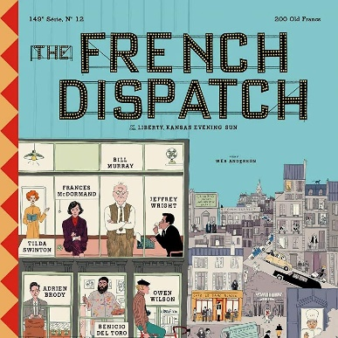
The successful release of The French Dispatch encourages Indie producers
Wes Anderson’s The French Dispatch opened in American cinemas the past 22nd of October to recollect a gross $1.3 million for per screen average of at least $25K.
This made it the most successful commercial product of the pandemic era with the permission of global blockbusters like Fukunaga’s 007 No Time To Die or Villeneuve’s Dune.
Dozens of theaters and theater associations across the US geography claim the French Dispatch to be the best performing specialty film since Covid began back in 2020. The movie was not expected to perform in such a manner, considering Wes Anderson’s esoteric style and its unpopular subject material, but this has not stopped it. In fact, The success of the film has turned Wes Anderson into a heroe for arthouse and indie directors, in search for a glimmer of hope in the pandemic era. Maybe the future of the cinema experience belongs to specialty cinema.


Dune’s success will be taken upon by a sequel set for 2023
Legendary Entertainment and Warner Bros recently announced that the success of Dune leaves them no option but to start producing its sequel, Dune 2, for a set release date in 2023.
Most importantly, the movie will enjoy an exclusive theatrical release, thanks to pressure on behalf of Legendary entertainment. The plan was always to release a second part to the story, but the company decided to base its decision to continue with the project on the basis of the results of the first movie. Dune then became the best release for Warner Bros this year both in the US and the global box office. Its success speaks to the possibilities of the traditional theatre experience to bring about great economic results in the pandemic and post-pandemic eras.

Blockbusters lead the way for the cinema industry’s comeback after the pandemic
Director Denis Villeneuve’s “Dune”, along with Sony’s comic book sequel “Venom: Let There Be Carnage” and the last Bond installment “No Time to Die” have become the most internationally successful movies of the year. Sony’s Venom reached $350 million in global ticket sales and was particularly successful in Asian and non-Western markets, with Dune following its tracks around the $300 million at the time of reporting.
Most importantly, leading the way was the last James Bond, which became only the second Hollywood film to surpass $500 million globally since the pandemic. Time will only tell if it will eventually generates the $800 million that it needs to break even.

Disney delays most of its major titles in 2022 and 2023
The company announced that it has delayed its release plans for several of its most popular incoming titles including: “Doctor Strange in the Multiverse of Madness”, “Thor: Love and Thunder”, “Black Panther: Wakanda Forever” from July 8 to Nov. 11, “The Marvels”, “Ant-Man and the Wasp: Quantumania” and “Indiana Jones 5”.
According to internal company sources, the delays are due to production and not the disappointing box office returns of its last titles, like “Shang-Chi and the Legend of the Ten Rings”. It must be remembered that most Disney movies operate in planned cinematic universes and that a delay in the production of one entry in the franchise necessarily affects the launch of the rest. However, the may be also rethinking its release strategy to adapt to post pandemic consumer behaviour and wait for its most detrimental effects to expire, according to industry experts.

Bond brings cinema’s back to pre-pandemic levels of attendance
Mooky Greidinger, CEO of Cineworld, the world’s second largest cinema exhibitor, claimed that the performance of the last Bond movie can stand as irrefutable proof of the return of cinemagoers of all ages to theaters. The optimistic sentiment was shared by Tim Richards, CEO of major chain Vue International, which also thought the Bond is in the process of taking the industry “back to pre-Covid levels”.
According to industry leaders, the public response to Bond’s new installment was not only good as a post-Covid release, but as a film release in general with solid numbers across European and American markets. Speaking about the success of the film, Veronika Kwan Vandenberg, President of Distribution for Universal Pictures International, claimed that her company’s vision was always to release the movies in theatres to push audiences to come back and embrace the theatrical experience again. Are things going back to normal?

Festivals

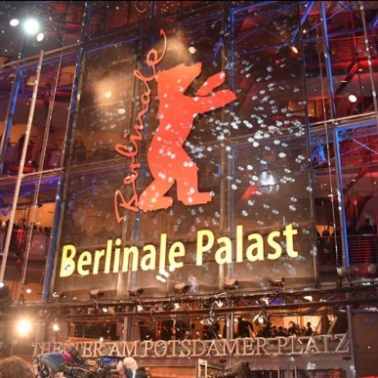
The Berlinale will return as a fully in-person event in 2022
The next Berlin Film festival will prioritize on site activity while continuing to offer online formats.
The move follows the on-going trend of European film festivals that have decided to return to primarily physical editions this year, including the Cannes and Venice. All of them include hygiene and social distance measures to protect attendees, and industry activity will nonetheless continue to be primarily online. However, the decision serves a shimmer of hope for a return to normality in the industry and European society as a whole.


Valladolid’s Seminci gathers the big names of world cinema
The 66th Valladolid International Film Festival will take place between the 23rd and the 30th of October in the Castilian city.
Robert Guédiguian’s Mali Twist and Paul Schrader’s The Card Counter will be competing for the Golden Spike in the Official Section of the festival. Other films in this gathering include the Spanish The Odd-Job Men and Libertad, produced between Spain and Belgium. Argentina will be the guest country this year, with actress Emma Suárez serving as the Seminci’s “godmother”. Find more about the festival here.

300 films presented at Ji.hlava 2021 for its 25th anniversary
The Ji.hlava International Documentary Film Festival will celebrate its anniversary edition from the 26 to the 31st October in Czech Republic, confirming thus its position as the leading European documentary festival. Some of the titles that will have their premieres at Ji.hlava are the Belgian Letter to Nikola and the Romanian You Are Ceausescu to Me. Domestic documentaries will compete in a separate section called Czech Joy. This year, the focus is set on the environment and the relationship between humans and nature, according to festival director Marek Hovorka. Find more about Ji.hlava 2021 here.

Recent studies


Unravelling the Digital Services Package? New report by the European Audiovisual Observatory
The Strasbourg-based European Audiovisual Observatory, part of the Council of Europe, is now presenting a report drawing on five webinars that were organized in the first half of 2021 on the Digital Services Act package (DSA).
The report, called Unravelling the Digital Services Package, draws on disinformation, content regulation, copyright issues and gatekeeping in its different sections. Download the full document here.

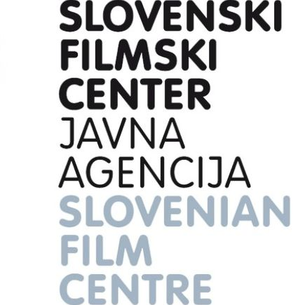
New study on works from small language environments by the Slovenian Film Centre
A new report, entitled “Study on the Accessibility and Competitiveness of European Audiovisual Works from Small Language Environments”, has been published by the Slovenian Film Centre.
The research, compiled by Wagner Hatfield, was presented at a two-day conference called “How to Increase the Accessibility and Competitiveness of European Audiovisual and Media Content”, held in the Slovenian capital between the 12 and the 13 October. Find more about the study here.

Mapping of national rules applicable to video-sharing platforms: Illegal and harmful content online, by the European Audiovisual Observatory
This report tracks the existent measures to tackle illegal and harmful content online. It includes a pan-European comparative analysis, detailed country profiles, as well as the perspective of industry stakeholders. Find more about the study here.

Events

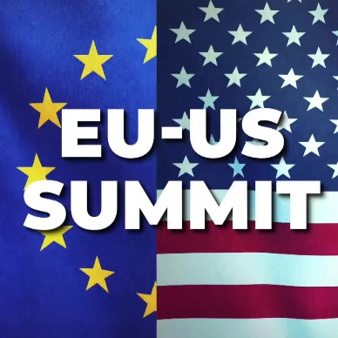
19th Annual US-EU Copyright Summit
On Tuesday 9 and 18 November, during the Annual US – EU Copyright Summit, industry and institutional stakeholders will discuss the current implementation of the EU Digital Single Market Copyright Directive (DSMCD) and changes in practices and enforcement.
Please find here the full agenda here and the registration for the conference here.


Co-Pro Pitching Session at SeriesMania 2022
Series Mania Forum selects 15 series proposals under the Co-Pro Pitching Session.
On this occasion, a jury of selected professionals will award the best project with a 50000 euros grant.
Applications are open until 6 January 2022.
Interested in participating? Find here the online portal with more details and the form for the submission of the project.

Stockholm International Film Festival
Date: 10th - 21st November
Find here the Festival's website (programme to be released)

Interesting links

- Lost in translation? The one-inch truth about Netflix’s subtitle problem
- European Alliance Execs Debate Difficulty of Competing With Streamers
- Denis Villeneuve on ‘Dune’ Success and the Road to ‘Part Two’

