
CEPI Newsletter
November 2021

Dear CEPI members,
November has been filled with CEPI meetings, starting with our General Assembly in Madrid last week, the first physical meeting since the beginning of the pandemic. It was great to finally have most of the CEPI members together, and for Salvatore and myself to finally meet you in person. EACiné, our colleagues in Spain did an outstanding job to organize these 2 days of meetings at the academy of Cinema of Spain.
The General assembly was the opportunity to review the CEPI activities for the past year and our priorities for the future. It was also the moment for you to elect a new Board of directors for the organisation. Susana Gato, from APIT in Portugal has been elected unanimously CEPI’s new President. Jerome Deschene will remain in the Board as treasurer after having served 5 years as president.
In Madrid, we also focused our discussions on the value of data for independent producers, with a workshop where a representative from the Spanish ministry of culture, a consultant specialized in data for TV, a representative from Comscore and CEPI highlighted the different situations with regard to access to data between TV, cinema and platforms and question its strategic importance.
On the second day, a large panel on the distribution windows included over 10 speakers from each segment of the exploitation chain, all discussing the importance of the cinema as a release window, but also the need for more flexibility. Finally, the meeting ended with an insightful workshop on sustainable production, where producers from different countries, sustainability experts and CEPI’s project manager exchange on the importance of bringing more sustainability in production and most importantly, how to do it.
CEPI has also been kept busy in November with the start of the European Commission stakeholder dialogue on increasing the availability of audiovisual content across the EU is now progressing, with the introductory meeting and the first working day set up by the Commission having taken place in the past week. CEPI has been organizing preparation calls with all members to help us define our position during these exchanges. The 1st full day meeting focused on how to foster the production of AV works able to reach a wider audience across the EU and how to improve the distribution and discoverability of AV works across the EU. The next meeting on the 10th of December will be dedicated to discussions on how to facilitate cross border access to audiovisual works. The Commission has scheduled 6 meetings until March.
On other news, the European Commission's long expected Media Outlook is now postponed until mid-2022, this, despite the pressing need of our industry to have such an assessment of the situation of our sector, in light of its rapid changes. The Digital Services Act is now in its last steps for adoption in the European parliament as a final vote in the internal market committee is scheduled for the 13th of December. France, which will be holding the presidency of the Council of the European Union starting on the 1st of January has already announced its intention to move rapidly on this file and on the Digital Markets Act by leading the trialogue negotiations. CEPI will continue to follow these developments, and collaborate with the different coalitions to influence the discussion.
With the Season’s holiday coming soon, December will be a short month. Exceptionally, the next CEPI newsletter will be sent on the 10th of January.
We hope you will find this newsletter informative,
Best regards,
The CEPI secretariat

Sections in this newsletter:
- Latest from the EU
- COVID 19: Impact on the sector
- Latest on the AV industry
- Copyright
- Digital Services Act (DSA) & Digital Platform Regulation
- Piracy

- Audiovisual platforms
- Film and TV
- Festival
- Recent studies
- Events
- Interesting links

Latest from the EU


Stakeholder Dialogue update: Increasing AV content availability across Europe
In december 2020, the Commission published the Media and Audiovisual Action Plan (MAAP) a document launching a set of Actions that would support the Audiovisual industry in its recovery, green and digital transformation as well as empowering industry citizens and talents.
On these bases, the Commission launched in November 2021 a stakeholder dialogue aiming at increasing AV content availability across Europe.
The Commission is demanding from the industry to propose industry led possible practices to foster the production of AV works able to reach a wider audience across the EU and propose industry led possible practices to Improve the distribution and discoverability of AV works across the EU.
During the first two meetings, respectively on 9 and 22 November, CEPI maintained a “cautious approach” reiterating the importance of understanding and assessing the recent development of the audiovisual market in Europe before starting this exploration of possible industry-led solutions to increase content availability or circulation.
As relentlessly argued by the industry, territoriality remains the main pillar holding the financing system of the industry. Hence, fostering coproduction could be the only solution related to content creation, however if this is the approach to take, we should make sure that there will be an appropriate distribution of rights and that independent Production won’t be affected.
In addition, the AVMS directive contains legal provisions already going in the direction of the aims of the dialogue. Content quotas and promotion obligations will likely have a huge impact on availability of content online. It would be interesting to include the possible benefits of these rules before exploring new possible measures.
The third meeting will take place on 10 December and will serve as a brainstorming session to identify ways to facilitate cross border access to AV content.
At the same time, during next meeting participants will be able to provide their views on some of the possible actions highlighted during the first meeting such as:
- Foster co-production: increase number of co-production (3 or more countries) ensuring equitable remuneration and right detention for producers
- Financial support for subtitling and dubbing: Public funds to cover costs
- Promotion of discoverability tools: Strengthening Agorateka platform.
- Assess the possibility of multi-territorial licensing: AVOD/TVOD
- Foster use of data driven AI technology: Support producers‘ ability to access technology to increase international competitiveness.
- Media and AV Literacy: foster awareness of European content via those parts of the value chain responsible for connecting content with audiences (Distributors, Festivals, VODs, Content discoverability tools).
- Rights’ revocation: Unexploited rights to go back to producers.
CEPI will hold a preparatory meeting next week. All members are invited to join and contribute to CEPI’s position. A calendar invite will be circulated soon.


The MAAP report is received with mixed reactions from Europe’s AV industry
The European parliament released its “Europe’s Media in the Digital Decade: An Action Plan to Support Recovery and Transformation” (MAAP) report in december. I prompted a series of mixed reactions among the leaders of Europe’s audiovisual industry.
Some welcomed the parliament's commitment to create a level playing field for media while cautioning against practices that may undermine contractual freedom, legal certainty or investments in the sector. The Association of Commercial Television and Video on Demand Services in Europe (ACT)’s points were mirrored by other organizations like Cineuropa or Eurocinema, but added concerns about potentially misleading definitions of media and audiovisual sectors and the lack of calls to action to not only assess but also react to streaming platforms' on-going takeover of the market.
Reflecting on the new report, CEPI’s Jérôme Dechesne considered MAAP to be “overall positive” despite his colleagues’ complaints. CEPI is especially optimistic about he call for the EC to ensure that the Invest Europe initiative should focus on supporting European independent production. It also welcomed MAPs focus on territorial licensing, its pledge to fight IP infringement online, its petition for the EC to assess the effect of streaming platforms on European markets and the impact that overwhelming economic powers can have on independent production, and its acknowledgement of the detrimental outcomes of uncertain job contracts. However, CEPI also felt like the report lacked a petition to the EC to include an analysis on the effect that new business models have on IP and cultural sovereignty and a deeper emphasis on transparency and access to data for producers - especially audience results from streaming and VoD services.

Final Adoption Council conclusion on increasing the availability and competitiveness of European audiovisual and media content
On 30 November the Ministers of the EU Member States who are responsible for audiovisual policy adopted Council Conclusions on "In increasing the availability and competitiveness of European audiovisual and media content."
The Council Conclusions are important as they show the political ambition of the EU Member States in audiovisual policy. Therefore, these past months the CEPI’s Secretariat has lobbied the Brussels based representatives of the EU Member States to include wording that supports the policy aspirations of our association.
The Council conclusions integrate a large variety of proposals in line with CEPI’s position like the protection of territorial licensing as the base of our sector financing system.
In addition, the document emphasises the need for assessment of the current situation of the industry and the need to promote “Promote licensing practices aimed at ensuring a more equitable relationship between VOD providers, platforms, independent producers and other right-holders.
As a demonstration of the fact that the topic of the relationship between Global VOD platforms and Data Transparency is gaining momentum in Europe, the Conclusions (§ 47) emphasise the ambition of the council to set standards for audience data sharing.
Last but not least, the text highlights the need to assess the definition of European works as an essential factor for a fair distribution of European titles in the market.(§38)
Please find here the official text.

2022’s EU Budget is ready to go!
The European Council has recently come to an agreement with the European Parliament on next year’s EU Budget. The total commitments were settled at €169,5 billion and payments at €170,6 billion. 2022’s budget will focus on the main priorities of the union, including economic recovery, fighting climate change, and the green and digital transitions. The budget will also include resources under the expenditure ceilings included in the 2021-2027 multiannual financial framework to allow the EU to react to unforeseeable needs.

The Commission’s funding guide for the European Cultural Industries
The European Commission has published an interactive guide to ease access to the funding opportunities available for the cultural and creative sectors in 2021-2027. Players in these sectors will have less difficulties identifying the most suitable sources of EU support for their projects. The results will include information on the available budgets, application processes of the different funding sources and a link to the specific programmes or calls. Please find the funding guide here.

Covid-19: Impact on the sector


New Covid curfew in Slovakia forces cinemas to close again
A state of emergency and a curfew were declared by the Slovak government with effect from the 25th of November, due to the rapidly deteriorating pandemic situation in the country.
Cinemas and other cultural institutions will be closed at least until the 9th of December, when the government will meet again to decide whether to prolong the measures beyond this date. CINEMAX, the largest cinema operator in Slovakia, decided to screen a pre-premiere of Ridley Scott’s House of Gucci before the closure.


Austrian cinemas to close due to national lockdown
Austrian cinemas were forced to close from the 22nd of November as part of the new national lockdown announced by the government. The measures are expected to last 10 days but could be extended up to 20 if Covid-19 cases don’t go down.
Exhibitors and distributors are now scrambling to rearrange release dates. Some titles that will be impacted negatively by the lockdown are Ghostbusters: Legacy, The Addams Family 2, Eternals and Dune. Austria’s seven-day incidence rate of 1,000 per 100,000 people is now among the highest of the European Union.

The Bertha Fund (IBF) expands its capital to support directors in Covid times
The Bertha Fund (IBF) of the International Documentary Film Festival of Amsterdam will increase the money it has foreseen to grant to documentary films by 50% from €17,500 to €25,000. It will also increase the funding of projects in development from €5,000 to €7,500. The added funding comes from the US Ford Foundation and the Bertha Foundation.
As a result, 25 projects will be supported each year instead of the current 20. The IBF will also raise overall project support for its Classics from €225.000 per year to €415.000 and only directors will be able to apply for the development grant from now on.
With this new push, the Fund intends to build up on its legacy of support to over 600 films, by continuing to assist small independent doc directors in the times of Covid. The pandemic has contributed to a surge in the number of applications for the fund. Last year, during the lockdown, IBF received 560 applications. Before, it could have only contributed to 10 of them but, with the Ford money, it was able to increase that number to 15.

France takes action in support of its local production industry with a new Subsidy Scheme
A selective funding scheme for French audiovisual content pre-financed exclusively by non-European platforms and producers has just been released by France’s National Film Board. The so-called “fonds sélectif plateformes” is designed to support French products in streaming services like Netflix, Amazon or Disney Plus and will have a total budget of €5 million. The measure accompanies a previous decision of the French government to force treamers to invest between 20%-25% of their French revenues in French content.
The new decree was released in line with previous European legislation trying to create a level playing field in a market dominated by streaming giants. The new funding scheme has been designed to accompany this decision and straighten the independence of the French production sector. The first selection of funding receivers will be held on December 3 with the other two expected for next April.

Latest on the AV industry

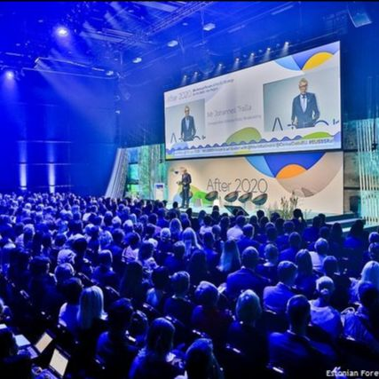
At Tallinn's European Film Forum, experts exchanged views on the future of virtual production
During the panel "Untackling virtual and remote production: What's the impact for creators, producers, service providers and the industry?" of the Tallinn Black Nights Film Festival, experts and industry leaders shared their opinions on the new frontiers of virtual production.
Max Pavlov, CEO of Latvia's Led Unit Studios, claimed that European productions should focus on spending less on production to earn more through sales by diminishing travel and transportation costs. In order to do so, Led Unit has built one of the largest and most technologically revolutionary European facilities for virtual production. He invited his colleagues to support projects like his, that are now being used for the production of full length films and upholds the environmental goals set by international organizations and the European Commission.
Others like Fireframe Studios' Chief Operating Officer Mikko Kodisoja, commented on the role that real time game engines will have in the future of filmmaking. He made the move from one industry to the other when he founded Fireframe to focus exclusively on virtual film production. Finally, Peeter Jalakas, one of Estonia’s most renowned theatre directors and innovators, insisted on the importance of investing in technological experimentation to bring artistic endeavours further in our current era.

Copyright


The Secrets of the new UK Copyright Bill - empowering authors
Britain’s new Copyright bill has now been released. The new piece of legislation proposes new laws for equitable remuneration for streaming, contract adjustment, right of revocation and transparency.
It comes as the result of a long year-long government effort to make the UK’s regulatory framework up to date with changes brought up by streaming services.
The bill includes a system of compensation for authors whose producer arrangement provides them with a disproportionately low level of financial compensation. Producers will now be obliged to provide “up to date, comprehensible, relevant and complete information on the exploitation of such work or works”. The Bill also adds to the author’s power by allowing for performers and composers who have transferred their rights to revoke such transfer after 20 years.
The new law will go through its second reading in Parliament on 3rd December 2021.


“Musical Creator” YouTube channel terminated after fraudulent copyright claim
YouTube’s copyright takedown policy is one of the most efficient weapons against infringing content creators, and examples of claimants being punished are still rare. However, now senders of inaccurate takedown notices are also at risk of losing their channels and videos.
In the beginning of November, the “Musical Creator” channel was terminated after submitting a fraudulent copyright claim. This is the first time this rigorous punishment takes place. The owner disagrees with this decision and has already complained to the platform. YouTube has given him the opportunity to prove that his copyright claim is legitimate, but the channel currently remains offline.

Sweden’s particular transposition of the DSM Directive
Even if the deadline for transposing the DSM Directive has passed, many countries are still working on its implementation. Sweden is still in the middle of the process: a memorandum has now been sent for consultation to the relevant actors, and once it is reviewed, it will be sent back to the Government and the Council on Legislation. However, there are some particularities and differences between the memorandum and the original EU text, more precisely concerning Article 17 of the Directive. For example, the wording of Chapter 6(b) in the Swedish document seems to suggest that the hosting safe harbour shall not apply to online content-sharing service providers (OCSSPs) altogether. Looking at other provisions, like Section 52(o) of the memorandum, it appears that the Directive is more peremptory in tone and possibly content. All in all, it will be interesting to see whether any major changes shape the final outcome of this Swedish initiative.

Digital Services Act and platform regulation


Digital Services Package moves forward in both Parliament as well as Council
This November, we witnessed major breakthroughs in both the Digital Services Act as well as the Digital Markets Act. The European Parliament did not make their own deadline of adopting both the DSA and DMA during the November 8 IMCO committee meeting and postponed it until last week Monday.
During this extraordinary committee meeting in Strasbourg, the IMCO committee adopted its report by Andreas Schwab (DE, EPP) on the Digital Markets Act. The Parliament’s Plenary vote is now expected on the 14-15 December.
The agreement set the scope of the legislation to cover 7 firms, including Google, Apple, Facebook, Amazon, Microsoft, Booking, and potentially in a few years, Zalando. The new version applies a total market capitalization requirement of €80 billion and the necessity of operating at least one core digital service for a corporation to be considered a gatekeeper. It also empowers the Commision to restrict such companies from making relevant acquisitions in key areas for a limited time in the name of the “contestability and fairness of the internal market”. Finally, the text also tackles the controversial issue of targeted advertising, with provisions to protect the personal data of minors and a recital on tying advertising processes to data minimization efforts as outlined in the GDPR.
On 25 November the EU Ministers at the Competitive Council agreed on their General Approach on the DMA. They have made minimal changes on the text presented by the Commission.
The report by Christel Schaldemose on the Digital Services Act is still to be adopted by the Internal Markets Committee. The committee has confirmed that the vote will take place on the 9th of December and will probably be on the plenary table in January 2022. The Ministers have also agreed on their position for the Digital Services Act. As expected, there is no exception on non-interference and in general many of the Council changes are not particularly helpful.


Creative and Cultural sectors join forces to express serious concerns over the Digital Services Act
CEPI has joined forces across Europe's cultural and creative sectors in sending a clear message to the Member States of the European Union over the current direction of the Digital Services Act. See the letter here.
The letter proposes concrete suggestions that would improve the text:
- The introduction of a “safe harbour” for search engines alongside “caching” services in Article 4 of the DSA would go against the EU’s general political commitment not to modify or broaden the liability limitations under the e-Commerce Directive.
- Proposals establishing that intermediary services can continue to benefit from the “safe harbour” privileges, even when they do not comply with their due diligence obligations, would equally remove all real and impactful incentives for compliance with their obligations under the DSA. Diligent behaviour is and should continue to be a factor to assess the eligibility for “safe harbours”.
- The lack of ambition in setting truly effective due diligence obligations fails to reflect the broad scope of illegal activity that takes place online. Extending the scope of application of the obligations to ensure the traceability of business users (“Know Your Business Customer”) is necessary to tackle the serious problem of illegal operators acting on a commercial scale and hiding behind false identities.

Piracy

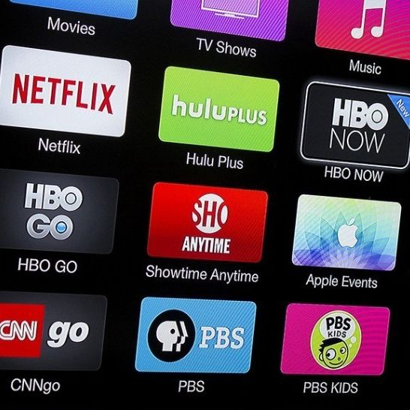
How are streaming services and PR affecting the popularity of pirate sites?
There were two spikes of piracy surges surrounding Villeneuve’s Dune before and after its release on HBO Max last month. Pre-launch leaks tend to be specially worrying for Hollywood as they undermine public interest in the cinema-going experience to enjoy a production, but the second wave can offer some insights about how piracy will look like in a film industry increasingly dominated by Streaming services.
One of the reasons why the second spike happened was the pirated HBO Max version of the film, which was of a better quality than the original Webrip. This may have motivated internet users to pirate the film instead of watching it in theaters. It points to a worrying trend, in which early pirated versions of film tend to be of better quality if they are released in online platforms early on. It also tells how advertising and PR campaigns contribute to the popularity of a production not only in theaters, but also pirate sites.


French authorities update their tools to fight against online piracy
France’s anti-piracy Hadopi agency will complete its merger with the Higher Audiovisual Council to create a new powerful regulator, Arcom. Arcom will serve as the main French anti-piracy agency from 2022 onwards. The creation of the new agent comes with the presentation of a new bill to regulate and protect access to cultural works in the digital age.
The new piece of legislation will grant French regulators with greater powers and jurisdiction over the entire field of audiovisual content that they would be unable to uphold with Hadopi. Thus the creation of the new regulatory agent.
Arcom will be launched in January 2022 and it will “operate with expanded investigation powers and will be responsible not only for tackling piracy but also for the protection of minors and the fight against disinformation and hatred online”, according to lawmakers. It will allow for the creation of a black list of infringing and repeat infringer sites,the establishment of a system to combat mirrors”, sites that help to facilitate access to platforms previously blocked following earlier enforcement actions, and the creation of a mechanism to deal with piracy and live sport events in line with the DSA’s compulsory rapid 30-minute takedowns

An important victory against online piracy in Denmark
Authorities in Denmark have arrested six men accused of being "ringleaders" or central staff at key torrent sites in the country following criminal accusations by Rights Alliance, an international anti-piracy group. Several arrests of a similar have been taking place beyond the nordic countries and it seems to have compelled other pirate sites to either avoid expansion or shut down completely.
This time, the searches were carried out by Danish police assisted by IT specialists from the National Police’s National Cyber ​​Crime Center (NC3). They arrested 6 individuals with ages ranging from 22 to 41 years old, apart from seizing computers, phones, other IT equipment and DKK300,000 (US$46,700). The money represents the profits from the sale of seedboxes, used to share illegal content remotely. Time will only tell if their users will also face the consequences from their illicit activities.

Dutch Internet providers sign a major pirate site blocking agreement
The anti-piracy group BREIN has signed a site-blocking agreement with all major Dutch Internet providers. What has been agreed is that when a court orders a provider to block a site, the rest will follow. Even if blocking measures are not infallible, they can push casual pirates to choose legal options instead. BREIN was one of the first organizations to request these blockades, first against The Pirate Bay in 2010. The current agreement has been signed in the form of a “Website Blocking Covenant”, involving Ziggo, KPN, DFN, T-Mobile, Canal+ and members of the industry organization NLConnect. It couldn’t have been reached without the help of the Duch Government and the Authority for Consumers and Markets, which took part in the negotiations. BREIN director Tim Kuik has confirmed that the group has already identified and targeted six additional pirate sites.

WIPO’s advertising blocklist now includes more than 5,000 names
The World Intellectual Property Organization (WIPO)’s pirate site blocklist has grown to include more than 5,000 domain names. This list has been elaborated through coordination efforts worldwide, with input from all around the globe. Its goal is to allow stakeholders from UN Member States to report pirate sites and share their names with advertisers, so they can be blocked. This will prevent problematic sites from getting ad revenue. Ad-focused anti-piracy initiatives have grown over the years, since most pirate sites can’t survive without advertising money, but this is one of the largest blocking campaigns to date. However, there is very little information available on the included sites. One of the main problems of the system is that WIPO can’t guarantee that the listed websites are copyright infringing, and there is no way to check and scrutinize the operation.

AVMSD


How is the AVMSD being transposed into national media law?
For those interested, the European Audiovisual Observatory has just released a new database on the state of transposition of the EU's Audiovisual Media Services Directive (AVMSD) into the national law of EU Member States. The new database is easily accessible and it includes a country and article research as well as comparative analysis between each of the countries (AVMSD).
To complement the latter, the European Audiovisual Observatory is also sharing an AVMSD tracker table that includes country overviews, copies of specific legal texts and an excel table that includes the original AVSM article, the way it has been transported into national law and an English translation. So far it only includes the countries that have completed the legal transposition, namely Austria, Bulgaria, Finland, Hungary, Latvia, Lithuania, Malta, Portugal, Sweden and the Netherlands. Check it out here.

AV platforms

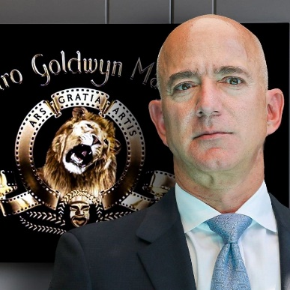
American unions oppose Amazon’s purchase of MGM studios
American unions and political figures are worried about Amazon's growing power over the subscription video streaming sector. The Strategic Organizing Center, a federation that represents nearly 4 million employees, is now calling the US competition authority to oppose Amazon’s purchase of the legendary Hollywood studio MGM.
Its film catalogue includes the James Bond saga, The Silence of the Lambs, and Thelma & Louise, as well as series such as The Handmaid’s Tale, Fargo and Vikings. According to a statement by the federation, Amazon’s control over massive amounts of content gives it an enormous power to exclude its competitors.
In response, Amazon pointed out the variety of choices currently available to consumers, particularly Netflix, Disney+, Apple TV+, HBO Max and so on. It claims as well that neither MGM nor Amazon were involved in the production or distribution of any of the top 20 films worldwide in 2018, 2019 and 2020. Nevertheless, the unions say that the company uses its powers to attack new markets through practices that are unfair and contrary to competition law. They are worried this merger would allow Amazon to use the same methods against the streaming industry, thus affecting producers and consumers.

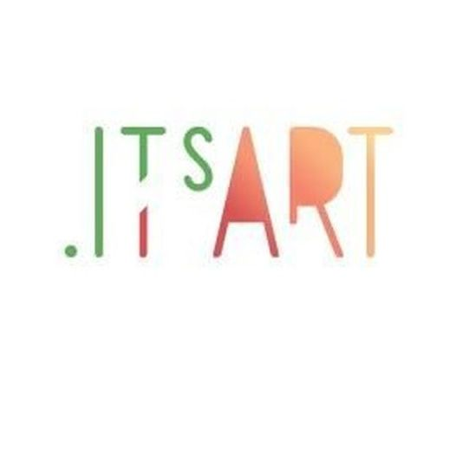
When it comes to culture, do Italians do it better?
The Italian authorities have spent millions of euros to create a new streaming platform focused on Italian cultural products from opera to arts and archeology. The new service will be called ITsArt and was launched on the Colosseum in the last week of November.
The idea was considered by the government in the midst of the lockdown limitations last year and it invested 19 million to make it true. It will offer more than 1,200 titles running to 95,000 hours of streaming. The content is varied, it ranges from concerts, museum videos and legendary football matches to documentaries about lesser known Italian artists such as Artemisia Gentileschi.

Universal Struggles to find its place in the VOD market
Peacock, NBC Universal’s streaming service will not break even in the foreseeable future, according to an analysis by LightShed Partners media analyst Richard Greenfield. To be more concrete, the company, headed by CEO Jeff Shel, is losing more than $8 on each of its approximately 21.5 million monthly active users. Most worrying to Shel, the figure is far away from the $7 to $8 average monthly revenue per user that the platform needs to breakeven at the original projected year of 2024.
Despite being on track with their goal of reaching 30 million to 35 million users by 2024, most of its new premium users do not pay extra fees and receive their service as part of their Comcast and Cox cable subscriptions. Besides, a third of monthly active accounts are reported to still be using a free tier subscription option. In response, NBCU is expected to invest extensively in the plattform, to make it more attractive to consumers, release new exclusive content and also turn it into a hybrid advertising/subscription service. Some investors are also demanding universal movies to be released on Peacock simultaneously with theaters.

A snapshot on the American VOD market
A report by Kantar found that, although the US subscription VOD market has continued to expand in the last quarter, the streaming penetration in the country, meaning the amount of US households that enjoy a VOD subscription, dropped to 85%. The decline has been driven by a 1,5% decline of paid SVOD subscriptions, which, according to the report, mostly comes from those users who had only 1 subscription in the previous quarter.In total, 4.5 million consumers cancelled their subscriptions, with Amazon prime being the most affecte, accounting for 69% of the decline among the group who had one subscription in the previous quarter.
The situation is not as bad as it sounds though. Most of the decline comes from Prime Day subscribers whose free trial recently expired. Besides, other streaming options like FAST (free ad-supported TV) and AVOD kept increasing their market penetration rate by 3% and 0,8 % respectively. The report also found wins for live pay-TV that increased its user base by 1% with respect to the previous quarter. In any case, the results seem to reflect an exceptional situation dominated by irregular lighter subscribers and the losses are expected to diminish or revert in the coming months.

Netflix should seize opportunities in content localisation
A report from Ampere Analysis has analyzed where Netflix is likely to increase its content investment, which has to do with the link between its subscriber base and its catalogue of local titles. According to its results, the streamer should seize the opportunity to further expand its local original content offer, which would provide a better service to existing subscribers and attract new ones. Netflix has already deployed this strategy in South Korea, Mexico and South America. Some markets in which the service is underweight for local titles are Poland and Turkey. This increased growth outside the USA highlights the importance of international markets to Netflix’s global expansion.

A new step for Netflix: the streamer unveils hours viewed for leading shows
Netflix has recently revealed its weekly global and country lists of its most popular titles. The streamer has chosen the number of hours viewed as the best indicator of a title’s popularity, as well as overall subscriber satisfaction. This is an unprecedented move for the SVOD provider, which had never revealed its performance metrics this way. From now on, and based on hours viewed from Monday to Sunday, the new Top10 on Netflix will be published on this website every Tuesday – for both original and licensed titles. The initial round of results was published on the 16th November, with Bridgerton season 1 being the most popular English language TV show, followed by season three of Stranger Things. Yet, Squid Game was still by far the winner, with 1.6 billion hours of viewing.
The streamer has taken into account that measuring popularity in the basis of hours viewed favours long series and films, and will occasionally publish speciality lists. Netflix has also engaged EY to review its new metrics, and has assured that it will post the independent accounting firm’s report during 2022.

Cinema & TV


BBC’s funding expected to freeze for at least two years
It looks like the BBC will have its funding frozen for the next two years. The sum could stop rising starting next year. Even if the UK inflation is expected to rise by 4.4% due to the economic impact of the pandemic, the government does not want to put an excessive burden on taxpayers.
The chain is currently funded via households’ licence fees (around £159 per year) and commercial revenues from BBC Studios. The BBC has already warned that it will struggle to keep up with its inflating programming costs if this happens.
These super-inflation issues continue to impact genres like drama, comedy and documentaries. The BBC is now being forced to co-produce or seek deficit financing for its content. Something that could ease the situation is the government’s decision to double BBC Studios’ borrowing limit to £700M.


Report by Sky reveals TV as a potential driver of behavioural change on climate
A third of consumers have changed their lifestyle because of content seen on TV, according to research carried out by the leading pan-European pay-TV provider Sky and the Behavioural Insights Team (BIT).
The report, launched at COP26 by Sky Group CEO Dana Strong, has revealed that TV has the power to encourage consumers to decarbonize by changing their life habits. It aimed to develop a clear role for broadcasters and content creators to inspire greener behaviours from their viewers. Strong believes that broadcasters ‘have a clear responsibility to encourage lifestyle changes that address the climate crisis.’ However, only 16% of respondents were aware of what they needed to do to act sustainably, and only one fifth of them knew how to recycle or save energy at home.

UK broadcasters committed to create content that reflects the realities of climate change
The BBC, Channel 4, ITV, STV and Sky pledged to create more and better climate-focused content across all genres at the UN’s COP26 climate conference in Glasgow. These companies represent more than 70% of time spent by UK audiences watching film and TV. This highlights the role TV and film can play in helping people understand how to tackle climate change and the choices to consider on the path to Net Zero. The screen industry organisation for environmental sustainability Albert, owned by BAFTA, facilitated the cross-industry collaboration behind this Climate Content Pledge.

Spanish TV going through acute decline of revenues
Spanish TV and radio advertising revenues dropped by 10.7% in the first quarter of 2021. Commercial channels’ TV ad revenues went from €348.7 million in 2020 to €303.8 million this year. Pay TV ad sales increased to €29 million in the same period, while public broadcaster ad revenues remained unchanged. 80% of the advertising revenue went to Mediaset and Atresmedia, owners of Telecinco and Antena 3, respectively. According to the latest market study by the CNMC, 8 out of 10 Spanish households now consume paid-for online audiovisual content. 53% of them use Netflix, HBO or Amazon Prime Video in 2021, compared to 49.1% in 2020.

Content.Agent platform for global film trade launched by IMZ
The Austrian IMZ International Music + Media Centre has launched a new digital marketplace and B2B search engine for global film trade in collaboration with major industry players around the world. The platform, called Content.Agent, will strengthen digital cooperation within the creative industries, allowing buyers and sellers of audiovisual content to browse, create, negotiate and buy global film licences. Its development has been financed by the EU’s Creative Europe MEDIA Programme.

Festivals

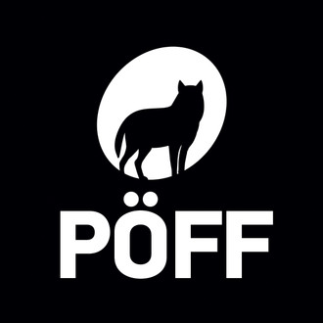
Tallinn Black Nights Film Festival unveiled its final details at the end of October
The Tallinn Black Nights Film Festival announced at the end of October the jury members for its 25th edition, the cash prize for its Grand Prix award – it has doubled to €20,000 this year – and its full line-up.
Sergei Loznitsa’s Mr. Landsbergis, Rainer Sarnet’s The Diary of Vaino Vahing and Manfred Vainokivi’s The Best of Salieri enriched the festival’s programme among other titles. The event took place from 12-28 November. Find more about this 2021 edition of the Tallinn Black Nights Film Festival here.


London TV Screenings to be celebrated in person in 2022
The 2022 edition of the annual export event London TV Screenings will be celebrated in person. It will go ahead as a live event without the draw of the BBC, since its showcase will be virtual this year.
This confirms the growing importance of independent TV distributors. The event will take place from the 28th of February to the 4th of March with the participation of All3Media, Banijay Rights, Entertainment One, Fremantle and ITV Studios. Find more about the 2022 edition of the London Screenings here.

Recent studies


A study corroborates the systemic obstacles for women in the VFX sector
A study produced by USC Annenberg found that, despite being present in almost every contemporary blockbuster film, women’s credit in the production of visual effects is virtually “invisible”.
Of the 400 top-grossing films of the period from 2016 to 2019, women only accounted for 21,6% of VFX credits. The study also found there has been an increase of around 10% of the presence of women in the sector during the period of study, from 0 to 22%, but this is not enough. As a result, not only are women misrepresented in the awards landscape but also in leadership roles. The situation gets only worse for women of color.
The study proposes several solutions based on its analysis on the major factors contributing to the low representation of women in the sector: entrenched industry hiring practices, a workplace culture that doesn’t meet women’s needs around work and family balance or encourage their participation, lack of role models and leadership perceptions that favor masculine traits for supervisory roles. Some proposed solutions to the problem include paying higher salaries to VFX producers, where women often get their start, and making that position eligible for Motion Picture Academy membership and awards.


Streaming continues to grow after the pandemic “peak”
The adoption of streaming services continued to grow in the post-Covid lockdown world, according to a State of Streaming report by Conviva. The report found that the global streaming viewing time rose by 21% during the third quarter of 2021 when compared to the same period of the previous year.
The rise varies from continent to continent, but there was an overall positive result in all regions. The study also found that investment in content also continues to ramp up, with Youtube and Google leading the chart with a 97% increase of content output coming from streaming platforms. The reasons behind these results are multivariate but can be understood as a result of lower average buffering times and higher image resolution rates. The overall growth in the sector was also accompanied by larger big screen TV global sale results and significant gains in the streaming advertising sector.

Localisation remains a key factor in for TV audiences in the streaming age
A majority of French, Italian, German and Spanish TV users find the localisation quality of TV services to be poor, according to a study from the Entertainment Globalization Association (EGA). Most concerning, close to two thirds (65%) of all those surveyed have stopped watching a movie or TV show as a result. The reasons noted in the study are varied, but mostly revolve around the different localisation quality standard of streaming services. Streaming platforms have lower barriers to entry and a wider range of content than other multimedia services, which allows consumers to move on with little consts from content to content until they find one that first their localisation. According to the study, in aggregate, these practices can seriously harm the brand associated with the platform and influence the opportunities for local content creation negatively. In response, EGA recommends companies to invest heavily in localisation operations.

Events


Conference: Rebuilding Europe with Culture, Where do we start?
The European Author’s Societies (GESAC), in coordination with MEP Christian Ehler (EPP, DE), the Federation of European Publishers and the European Movement International will host a high level online conference on how Europe’s post-pandemic recovery plan will help culture and creative industries. The objective is to mobilize as many social agents as possible to raise awareness about the needs of EUrope’s cultural industries and, with it, ensure that an adequate portion of Europe’s financial recovery package is put towards the sector.

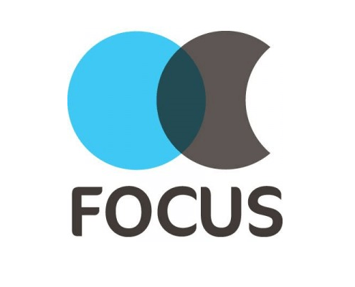
London’s Focus Show returns as a hybrid event this December
Billed as “the meeting place for international production”, London’s Focus show will return as a live event the 7 and 8 December. This seventh edition will combine two days of live events at London’s Business Design Centre, and four more days of online streaming.
It will allow delegates to meet with content makers, film commissions, production services and location providers from all over the world. Speakers during the program include Samantha Perahia, head of production U.K. at the British Film Commission and Vladyslav Riashyn, president of the Russian global production company Star Media. Find more about Focus 2021 here.

FERA organises 2 interesting conferences in December 2021
As part of its General Assembly Annual Conference, the Federation of European Screen Directors (FERA) will hold two livestream panels hosted by LICHTER FilmFest International Frankfurt, which will gather filmmakers and key industry representatives to discuss perspectives for the future of European film, and whether a “new deal” is possible for audiovisual authors’ rights in Europe in light of recent industry evolutions:
Wednesday, December 1 – 17:00 to 18:30 CET / Access link: https://youtu.be/k-uLkxeoTyM
PERSPECTIVES ON EUROPEAN FILM’S FUTURE
Panel discussion with Costa Gavras, Filmmaker, Rebecca O’Brien, Film producer & European Film Academy Deputy Chairwoman, Lucia Recalde, European Commission DG Connect, Deputy Director and Head of Unit “Audiovisual Industry and Media Support Programmes”, and Edith Sepp, Estonian Film Institute CEO and EFAD Vice-President
Moderated by FERA Chairman Klemen Dvornik and FERA CEO Pauline Durand-Vialle
Thursday, December 2 – 10:00 to 11:30 CET / Access link: https://youtu.be/8GR7mfrCU5I
A NEW DEAL FOR AUTHORS’ RIGHTS IN 21ST CENTURY EUROPE?
Panel discussion with Cécile Despringre, SAA Executive Director, Marc du Moulin, ECSA Secretary General, David Kavanagh, FSE Executive Director, Ada Solomon, Producer & European Film Academy Deputy Chairwoman, and Katharina Uppenbrink, Initiative Urheberrecht Managing Director
Moderated by FERA Chairman Klemen Dvornik and FERA CEO Pauline Durand-Vialle
More details on our annual conference event here.

FRENCH FILM FESTIVAL 2021 | Online 3 NOV - 15 DEC Info

25th Made in Prague Festival | London & Online 7 NOV - 10 DEC Info

Red Sea Film Festival 2021 | Saudi Arabia & Online 6 - 15 DEC Info

FOCUS 2021 | London 7-8 DEC | Digital 7 - 10 DEC Info

Les Arcs Film Festival | 11 - 18 DEC | Info

Interesting links

- Facebook's Anger Content May Have Value For TV
- Spanish Sales Agents Reflect on Theatrical After COVID
- Seville's European Coproductions Forum focuses on Germany

