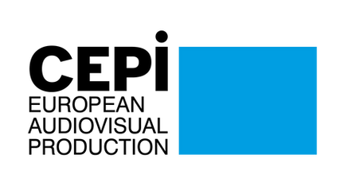
CEPI Newsletter
January 2022

Dear CEPI Members,
As we are settling into 2022, CEPI continues its work on the priorities of independent producers.
We were thrilled to see that France, who hold the presidency of the Council of the EU, decided to organise a conference focused on the role of independence in preserving creative diversity. This widely followed event looked into issues which CEPI has been actively supporting in the past year, such as the definition of European work or the role of the AVMS directive in today’s audiovisual market. CEPI addressed the Commission on this issue back in September, and seeing it being discussed at that conference definitely feels like a progress CEPI contributed to. Please read our summary of the discussion in this newsletter.
In January, the European Parliament adopted its position on the Digital Services Act. CEPI has been pushing hard with other trade associations to ensure that our key issues would be recognized by the Parliament. While we have been very successful in convincing MEPs to table new amendments for the vote in, on the day of the vote, many MEPs didn’t or would not listen to the cultural sector. Our policy efforts are now dedicated, together with the entire audiovisual industry present in Brussels, to work with policy makers during the trialogue negotiations between the parliament and the Council.
In parallel tracks, the Digital markets Act is also going through trialogue negotiations, and represents the opportunity for CEPI and other trade associations to argue in favor of access to data detained by specific streaming services for producers. The DMA is primarily aimed at setting rules for online gatekeeper, but remains an opportunity to bring this issue on the agenda of policy makers.
The European Commission has still not announced the date of the next stakeholder dialogue on availability and access to AV content. The industry is now requesting the Commission invite the European Audiovisual Observatory to be present at the next meeting, in order to present more detailed data, which should show that nowadays, viewers have access to more audiovisual content than ever.
CEPI will not meet in Berlin this year, as the festival has now moved primarily online. But CEPI is now working with the Series Mania festival to prepare a panel on the value of being an independent producer in this day and age. We hope to see some of you in Lille in march. We are also starting to prepare for CEPI’s general assembly in Cannes where we hope to see as many of you as possible in what I wish to be a post-covid time.
Until next month, we hope you will enjoy this edition of the CEPI newsletter.
Enjoy the reading!

Sections in this newsletter:
- Latest from the EU
- COVID 19: Impact on the sector
- Copyright
- Digital Services Act (DSA) & Digital Platform Regulation
- Territoriality
- AVMSD

- Piracy
- Audiovisual platforms
- Film and TV
- Festival
- Recent studies
- Events
- Interesting links

Latest from the EU

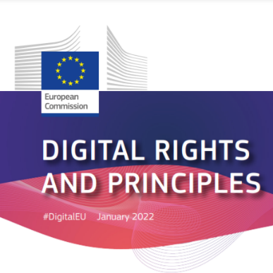
Commission puts forward declaration on digital rights and principles
A new declaration of digital rights and principles was proposed by the European Commission on 26 January. It aims to steer Europe’s digital transformation following clear principles, including ensuring privacy, a safe Internet and freedom of choice.
The Commission notes the risks and effects for citizens that may come from technology, including artificial intelligence, cyberattacks and mass surveillance. The European Parliament and the Council will now examine the proposal to hopefully endorse the charter before summer 2022.


The Commission’s plans to increase the potential of the international competitiveness of the European filmmaking industry
A new call for ‘Research and innovation on cultural heritage and CCIs – 2022’ under the programme Horizon Europe has been launched by the Commission, having 20 April as deadline.
The research will examine the state of the art of the European filmmaking industry, in order to analyse its limitations. Proposals will assess the needs and development of the European filmmaking industry and address potentialities for further development. A comparative assessment of the international competitiveness of the industry should be developed. The admissibility conditions are described in Annex A and Annex E of the Horizon Europe Work Programme General Annexes. Find more information about the call here.

The French Presidency’s agenda regarding digital and cultural policies
The six-month programme of the French Presidency detailing the priorities and guidelines for the functioning of the Council of the European Union between January and June 2022 is already out. The orientations of the French Presidency are in line with the work carried out by the Slovenian Presidency, as well as in the broader framework of the Trio programme prepared with the future Czech and Swedish Presidencies. The French priorities have been defined around three ambitions: a more sovereign Europe, a new European growth model and a human Europe.
In the digital field, it will aim to make progress on a number of strategic issues in the service of digital sovereignty, particularly in the areas of data protection, development, artificial intelligence, security and the strengthening of networks and infrastructures for greater resilience. The strengthening of cybersecurity will be a priority area of work, as well as the development of artificial intelligence that is trustworthy and at the human service. Overall, the Presidency will strive to develop a balanced, coherent and secure legal framework that reconciles the preservation of citizens' rights, the protection of the interests of the Union and its Member States and the development of innovative uses and services by businesses and public authorities.
Regarding culture, putting the cultural sector at the heart of the recovery is essential for the French Presidency. It will promote a new European strategy for cultural and creative industries to encourage innovation and to support the export strategies of European cultural enterprises. It will focus on the development of intercultural exchanges in the European space through the mobility of artists and cultural professionals and multilingualism in the digital environment. The Presidency has also defined cultural diversity as one of its main priorities, particularly the preservation and promotion of media pluralism and the diversity of the digital cultural offer.

Antitrust clearance granted to Discovery and WarnerMedia merger by the European Commission
In May 2021 it was revealed that AT&T is spinning off WarnerMedia to combine it with Discovery, a transaction expected to close in mid-2022 pending regulatory approvals. This merger would combine WarnerMedia’s assets (HBO Max, Turner, Warner Bros) with Discovery’s cable channels. Under the planned WarnerMedia spin, it will receive $43 billion in cash to pay down debt. Now, the European Commission has granted antitrust clearance of the proposed acquisition, which according to Discovery’s president and CEO David Zaslav, is a key milestone toward completing the transaction with AT&T. The European antitrust clearance is a relief to Discovery, as it faces a bigger hurdle in the US given the expressed antitrust concerns.

Covid-19: Impact on the sector


Report on the national resources destined to culture in recovery plans
On 17 January, MEP Nikolas Nienass (Greens) released the draft of its report on the implementation report on the Recovery and Resilience Facility.
The document, to be officially presented on 7 February in front of the CULT committee, highlights that only 14 out of 26 Member States have included culture in their national recovery and resilience plans. The goal to earmark at least 2% of the EU's Recovery and Resilience Facility (RRF) budget to culture – demanded by the European Parliament (EP) in its Resolution on the Cultural Recovery in Europe from 17 September 2020 and supported by the cultural and creative sectors – has been achieved at an aggregated EU level only.
Different allocation of resources for culture will lead to disparities between member states.
MEP Nienass called on the Commission to recalculate and reassess the data available, presenting more detailed numbers on the achievements, in particular specifying which investments directly benefit the creation of cultural works as opposed to rather indirect investments.


Dutch film sector celebrates the reopening but expresses concern about the announced restrictions
The Dutch film sector’s previous joy about the cultural reopening has been replaced by disbelief about the newly announced restrictions. Culture, catering and sports will be forced to close at 10 p.m.
Visitors will have to maintain a safety distance of 1,5m and to present their Covid pass at the entrance. Of course, wearing a mask will be mandatory inside cinemas and cultural venues.
With these reopening conditions, the expected number of visitors is very low. With a closing time of 22:00h, only one session with 30% audience capacity can take place. The requirement to present a Covid safety ticket to access the cinemas will also impact the audiences, since the vaccination percentage in the Netherlands is one of the lowest in Western Europe. As a result, the number of films yet to be released continues to grow. The resources to invest in the production and promotion of new films is currently insufficient and without a clear prospect of compensation. This will have far-reaching consequences for the diversity of the film on offer in general and Dutch film in particular.

New financial and production protocol launched by the Netherlands Film Fund
The Netherlands Film Fund is aiming to forge a better connection between cultural and media policies with the launch of a new financial and production protocol. Its main goal is to maintain and strengthen the range of independent Dutch films, series and documentaries in the context of a rapidly changing international market.
One key novelty in the financing system is the more generous support being provided to Dutch productions. The film fund has had a larger amount available since the beginning of 2022, increasing the budget to €5 million per year for the next two years and €6.3 million annually from 2024. The focus here remains on quality films of all genres and from all categories.
As the pandemic continues apace, the support measures intended to cover additional costs for production and distribution remain in force. This also applies to the pandemic guarantee scheme, which is being extended to TV documentaries, and drama, animation and series from NPO, a parent organisation that oversees individual public broadcasters in the Netherlands.

What perspectives for the global film industry in 2022?
During the pandemic, theatrical windows have shrunk significantly to almost 30-45 days in some cases. The international rollout of HBO Max means Warner Bros titles now have just a 31-day window in the UK (45 days in the US). On the whole, studios are now expected to play their part in growing subscribers on in-house platforms and their media corporation parent companies will be competing to bring films to home audiences as quickly as possible. It also appears like more and more exhibitors will need to cut VoD revenue-share deals with distributors, implement dynamic ticket pricing, programme alternative content and make more noise with fewer sites. The pandemic has shifted the balance of cinema releases even further away from local and independent titles. Indie distributors are looking to find space for titles among a release schedule that is still holding back blockbusters that were planned for 2020.
Festivals are already adapting to the situation, but uncertainty is not sustainable for these events in the long term. While many of them took place last year with varying degrees of ‘Covid safety’, such measures are expensive. Buyers and sellers cannot sustain this uncertainty in the long term either. As for streamers, US platforms may meet greater regulation in Europe in 2022. Their investment in local content is a plus, but there is growing unrest in the independent community over the all-rights demands they impose and how they are pricing local producers out of their own markets. Other countries may follow France’s bold transposition of the AVMS Directive this year.

Screen Flanders to increase support for audiovisual industry during Covid-19
The funding agency Screen Flanders has invested around €2.5m in 15 productions. The list of supported projects announced by Hilde Crevits, the Flemish minister for the economy, spans five scripted series, two documentary series, an animated series and seven feature films. Among the scripted series are Barber Aziz, set among a Flemish family of Turkish-Algerian descent, and The Swarm, an adaptation of Frank Schätzing’s environmental thriller novel of the same name. scripted series Exes, Fair Trade 2: The Road Back and The Twelve and documentary series Draw for Change! and Mobutu will also receive support.
The Flemish government made an additional investment of €960,000 in the second Screen Flanders call of 2021 to support the region’s audiovisual industry in difficult times. This enabled a total investment of €2.46m in 15 audiovisual productions. The amounts awarded vary from €40,000 to €350,000 per project.

Challenges ahead for the UK film industry in 2022
2022 will be an interesting time for public funds, especially regarding Film4 and BFI. Film 4, BBC Film and the BFI head into this new year facing fiercer competition for talent and projects from the US streaming platforms.
Although 2022 began promisingly for UK exhibitors and distributors, with open cinemas and great box office admissions thanks to Spider-Man: No Way Home, major challenges still remain. Fingers are crossed that US studios don’t shift major releases to later in the year. The UK’s cost of living keeps rising, which also poses a challenge to the sector. However, a bright spot for exhibitors has been the Culture Recovery Fund, which paid out £33.7m to venues since May 2021. This prevented a great number of venues from going out of business directly because of Covid.
However, indie producers are increasingly fearful for survival. The UK production boom seems to indicate that the country is on track to become a service industry for the US giants. The US dominance makes it very difficult for the indies to produce films through a UK lens and has compelled some to shift focus to TV. As Amazon’s Lord Of The Rings gears up to move from New Zealand to the UK, these challenges will only intensify. An immediate remedy could be increasing the level of tax credit for independent UK films.
The Global Screen Fund is also working to change the UK ecosystem. Administered by BFI, it replaced the Creative Europe Media funding lost after Brexit. It is now aiming to halt the slide in the number of UK-international co-productions and support the distribution on non UK titles.

French cinema is picking up after a gloomy 2020
According to figures published this Thursday by the Centre national du cinéma et de l'image animée (CNC), French cinemas recorded 96.17 million admissions in 2021, despite the health context. In France, cinemas were closed for 138 days and were impacted by a curfew between 19 May - the day they reopened - and 30 June. Additionally, they were affected by the entry into force of the health pass on 21 July. Nevertheless, French cinema is up 47% on 2020, which was also a complicated year on the health front, but is down 55% on its 2019 level. December generated the highest number of admissions thanks to the release of Spider-Man: No Way Home, with 20.43 million French people attending according to provisional data, compared to 14.47 million the previous month and 14.32 million in October.
In terms of films, French productions were overtaken by their American counterparts with respective market shares of 40.8% and 42.4%. But the drop in cinema attendance was less significant than that observed in the United States. Spider-Man: No Way Home is the only film to reach the 5 million mark, whereas five films had exceeded 5 million two years earlier.

Spanish box office closes 2021 with pre-pandemic figures
Attendance at Spanish cinemas in 2021 rose 45% year-on-year to 41 million viewers and box office reached €251 million, also up 45% on 2020, according to provisional data collected by ComScore. During the first half of 2021, marked by continued restrictions, cinema attendance amounted to 9.5 million, 43% less than in the first half of the previous year. However, from the 2 July, when Fast and Furious 9 premiered and with more than 91% of cinemas open, the trend changed radically and cinema attendance increased significantly, reaching its peak on the weekend of 17 December with the release of Spiderman: No Way Home. That weekend the box office achieved pre-pandemic figures for the first time since the reopening of cinemas.
As for Spanish cinema, it is recovering but still at a low level. It closed 2021 with a market share of 16.6%, more than a point and a half higher than in 2019. Even so, this figure will be the lowest since the beginning of the 21st century.

Copyright

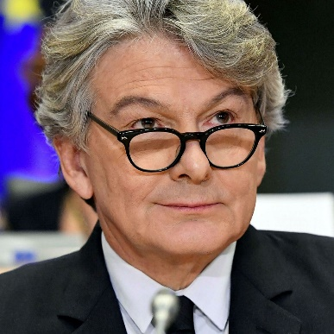
Breton responds to MEPs written question on Copyright Directive
Last October, a group of MEPs from the left, Green and S&D groups, sent a written question to Commissioner Breton urging the commission to act upon the delay of the vast majority of Member States on the transposition of the Copyright Directive.
In addition, the question addressed the issue of stakeholders consultation in member states. MEPs reminded the Commission that a swift transposition is essential to ensure that authors and performers can recover from the nefast impact of the pandemic via the implementation of new remuneration rules.
In his response, published on 20 December, Commissioner Breton ensured that action has already been taken concerning the transposition delay. The Commission has in fact opened an infringement procedure on 26 July 2021 (deadline for the transposition being fixed to 7 june 2021) asking 22 EU Member States to quickly provide information on how the Directive on copyright in the digital single market was being transposed into their national law.
On the issue of stakeholder consultation, Breton said that consulting stakeholder is a Member States responsibility and included in recital 77 of the directive.


Estonia amends the Copyright Act to include provisions of the DSM Directive
The act amending the Copyright Act to include the provisions of the DSM Directive was adopted by the Estonian Parliament on the 8 December 2021 after a discussion in the Committee on Culture.
The extensive process involved a public consultation that provided stakeholders with opportunities to contribute to the implementation process. After releasing the draft, the Estonian government sent it to the stakeholders for comments and also met with them to discuss the draft.
The implementation of Article 17 restates the text of the Directive, not narrowing down the definition of platforms affected by the rules. It doesn’t contain any specific ex-ante safeguards for user rights either. However, the law authorizes the Consumer Protection and Technical Surveillance Authority to take action against platforms that fail to comply with their obligations to protect user rights, providing an additional layer of ex-post remedies against overblocking.
The Estonian lawmaker maintains its non-remunerated exception for education and scientific research purposes, while implementing the education and text and data mining exceptions foreseen in the DSM Directive. Reproductions of public domain works are excluded from the scope of application of the Copyright Act. Also, Article 12 of the Directive is implemented, allowing domestic extended collective licensing schemes.

Digital Services Act and platform regulation

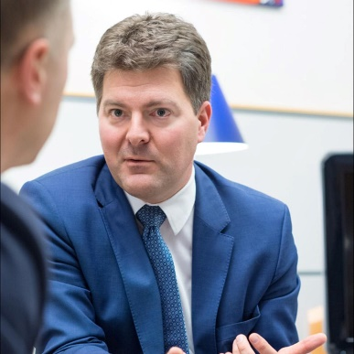
Digital Market Act: CEPI meets European Commission and Internal market committee DMA rapporteur Andreas Schwab’ Office
On 21 January, together with an informal coalition representing producers, distributors, book publishers and sellers, CEPI engaged with the European Commission, to discuss the Digital Markets Act (DMA), as the trialogue negotiations on the text started just this week.
For this coalition, it is important that the DMA also covers the ancillary services of online gatekeeper. While DMA will not apply to streaming platforms, this measure sets the ground to oblige streaming associated services of gatekeepers’ core businesses (Amazon Prime, Apple Itunes) to share data. CEPI successfully managed to have an Amendment to that effect included in the parliament text adopted in December.
The meeting has been a great opportunity for the industry to clarify the role of data and the impact the lack of access to it generates for producers. The access to large quantities of data by some streaming services strengthen the production decision of these same services, at the expense of independent producers, which also weaken their ability to effectively value their own catalogues available online hence reducing their bargaining power when negotiating with streamers, CEPI explained.
On 28 January, CEPI’s secretariat held a similar meeting with the office of MEP Andres Schwab (EPP) and rapporteur of DMA in the leading committee IMCO.
Our coalition brought to the table a good example of why it is necessary that ancillary services are covered by the same obligations as Core platforms. Gatekeepers, for instance Amazon, provides different sets of services including AV content streaming via it’s ancillary service Prime.
The advantages leveraged by Amazon, such as its access to large amounts of data, through its portfolio of services have a substantial impact on the European Audiovisual sector. The European Audiovisual industry relies on audience data to get a sense of the content people like to watch, allowing it to invest and produce diverse content enjoyed by millions of viewers. When shown on online streaming services such as Amazon Prime, European producers and distributors are excluded from accessing their films and series audience data. However, such data is being used by Amazon Studios for their own production decision, and marketing strategy.
Having said this, it is clear that data transparency obligations for Gatekeepers ancillary services will make a more competitive and fair online market which is the main objective of DSA.
MEP Schwab office seemed to be well receiving our comments and informed us that during the trialogue there will be discussion on the possible expansion of obligations to ancillary services.
CEPI together with the other organisations fighting on this subject will send written clarifications of our requests enabling the DMA to ensure a fair digital market for the Audiovisual sector:
- The scope of the obligations under Article 6 be extended to all ancillary services offered by the gatekeeper, in order for the data sharing obligations to also apply to these services
- The data foreseen in Article 6 be made accessible to business user as well as suppliers to the ancillary services, in order to ensure that the industry which allows for the gatekeeper to provide such ancillary services get the necessary access to data, enabling them to compete on fair ground.
- The recital 14a to clarify, for legal certainty, that ancillary services include retail and distribution services
- The article 2.14 to include in the list of ancillary services, “delivery services”.

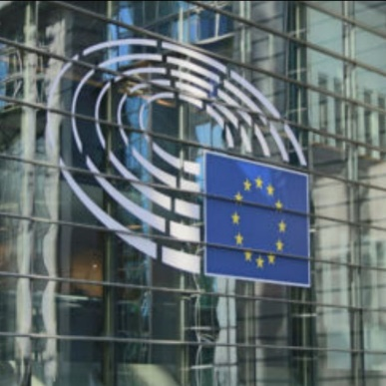
European Parliament misses the opportunity to make the Internet a safer space for everyone
On 28 January, CEPI published on its website a joint statement cosigned by Cultural and creative industry organisations expressing disappointment over the direction of travel of DSA after the negative outcome of the plenary vote of 20 January (see our CEPI January update for specific information on the vote results).
Our statement highlights the EU missed opportunities to make online services reliable for and reactive to the presence of online copyright infringing content.
With the DSA regulation going now into trialogue negotiations, CEPI is hopeful that the European Commission and Council of the EU will be able to rectify some of the loopholes left within the parliament text.
Ahead of the next trialogue discussion, our coalition will send a statement including the common position of the Audiovisual industry emphasising the steps to be taken in order to ensure a fair and safe online environment.
This includes:
- Remove liability exceptions for search engines
- Apply Business User identification obligations for all intermediary services
- Eliminate Subsidiarity principle in recital 26 which encouraged rightholders to attempt to resolve their claims without involving intermediary services, since intermediary services are best placed to eliminate illegal content in the majority of the cases.
- Eliminate the provision allowing the commission to release guidelines on the relationship between DSA and existing European directives as this might bring additional uncertainty to the effect of DSA.
- Remove article 14.3.a introducing stay up provision for notified illegal content during the assessment of its illegality: “The Parliament’s proposed Article 14.3.a new potentially undermines the conditions of Article 5 by suggesting that content should remain accessible while the assessment of its legality is pending without any implications for the liability exemption of Article 5. In order to avoid compromising a safe and trustworthy online environment, “actual knowledge” and “acting expeditiously” should remain the only criteria for assessment of liability under Article 5.”
We will publish our new joint statement on our website.
The document will be sent to all institutions involved in the trilogue negotiations before 3 February.

Territoriality

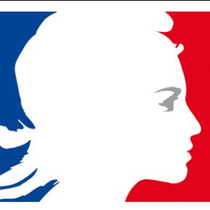
France resets media chronology for streaming age in landmark accord
On 24 January, the French ministry of culture struck a three years deal with the Audiovisual and Film industry on the French release windowing system.
The agreement ties in with France’s transposition of the European Union’s updated Audiovisual Media Services Services Directive, overhauling audiovisual legislation for the digital age. Under the country’s implementation streaming platforms are obliged to devote 20% of their turnover in France to French and European series and films and non-fiction programming.
Please find below what the new windowing system entails.
Subscription-based TV broadcasters can show movies:
- 9 months after its cinema release.
- Between 6 and 9 months after its release if the TV channel has made an agreement with professional film organizations, that includes commitments on investment in European and French-language content. Another condition is that the broadcaster respects legislation on the audiovisual sector and has signed a deal with the regulator Arcom.
For subscription-based streaming platforms:
- 17 months after the movie’s release.
- 15 months after the movie’s release when the platform respects legislation and has signed an agreement with professional film organizations – films produced in France
- Between 6 and 15 months if there’s a specific agreement with professional film organizations.
For free TV broadcasters and their catch-up services:
- 22 months if they have invested 3.2 percent of their turnover into cinematographic content.
- 30 months otherwise.

AVMSD

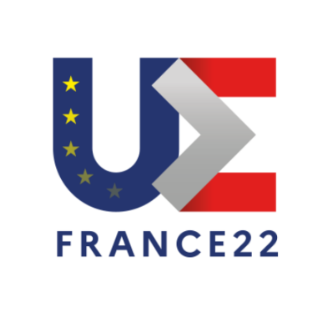
The French presidency of the Council of the EU presents Cultural and Creative sector priorities in Angers
On 25 January, the incoming French presidency of the Council of the European Union held an Online conference presenting the priorities and assessing the evolution of the Cultural and Creative sector in Europe.
The French minister of culture Roselyne Bachelot-Narquin, highlighted the importance of protecting European Cultural Strategic assets. This topic is intrinsically related to ownership of intellectual property protected content, more than ever purchased by international private foundations that often don’t ensure an appropriate use and exploitation.
Considering the advent of global streamers and the increased online consumption of film and audiovisual content, claiming ownership over catalogues is essential.
The French presidency identified three main areas ow work that are at the base of Europe’s cultural sovereignty:
- Protection of IP rights
- A clear definition of European works and
- A viable production and exploitation infrastructure
During the afternoon, invited guests representing a wide array of rightholders and public institutions debated on what measures or practices could strengthen cultural sovereignty of Europe.
In this respect, the discussions tackled the question of the definition of European works, still based on criteria such as the nationality of the creators involved in production rather than the consideration of the final ownership of the IP.
The issue of the definition of European works has been exacerbated by Brexit. Considering the recent implementation of the AVMS directive, introducing catalogue quotas for European content available on SVOD services, panelists discussed the way UK produced content might overtake the space available for European works on VOD.
The French Presidency will indeed work on this issue however, as reminded by many participants including MEP Laurence Farreng, the current definition is based on the European Convention on Transfrontier Television, a text of the council of Europe including 14 countries outside the EU. Revising the definition might create political tensions with these European neighboring countries.
During the panel dedicated to ways to foster European creativity, panelists discussed the new investment obligations imposed to global SVOD services. The French transposition of the AVMS directive has been very ambitious in the investment level imposed on SVOD services; however, not all member states are opting for the same approach. In fact, global platforms represent a major source of investment for creation in Europe and small capacity countries decided to maintain low financial obligation levels and secure large production interest in the local market.
Last but not least, panelists discussed the need to secure a large number of skilled talents hence increasing educational opportunities in the audiovisual sector but also make sure that european content can be visible and discovered. In this sense, it is essential to ensure a good level of co-production, partnership with Film festivals and an appropriate level of public investment both at European and national level.
Please find here the agenda and the invited speakers

Piracy

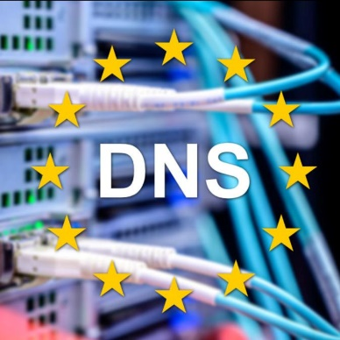
The European Union’s plans to develop its very own DNS resolver
The European Union is now planning to develop its own government-run DNS resolver. Named as DNS4EU, the project is meant to act as a counterweight to the popular resolvers that are mostly based in the U.S.
This solution would be able to block illegal websites, including pirate sites. Last week, the European Commission published a call for proposals, which also describes in detail what features the government-controlled DNS should offer. Its overview makes clear that DNS4EU is meant to protect the privacy of end-users and keep them secure. The resolver will also be available to Internet backbone networks that handle traffic in, from, and to Europe. These backbones are part of global traffic routes which means that million people could potentially be impacted.
The DNS resolver is not allowed to monetize user data and has to comply with applicable privacy regulations including the GDPR. At the same time, there is also a heavy focus on filtering. And while details are scarce at this early stage, the language in the official documentation suggests that “illegal content” could be blocked as well if there is an applicable court order. These filtering and blocking measures should be inline with national rules.

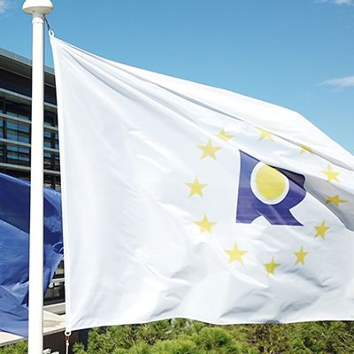
EUIPO gets rewarded for its efforts to fight online piracy
The Audiovisual Anti-piracy Alliance (AAPA), formed by prominent media players such as BT, Canal+, Fox Networks, Irdeto, La Liga, Premier League or Sky, has decided to award the EU Intellectual Property office (EUIPO) with 2021’s “Anti Piracy Award”.
To be more specific, the honors go to a team at the European Observatory on Infringements of Intellectual Property Rights, which is part of the EU Intellectual Property Office.
Other awarded institutions in past editions included the Spanish Police’s anti-piracy unit and Italian law enforcement. This year’s decision to award the EUIPO because of its effort to pave the road for future enforcement mechanisms at the European and national level. The organisation helped get piracy reinstated as part of the European Multidisciplinary Platform Against Criminal Threats (EMPACT) and played a big role bringing stakeholders together.

A victory against online piracy
Several main Hollywood studios and Netflix have managed to achieve a High Court injunction to block 15 pirate streaming sites in the UK. This is an important step in the fight against repairing pirate sites due to the fact that the targeted domains accrue staggering levels of traffic.
The latest application targets 17 domains that operate the aforementioned 15 sites. None of the sites offer content but they aggregate links to pirated movies and TV shows hosted on third party providers.

Pirate site “Popcorn Time” shuts down due to lack of users
Popcorn-Time.to, which once had Netflix CEO Reed Hastings worried, has decided to shut down. The team informs that a lack of use is the main reason behind this decision, which is likely the result of competition from other pirate tools. The software offered an easy-to-use interface to stream pirate movies and TV shows, all powered by BitTorrent. The page was subject to plenty of legal threats, mostly from Hollywood, since Google searches for Popcorn Time began rivaling those for Netflix at some point.
This triggered a wave of enforcement actions, including a lawsuit in the US, targeting the alleged operator of Popcorn-Time.to, but the case was eventually dismissed. However, legal issues didn’t play a role in the shutdown of the service. According to its team, “the world doesn’t need Popcorn Time anymore”. But this doesn’t mean that Netflix has successfully beaten online piracy, of course. Pirate streaming sites and devices remain a massive challenge, and Netflix content is still widely pirated on regular torrent sites as well.

AV platforms


France’s new windowing rules reward Netflix with earlier access to new movies
After months of debates, the French film industry has set new windowing rules for movies that are released in French cinemas and local theatres.
Netflix is the only streamer to have signed the agreement and will therefore benefit from having access to fresh movies 15 months after their theatrical release, in comparison to the 36 months under previous windowing guidelines. Netflix will invest roughly €40 million per year on 10 independent movies whose rights will be owned by their producers and creators. A diversity clause also requires the streamer to spread its investment across smaller movies budgeted under €4 million.
Other services, including Disney Plus, have not signed the agreement and will therefore have a 17-month window on new pics. This is explained because windowing rules are giving free-to-air channels an exclusive window on movies they pre-buy 22 months after their release, which means that Disney Plus would have had to temporarily pull their films from their platforms during the months when its movies aired on French TV.
The rules will apply to all platforms, since the pact only required the signature of a single streamer in order to be enacted. This new release window complements the rules established in the local application of the European Union’s Audiovisual Media Services Directive. WarnerMedia’s HBO Max and Paramount Plus are set to launch in France later this year, and both have already started commissioning local original content.
FIAD’s French Member the Fédération Nationale des Éditeurs de Films released a press release welcoming the development.

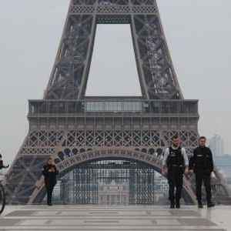
Canal + and France’s film Industry make peace to face American competition
The French audiovisual giant has completed a landmark deal that will make it commit to invest €600 million in film production over the next three years.
In exchange, Canal + will loosen up the current strict theatrical windowing regime that has hurt the industry for the past years. The conglomerate will provide an advanced window to ebing six months after movies are released theatrically, with an exclusive window of at least nine months to distribute them and a second window of up to 16 months.
The new arrangement will cement Canal + as the chief source of finance for the French film industry, and will empower its brand as producer and provider of domestica and local content. In the meantime, Us streamers, the French gant’s biggest competitors, will be forced to help finance the same kind of content from next year onwards under the new European Audiovisual Media Services directive.

Is the SVod-led production growth bubble about to burst in Europe?
A December report by François Godard, Tom Harrington and Tom Standen-Jewell on SVoD-led production has predicted that the boom in content may not last as long as expected. The authors, working for London-based research firm Enders Analysis, found that already in the second quarter of 2021, Netflix penetration in North American markets.
According to their findings, Europe is destined to follow similar trends due to the fact that “penetrations in the top EU markets, the UK and Scandinavia, are at US levels and growth has slowed down notably.” Netflix subscriber growth in the EMEA region for the year was already just above one-third of its rate duin the same period of 2019. Prices of subscription services are also expected to decline with “the independent production model expected to gain more traction with the streamers owing to the regulation and consolidation of producers.”

Great year for on-demand French content, now focused on US markets
French content has drawn more audiences. France has drawn more eyeballs worldwide in 2021 than it has in years, thanks to shows like Lupin and Emily in Paris, and to the success of directors like Julia Ducournau and Audrey Diwan. Now, a groundbreaking agreement with global streamers to invest up to €300 million in French content looks to continue that trend. Taking advantage of this, the government is encouraging French creatives and locations to conquer international markets, with a focus on the US. Following the massive investing scheme France 2030, Macron is looking to revitalize the country’s industrial sectors, including the film and audiovisual industries. France’s Presidency presidence of the Council of the EU during these first six months of 2022 will also give it the opportunity to embolden European culture with a new impulse.
Stemming from that mandate is the initiative Villa Albertine, which hosts a US-wide residency for creatives ranging from filmmakers to architects. According to its director, Gaëtan Bruel, this initiative is ‘a formidable market and a launchpad for French creatives to shine around the world’. He also declared that it is ‘striking to see how French artists often need to make their marks in the US to be better acknowledged in France’. This project could be a game changer by giving French talent the opportunity to gain first-hand experience and knowledge in the US, as stated by Gagarine producer Julie Billy.

Netflix’s wise bet on non-English shows
After years of investing in non-English language shows, Netflix has proved in 2021 that the future of TV is international. The streaming service has made shows in 40 different countries, subtitled series in 37 languages, and dubbed them in 34 languages. According to a USA Today article, since 2019 non-English language viewing has increased 71 percent in the United States. For Netflix, the great success of Narcos in 2015 was soon followed by other series: Spanish-language hits like Cable Girls and broader international productions like the Danish The Rain and the German Dark.
In the beginning of 2021, the French Lupin was the most watched non-English language series on Netflix, followed by Who Killed Sara? and Squid Game, which soon became the most watched Netflix series of all time. Similarly, Money Heist became the most in-demand series worldwide in the month of September. These are just some examples of the success of international shows on the streaming platform. Six years ago, Netflix bet on series like Narcos, and now we’re seeing how that pays off in a way that rewards international television leaders for excellent storytelling.

New OTT partnership in Ukraine to improve TV viewing analytics
Ukraine’s Kyivstar TV and Big Data UA have now joined forces to improve TV viewing analytics in the OTT segment. The head of Kyivstar TV, Pavlo Rybak, explained that thanks to the analysis of watching TV channels through Kyivstar TV, Big Data data will become more accurate and market players will receive additional analysis of the popularity of TV products. According to past research by Big Data UA, the main users of online TV services in Ukraine are socially active and modern audiences – mainly couples under 45 with young children. As Serhiy Boyko, head of Big Data UA, declared, “increasing the research audience provides a clearer picture of the audience mood of all OTT users in Ukraine and adds territories that were previously unrepresented”. He also stated that he believes this partnership will benefit the development of the entire OTT segment in the country.

Cinema & TV


Spider-Man: No Way Home stands as the eighth-highest grossing movie in history despite the pandemic
Spider-Man: No Way Home is still breaking box office records. It has grossed $1.53 billion worldwide, cementing its place as the eighth-highest grossing movie ever at the global box office.
The film’s tally has been pushed past slots 9 through 12 on all-time rankings, which belonged to The Avengers, Furious 7, Frozen II and Avengers: Age of Ultron. At the domestic box office, the film has remained a force on the big screen despite the new omicron variant of Covid-19. Internationally, it has collected $867.5 million since its premiere in December, and it has done especially well in the U.K., Mexico, South Korea and France.
Another holiday release, Disney and 20th Century’s The King’s Man, added another $13.4 million from 43 territories over the first weekend of January. The Matrix Resurrections has also struggled to attract audiences in North America and overseas. Among Hollywood movies, Disney’s Encanto earned $5.8 million from 36 international territories.

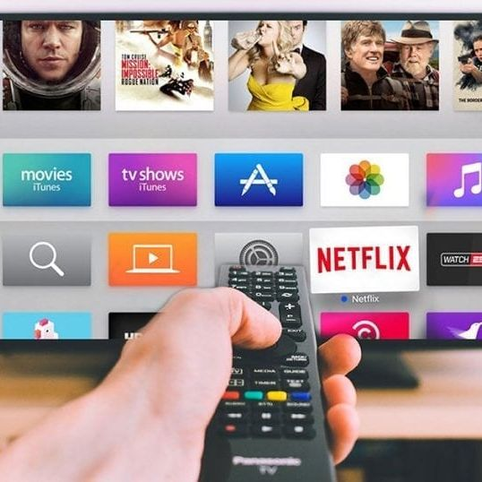
Connected TV reveals itself as a great platform for advertising due to viewership growth
The connected TV (CTV) performance advertising platform tvScientific has published the report How CTV Advertising Powers The Performance TV Revolution, in which it analyzes first-party and consumer data to better understand how CTVs are powering the performance TV revolution and what it means for advertisers. The research proves that more than half of consumers watch video content from connected TVs, while brand recall on CTV advertising is at least 39% higher than social media and other ad digital channels. The report reveals that 57% say the primary way they watch television and video content is by streaming it digitally, compared with just a quarter who watch through cable or linear TV. Audiences claim that they find ads on TV or streaming less annoying than ads on social media or websites. The report also found that more than half of consumers watched streaming video content just from their smart TV or CTV, which was more than all other digital viewing options combined.

Festivals


Dutch lockdown forces the International Film Festival of Rotterdam to take place online
Due to a new Covid-19 lockdown in the Netherlands, the International Film Festival Rotterdam (IFFR) will be moved online in 2022 for the second consecutive year.
This decision has made it the first major European film festival to adopt the virtual format in 2022. The programme of this 51st edition will be available on IFFR.com. IFFR Pro industry events CineMart and Rotterdam Lab will also take place online. The festival has confirmed that, even in the case the current restrictions are lifted after the 14th of January, the sheer scale of the festival is no longer compatible with a last-minute transition to an in-person event. Its education programmes will be adapted or postponed until later in the year to offer students access to IFFR-curated cinema.

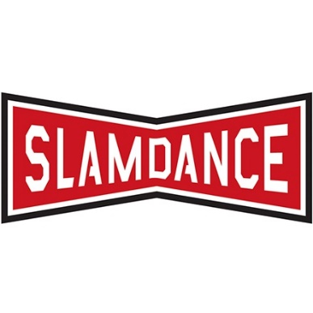
28th edition of the Slamdance Film Festival to take place in a hybrid format
The 28th edition of the Slamdance Film Festival will return to Park City, Utah from 20-23 January 2022. It will take place in parallel with the Sundance Film Festival as a physical event, while also running as a virtual gathering until the 30 of January.
All competition films are directorial debuts without US distribution and with budgets of less than $1 million. Three strong debut features have been elected from the EU: Poland’s Love Tasting by Dawid Nickel, North Macedonia’s Snow White Dies by Kristijan Risteki, and the Spanish Ultrainnocence by Manuel Arija de la Cuerda. The innovative DIG section of the festival, a showcase of digital, interactive and gaming works, will present content from several European independent artists. Find out more about the hybrid Slamdance Film Festival 2022 here.

Dates and links for upcoming festivals
- BFI Future Film Festival, UK – February 17-20 (Online), Info
- Dublin International Film Festival, Ireland – February 23-March 6 (hybrid), Info
- Glasgow Film Festival, UK – March 2-13 (hybrid), Info
- Sofia International Film Festival, Bulgaria – March 10-20 (in-person), Info
- Thessaloniki Documentary Festival, Greece – March 10-20 (in-person), Info
- SeriesMania, Lille FR - 18 - 25 March (in-person), Info
- Malaga Film Festival, Spain – March 18-27 (in-person), Info
- CPH:DOX, Denmark – March 23-April 3 (in-person), Info
- Vilnius International Film Festival, Lithuania – March 24-April 3 (in-person), Info

Recent studies

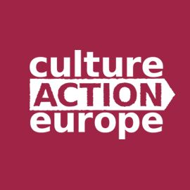
2% of the National Recovery and Resilience Plan destined to Culture? Not really the case!
Seems like long ago but only on March 2021, CEPI cosigned a letter asking Heads of State and Government, Ministers for European Affairs, Ministers for Finance, Ministers for Culture and Presidents of the European institutions to ensure that in each member states NRRP, at least 2% of the resources would be allocated to Culture.
Last month (9 December) Culture Action Europe analysed all the 26 NRRPs that have been presented so far (only The Netherlands missing) and put together an overview of both the financial envelope available and the lines of priority intervention.
You can find and download the publication here.
The mapping shows that the 2% has been achieved on an aggregate basis, but still 22 countries out of 26 either do not foresee any specific funding for culture or do allocate around 1% of their recovery budget.


New report by the European Audiovisual Observatory: Key figures of the animation films and TV series in Europe
The report compiles data on the production and exploitation in cinemas and in VOD of animation films and audiovisual content produced in Europe. It also provides new data regarding the production of animation TV content.
The report finds that Europe produces around 55 theatrical animation films per year, France, Russia and Germany being the main producing countries. Theatrical animation films are significantly more often international co-production than films of all categories. In the same line, the UK, France and Russia get the highest share of admission to European animation films.
According to the EAO, the top 20 European animation films account for 60% of all admissions to European animation films, which in general get a lower market share than films of all categories. The first non-European market for European animation films appears to be China. Read the full report here.

New report by the European Audiovisual Observatory on media ownership in Europe
The study is based on data provided by the EAO’s MAVISE database, Ampere Analysis, Glance and the European Metadata Group. 40 countries are covered with the aim of shedding light on the structure of Europe’s audiovisual industry in terms of revenues and other performance indicators specific to key audiovisual market segments.
The study finds that Europe’s top 100 audiovisual companies showed some resilience to the pandemic, which was possible because “players whose business models are primarily based on pay TV and public funding proved more resilient”, whilst “those relying on advertising were more severely affected”. A second key finding suggests that M&A activity has been pushed up by the streaming race and the pandemic. Moreover, the study demonstrates that the geo-economic scenario has changed dramatically: the weight of US interests in top 100 revenues has significantly increased owing to the rise of the pure SVoD players. Nonetheless, US interests are less significant in terms of TV audience, accounting for just 11% of the viewing time. SVoD emerges as the most concentrated audiovisual market segment in Europe, followed by pay TV with 72% of subscriptions cumulated by the top 20 pay-TV operators. Access the full report here.

The figures of female representation in Europe’s film industry
According to a report by the European Audiovisual Observatory, women only represented 23% of all directors of European feature films active between 2016 and 2020. They amounted to only 33% of producers, 27% of screenwriters, 9% of composers and 10% of cinematographers. The need for more women behind the camera is evident, given the fact that they accounted for 39% of all actors in front of it. These figures prevailed across all categories except lead roles, where parity has been achieved.
The study also found that women are more likely to work behind the camera in teams, in partnership with other colleges, also across all categories concerned, in prevalent gender mixed teams. However, they were also slightly less active than their male counterparts, with 89% of female directors only directing one single film, compared for 83% for men. Despite this, only 18% of European feature films were written by a female-driven team.

Piracy is becoming a thing of the past, according to study
A new report released by EUIPO claims that piracy traffic online has fallen sharply in recent years. The trend was noted in variety of online media, from movies to music, the latter of which suffered the sharpest decline - 80%. It also showed how TV remains the most recurring pirated form of media with films and music taking over just 30% of all pirated content.
Most importantly, the results show that consumers preferred to enjoy content through legal channels in overwhelming numbers during the pandemic. However, the study focus on web trafficking, which means that apps, streaming devices and IPTV services were not included in its research. Despite so, the downward trend in the popularity of piracy is predicted to resist their inclusion. These are great news for artists and content creators.

Events


Creative Europe - Media Calls: Relais Culture Europe organises info session for producers
With the upcoming publications of the Media programme 2022, Relais Culture Europe organises an info session on 8 February at 11 AM.
The aim of the webinar is to guide producers in understanding the opportunities available through the calls of the Media cluster of Creative Europe.
Unfortunately the event will be in French with no real-time interpretation.
Please find here the registration form.

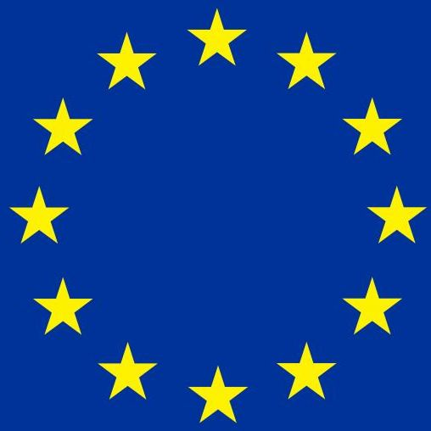
The Commission’s plans to increase the potential of the international competitiveness of the European filmmaking industry
A new call for ‘Research and innovation on cultural heritage and CCIs – 2022’ under the programme Horizon Europe has been launched by the Commission, having 20 April as deadline. The research will examine the state of the art of the European filmmaking industry, in order to analyse its limitations. Proposals will assess the needs and development of the European filmmaking industry and address potentialities for further development. A comparative assessment of the international competitiveness of the industry should be developed. The admissibility conditions are described in Annex A and Annex E of the Horizon Europe Work Programme General Annexes. Find more information about the call here.

Seminar: Financial contributions under the Audiovisual Media Services Directive (AVMSD)
On 3 February at 13:00 CET, the University of Amsterdam will hold a seminar on financial contributions imposed on media service providers under Article 13 of the revised Audiovisual Media Services Directive (AVMSD).
During this seminar, the legal framework associated with such financial contributions will be the focus of discussion by representatives from government, business and academia working both in the audiovisual and tax domains. Along three different panels, the speakers will analyze the financial contributions imposed on media service providers from both an EU and International Tax Law perspective. By focusing on this specific industry-related regulation, the seminar will build a bridge between two regulatory fields that usually do not speak to each other. The aim is to provide impetus for further reflection on a still underexplored but extremely relevant subject.
Registration form is available here.

Interesting links

- New Film Studio Will Be Built in Space by 2024
- French Film Executive Eric Lagesse on His Connection With Arab Cinema, State of the Arthouse Sector
- Women In Film Launches 2022 ‘Vote For Women’ Awards-Season Campaign
- Netflix Introduces Emerging Filmmaker Initiative (EXCLUSIVE)

