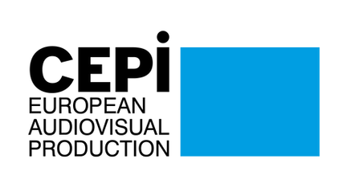
CEPI Newsletter
February 2022

Dear CEPI Members,
The last few days have brought shock into our daily lives and horrors in the lives of Ukrainians, including our friends and colleagues from the Ukrainian filmmaking community.
CEPI stands in solidarity with the Ukrainians and the Ukrainian audiovisual community, and strongly condemns the actions taken by the Russian government against Ukraine. In situations such as this one, the value of CEPI lies in its network of national associations, you, and our capacity to mobilise an entire community.
We are already coordinating to provide our Ukrainians colleagues with points of contact for help and support in various European countries. Some of you are already proactively engaging to provide support and we would like to thank you for your amazing work. You will soon receive more information on how to help as well.
Despite this horrible situation, the work carries on in Brussels, with the ongoing negotiations on the DSA, the Digital Services Act. Together with other trade associations, CEPI continues to advocate with policy makers involved with this file, calling for a better alignment of the provisions with the interest of the cultural sector, including with a final letter and a MythBusters calling for an extension of the scope of the KYBC provision. In addition, national initiatives continue to apply pressure at all levels of the negotiations, such as this statement from 54 French associations addressed to the French government currently holding the presidency of the Council of the EU.
Back in December, CEPI received a response from the Commission to our letter on the definition of European work, where the Commission confirmed its intention to consider the issue during its work on the Media Oultook study scheduled to start in June this year. Under the impulse of CEPI and a few other organisations, MEP Emmanuel Maurel addressed Commissioner Breton with a parliamentary question asking for the commission’s intentions on establishing a new definition of European works. In his response, Commissioner Breton reassured that the commission is aware of the issue and currently evaluating the situation in light of the AVMS directive implementation and that the question of the definition of European works will be explored within the upcoming report “Media Outlook”.
With the new year, the new calls for the MEDIA programme have been published earlier this month. You can find here the open calls and the application procedure.
Only 3 weeks left before the next edition of Series Mania in Lille from the 18th to the 25th of March. Join CEPI on the 23rd for a panel on independence. What makes our independent producers unique and how to preserve their richness in this ever changing environment.
Until next month, we hope you will enjoy this edition of the CEPI newsletter.
Enjoy the reading!
The CEPI secretariat

Sections in this newsletter:
- Latest from the EU
- COVID 19: Impact on the sector
- Creative Europe
- Copyright
- Digital Services Act (DSA) & Digital Platform Regulation
- Territoriality
- AVMSD

- Piracy
- Business News: VOD
- Film and TV
- Festival
- Recent studies
- Events and Opportunitires
- Interesting links

Latest from the EU


Support to Ukraine: How is the AV and Film industry reacting?
CEPI wishes to manifest its full support to Ukraine and Ukranians. The Russian invasion of Ukraine left us deeply concerned for our dear friends of FIAU and our thoughts go to their family and friends.
In response to FIAU request to mobilise European’s leaders' intervention in support of Ukraine, the secretariat published a statement calling for immediate response with a focus on the necessity to provide humanitarian aid and expeditious support for Ukrainians to access the EU territory.
On this issue, we also thank and admire all the work taken on by our Polish members from KIPA, who immediately organised a response to help Ukrainian Filmmakers.
Kipa is collaborating with law firms and other associations to help Filmmakers secure jobs and shelter in Poland while at the same time engaging with the Polish Filmmakers Association and non-governmental organisations, to organise the transport of Ukrainian filmmakers from near the Polish border to Warsaw or other cities.
If you have any questions regarding the help for Ukrainian colleagues please do not hesitate to ask KIPA via mail biuro@kipa.pl.
In parallel, our French members USPA, AnimFrance and le SPI joint under the CISA- Coordination Inter-Syndicale de l’Audiovisuel, published a press release stating their profound sorrow for the situation in Ukraine, their availability to provide shelter for those fleeing the country but also support to rebuild the their professional life either in France or Ukraine after the conflict.
Here is an overview of the reactions from film professionals that have been pouring in since the beginning of the invasion:
The European Film Academy (EFA) has issued "an unequivocal condemnation" of President Putin’s invasion of Ukraine, excluded Russia from the European Film Awards and joins the Ukrainian Film Academy in a boycott of Russian films (read more).
The Ukrainian FIPRESCI branch asked members of FIPRESCI "to abstain from participating in any film or other event organised, hosted or funded, directly or indirectly, by the Russian Federation. We urge you not to take part online or otherwise in any film festivals and cultural forums in the Russian state" (read more).
The Belarusian film community has issued a statement in which it "strongly condemns the Russian military aggression against Ukraine. We are outraged that the Russian aggressor uses our territory for launching deadly missiles into Ukraine" (read more).
The international documentary community of filmmakers and film professionals stands with the Ukrainian people and asks that the response of the international community will be adequate (read more).
Over 250 film professionals and institutions across the world, including producers, distributors, festivals, directors, publicists, journalists, cinematographers and other industry professionals, replied to Ukrainian filmmakers’ call not to remain silent in the face of Russia’s invasion (read more).
Federation of European Screen Directors (FERA) representatives said: “We stand in full solidarity with the Ukrainian people, with our colleagues, relatives and friends in Ukraine, as well as those opposing the conflict in Russia and Belarus, amidst a dangerous and uncertain situation following the invasion of Ukraine by the Russian army." (read more)
The Berlinale team stated: “We – festival workers, artists, filmmakers… – think fondly of our friends in Ukraine, and we are by their side in a call for peace." (read more)
The International Coalition for Filmmakers at Risk (ICFR) stands by the Ukrainian film community and is ready to take concrete steps to help, such as an emergency fund to support Ukrainian filmmakers (read more).
Ukrainian filmmakers Oleh Sentsov, Valentyn Vasyanovych, Maryna Er Gorbach, Nataliia Vorozhbyt, Iryna Tsilyk and Nariman Aliev, and executive director of the Ukrainian Film Academy and the Odesa International Film Festival Anna Machukh are appealing to the international audience not to be silent and not to stand aside, and asking for help and certain actions that can help Ukraine regain peace (read more).
The International Union of Cinemas (UNIC) expressed its solidarity to Ukranian exhibitors and the Ukranian people, ensuring their “support [to] Ukrainian colleagues when the time comes to rebuild those cinemas destroyed by Russian aggression, so that their audiences can once again enjoy the inclusive big screen experience” (read more).


New Data act proposal - new opportunities for data access?
On the 23rd of February, the European Commission published a new proposal, the Data Act, aimed at " to maximise the value of data in the economy by ensuring that a wider range of stakeholders gain control over their data and that more data is available for innovative use, while preserving incentives to invest in data generation. " The data act looks at BtoB and BtoG data sharing as well as rules to switch data processing services, and is complemented by a few other provisions. While this proposal will not apply to producers, many IoT devices will be captured by it, and the act could potentially provide some new opportunity to access audience data.
The proposal regulates both the sharing of personal and non personal data generated through the use of a connected product or related services, such as virtual assistants, smart speakers, smart TV and any other IoT devices. The Act introduces a new right for consumers to request access from Data holders (legal or natural persons who haves the right or obligation to make available data in accordance with the data act, or other national or union legislation - and a limited exception for SMEs) to data generated by their use of the product or the related service, and the right to authorise third parties to access this data (with the exception of gatekeepers as defined under the DMA). In effect, the Act creates new BtoB data sharing obligations. Data holders would have to make data availallbe in a fair, reasonable and non-discriminatory manner, while users and data recipient may not use such data for developping a competing product or services, nor for profiling purposes. Data holders and data recipients would have to agree on terms for making the data available, including compensation. Freedom of contract would continue to be the basis for BtoB data sharing contract, yet the Data Act includes provisions on unfair contract terms, to protect micros and SMEs from being imposed unilaterally unfair terms for the access and use of data. The scope of the proposal is very broad and not defined enough at this stage, but already a recital refers to television cable network and home equipment, which leads to think that smart TV may be considered as data holders, and could have an obligation to share data under this new legislation.
The Data Act already creates interplay with several pieces of legislation such as the DMA (gatekeeper cannot access data from data holder), the platform to business regulation (rules on making data available in a transparent manner) and the GDPR (in the case of making available personal data).
Chapter V of the Data Act sets new provisions on Business to government data sharing, to allow greater data access to public sector bodies in cases of "exceptional needs", such as public emergency, or for the fulfillment of the public sector obligations where the data could not be obtained through other means. This chapter is likely to create new obligations on any data holders to share data with governments. It is likely that many stakeholders will want to provide input on this chapter to further define its scope of applicability, the concepts of "exceptional needs" and "public emergency", and potentially carve out specific exemptions.
Having been sent to both the Council and the European Parliament, this technical file is likely to generate some tensions and interplay with existing privacy legislations, the DMA, the data governance act and other pieces of legislation.

European Media Freedom Act ‘call for evidence’ open until 21 March
In December 2021, the European Commission issued a call for evidence on the Commission's upcoming proposal for a Media Freedom Act. The purpose is to invite stakeholders to express views on the Commission’s description of the Media Freedom Act initiative, why it is necessary, and what it aims to achieve. Crucially, the call for evidence is accompanied by an important document setting out detailed options on the Media Freedom Act initiative, which is entitled “Safeguarding media freedom and pluralism in the internal market”.
The Commission first sets out the problems the upcoming proposal aims to tackle. These problems can be seen in the document on the Commission’s website. Notably, the Commission states that “interference” in editorial and management decisions of media may lead to “biased media coverage”, and can affect investment or market entry decisions; while state resources “may be used to put pressure on media”.
The objective of the Media Freedom Act will be to ensure that (a) media companies can operate in the internal market subject to consistent regulatory standards, including in regard to media freedom and pluralism; (b) ensure that EU citizens have access to a wide and varied media offer both offline and online; (c) safeguard the editorial independence and independent management of the media, which is a precondition of media freedom and of the integrity of the internal market; and (d) foster undistorted competition between media companies by ensuring a transparent and fair allocation of state resources.
Input in response to the call for evidence can be provided until 21 March 2022, and the Commission will publish an impact assessment in the second quarter of 2022. The Commission states that the Media Freedom Act is “planned for adoption in the course of 2022”.

Covid-19: Impact on the sector

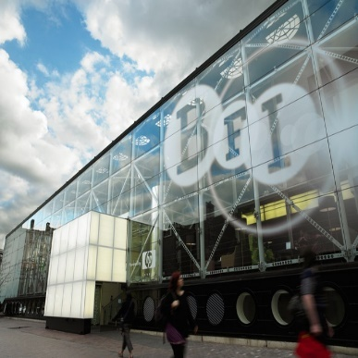
The gradual and uneven recovery of cinema attendance in EU and UK
Based on preliminary data the European Audiovisual Observatory estimates that the cinema attendance in the European Union and the United Kingdom increased to 383.2 million tickets sold in 2021. This is 83.8 million admissions more than in 2020, representing a year-on-year growth of 28%. The rebound was less pronounced in the European Union only (EU27), where ticket sales increased by 21% to 309.2 million admissions, 53.8 million visits more than in the previous year. While these results represent a clear sign of recovery after the impact of Covid-pandemic in 2020, levels are still below pre-pandemic period.
Admissions for 2021 are still 61.9% below the figures registered in 2019, when cinema attendance in the EU and UK topped 1 billion admissions, representing a total loss of 623.5 million tickets. Moreover, in most territories, the market share taken by national films decreased in comparison to 2020, when it had reached exceptionally high levels due to the shortage of US blockbusters on release.
Finally, preliminary data suggest that in the EU and the UK the box office was mainly driven by the success of US studio hits. The top-ranking films for the year include No Time to Die (GBinc/US), Spider-Man: No Way Home (US), Dune (US/CA) and Fast & Furious 9 – The Fast Saga (US).


UNIC report highlights the increase of the European theatrical box office in 2021
According to the International Union of Cinemas (UNIC) report, cinema admissions rose an estimated 38% in 2021, with over 590 million total tickets sold, generating a 42% rise in box office to €3.7 billion ($4.2 billion) compared with the all-time low year of 2020. At the EU level, covering also the U.K., over 400 million tickets were sold in cinemas, worth an estimated €2.9 billion at the box office ($3.3 billion).
While the impact of the COVID-19 pandemic on the European cinema industry remains significant, France, the UK, Russia and Poland show encouraging box office results.
As in past years, European box office was mainly driven by major Hollywood blockbusters with an over $1.77 billion haul at the global box office and counting. Local titles have also played a key role in the ongoing recovery process of European cinemagoing. The market shares for homegrown movies were higher than normal years across the region, most notably in France, Czech Republic and Denmark.
UNIC is expecting 2022 to be a pivotal year for the European industry.

“The Future of Nordic Feature Film at a Crossroads”: highlights
On Friday 21 January, the Nordisk Film & TV Fond organised a panel titled “The Future of Nordic Feature Film at a Crossroads”, moderated by Thomas Gammeltoft, of True Content Entertainment. The debate covered several key topics, including content, production volumes, and flexible funding models and distribution windows.
On the topic of content strategies, Alexander Bastin revealed the ambition of the NENT Group to be appealing to international audiences while still “pursuing the ‘localness’” as a main strategy.
Market competitiveness and its effects on the variety of content offered have been strongly debated. While Ruben Östlund believes that the liberalisation introduced had an unexpected result in “narrowing the taste” of the audience, Tim King claimed that the current offering is still very broad, but that local features suffer because of the competition from global blockbusters.
Lucía Recalde, Creative Europe – MEDIA’s Head of Unit, stressed that European content should refer to high-quality “locally grounded” pieces with “the potential to reach out to as many Europeans as possible”.
On the topic of flexibility, Bastin explained his group’s priority to secure an exclusive first window for its original productions. In addition, by co-existing with exhibitors, audiences would end up shaping more flexible viewing models, as they will be the ones to specifically determine when and where to watch titles.

Czech productions dominated national theatres in 2021
In 2021, Czech box office registered a slight improvement compared to the previous year. The total earnings grew by 20.18% on 2020’s figures. Domestic theatres had been completely shuttered until 23 May; after this date, they reopened and continued to be operational until the end of the year but with some restrictions. The total earnings thus reached €44,609,633, generated by 7,141,609 cinemagoers (with attendance levels having dropped to levels last seen in the 1990s) at a total of 288,405 screenings. The average price of a ticket rose by 7.45% to a historic high of €6.25.
In 2020, Czech productions were dominant in national theatres with a 52% share of all attended films distributed locally. In 2021, the share fell slightly, but local movies still maintained a stronger presence compared to other countries.

Creative Europe

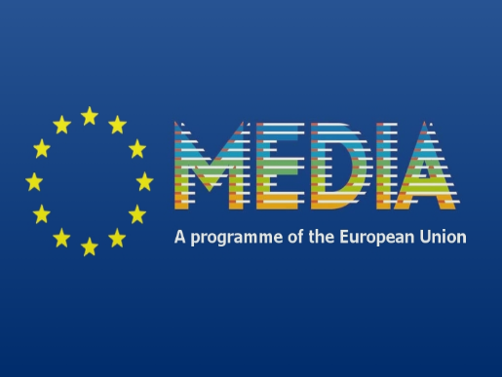
Creative Europe MEDIA 2022: publication of the first three calls for proposals
The Commission has published the first three calls for proposals opened under the framework of the Creative Europe MEDIA 2022, a programme with a total of €226 million of EU funding available for the 2022. It aims at supporting the recovery of the audiovisual industry and strengthening its competitiveness.
The Creative Europe programme consists in three strands: the MEDIA strand providing support for the audiovisual sector, the Culture strand covering every other area of the cultural and creative sectors, and the Cross sectoral strand providing opportunities for cross-sectoral collaboration and the news media sector. The budget for the 2022 Creative Europe is €385.6 million, an increase of about 30% compared to 2021.The Multiannual Financial Framework 2021-2027 has allocated €2.2 billion to this programme, becoming the biggest ever funding programme devoted to supporting the cultural and creative sector at EU level.
The Creative Europe MEDIA programme has introduced three new calls for proposals under video games and immersive content development, networks of European festivals and MEDIA 360° (representing €41 million in EU funds), and a call focused on media literacy (representing €2.4 million).
Please find here the open calls and the application procedure.
Deadlines:
TV and online content --> 05 April 2022 17:00 CET
Video games and immersive content development --> 12 April 2022 17:00 CET
European slate development --> 27 April 2022 17:00 CET

Copyright

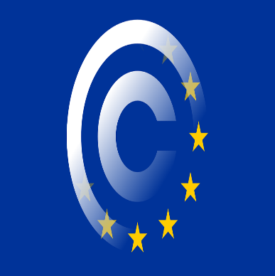
Transposition of the Copyright Directive in Italy
On 8 November 2021, the Italian Government approved legislative decree no. 177/2021 implementing Directive (EU) 2019/790 of the European Parliament and of the Council of 17 April 2019 on copyright and related rights in the Digital Single Market and amending Directives 96/9/EC and 2001/29/EC (“DSM Copyright Directive”).
The Italian transposition of the DSM Copyright Directive is, overall, consistent with the original text. However, there are a few significant differences on certain subjects.
Online content-sharing providers (“OCSSPs”) shall obtain an authorisation from rights holders when they give public access to copyright-protected works or other protected materials uploaded by their users (Article 1 paragraph 1 (n) of the Legislative Decree transposing Article 17).
Authors and performers shall enjoy the right to appropriate and proportionate remuneration, to be exercised directly or through the CMOs and IMEs to which they have given appropriate mandate (Article 1 paragraph 1 (p) of the Legislative Decree implementing Article 18).
Article 1, paragraph 1 (q) of the Legislative Decree transposes Articles 19, 20, and 21 by introducing specific provisions setting forth the transparency obligation – the subject of a detailed and far-reaching implementation, including biannual reporting, VOD-specific obligations and pecuniary sanctions in case of non-compliance – the new contract adjustment mechanism, and the ADR procedure for rightsholders and representative bodies of rightsholders to bring claims over the transparency and contract adjustment provisions.

Digital Services Act and platform regulation


Schwab optimistic that DMA can be wrapped up by the end of March
In an interview to Reuters, Andreas Schwab (EPP, DE) repeated that the aim is still to finalise the negotiations of the Digital Markets Act at the end of March, beginning of April. However he said both sides disagree on the European Commission’s role, with lawmakers insisting on the EU executive as the sole enforcer and with veto power, while EU countries want national watchdogs to have more say and no veto power for the Commission.
Schwab said MEPs will not compromise on a proposal that would allow regulators to impose structural remedies such as the breakup of any tech giants which breach the rules, even though EU countries are not keen on it.
Still, there is room for compromise, he said, with all sides eager to adopt rules that could set a global standard.
The next political trialogue meeting will take place on 1 March.

Territoriality

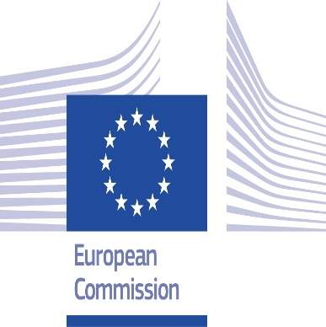
Stakeholder Dialogue: Last meeting to take place in March
According to informal sources, the European Commission will organise a last meeting for the stakeholder dialogue this March 2022.
While we still do not have a defined date, we have been informed by civil servants of the member state permanent representation in Brussels that the commission updated the council audiovisual working party on the results achieved so far.
In general, the commission is disappointed by the unresponsiveness of the stakeholders who maintained a stable position on the need to maintain the pillar of territorial exclusivity.
During the past months, CEPI kept suggesting to the commission that reviewing the Geoblocking regulation at this stage is risky and premature. This is particularly true due to the slow recovery process taking place from the terrible impact on the whole value chain and; the fact that the ecosystem is evolving in an unprecedented way leaving little space for new measures.
On the other hand, the reasons behind the commission's urge to review territoriality remain unfunded. Any future recommendation should be supported by a clear analysis of the circulation trends across Europe. Considering the recent implementation of the AVMS directive, the situation might change and only for the best. Hence we will keep maintaining our united position on the issue.
We will inform you of the dates for the new meeting once we will receive the commission invitation.

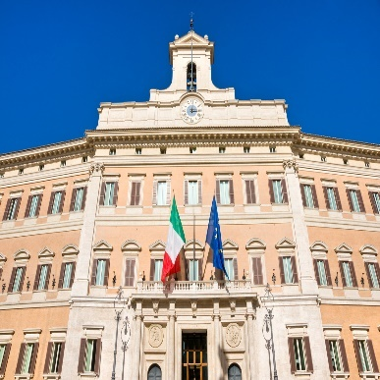
Transposition of the SatCab Directive in Italy
On 8 November 2021, the Italian Government approved legislative decree no. 181/2021 implementing Directive (EU) 2019/789 of the European Parliament and of the Council of 17 April 2019 laying down rules on the exercise of copyright and related rights applicable to certain online transmissions of broadcasting organisations and retransmissions of television and radio programs and amending Council Directive 93/83/EEC (“SatCab Directive”).
The most debated topics included the application of the country-of-origin principle to ancillary online services and the transmission of programmes through direct injection. Overall, the Italian transposition of the SatCab Directive is consistent with the original text.
The Legislative Decree unified the two disciplines concerning cable and non-cable retransmission.
The main novelty of Article 16-ter transposing Article 4 concerns the possibility for rightsholders to only grant or refuse authorisation for a retransmission through a CMO that meets the requirements set out in Legislative Decree no. 35/2017.
To protect the interests of the AV industry, Article 16-quater implementing Article 3 stipulates that the country-of-origin principle shall apply only to (i) radio and TV news and current affairs programs, and (ii) self-produced programs entirely created, financed and realised by a radio or TV broadcasting organisation using its own resources.
Finally, Article 110-bis transposing Article 6 of the SatCab Directive establishes that in the event of failure to obtain authorisation for the retransmission of a broadcast, the parties concerned may have recourse to a third party, chosen by common consent, for the formulation of a contractual proposal.

AVMSD

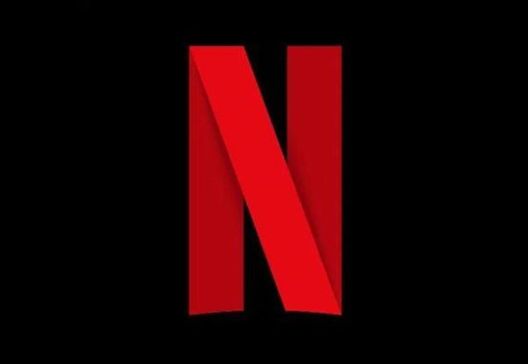
First agreement between French Film industry and Netflix
In the framework of the recent funding obligations for SVOD platforms, the French film organisations (represented by the Film Industries Liaison Office (BLIC), the Film Organisations’ Liaison Office (BLOC) and the Civil Society for Authors, Directors and Producers (L’ARP)) and Netflix have signed the first ever agreement between a film industry and a subscription-based, on-demand video service (SMAD) on the 22th of February.
As part of this three-year agreement, Netflix undertakes to invest 4% of its annual net turnover achieved in France by way of a minimum guarantee of €30m invested yearly in original, French-language film creation.
In total, this should amount to an estimated investment of €40m in French and European film creation in 2022. As a privileged partner of the French film industry, Netflix will enjoy first and exclusive access to films for a duration of seven months (15 months after their cinema release) in theFrance’s new media chronology.
Please find here a press release available on the website of Le SPI.


European Audiovisual Observatory updates AVMSD tracking table
The transposition deadline for the MS’s for the Audiovisual Media Services Directive expired on the 19th of September 2020. Certain countries however, are still in the process of transposition. Therefore, the European Audiovisual Observatory has revised their AVMSD tracking table. The table can be seen through this link.

Piracy


Global threats to the legal distribution of digital content
The International Intellectual Property Alliance (IIPA) warns of copyright protections and other threats to the legal distribution of digital content, which will affect the ability of media companies to expand into international markets. IIPA's report describes several ongoing threats, including IPTV and cable and satellite piracy.
By examining the effectiveness of intellectual property rights protection in the US, the report stresses that when the U.S. enacts strong IP laws, effectively enforces those laws, and eliminates barriers to their markets, it benefits American creators, producers, workers, and consumers. The report recommends strengthening copyright protections, including in countries identified as higher risks for infringement, and addressing the piracy ecosystem that includes devices that provide illegal access to movies and TV shows. China is a major source of set-top boxes and apps that enable unauthorised access to streaming video and other content, but enforcement against them presents complex challenges.

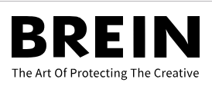
$290K collected in settlements by the Dutch anti-piract group
Dutch anti-piracy group BREIN collected cash payments of $290K from pirates in 2021, with settlements presented as an alternative to legal battles. Usenet is popular with users and anti-piracy groups, but is often made difficult by the abundance of copyrighted content found on the system.*
BREIN is interested in tackling piracy on Usenet, but has been successful in shutting down five Usenet indexes. BREIN rarely names the sites it takes offline but in 2021 NZBXS agreed to shut down and give BREIN sensitive data in exchange for shutting it down. BREIN targets pirates who are part of the ecosystem by uploading or even linking to copyrighted material.

Piracy warnings: BREIN v Ziggo
The Dutch anti-piracy group BREIN was able to send warning letters to pirate subscribers because of a separate data processing licence. The Netherlands' largest ISP, Ziggo, refused to do so due to privacy concerns. BREIN requested permission from the Data Protection Authority to track and store personal data of BitTorrent pirates. This permission was granted, and BREIN launched a mass warning campaign. BREIN sent its warnings to Ziggo that refused to forward them to their subscribers, saying that linking IP addresses to specific subscribers raised serious privacy concerns. BREIN took the matter to court, but the Utrecht court decided against them. The Court declared that since Ziggo doesn't have a licence to process data from BREIN, it is not required to forward warnings from BREIN to its subscribers. However, the anti-piracy group states that Ziggo is acting unlawfully if it does not apply for a licence, declaring also that even without a licence, it should be possible for ISPs to forward notices.

BBC adoption of IBCAP’s antiparacy lab
BBC Studios will be able to monitor pirate threats using IBCAP's anti-piracy lab, which is used to prevent the illegal streaming and distribution of international television content in the US. They will work with IBCAP to help monitor piracy and prevent it from harming UK producers and broadcasters. "IBCAP continues to expand its membership," said IBCAP executive director Chris Kuelling. "We welcome BBC Studios as our newest member and we are thrilled to have them as part of our coalition."

BUSINESS NEWS: VOD

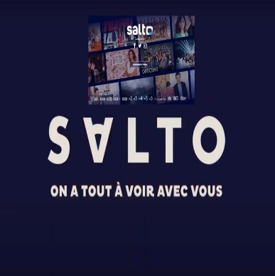
CNC figures point out that Salto is underperforming
Salto, the French SVOD streamer launched by pubcaster France Télévisions and commercial broadcasters TF1 and M6 is underperforming with only about 500,000 paying subscribers. These figures, if correct, are only half the number originally predicted for the offering by the end of last year.
According to the CNC’s Baromètre de la video à la demande (VàD/VàDA) survey, Salto reached only 8.4% of internet users who said they had paid to watch movies or TV programmes on-demand, compared with 62.9% for market leader Netflix. Salto in fact is 16th placed among the 20 services covered by the CNC survey. The streaming service has also been criticised for being priced too high and for offering too little original content. It also suffers from limited distribution, with only Bouygues Telecom making it available via its set-tops among the country’s major ISPs.

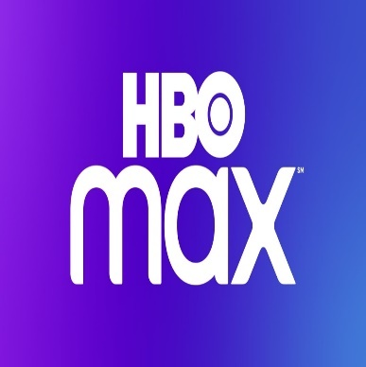
HBO Max prepares rollout in another 15 European countries
HBO Max is launching in an additional 15 countries on March 8, this time targeting Central and Eastern Europe. This covers Bosnia and Herzegovina, Bulgaria, Croatia, Czech Republic, Hungary, Moldova, Montenegro, North Macedonia, Poland, Romania, Serbia, Slovakia, Slovenia, Portugal and the Netherlands.
The rollout began in earnest in October with launches in the Nordics, Spain and Andorra. HBO had already been operating different brands (HBO Portugal and HBO Go) in Central and Eastern Europe, so it is now preparing for another migration to HBO Max.
The question now is when HBO Max will launch in key Western European markets such as the U.K. and Germany, where WarnerMedia has a lucrative output deal with Comcast-backed pay-TV operator Sky that officially expires in 2025. The platform also confirmed in October that Warner Bros. movies will launch on HBO Max in Europe 45 days after their theatrical release.

The weakness of streaming services: people sign up for one show and then cancel their subscription
New research performed by Antenna about the habits of streaming subscribers finds that many of them sign up for only a brief time and then cancel their subscriptions. When they finish watching their preferred content, many of them unsubscribe. Some movies are so highly anticipated that many new subscribers sign up “within three days” of the release of movies on the streaming services. However, the new subscribers who stick around after subscribing for that one show or movie outnumber the ones who cancel.
This points out that today’s subscription streaming services are not in business to lose subscribers. The perpetual competition for subscribers is more intense than ever today, and streaming services are locked in a process of developing and producing new content to lure new subscribers and keep them. Last year, Netflix was on track to spend $13.6 billion on content, and its annual content spend could reach $18.9€ billion by 2025.
Amazon Prime Video overtakes Netflix’s lead in Germany
Amazon Prime Video is now the market leader in Germany, according to recent figures disclosed by Ampere Analysis. The streaming giant overtook Netflix’s lead, and the gap is expected to grow in the coming years. This can be explained by Amazon’s larger proportion of German language content and its live sport rights, such as the recently acquired rights to broadcast UEFA’s Champions League matches in Germany for the 2021-22 season. While there are some Central and Eastern European markets where local streaming services have the market lead – for example, Kinopoisk HD in Russia – Austria and Germany are the only European countries where Amazon has the lead, and the only Western European countries where Netflix is not the market leader.
Record 10-year deal between Amazon Prime Video and Shepperton Studios
Amazon Prime Video streaming service has struck a record-breaking deal to lease space at Shepperton Studios, home to productions ranging from Alien to Mary Poppins Returns. This is the company’s first long-term commitment to making TV programmes and films in the UK. The deal will see Amazon Prime Video join its rival Netflix in having an exclusive contract at the Surrey studio as the streaming wars continue to fuel a race for space to ensure that productions can be filmed without delays. It is understood that Amazon’s lease is for well over 10 years – longer than similar deals struck by Netflix and Disney.
Amazon said that the next two years were expected to be its busiest yet for UK-made productions, with Shepperton due to come online in 2023 when an expansion of the site is complete. The company would not say whether Shepperton would play a major role in the shooting of the eagerly anticipated Lord of the Rings adaptation, after the decision to shift filming from New Zealand to the UK.
Netflix doubles German-language investment
Netflix has announced 19 new German-language projects from Germany, Austria and Switzerland, while doubling its investment in content from the region to € 500m ($571M) between 2021 and 2023.
Among the new shows headed to Netflix are two projects from Constantin Film (the eight-part series Achtsam Morden and the six-parter Liebes Kind), King Of Stonks hails from Cologne-based production studio BTF, the action-thriller series Kleo produced by Zeitsprung Pictures, Michael Souvignier and Till Derenbach, the modern historical series The Empress, and mystery series 1899.
Films headed to the streamer include spaghetti western Blood and Gold ; How to Sell Drugs Online (Fast) spin-off Buba and an adaptation of Erich Maria Remarque’s anti-war novel Im Westen Nichts Neues.
Unscripted projects announced at the show include Queer Eye Germany and true-crime series Soering.
Finally, Wirecard is headed for the documentary thriller section.
ARCOM’s procedure for suspending retransmission of certain TV and VOD audiovisual media services
The French Autorité de régulation de la communication audiovisuelle et numérique (ARCOM) has the power to suspend the retransmission of television and on-demand audiovisual media services that fall under the jurisdiction of another EU member state. Such a sanction can be imposed if a service poses a serious risk to public safety or national security, clearly and seriously violates the ban on broadcasting a programme or commercial communication likely to harm minors or the ban on inciting racial or religious hatred, condones terrorism or poses a serious risk to public health. In urgent cases, the suspension can be enforced no earlier than 48 hours of the alleged breaches and planned measures being notified to the service provider, all its distributors and the satellite network operators concerned. The decision is also notified to the European Commission and to the member state in which the service provider is based. The measures can only be implemented once the European Commission has ruled that they are compatible with EU law.
France: obligations to video-sharing platforms for commercial communications
Decree no. 2021-1922 of 30 December 2021 explains the obligations of video-sharing platforms in respect of commercial communications that are marketed, sold or organised by these platforms.
The Decree prohibits surreptitious advertising (Art. 4) and the use of subliminal techniques (Art. 5) as regards to commercial communication. In accordance with Article 9(1)(c) of the Audiovisual Media Services Directive, commercial communications provided on video-sharing platforms must comply with certain principles: they must not violate human dignity, they must respect the female image and they must not promote discrimination or encourage behaviour that is “prejudicial” to health or safety or “grossly prejudicial” to the protection of the environment. Moreover, they must not be harmful to minors (Art. 7)
The decree includes video-sharing platforms to the list of companies that are prohibited from participating in sponsorship and it also extends by eight month (October 2022) the experimental authorisation of television advertising for cinema films.
Latvia takes action against unregistered on-demand AV platforms
Following the increased activity of the Latvian National Electronic Mass Media Council (NEPLP) to promote the compliance of the on-demand audiovisual media service providers, guidelines promoting a common understanding of the characteristics of on-demand services and their content have been recently adopted. The guidelines are designed for the NEPLP employees to carry out inspections of audiovisual media service providers, but also to help audiovisual media service providers in determining whether their service meets the characteristics of an on-demand audiovisual media service, and thus whether the provider is obliged to submit a notification to the NEPLP.
The second section of the guidelines identifies seven characteristics that must be cumulative for a service to be considered as an on-demand audiovisual media service:
- the provider must offer an audiovisual media service with the aim to provide such a service for remuneration
- the primary purpose of the service provider is to offer (produce or distribute) television-like audiovisual programs via public electronic communication networks, including websites
- audiovisual media services are available to the public via public electronic communication networks, whether for a fee or free of charge, with or without registration, including Internet websites
- the service provider organises a catalogue within the service in which the audiovisual programs are placed
- an on-demand audiovisual media service is designed and made available to the broadest possible audience, and as a result, may have a significant impact on it
- the purpose of the on-demand audiovisual media service is to “inform, educate or entertain” the general public
- the audiovisual media service provider has editorial responsibility (“effective control”), or the right and ability to decide, which programs will be broadcast on the audiovisual service in question.

Cinema & TV


The UK’s film and TV industries pull off a record year in 2021
The UK’s high-end TV (HETV) and film industries have delivered a massive £5.6B ($7.6BN) of production spend in 2021. Film spends returned to an increase in 2021, rising by 13% to £1.5BN, but it was the UK’s booming HETV sector that really reaped the rewards, skyrocketing by 155%.
This growth is also double pre-pandemic levels. Shows such as Netflix’s Bridgerton series two, which defied several Covid shutdowns to push on, Call My Agent! and co-produced BBC dramas such as Chloe and The Girl Before brought in huge amounts. The majority of HETV spend came from international spend or co-productions. The rapid growth was also helped by a sharp increase in single long-form productions made for the streamers. These high-end shows contributed £740M to the overall £4.1BN spend.
It was another challenging year at the UK box office, with pandemic-enforced closures affecting exhibitors across the first four months of 2021. Once cinemas did reopen in May, however, the green shoots of recovery were visible. No Time To Die was the biggest factor, attracting 16.4 million admissions and grossing a hearty £96.6M. In total, admissions across 2021 were 74 million, an increase of 68% on 2020’s challenging numbers. The top grossing UK indie film of the year was technically The French Dispatch (£4.1M).


UK film industry strengthening the relationship with European partners
The figures recently released by the British Film Institute (BFI) show that film and high-end television spend in the UK reached over £5.64 billion in 2021, achieving a new record and far ahead pre-pandemic production levels. Of that, £4.77 billion was spent on inward investment and co-production; double the spend of 2020.
The UK film sector is evidently working hard to develop its European and international relationships and export opportunities. As hard as to be defined as a “torrent of production” by Adrian Wootton, chief executive of the British Film Commission (BFC) and Film London. The BFI has particularly encouraged initiatives and activities specifically to support UK screen businesses looking to make new global partnerships and explore international markets including Europe. The collaboration with the european film partners has been beneficial for both sides, leding to an exchange of talent and resources. In October 2021, the BFC signed a Memorandum of Understanding with Spain Film Commission, to encourage greater creative, commercial and cultural exchange, as well as support of film and high-end television productions in both territories.
Recent projects to have shot in the UK and Spain include Marvel’s Eternals, which was based at Pinewood Studios and shot on location in London, Oxford and Fuerteventura in the Canary Islands, Netflix hit The Crown and Sony’s Spider-Man: Far From Home. No Time To Die was also based at Pinewood Studios and shot throughout London and the south east, Scotland, Norway and Italy.
Pradoxically, Covid and Brexit pushed the BFI to work more closely with European commissions because of the need to support productions with things like travel restrictions and changing work permits.

Festivals

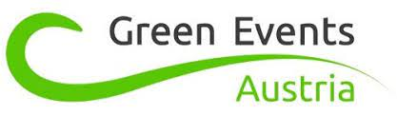
Austrian film festival first to be called a ‘Green Event’
The ‘Vienna Shorts’ film festival is the first Austrian film festival to receive the certificate for a ‘Green Event’. The certificate is valid for four years which allows the festival not only to label its own events as green, but also to award this distinction to the events of other organisers.
In order to receive the certificate, the organisation had to meet various criteria set out by the Austrian Climate Ministry. The festival has pledged to avoid the unnecessary squandering of resources whenever possible. This includes making environmentally friendly travel arrangements for filmmakers and industry guests, the prevention of waste, and the use of energy-saving equipment during the assembly and dismantling of the venues, sustainable print forms (or avoiding them altogether) and a CO2-neutral server landscape for the digital infrastructure, as well as ensuring regional, seasonal and fair-trade catering.
The 19th edition of the Vienna Shorts will take place in May this year.

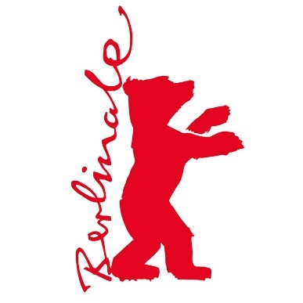
Berlin Film Festival will focus on sustainability and transformation in the AV-sector
The Berlin Film Festival’s European Film Market experienced its second virtual edition (10-17 February) with an improved online infrastructure for exhibiting companies and a wide-ranging conference program that focused on a transforming industry and the changes that are shaping its future. With the new wave of Omicron, the festival had to quickly shift from a hybrid to an online event.
During the EFM Industry Sessions, titled “Shaping Change,” the latest developments and the sector’s evolution were examined looking in particular at their declination within the three core themes of future, sustainable development, and diversity and inclusion.
The conference program comprised four sections: “Producers,” “Distribution,” “Documentary” and “Series.” Beyond the major topics of the conference, the growing call for major streaming services to commit to investing in local markets and the TV series landscape in Africa, where female creators are playing a significant role, were at the centre.
The EFM also expanded its Toolbox program, providing “a toolkit of business connections and know-how” for filmmakers and producers from underrepresented groups and the Global South. The Doc Toolbox Program included 28 participants and their projects, while the Fiction Toolbox Program debuted with 13 participants and projects.
600 companies exhibited this year (up from the 504 that took part in last year’s market).

Edinburgh TV Festival will hold a physical event in August 2022
After two years online, the Edinburgh TV Festival will hold a physical event in the Scottish capital between 24 and 26 August. News on this year’s speakers, sessions and the new advisory chair will be announced in the coming months, organisers said, adding that there will be in-person and live streamed sessions hosted in the months leading up to the event. These will include a ‘BBC at a Crossroads’ panel on Thursday, 10 February at 09.30 UK hosted by Krishnan Guru-Murthy, discussing the future of the BBC and the licence fee.
Dates and links for upcoming festivals
Ongoing
- Dublin International Film Festival, Ireland – February 23-March 6, hybrid
- Glasgow Film Festival, UK – March 2-13, hybrid
March
- Borderlines Film Festival, UK – March 4-20, hybrid
- Celebrating Women in MEDIA, Europe - March 8-13, online
- Sofia International Film Festival, Bulgaria – March 10-20, in-person
- Thessaloniki Documentary Festival, Greece – March 10-20, in-person
- BFI Flare: London LGBTQIA+ Film Festival, UK - March 16-27, hybrid
- Sofia Meetings, Bulgaria – March 16-20, in-person
- Series Mania, France – March 18-25, in-person
- Malaga Film Festival, Spain – March 18-27, in-person
- CPH:DOX, Denmark – March 23-April 3, in-person
- Vilnius International Film Festival, Lithuania – March 24-April 3, in-person
April
- Canneseries, France – April 1-6, in-person
- MIPTV, France – April 4-6, in-person
- Diagonale, Austria – April 5-10, in-person
- Visions du Réel, Switzerland - April 7-17, in-person
- Istanbul Film Festival, Turkey – April 8-19, in-person
- Far East Film Festival, Italy – April 22-30, in-person
- IndieLisboa International Film Festival, Portugal – April 28-May 8, in-person

Recent studies


Women still represent less than one film director out of four in Europe
Published in January, this report provides an assessment of the gender imbalance among film professionals within the European film industry.
Women only represented 23% of all directors of European feature films active between 2016 and 2020. As for professionals working “behind the camera”, the female presence was slightly higher among producers (33%) and screenwriters (27%). In turn, the gender gap was more pronounced among composers and cinematographers, where women respectively accounted for only 9% and 10% of active professionals. The analysis suggests that female presence was more balanced “on screen”, with women accounting for 39% of all actors appearing in a lead role in a feature film.

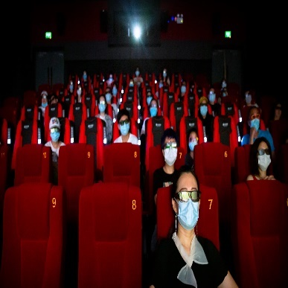
EU & UK cinema attendance gradually recovering: ticket sales up by 28% in 2021
On 15 february, the European Audiovisual Observatory published a report in the recovery of Cinema theatres in the EU27 + UK.
The report results represent a clear sign of recovery for the exhibition sector after the massive crush registered in 2020, when admissions in the EU and the UK nosedived by 70% in 2020 due to the coronavirus crisis.
In spite of the upswing, these figures are still well below pre-pandemic levels, as the prolonged closures of cinemas in the first half of the year, coupled with other restrictive measures, had a significant impact on the annual cinema attendance. Admissions for 2021 are still 61.9% below the figures registered in 2019, when cinema attendance in the EU and UK topped 1 billion admissions, representing a total loss of 623.5 million tickets. A similar decline on 2019 (-62.8%) was observed for the European Union only (EU27).
See the report here.

Study into French consumer sentiment of paid streaming services
A study by Whip Media surveyed nearly 3,000 consumers in France to understand consumer sentiment surrounding paid streaming in the market. The study found that Netflix is and remains the indispensable SVoD to 88% of French respondents and 76% of people surveyed said they would hold onto Netflix if they could keep only one streaming subscription.
Furthermore, the study found that French viewers are highly satisfied with streaming platforms that offer locally produced content. Netflix leads the market with 42 French productions that were available on the major international platforms as originals during Q4 2021.
Another interesting finding is that 56% of the respondents feel that there are too many SVoD platforms and therefore the costs are too high.
Read the full study via this link.

Events and Opportunities


Estonian Film Institute Distributes Over 1.5 m EUR in 2022 First Round of Project Support
The Estonian Film Institute (EFI) has distributed over 1.5 million EUR in the first financing rounds of 2022. Two feature films, Lioness by Liina Trishkina-Vanhatalo and Dog by Rasmus Merivoo, received grants in the total amount of 1.16 million EUR, which will be divided between 2022 and 2023.
In addition, the EFI supported four feature film minority coproductions with 410 000 EUR in total, two of them are Finnish, one Latvian and one a French coproduction. Minority coproduction grants were given to Estonian production companies to participate in international projects.
The grants were announced on 18 January. The second round of feature film production grants is on 26 April, with 834 000 EUR to be distributed. The second round for minority coproduction projects takes place on 13 September, with 190 000 euro to be given.
Find here all the 2022 funding deadlines.


Italy launches new production calls “Selettivi 2022”
Italy’s Minister for Culture Dario Franceschini announced the publication of calls for the production and promotion of film and audiovisual works for 2022 on the website of the Italian Ministry for Culture’s Film and Audiovisual Department.
42.3 million euros have been set aside to fund subsidies for screenwriting projects, projects in development and in pre-production, and film and audiovisual production, while activities and initiatives for film and audiovisual promotion are set to be shored up to the tune of 10.7 million euros.
The call “Selettivi 2022” will be decided into three sections:
- Script writing =1,2 million;
- Development and pre-production =3 million;
- Production = 38,1 million
Find here the deadlines:
- 1st sessione, 8 - 29 March 2022;
- 2nd session, 7 - 28 June 2022;
- 3rd session, 6 - 27 September 2022.
Funding requests can be submitted by public and private bodies, foundations, cultural committees and associations, as well as those involved in the promotion of film and audiovisual in Italy and abroad, universities and research bodies, and institutions offering higher education in the arts. Eligible projects will be awarded subsidies not exceeding 80% of their costs.

International Documentary Festival «Beyond Borders»: Call for submission open
The 7th International Documentary Festival «Beyond Borders», Castellorizo island, has the pleasure to invite documentary film-makers to submit their films from 2nd of January 2022 until 30th of April, 2022. The Festival’s objective is to promote the most important documentary productions worldwide that focus on history, culture, politics and other social issues.
«Beyond Borders» which takes place every year during the last week of August, will be held once again under the patronage of H.E. «Beyond Borders» includes a selection of Greek, European and worldwide productions of the last five years, workshops, parallel events and master classes. Find here the online submission form.

Interesting links

- [FR] NEW FRAMEWORK OF OBLIGATIONS TO CONTRIBUTE TO CINEMATOGRAPHIC AND AUDIOVISUAL PRODUCTION
- [RO] MODIFICATION OF THE AUDIOVISUAL AND CINEMATOGRAPHY LEGISLATION
- [DE] STUTTGART REGIONAL COURT: STATE MEDIA TREATY’S REGIONAL TV ADVERTISING BAN BREACHES EU LAW
- [DE] PROCEEDINGS OPENED AGAINST RT FOR BROADCASTING WITHOUT A LICENCE
- [DE] COURT RULES IN ARD’S FAVOUR IN CASE AGAINST BILD LIVE CONCERNING UNLAWFUL BROADCAST
- [DE] REMIT AND STRUCTURE OF PUBLIC SERVICE BROADCASTING TO BE REFORMED

