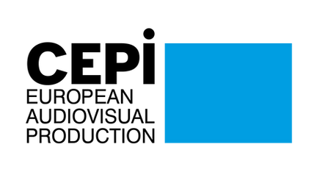
CEPI Newsletter
March 2022

Dear CEPI Members,
CEPI had a full month of March. Continuing to support the filmmakers community from Ukraine, CEPI carry on its effort to centralise information. We had the opportunity to exchange twice with Dariusz Jabłoński, President of the Polish Film Academy who coordinate the collection and transport of Material to film makers who are staying in Ukraine. CEPI also organised a meeting with all members, where we had the opportunity to hear directly from our Ukrainian colleague and exchanged on different initiatives and efforts you are all actively working on. Finally, the CEPI board is now meeting on a weekly basis to coordinate with KIPA in Poland and FIAU in Ukraine.
March was also the month of the Series Mania Festival in Lille. The CEPI team was present, and had the opportunity to meet some of you and follow some of the very interesting panels of the forum, as well as a speech from Commissioner Verstager. CEPI was also happy to organize and moderate a dedicated panel during the forum: I choose to stay independent, ask me why. With speakers from Brazil, France, the UK and Italy, the discussions looked into the fundamentals of what makes a producer independent, and how they carry on to support creativity and diversity despite many challenges.
On the policy front, the negotiations on the Digital Services Act are getting close to an end with the last trialogue meeting expected at the end of April. CEPI and other trade associations continue their effort to alert the negotiators on the importance of the text for right holders, especially to support the extension of the scope of the KYBC provision, and to avoid any loopholes in platform and search engine liability. In parallel, negotiators found an agreement on the Digital Markets Act few days ago. Once it gets the final agreement from Parliament and Council, the DMA will “ensure that platforms cannot unduly leverage their gatekeeping position from one service to another. Take, for example, a platform that is a gatekeeper for a core “marketplace” service. If this platform starts offering a streaming service as an additional ancillary service, it will not be allowed to combine the data generated on its marketplace with its new streaming service” explained Commissioner Verstager in Lille.
The Commission still hasn’t announced the next stakeholder dialogue on circulation and access of Audiovisual content. However, the European Audiovisual Observatory is expected to publish a new report on circulation of content which will show that Europeans have access to more content than ever.
CEPI has joined a new consortium to apply for a Horizon Europe project: Increase the potential of the international competitiveness of the European filmmaking industry. This project outcomes include knowledge on the needs and developments of the European filmmaking industry, innovative policy scenarios and tools, including digital ones; Increase further the competitiveness of the European filmmaking industry in the international arena, and provide evidence of the users/viewers preferences on filmmaking, as well as limitations to identifying their preferences, in order to widen and diversify audiences. CEPI’s work on the green project for sustainable production is also progressing, with the organisation of a steering group last week, and the preparation of two capacity building seminars in the coming month.
Until next month, we hope you will enjoy this edition of the CEPI newsletter.
Enjoy the reading!
The CEPI secretariat

Sections in this newsletter:
- Latest from the EU
- AV industry starting up again? & COVID impact on the sector
- Copyright
- Digital Services Act (DSA) & Digital Platform Regulation
- Territoriality
- AVMSD

- Piracy
- Business News: VOD
- Film and TV
- Festivals
- Recent studies
- Interesting links

Latest from the EU

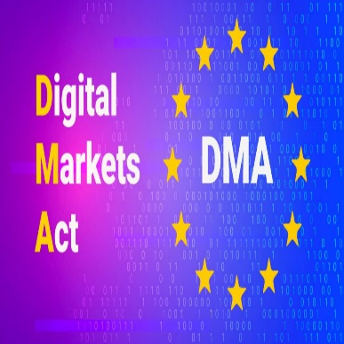
European Parliament and Council agree on the Digital Markets Act
On the 24th of March, the European Parliament and the Council reached a political agreement on the Digital Markets Act (DMA). The Commission welcomed the agreement reached. The DMA will introduce obligations and prohibitions to online gatekeepers in order to address unfair market practices or barriers to market access while ensuring the contestability of gatekeepers' digital services.
The text has been provisionally agreed by European Parliament and Council negotiators and targets large companies providing so-called “core platform services” most prone to unfair business practices, such as social networks or search engines, with a market capitalisation of at least €75 billion or an annual turnover of €7.5 billion. To be designated as “gatekeepers”, these companies must also provide certain services such as browsers, messengers or social media, which have at least 45 million monthly end users in the EU and 10 000 annual business users.
The political agreement is now subject to formal approval by the two co-legislators. Once adopted, the DMA Regulation will be directly applicable across the EU and will apply six months after entry into force.

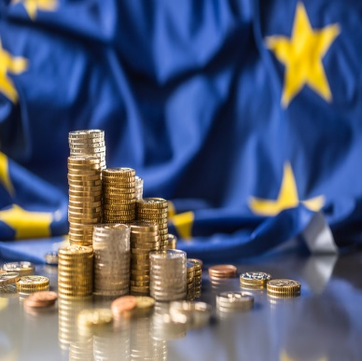
Council priorities for the 2023 EU budget
The Council has set its priorities for the 2023 EU budget, underlining its key role in the development and delivery of the long-term objectives and political priorities agreed by the Union, contributing to the recovery of the European economy in the aftermath of the COVID-19 pandemic. For the third consecutive year, the budget for 2023 will be reinforced by the funds from the temporary recovery instrument, Next Generation EU (NGEU). See all the priorities here.

SeriesMania Forum: Margrethe Vestager
At the SeriesMania Forum (24th March), Executive Vice-President for A Europe Fit for the Digital Age and Commissioner for Competition, Margrethe Vestager opened the LilleDialogues. During her speech, she emphasized the need for an open but fair audiovisual market, providing European actors with the resources they need to compete with the American giants.
In her speech she applauded the Digital Services Act as a vital tool to enhance liability of the online platforms:
“And then we have the Digital Services Act, which is also in its final stages of negotiation. Currently, platforms are setting the rules of content moderation, which they enforce without sufficient safeguards and transparency. The Digital Services Act will introduce clear due-diligence obligations when it comes to illegal content.
Our guiding rule is simple: what is illegal offline is also illegal online, and therefore needs to be addressed effectively. But the content moderation rules of platforms also need to have strong safeguards to protect the freedom of expression.”
Unfortunately, the Commissioner’s rhetoric does not match the reality. We know that the direction of the Digital Services Act has failed to live up to the expectation that what is illegal offline should be illegal online.
Commission approval of the German Motion Picture Fund according to EU state aid rules
Germany expressed its intention to support the production of feature films and television series from 1 January 2022 until 31 December 2023. By providing the German Motion Picture Fund (GMPF) with an estimated total budget of €150 million, the support will take the form of direct grants to producers and co-producers of certain feature films and TV series.
The GMPF falls under the responsibility of the Federal Government Commissioner for Cultural and Media Affairs. Its funds are available to producers and co-producers, with their domicile or a registered office in Germany, who have produced at least one film or TV series in the previous five years. Moreover, at least 40% of the total production costs must be spent in Germany.
Because of the scale of the scheme, the GMPF had to be assessed under EU state aid rules. The Commission approved it, considering that the scheme supports cultural works only, is not channelled towards specific production costs and respects aid intensity limits, in particular the 40% rule. It also concluded that the GMPF contributes to the promotion of culture without unduly distorting competition in the Single Market.
Ukrainian audio-visual sector call for a cultural boycott of Russia
As a response to the Russian attack, a group of prominent Ukrainian film-makers demanded a cultural boycott of Russia, saying that it would be “an attempt to cleanse the world of the propaganda of a terrorist state”.
Seven film-makers, including Roman Bondarchuk , Nariman Aliev, Alina Gorlova and Valentyn Vasyanovych, have each released statements outlining their support of a boycott as well as their criticism of Russian film-makers who are failing to oppose the attack on Ukraine.
In this cultural war against Russia, also the Ukrainian producer Denis Ivanov decided to join by sending an open letter about the boycott of Russian cinema and culture.
European Broadcasting Union suspends its Russian members
Russian Members of the EBU’s Executive Board have been suspended from serving in the governance groups.
In light of this decision, delegates from RTR, Channel One and RDO will no longer participate in the broadcast union’s Executive Board and all Statutory Committees. They had already indicated their intention to pull out of the organisation following the decision to exclude Russia from the 2022 Eurovision Song Contest.
Declaration of the European ministers responsible for culture and media on the situation in Ukraine
On the 7th and 8th of March, an informal meeting of EU Member States ministers responsible for culture and the media took place in France. During the meeting, the ministers adopted a declaration to express their support for Ukraine and its people, in particular its artists, journalists and professionals of culture, and the Ukrainian media. The informal meeting also provided the opportunity to reaffirm the ambition shared by all the EU Member States to take action at the European level to reinforce European policies to support the future of the media and the diversity of online cultural content. At last, they discussed the abundance of cultural content available online today. The ministers discussed ways to boost the discoverability of European cultural content, in terms of their availability online and how easily they can be found.
At the end of the meeting, the ministers adopted a declaration in front of some of the Commissioners, to express their support for Ukraine, in particular to its artists, journalists and professionals of the culture.

AV industry starting up again? & Covid impact on the sector

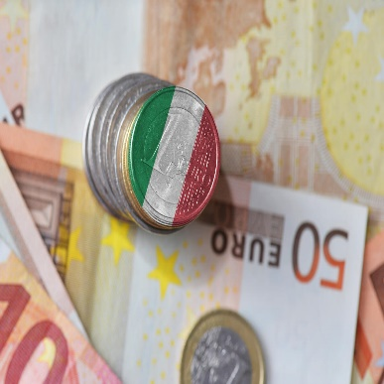
Italy pledges €53 million support for film production and promotion in 2022
Italian Minister for Culture Dario Franceschini has announced calls for film and audiovisual production and promotion proposals for the year 2022. 42.3 million euros have been set aside to fund screenwriting projects, projects in development and in pre-production, and film and audiovisual production, while activities and initiatives for film and audiovisual promotion are set to be shored up to the tune of 10.7 million euros.
Funding requests can be submitted by public and private bodies, foundations, cultural committees and associations, as well as those involved in the promotion of film and audiovisual in Italy and abroad, universities and research bodies, and institutions offering higher education in the arts. Eligible projects will be awarded subsidies not exceeding 80% of their costs.

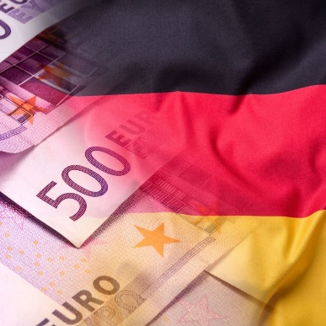
Germany's 2022 film support act has entered into force
In Germany, the new Film Support Act (Filmförderungsgesetz, FFG) has entered into force. The new ‘2022 act’ renews the 2017 FFG and only contains some minor changes. The act will remain in force until the end of 2023.
The new act extends the scope of responsibilities of the Film Support Agency (Filmförderungsanstalt, FFA). In addition to its existing tasks, the FFA will be required to ensure that film industry workers are employed under conditions that are both socially responsible and fair. It must also take into account the need to promote gender equality, the requirements of people with disabilities and diversity.
New provisions have also been introduced in response to the pandemic , in such cases, a film’s initial release or continued exploitation in cinemas can now be replaced with a premiere on paid video-on-demand (VOD) services if the film cannot be shown in cinemas throughout the country for a considerable period of time.
And last, the concept of an “equal state” is introduced: which is a non-member state that is treated the same as a member state under EU law in relation to film support. Switzerland, for example, as a non-EU member state, is already eligible to benefit from German film support, the new terminology does not change anything. These changes create the possibility for the UK to be treated as a ‘member state’ if it were to sign a similar agreement.

Norwegian Ministry of Culture grants 30 million crowns to help recovery of film industry
At the beginning of March, the Norwegian Ministry of Culture and Gender Equality granted an additional 30 million Norwegian crowns (€3 million) to help the recovery of the country’s audiovisual industry. The funds will be administered by the Norwegian Film Institute (NFI).
“The main goal of our pandemic-related measures has been to stimulate the sector and help future productions to be finalised with the right care and meet their audience. The Minister of Culture has now chosen to allocate a further 30 million to the Norwegian Film Institute, in order to help the recovery”, Kjersti Mo, director of the NFI said. She continued, “These funds give us room to implement new measures — in collaboration with industry players — so that Norwegian projects can position themselves internationally and be launched successfully, but they will also help attract people back to the cinemas.”
The funds will also help to compensate producers who incurred in extra costs as a result of increasing expenses and it will back stronger promotional campaigns to stimulate cinema going.
Report by Motion Picture Association: consumer spending on movies back at pre-pandemic levels
Consumer spending in the global entertainment market is back at pre-pandemic levels according to a new report by the Motion Picture Association. The global entertainment market consists of theatrical box office and home entertainment, which reached $99.7 billion during 2021.
​​In 2020, when the entertainment industry and world at large first began to grapple with COVID-19, consumer spending for theatrical and home entertainment sank to $80.8 billion, down 18% from the year prior. Now, consumption is closer to levels in 2019, when revenues hit a record $101 billion. That year was the first time in history the global entertainment market surpassed the $100 billion mark.
Even though the box office started to recover from the pandemic, most of the growth in revenue is coming from streaming.
Subscriptions to streaming services reached 1.3 billion globally, a 14% increase from the 1.2 billion in 2020. But that does not mean consumers gave up on more traditional viewing methods. When factoring in pay TV to theatrical and home entertainment, worldwide consumer spending reached $328.2 billion, matching 2019’s all-time high.
“As the Motion Picture Association marks its 100th anniversary this year, our latest THEME Report underscores how resilient and dynamic our industry is, and I couldn’t be more optimistic about the future of our business,” said Charles Rivkin, chairman and CEO of the Motion Picture Association.

Copyright


Italian Supreme Court interpreting the quotation exception in copyright law
In the framework of the “unauthorized quotation” exception recognized in article 5 of the InfoSoc Directive, the Italian Supreme Court (Cassazione civile, Sez I, No 4038/2022) decided that the exception cannot be applied for quotations reproducing the work in its entirety.
The case at stand concerned the unauthorized reproduction of thousands (24,000) of paintings of a well-known Italian artist in the context of an archiving project aimed at producing a catalogue of records held by a foundation initially established with the goal of maintaining and protecting the works of the now-deceased artist.
According to the CJEU interpretation in Pelham, there may be situations in which a work needs to be reproduced in its entirety to establish a 'dialogue' with the author. As such, the holding of the Italian Supreme Court that no full reproduction can ever be allowed is too trenchant and contrary to the required case-by-case assessment, as well as the principle – increasingly visible in CJEU case law itself – according to which exceptions are not just to be interpreted strictly, but are also to be interpreted in such a way that their effectiveness is guaranteed.

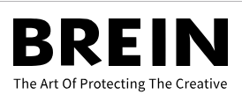
The Netherlands ensuring copyright protection through the Covenant
Copyright holders, represented by the Dutch Federation of Copyright Holders (Federatie Auteursrechtbelangen) and the BREIN Foundation, along with several Internet Access Providers (hereafter: the Parties) in the Website Blocking Covenant, reached an agreement on 25 October 2021. With the Covenant, copyright holders and Internet Access Providers are taking steps to work together to ensure the rights granted to copyright holders are guaranteed.
The Covenant fast-tracks the procedure to block a website that is hosting copyright-infringing content. The main goal is to lay down arrangements between the Parties on how to shape procedures regarding blocking orders, what they can expect from each other, and what the consequences for third parties are when a blocking order is granted by a judge. The Covenant is only applicable in cases in which the BREIN Foundation - whose objective is combating illegal websites and services- is seeking legal action against Internet Access Providers with at least 100,000 subscribers.

Digital Services Act and platform regulation

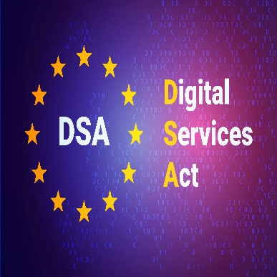
CEPI advocacy efforts before Political trilogue of the 31st March
Prior to the Political Trialogue on the DSA, CEPI reached out to the IMCO rapporteurs representing the parliament mandate in trialogue as well as the Deputy representatives of Member states in COREPER. Our demands stressed on the necessity to ensure effective removal of copyright infringing content online through effective Notice and Action rules under DSA, and avoid creating additional barriers for rightholders.
Considering the last changes of the negotiating text, CEPI highlighted three priorities:
- Create a new classification for Online Search Engines setting clear obligations. Considering Search Engines as caching or hosting intermediaries on a case-by-case manner as currently upheld within the parliament’s mandate, introduces a new layer of unclarity whilst eliminating incentives for these services to behave as diligent operators and delisting websites that could contain illegal content (copyright infringements and other content harming consumer safety). Our request founds the ground in the Commission non paper released on 23 March. (find here)
- Prevention and fast removal of illegal and unlicensed content should be the rule – not the exception. The Commission’s proposal to harmonise notice and action mechanisms in Article 14 fails to introduce a real outcome-oriented obligation to act for hosting services providers. In addition, “actual knowledge” and “acting expeditiously” should remain the key criteria for assessing liability under Article 5 of the DSA.
- Expand the scope of KYBC to all intermediaries and not simply to Online Marketplaces. This will allow the identification of fraudulent operators and prevent them to make infringing content available on different websites or mirror sites under a slightly different domain name.
While expecting the results of the dialogue, please find here a possible calendar of the DSA negotiations:
- March 31 - Political Trilogue
- April 1 - DSA Council WG group
- April 7 - Political Trilogue
- April 27 - Political Trilogue (TBC)

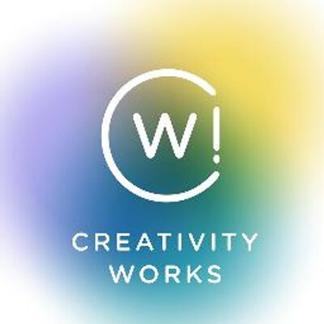
Creativity Works! Plenary meeting (17th March)
During the Creativity Works! Plenary meeting DSA key issues and updates were discussed. Moreover, after an initial internal discussion, Mr. Charles-Pierre Astolfi, cabinet member of France’s Secretary of State for digital issues, was invited to join the meeting.
Mr. Astolfi was asked to comment on some DSA key points:
- Trusted flaggers: the Council will be pushing for trusted flaggers as it is in its mandate. It is not a done deal yet with the European Parliament, but there is hope that “collective interest” will not be a criterion for entities to be awarded trusted flagger status.
- KYBC: it is not part of the Council’s mandate. Thus the margin of manoeuver is limited on the Council’s side despite a number of Member States being highly supportive of an extension of the scope. The Parliament needs to ask for an extended KYBC and make it a priority. If the Parliament pushes for it, only then can it be discussed again in the Council and be part of a revised mandate.
- Stay up and Notice & Action (Article 14.3.a.): the stay up provision could be removed;
- General monitoring: Mr Astolfi was optimistic about the points CW! made on the matter.
- Search engines: some countries are having second thoughts, while the Commission is trying to give options in order to overcome the gap between the Parliament and the Council.
- Subsidiarity: Mr Astolfi said that the French government is aware of our position on this topic.

MEPs letter on DSA
On 11th March, a group of MEPs sent a letter to the Parliament’s negotiators of the Digital Services Act expressing their concerns about the impact of the DSA on the EU cultural and creative sector.
In the letter, expressed reference was made to the notice and action, search engines and KYBC issues.

Territoriality

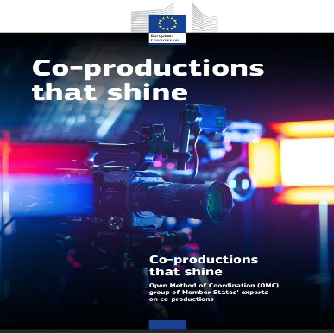
Co-Productions that shine: report on co-productions
The report published through the Open Method of Coordination (OMC) analyses cinematographic works covered by the revised Council of Europe Convention on Cinematographic Co-production and the organic forms of cooperation among EU-27 producers, notably in the field of TV series. Primarily addressed in this paper are policy-makers at the EU, national and sub-national level, as well as professionals working in the audiovisual industry. The members of this OMC group have formulated recommendations for an ecosystem that encourages co-productions among EU-27 countries, whose effective implementation will be instrumental in the transformation of the European ecosystem.
The report acknowledges the impact of streaming platforms on IP arrangements. Due to the limited bargaining power of European production companies, the common trend is the full attribution of IP rights to streaming platforms. The result of this trend is increasing market concentration in the audiovisual sector and hindering “the ability of the independent producers to recoup their investments and monetise their work on a long-term basis”. On the basis of this analysis, the report claims the need to “reaffirm the classic European model based on independent production companies owning the IP and exploitation rights in line with the territoriality principle”.

AVMSD


UK’s audiovisual competition authority issues guidance on on-demand ‘European Works'
In the United Kingdom, audiovisual regulator Ofcom has issued proposed guidance about how on-demand programme service (ODPS) providers should comply with new requirements concerning European works.
The proposed guidance reflects changes to the regulatory framework, effective since 1 November 2020, and will replace Ofcom’s existing guidance on European works obligations for ODPS providers. The regulatory change arises from the UK’s transposition of the revised Audiovisual Media Services Directive 2018 into UK law, pursuant to the terms of the EU Withdrawal Agreement.
Under the AVMSD, there are requirements on ODPS providers to ensure that in each year prominence is achieved with at least 30% of the programmes included in their services are European works. Since the UK is still part of the European Convention on Transfrontier Television of the Council of Europe (“the ECTT”) and thus UK productions still qualify as European works. For more information on Ofcom’s guidance we suggest the following article by the European Audiovisual Observatory.

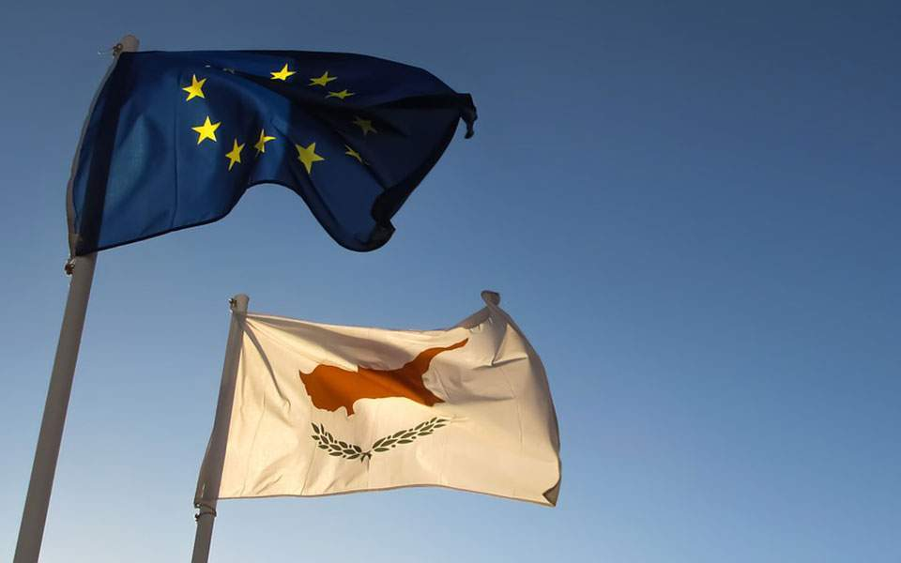
Cyprus transposes AVMSD into national law
Cyprus has transposed the AVMSD after having received a reasoned opinion from the European Commission in September 2021 for failing to implement the directive within the deadline. Cyprus was one of 9 MSs that received the reasoned opinion.
The Law amending the Law on Radio and Television Organisations that regulates licensing and the operation of commercial audiovisual media services and transposes the AVMSD in full.
The Radio Television Authority is defined as the national regulatory authority; a new section explicitly provides for its independence, as a “legally distinct and operationally independent from the Government and any other private or public body”. The Authority “acts impartially and transparently” and should not seek or receive any advice from any entity.
The following article in Lexology provides further information on the specifics of the Cypriotic transposition.

Slovenia: levies and Direct investment obligations for streamers
The Slovenian Ministry of Culture has opened a public consultation of the bill on the Slovenian Film and Audiovisual Centre. The proposal defines extra-budgetary resources for financing audiovisual activities, raises funds for the promotion of film and AV production, changes the support system, determines the new assembly of the Slovenian Film Centre's (SFC) council, and proposes that the public institution FS Viba film should merge with the SFC.
Uršula Menih Dokl, General Director of the Media Directorate, explained that the purpose is to increase the accessibility of Slovenian and European audiovisual works, and to provide a foundation for the development of the sector. The Slovenian Film Centre should become a more modern, flexible and autonomous institution, that could adopt medium-term strategies, while its director and programme council would have more powers.
At this point, it is unclear when the law will be submitted to the Slovenia parliament.
Spanish AVMS providers must comply with diversity quotas
Audiovisual media service providers must comply with the quotas established in the Law on General Audiovisual Communication. That is what the Spanish National Markets and Competition Commission (CNMC) said in their annual audit. The quotas are 5% of profits from the previous year for providers and operators of services of a private nature, and 6% for those of a public nature.
The CNMC has issued a report comprising of the performance of 21 service providers. They commission states that a total of 15 service providers have complied satisfactorily with the quotas, two have registered small deficits in some of the categories (Veo TV and Atresmedia), one has requested the transfer of these obligations to the following year (Cineclick), one has not exceeded the obligations imposed (The History Channel) and, finally, two of them have not been considered as obligated service providers given that they have not broadcast audiovisual works that are less than seven years old (13TV and Ten Media). In contrast to the analysis for the previous year, none of these service providers exceeded the established quotas.
Spanish consultation labels streamers and vloggers as Audiovisual
In Spain, the National Markets and Competition Commission (CNMC) published a consultation on a draft communication that will clarify criteria for who can be considered an audiovisual media service provider. In the draft criteria they explain that they believe that streamers and content creators that offer their work in Spain using video-sharing platforms, such as YouTube or Twitch, could be considered audiovisual media service providers. In such a case, these creators, or so-called vloggers, would have to comply with the requirements set by the General Law on Audiovisual Communication.

Piracy


Fight against illegal streaming in Singapore
The Singapore High Court has granted an Order to block 30 illegal streaming sites and almost 150 associated domains responsible for the distribution of considerable quantities of illegally streamed content in Singapore.
Under the Order, Internet Service Providers must disable access to these illegal sites and their associated domains, also informing consumers that the sites are illegal. The Order covered the greatest number of sites and domains yet sought by Asia Video Industry Association’s Coalition Against Piracy (CAP) member, and the CAP also welcomed the ongoing ability and willingness of Courts in Singapore to take action against illegal streaming sites.
A recent study on the online content viewing behaviour in Singapore, commissioned by CAP and conducted by YouGov showed that blocking sites is effective with the percentage of Singaporean consumers accessing illegal streaming sites and using illicit streaming devices (ISDs) dropping in recent years. Moreover, a new study commissioned by CAP “Time to Compromise” showed that a typical user visiting illegal streaming sites could be infected by ransomware, several trojan horses, and other Advanced Persistent Threats (APTs) within 42 seconds on a Windows machine, and 78 seconds for an Android device.


High Court in London granting permission to Hollywood and Netflix to block several pirates sites
In December 2021, the High Court in London allowed the Motion Picture Association (MPA), which includes the major Hollywood studios and Netflix, to block dozens of additional pirate sites (find the decision here). The long list includes torrent sites TorrentGalaxy, Zooqle, TorrentLeech, MagnetDL and GloTorrents, plus a selection of unblocking portals and release blogs/DDL sites.
In the UK it’s possible for copyright holders to obtain High Court injunctions to have pirate sites blocked by major internet service providers including BT, EE, Plusnet, Sky, TalkTalk and Virgin Media.
The list includes TorrentGalaxy ( 17 million visits per month),covering its three domains (torrentgalaxy.to, torrentgalaxy.mx and torrentgalaxy.su) and additional domains; Zooqle (zooqle.com), a torrent search engine and indexer with 5 million visits per month; MagnetDL (magnetdl.com, magnetdl.org), another pretty big player with an estimated 6 million visits per month; the private torrent tracker TorrentLeech (torrentleech.org); and GloTorrents (glodls.to, gtdb.to) whose 30% of its traffic is from the UK (1.3 million visits per month). Several so-called DDL sites domains are also present in the latest injunction including rlsbb.ru, rlsbb.to rlsbb.com, releasebb.net, proxybb.com and tfp.is. Finally, the order(s) also cover the main domain and dozens of sub-domains of mxdcontent.net.

MPA fight against piracy
Jan van Voorn, MPA’s executive vice president and chief of global content protection, claims to protect the legitimate content creators, big and small, and keep the marketplace clean.
In 2021, from 1,400 illegal platforms in North America, the antipiracy campaigns were able to reduce that number to 238. Taking down the intermediaries has been demonstrated to be very effective.
Since the formation of the Alliance for Creativity and Entertainment (ACE) - a coalition of high-impact global companies cooperating to drive traffic to legitimate content platforms- in 2017, the efforts have been increased.
Nitro TV piracy case law
Pirate IPTV service Nitro TV was sued by DISH Network in 2021 for mass violations of the Digital Millennium Copyright Act (DMCA) anti-circumvention provisions and breaches of the Federal Communications Act. Nitro TV's operators could face a damages award of $100m and that's with DISH significantly lowering what it says it is entitled to claim under the law.
In April 2020, a coalition of entertainment companies led by Universal, Paramount, Columbia, Disney and Amazon filed a copyright infringement lawsuit against the operators of ‘pirate’ IPTV service Nitro TV. While this case is still ongoing, a second lawsuit from broadcaster DISH Network has been filed in August 2021, complaining that the defendants received millions of dollars in exchange for subscriptions to their pirate service.
The defendants failed to respond in court, meaning that the case is now moving towards a significant default judgment in favor of the plaintiffs.
The motion for default request that since “the account records provided to Plaintiffs show that Defendants sold at least 100,363 Device Codes, statutory damages should be awarded in the amount of $100,363,000 (100,363x $1,000), jointly and severally against Defendants.” The defendants also received subscription payments via Facebook Pay, Coinbase, and Paymentech but these were not included in the claim since the plaintiffs couldn’t determine exactly how many subscriptions were involved. What they could establish is the amount of money Alejandro and Martha Galindo received into their bank accounts – a total of $5.5 million across two accounts at Wells Fargo and Chase.

BUSINESS NEWS: VOD


Amazon acquisition of MGM
The European Commission has approved unconditionally, under the EU Merger Regulation, the proposed $8.45 billion acquisition of MGM Holdings Inc. by Amazon.com Inc. The acquisition of the nearly century-old studio—with more than 4,000 film titles, 17,000 TV episodes, 180 Academy Awards, and 100 Emmy Awards— will make Amazon a more formidable streaming competitor. The acquisition passed also the US competition check receiving the green light from the Federal Trade Commission.
At the moment, Amazon has not revealed a reporting structure but in the case that the senior team of MGM will stay this could be helpful to Amazon to bolster its content — however many don’t believe the studio has a long path ahead as a separate, influential entity. Even if MGM functions autonomously within Amazon, the question of distribution remains unclear.
Analysts expect the tech company to try and exploit MGM’s best-known pieces of intellectual property for future gain. By obtaining the intellectual property of big titles, Amazon is trying to bolster its reserves of intellectual property to take on Disney and other streaming services that have deep catalogues of video games, movies, and TV. Many believe that the production of TV shows and other ancillary properties would unlock the true potential of the big titles.
Beyond Bond, there are other ways that Amazon can exploit this deal. Peter Newman, head of Tisch School of the Arts’ MBA/MFA program at New York University, suggests that the MGM library will be used to drive Amazon’s broader relationship with consumers.
Amazon's purchase of MGM could exacerbate the recent shift towards streaming production. John Fithian, the head of the National Association of Theatre Owners (NATO) defined the acquisition as a "potential harbinger of the impact of big tech." The fear among exhibitors is that Amazon would debut MGM's recent movies simultaneously, or even exclusively, on Prime Video. The company has been aggressive recently in buying movies with commercial appeal, like "The Tomorrow War" and "Without Remorse," both of which it released exclusively to Prime Video.
Finally, a reflection in terms of variety of content. By acquiring intellectual property of big titles, it is quite predictable that Amazon will produce tv shows of well-known stories. However, while consumers may enjoy this kind of spin-off, the market will lose variety and production of new stories.

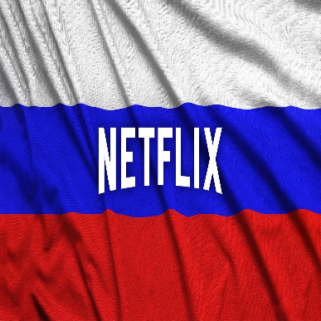
Netflix withdraws its “nonpartisan” position on Ukrainian conflict
In the face of a growing public pressure asking Netflix to adopt a coherent stance on Russia, the US streamer dialled down its involvement in the Russian TV and film market. The twitter hashtags #netflixstopsupportingrussia and #CancelNetflix had attracted thousands of retweets in the previous days, attacking the initial decision of Netflix to adopt a “nonpartisan” position.
The decision led to the discontinuation of the four Russian-language series (including “Anna K” and “Nothing Special”) that had been in either production or post-production until further notice.
On 28th February, Netflix already refused to comply with the so-called Vitrina TV Law, which would force "audiovisual" firms to carry at least 20 state-supported channels. Netflix’s opposition to Russia’s attempts to use it as a platform for carrying state-supported content has been applauded by some Western politicians, such as by EU Internal Market Commissioner Thierry Breton.

The launch of Viaplay in the Netherlands
Viaplay has launched in the Netherlands with a unique combination of premium live sports, Viaplay Originals, Hollywood films and series, and kids content.
The service comprises a single package with an introductory price of €9.99 per month (rising to €13.99 per month in August) and it is available through distribution partners KPN, VodafoneZiggo, T-Mobile Netherlands and Delta Fiber, and as a direct subscription. The launch takes Viaplay’s footprint to 11 countries, with at least five further markets – UK, Canada, Germany, Austria and Switzerland – to follow by the end of 2023.
All Viaplay Originals and international content have Dutch subtitles, and all kids content has Dutch dubbing.In the Netherlands, Viaplay is supported by a wide range of devices and platforms (including smart TVs, iOS and Android smartphones and tablets, Chromecast and Apple TV, Amazon Fire TV, and PC and Mac).
NENT Group notes that around 48% of the Netherlands’ 8 million households have a video streaming subscription, with approximately 1.6 subscriptions per streaming household. In 2025, streaming penetration is expected to increase to 66% and the number of subscriptions per streaming household to 1.9. Almost all (98%) of households in the Netherlands have a broadband connection.
Ad-Supported subscription offer on Disney+
Disney announced the introduction of an ad-supported subscription offer on its Disney+ streaming service in late 2022. The ad-supported offering is seen by the company as a “building block” towards the long-term target of 230 million–260 million Disney+ subscribers by FY24. Kareem Daniel, Chairman, Disney Media and Entertainment Distribution considers the expansion of the access of Disney+ as “a win for everyone—consumers, advertisers, and our storytellers".

Cinema & TV


Italy extends the 90-day theatrical window to all films
The Italian government has signed a law that will extend the existing 90-day theatrical window for Italian films that had benefitted from government subsidies to now include all films, regardless of where they are produced or how they are financed.
Netflix will thus have to deal with a different situation from the one that has allowed, even recently, to offer its titles for short periods on the big screen before a streaming debut after a few days or a couple of weeks.
Dario Franceschini, Minister of Culture, also underlined that it is necessary to increase the number of spectators.
The president of the Union of Italian cinema executives (UECI) strongly criticized the new law. Cinemas indeed have been heavily impacted by the pandemic and its following restrictions (it is still mandatory to present the Covid pass and wear the masks) and the 90-day theatrical window is very below the proposed 150-day of the previous minister.

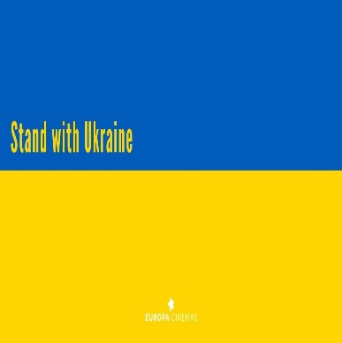
European film industry response to Russian invasion
Europe’s film industry has adopted different approaches regarding the request for a boycott on Russian cinema in order to express solidarity with the Ukrainian film community.
While some film festivals, such as Stockholm and Glasgow, haven’t hesitated in boycotting Russian state-funded films outright, others like Cannes and Venice are taking a more nuanced approach, banning official delegations, but not necessarily Russian films and directors. The immediate and general effect has been an increase in terms of visibility of Ukrainian cinema in the festival arena and beyond.

Box Office: The Batman
The Batman earned $21.6 million on Thursday (3th March) previews, achieving the second-best pre-show opening of the pandemic era — Marvel’s “Spider-Man: No Way Home” still holds the record with its $50 million Thursday debut in December. “The Batman’s” Thursday haul also beat pre-pandemic openings by DC Comics’ “The Joker” ($13.3 million), “Aquaman” ($13.7 million) and 2016’s “Suicide Squad” ($20.5 million). “The Batman” represent a big bet for Warner Bros. and its DC Films division. The production cost $200 million, without including $10 million more in marketing and distribution costs. So far, “The Batman” has generated $332 million in North America and $672 million globally.
CineEurope awards
CineEurope has named Steve Knibbs, COO of VUE International, as the 2022 recipient of the “International Exhibitor of the Year” award and Anna Marsh, CEO of STUDIOCANAL (a CANAL+ Company) for the “International Distributor of the Year” award. The CineEurope Awards Ceremony will take place on Thursday 23 June, at the Centre Convencions Internacional Barcelona (CCIB) in Barcelona, Spain.
Releasing of covid-restrictions in France
From the 14th of March, the covid-pass was not required anymore at cinemas. Since the 28th of February, cinemas were already not subject to the obligation of wearing masks.
In-depth assessment of the TF1-M6 merger
On the 18th of March, the French competition authority decided to continue probing the merger between French broadcasters TF1 and M6 by opening a so-called Phase 2 investigation. The main concerns regard the possibility that the group resulting from the merger would “indeed hold sometimes significant market shares” in sectors including the acquisition of broadcasting rights for audiovisual content, publishing and marketing of television channels, distribution of television services and advertising.
The French watchdog will look into whether competition from digital giants should be taken into account when assessing the possible anti-competitive effects of the tie-up, as suggested by TF1 and M6.
Renewal of the partnership between Europa Distribution and Cartoon Movie
Europa Distribution renewed its collaboration with Cartoon Movie for the 13th year in a row. This partnership aims to facilitate access for independent film publishers and distributors to the most important market and pitching event dedicated to European animated films. It is also an important opportunity for the European Network to focus on its members' release strategies, promotional campaigns and innovative projects, in this case with a focus on animation.
During the event (8-10th March) case studies on recent European and international animation films released by Europa Distribution's members in diverse European countries have been analysed.

Festivals

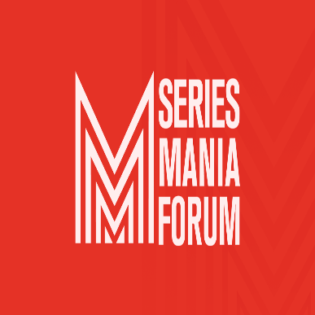
I choose to stay independent, ask me why
At Series Mania, CEPI led a lively discussion on what it means to be independent with a panel of independent producers. Caroline Benjo – producer at Haut et Court TV, Tiago Gomes Mello – executive producer at Boutique Films, Odile McDonald – producer at Wildcats productions, Tim Mutimer – CEO of Cineflix Inc. and Carlotta Ca’Zorzi – Head of business and legal affairs at Fandango SPA, with Mathilde Fiquet from CEPI as moderator, exchanged in a passionate discussion on the role of independent producers in today’s market where big players and consolidation bring opportunity but also a lot challenges.
Each of them had different views about what it means to be an independent producer, but also a lot of convergence, especially around the importance of creative freedom, ability to choose and develop projects, and owning the IP of their work. But being independent nowadays comes with challenges, especially when having to negotiate with large financial players and their demands.
While there is a growing demand for content, producers feel the increasing reticence of larger players to take risks in investing in new and different projects. This contradiction is de facto outsourcing the risk to producers, said Caroline Benjo. Innovation in creation is often the result of independent producers' balder projects, and their courage to experiment new ideas and possibly fail: successes may arrive but not without trying again and again.
The presence of larger players able to connect us to a global audience is also an opportunity, says Tiago Gomes Mello, as it gives producers the opportunity to join projects from other side of the world, which would have been almost impossible before. Securing talents has also become a challenge. In such a high demand market for AV content and shortage of creators and crews, production costs are rising. The arrival of global streamers has been a huge opportunity for producers in Europe; however, such large players can have an easier life securing collaboration with talents to prices that independent producers are not able to afford, pointed out Carlotta Ca’Zorzi.
How can independent producers prevail in the face of these challenges? Does Europe need to have clearer and protective legislation on independent production?
Odile McDonald highlighted how independent producers secure opportunities via their networking and nurturing relationship with consolidated partners. Financial capacity isn’t the only way to find co-production and distribution partners. Network is important, confirmed Tim Mutimer, adding that a distributor like Cineflix can accompany producers from the beginning of a project, with financial investment, as well as in helping producers negotiate with other partners in an independent way. While vertical integration of players is building up, horizontal collaboration, such as with networks of producers from different countries, can be an efficient tool enabling producers a better leverage in negotiations, in securing talents, and access funding, Caroline Benjo explained, with the example of the network The Creatives.
Consolidation is also a growing trend for production companies, which comes at a certain cost for their independence. But market driven solutions may not be enough. The panellists agreed that more legislative and funding efforts should be made by institutions to create a level playing field and preserve independent producers and their creative added value.
The Audiovisual Media Service directive surely is a first step in the right direction, enabling EU member states to impose investment obligations to online players towards creation. This is a positive trend showing the presence of a political ambition to maintain a vibrant local creative sector, which needs to be broadened all across the EU. Odile McDonald held the last word of the discussion: Diversity, the reason we all fight to keep independent producers thriving.

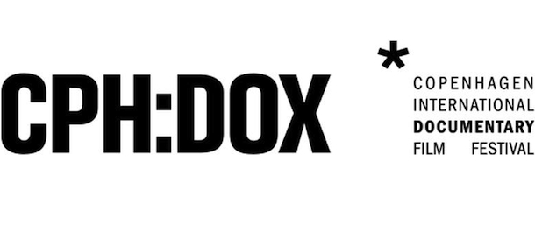
Copenaghen International Documentary Film Festival
Ukraine and Russia are high on the agenda at Copenhagen International Documentary Film Festival (23 March - 3 April). Indeed, among the dozen documentaries that are competing for the top prize in the main Dox: Award competition, a quarter of them were shot in Russia and Ukraine.
Moreover, the program reflects strict gender parity with 50% of the films directed or co-directed by female directors. The selection includes films by established, award-winning directors as well as new voices across the five competitions.
The conference program, known as CPH:CONFERENCE (running online and in-person between March 29 and April 1), is presented in partnership with the training initiative Documentary Campus. According to the programme the morning has been devoted to “storytelling, craft, and creative dilemmas of documentary filmmaking at the intersection of art, science and society,” while the afternoons have “given access to unheard voices and explore new strategies for the documentary community.” On the 29th, the themes of ownership of the story and creative collaborations have been addressed. On the 30th, new opportunities for film funding have been explored. Metrics of success and sustainable careers, including basic universal income for artists and other bold ideas, have been discussed by filmmakers and industry representatives on March 31. Finally, a special program on March 31 has explored the art and impact of climate storytelling.

Cannes, Venice and Toronto Film Festival position on Russian films
Following the statements of Cannes Film Festival and Venice Biennale, the Toronto Film Festival (FITT) declared it will not ban Russian filmmakers or their films this year, as long as they are opposed to the current regime in the country. However, the festival will not accept the presence at any of its events of official delegations, institutions or persons tied in any capacity to the Russian government.
The festivals reacted to a call from the Ukrainian Film Academy for a widespread boycott of Russian cinema in response to Vladimir Putin’s invasion of Ukraine.
A female presidency at the Cannes Film Festival
At its meeting on the 23 of March, the board of Directors of the Festival de Cannes elected a female executive for the first time ever. Iris Knobloch, former boss of WarnerMedia France, Germany, Benelux, Austria and Switzerland, will succeed Pierre Lescure. She has been pushed forward by high-profile figures within the French government, including the culture minister Roselyne Bachelot and Dominique Boutonnat, the president of the National Film Board.
Although presiding over Cannes is more of an honorary role than an operational one, it requires special skills to navigate the inner politics of the festival and work smoothly alongside Thierry Fremaux, the event’s artistic director and general delegate, on top of helping secure new sponsors.
Dates and links for upcoming festivals
April
- Canneseries, France – April 1-6, in-person
- MIPTV, France – April 4-6, in-person
- Diagonale, Austria – April 5-10, in-person
- Visions du Réel, Switzerland - April 7-17, in-person
- Istanbul Film Festival, Turkey – April 8-19, in-person
- Far East Film Festival, Italy – April 22-30, in-person
- IndieLisboa International Film Festival, Portugal – April 28-May 8, in-person
May
- Beldocs International Documentary Film Festival, Serbia – May 11-18, in-person
- Cannes Film Festival, France – May 17-28, in-person
- Nippon Connection Film Festival, Germany – May 24-29, in-person
- Docaviv, Israel – May 26-June 5, in-person
- Krakow Film Festival, Poland – May 29-June 5, in-person; June 3-12, online
- Monaco Streaming Film Festival, Monaco – May 31-June 2, in-person

Recent studies

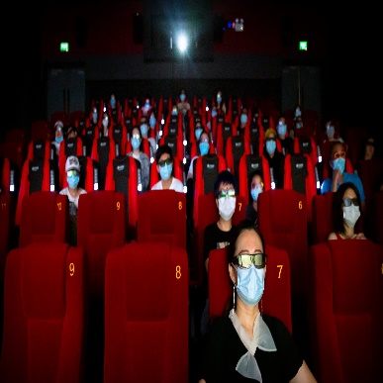
Report on Fiction film financing in Europe: average film budget in 2019 was €2.07
Mid-March, the European Audiovisual Observatory released a report called “Fiction Film Financing in Europe”.
This new report finds that:
- The median average budget of a European theatrical fiction film released in 2019 was EUR 2.07 million.
- The largest financing source was clearly direct public funding which contributed 28% of the total financing volume, followed by producer investments and broadcaster investments, both of which accounted for 18% of total financing.
- The percentage share of direct public funding in film financing decreases with increasing market size and budget volume.

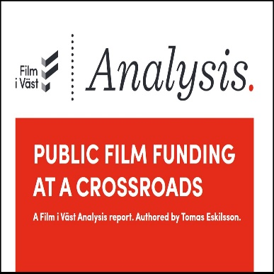
Film i Väst publishes report on public funding for film
Sweden’s Film i Väst published a study titled “Public Film Funding at a Crossroads”. The report comes at a time during which film policy and its current practices in Europe are under pressure and digitalisation has brought about radical changes in the physical methods through which films are made, circulated and are consumed.The study identifies the main challenges affecting public film funding, but also provides a series of recommendations to guide the actions of industry players and policy makers.

France produces the most feature films ever in 2021, according to CNC report
After a year marked by lockdowns and COVID restrictions, the volume of French productions surged by 43.5% in 2021, with 340 films made after widespread postponements in 2020, according to a report unveiled by the CNC (National Film Board).
Starting on page 50 of the report, the CNC also discusses the impact of COVID on distributors.
Read the full report by the CNC here.
Theatrical releases continue to deliver at the box office
Net theatrical revenues for six US studio groups reached nearly $2.4 billion (€2.1bn) in 2021, down at half of the value Ampere estimates could have been achieved pre-pandemic. That is the outcome of research by an Ampere report published this week.

Interesting links

- Prime Video commits £10m for UK training and development
- 2022 EE British Academy Film Awards: The Winners

