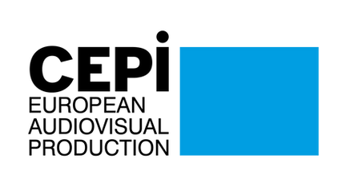
CEPI Newsletter
April 2022

Dear CEPI Members,
CEPI continued its efforts during April, and saw the conclusion of several policy files. On 22 April the European negotiators involved in the trilogue reached a political agreement on the Digital Service Act. This agreement is the outcome of CEPI’s effective advocacy work during the past year, as the text has been successfully rebalanced to ensure that new rules for the removal of copyright infringing content will remain clear and aligned with the copyright directive as well as national laws, both CEPI high priorities. However, some of the other policy aspirations of CEPI have not been considered by the negotiators by the end of the technical review.
Once the agreed upon text is reviewed by the legal department, the final version will be made public and submitted to vote in the European Parliament and adopted in the Council. The new rules will become applicable 15 months after its entry into force. More detailed information is available in the DSA section of this Newsletter .
The Copyright Directive is yet to be implemented in many member states but the court of justice of the EU has confirmed the legality of article 17. On the 26 of April, the Court confirmed that article 17 of the Copyright Directive provides a “fair balance” between the right to intellectual property and freedom of expression. The Polish government had complained that the new provision adopted in 2019 infringed on the fundamental right of freedom of expression. Find more below.
On 13 of April, CEPI welcomed a new study published by the European Audiovisual Observatory analysing the level of circulation and availability of Films across Europe. According to the study, 8.500 European films are available on VOD platforms in their countries on average. In addition, a rapid increase of films available during the last decade can be observed, thus confirming that the current model in place based on territorial licensing can provide consumers with wide access to titles. CEPI, in coalition with other associations representing the European creative industry, welcomed these findings and has encouraged the commission to include them in the conclusions of the stakeholder dialogue initiated in December, in support of the arguments already brought forward by the industry. Find an article in the territoriality section of this newsletter.
Last but not least, this month CEPI’s Secretariat is working on the preparation of the many meetings and events programmed during the Cannes Film Festival. Do not forget to register to CEPI’s General Assembly (22/05, 10:30-12:30), which will be followed by a conference at the Stand of Le SPI in the afternoon (more information soon).
In addition CEPI will participate as a guest speaker in the European Audiovisual Observatory on 23 May and a joint industry conference on the 24.
Please check the events section for more details.
We look forward to seeing you all in Cannes.
Enjoy the reading!
The CEPI secretariat

Sections in this newsletter:
- Latest from the EU
- COVID impact on the sectorAV industry starting up again? &
- Creative Europe
- Copyright
- Digital Services Act (DSA) & Digital Platform Regulation
- Territoriality

- AVMSD
- Piracy
- Business News: VOD
- Film and TV
- Festival
- Recent studies

Latest from the EU

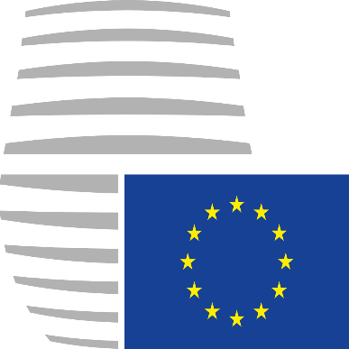
Building a European Strategy for the Cultural and Creative Industries Ecosystem - Council Conclusions adopted by EU Member States
On 4 April the Ministers of the EU Member States who are responsible for audiovisual policy adopted Council Conclusions on “Building a European Strategy for the Cultural and Creative Industries Ecosystem.”
In the following themes the Conclusions support our efforts:
- Improving access to funding
- “Facilitate access for CCIE enterprises, in particular independent companies, including the smallest ones, to public and private funding schemes, loans, guarantees, risk capital solutions and equity finance, taking into account the specificities of these businesses, and simplifying procedures.”
- Maintaining territorial exclusivity:
“particular regard should be given in the audiovisual sector to co-productions and to the territoriality of rights, which are key to the sustainable financing of the sector and to distribution strategies.”
- Promoting discoverability tools:
- “Promoting strategic approaches on the online discoverability of European cultural content in all official EU languages, and in particular of independent works, building where appropriate on strong synergies with Europeana, Agorateka, the ERGA, Eurimages and the European Audiovisual Observatory.”
- “Developing a better understanding of the role of recommendation algorithms in promoting European works and reflecting on their transparency; and if appropriate proposing courses of action notably on standardisation, the provision of metadata, interoperability, and tools to facilitate audience access;”
In particular, the strong wording on territorial exclusivity and promoting discoverability tools is extremely important in the ongoing Stakeholder Dialogue with the European Commission.
Find here a link to the Conclusions.

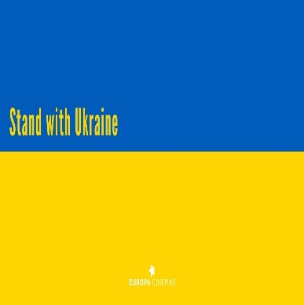
Support for Ukrainian Film professional
CEPI continues standing alongside Ukrainians and Ukrainian Film Makers. CEPI is collecting, centralising and communicating to FIAU in Ukraine all the points of contacts established in each country to support.
Please communicate with us any central point of contact you may have established in your country to provide support and any other initiatives, which we can share with FIAU.
This support includes:
- providing a single point of contact in your country for film workers fleeing Ukraine
- providing shelter and accommodation
- Providing assistance in formal matters and administrative procedure for their stay in the country (The EU has adopted the temporary protection directive providing Ukrainian refugees with residence permits for at least one year, with a simplified procedure)
- Providing guidance to producers on how to employ Ukrainian film workers
- helping put into contact Ukrainians film workers and producers
In addition, our colleagues at KIPA, in Poland, are coordinating with the Polish Film Academie, to collect and send material to Ukraine. The list of material needed is in constant changes, but they are currently in urgent need of the following for the people who stayed in Ukraine:
- Professional or semi-professional reporters equipment (cameras, hard-drives, memory cards, used or new MacBooksAir for copying and editing, etc)
- Life-saving amenities (kevlar helmets, bulletproof vests, personal first aid war kits, walkie-talkies)
If you have the ability to send this material (as many as possible and as soon as possible), please contact the Polish Film Academy at +48 691 267 771
Please find attached an CEPI's note providing information on the needs of their Ukrainian counterparts and on various initiatives that can be developed at national level to provide support and assistance.
Also attached the initiatives available in Italy and Portugal.

Film industry reaction to the Russian attack on Ukraine
Below there is an overview of the reactions from film professionals that have been pouring in since the beginning of the invasion:
- EFP (European Film Promotion) is also offering promotional support for finished and unfinished films from the Ukraine via its initiative, Film Sales Support (FSS) (read more).
- Ukrainian media companies launch a $20 million content fund to help the country’s TV industry (read more).
- the "Emergency Fund for Filmmakers" has already supported 108 filmmakers who are in direct danger because of the ongoing war in Ukraine (read more).
- The Italian Minister of Culture, Dario Franceschini, has signed a decree that allocates 2 million euros to 20 Italian cultural foundations for the realization of artistic residences for Ukrainian artists in their respective sectors of activity: theater, cinema, visual arts, opera, dance, museology (read more).
- CinEast4Ukraine: CinEast supports the victims of the war in Ukraine with a special charity screening of The Earth Is Blue As An Orange (read more).
- The FIAPF (International Federation of Film Producers Associations) announced that the Moscow International Film Festival and Message to Man International Film Festival have had their accreditation paused “until further notice.”
- Sergei Loznitsa is expelled from the Ukrainian Film Academy.
- Four short films made by Mariupol locals are available worldwide on Ukrainian VOD platform Takflix, with 50% of proceeds going to Mariupol City Council and its humanitarian missions (read more).
- Bif&st-Bari International Film Festival will confer the Federico Fellini Award to the filmmakers of Ukraine (read more).
- CPH:DOX stands with Ukraine In solidarity with Ukraine and its filmmakers. The festival adds three Ukrainian films to this year’s programme, and hosts a dedicated programme of seven powerful films focusing on Ukraine (read more).
- The Berlinale takes a clear stand against a general boycott of cultural works on the basis of their origin (read more).
- The Molodist Kyiv International Film Festival has published an open letter to the film industry calling for the boycott of Russian cinema (read more).
- French filmmakers Nicolas Blies and Stéphane Hueber-Blies, have sent an open letter supporting Ukrainian filmmakers and calling for a boycott of Russian cinema (read more).
- The Sarajevo Film Festival adds Ukraine to its regional programmes (read more).
- Filmmakers for Ukraine is a place of help for filmmakers and their families and minorities in and from Ukraine (read more).
- The Tallinn Black Nights Film Festival (PÖFF) will present Ukrainian projects in Cannes this May and launch a film programme dedicated to Ukrainian cinema on its web cinema platform (read more).
- The Slovak Film Institute strongly condemns the Russian Federation's aggression against Ukraine's sovereignty and expresses solidarity and full support for its people and takes several steps against Putin's government and in support of the Ukrainian filmmaking community (read more).
- The International Coalition for Filmmakers at Risk (ICFR) launches "Emergency Fund for Filmmakers" in the wake of the Ukraine war (read more).
- Netflix has announced that it will halt its services entirely in Russia amid ongoing concerns over its invasion of Ukraine.
- Europa International stands in solidarity with the Ukrainian people, and its members will put on hold further business with Russia as the war rages on (read more).
- The Polish Film Institute supports Ukrainian filmmakers with the creation of a fund to promote Polish-Ukrainian film and cultural initiatives, publishes jobs ads under their "Help for Ukrainian Citizens" tab and offers office space, legal assistance (read more).
- Ukrainian producer Denis Ivanov sends an open letter to ask for support of the boycott of Russian cinema and culture (read more).
- The Stockholm International Film Festival stands with Ukraine and announces the country as the centre of this year's edition's focus (read more).
- The Festival de Cannes (read more) and la Biennale di Venezia (read more) decided that they will not welcome official Russian delegations nor accept the presence of anyone linked to the Russian government.
- The Estonian film industry calls for a boycott of films from warring Russia and Belarus (read more).
- The European Film Academy (EFA) has issued "an unequivocal condemnation" of President Putin’s invasion of Ukraine, excluded Russia from the European Film Awards and joins the Ukrainian Film Academy in a boycott of Russian films (read more).
- The members of the Ukrainian Film Academy, on behalf of the society of Ukrainian film professionals and cultural figures, call for a boycott of Russian cinematography (read more).
23 co-productions supported by the Eurimages Fund
After the first project evaluation session of 2022, the Executive Committee of the Eurimages Fund has decided to support 23 feature films, including 7 documentaries and one animation, for a total amount of €5.516.000. Projects with female directors represented 34.4% of the eligible projects examined and of the projects supported, 52.2% are to be directed by women. These projects represent 53.3% of the total funding awarded.

AV industry starting up again? & Covid impact on the sector


U.K. announces final round of recovery funds to aid independent cinemas
Early April, the U.K. government announced a third and final round of the Culture Recovery Fund, accounting for £35 million (ca. €41.5 million) and set to back 340 cultural organisations across England. The aid package will be essential to help these bodies to survive beyond the pandemic and protect jobs.
So far, the British government has distributed £1.57 billion (ca. €1.86 billion) to around 5,000 bodies and sites across the country, “giving a lifeline to theatres, museums, independent cinemas and many more cherished organisations around the country through the pandemic.” The final round of funding has rescued “organisations through the latest challenges, in particular those affected by the Omicron variant this winter.”
Ben Roberts, chief executive of the British Film Institute (BFI) said: “Every penny of the Culture Recovery Fund including over £500k in this final round of funding to independent cinemas across the country has been vital to their survival, enabling them to recover and welcome back their audiences. As well as bringing people together to experience the magic of experiencing film on the big screen, local cinemas are hubs for educational and film activities and provide thousands of jobs contributing to regeneration and local economies.”


Estonian government raising cash-rebate budget for 2022
At the end of April, the Estonian government raised Film Estonia’s 2022 cash-rebate budget from €2 million to €5.4 million. It has been estimated that the additional funding will attract around €11.4 million to Estonia, with a net impact on the local economy of at least €8 million.
According to Edith Sepp, the CEO of the Estonian Film Institute, the idea is to have a four-year perspective with the maximum sum of €20 million, and use it as needed. This represents a first step, considering that many projects are already on the table.
The system will remain clear, fast and uncomplicated, but with a bit of fine-tuning. Edith Sepp finally stressed her direct involvement in ensuring that Estonian national film funding – namely, movies in the Estonian language and about Estonian culture – will remain in balance with the cash-rebate funding.

Creative Europe

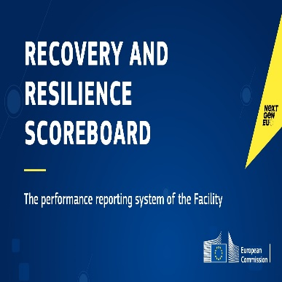
Thematic fiche on culture and creative industries
The thematic fiche on culture and creative industries has been published on the Recovery and Resilience Scoreboard (europa.eu). The Scoreboard gives an overview of how the implementation of the Recovery and Resilience Facility (RRF) and the national recovery and resilience plans is progressing. Member States will use the funds provided by the RRF to implement ambitious reforms and investments to make their economies and societies more sustainable, resilient and prepared for the green and digital transitions.


New Pact for Skills partnership set up to promote skills in cultural and creative industries
On the 28th of April, with the support of the Commission, a large-scale skills partnership for the Cultural and Creative Industries ecosystem was set up. The partnership aims to establish a shared model for skills development in Europe to pool resources and engage in concrete upskilling and reskilling initiatives in the cultural and creative industries.
The partnership will promote learning opportunities and ‘on the job’ training to strengthen the resilience of the sector and equip its professionals with the skills they need, with a particular focus on digital, green, entrepreneurial and technical skills as well as on arts and crafts.
This partnership will contribute to and complement the support already available to the industry for reskilling and upskilling, including through several EU funding instruments and the Creative Europe Programme. Following commitments in other industrial ecosystems, this partnership between European umbrella associations, networks, sectoral associations, vocational education and training providers as well as trade union is based on the Pact for Skills, one of the flagship initiatives under the European Skills Agenda for sustainable competitiveness, social fairness and resilience.
More information on the EU Pact for Skills is here.

EU support to Ukraine through cultural tools
The Commission has decided to extend the 2022 Creative Europe cultural cooperation projects call from 31 March to 5 May 2022, to allow more Ukrainian partners to participate. In addition, maximum flexibility has been allowed for ongoing EU-funded projects involving Ukrainian partners.
Special action for Ukraine under the Creative Europe programme will be proposed by the Commission to Member States for both Ukrainian artists and organisations in Ukraine.
The “Creatives Unite” platform, for and by cultural and creative sectors and co-funded by the EU, can be used by cultural and creative sectors, Member States and other actors to inform about their initiatives and responses to the crisis.
The Commission will also launch a dedicated action on sharing expertise and capacity building of Ukrainian professionals for the reconstruction of cultural heritage sites.The Commission stands ready to deliver emergency equipment for the protection of Ukrainian cultural heritage under the EU Civil Protection Mechanism (UCPM).
“Save the Ukraine Monuments” is an initiative to save the digital documentation of Ukrainian cultural heritage, to preserve its memory and support the future restoration of assets from the damages caused by the war.

Copyright

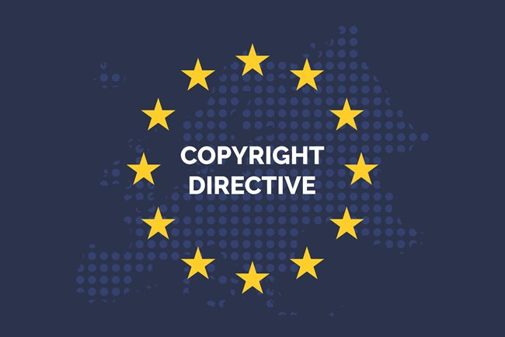
The situation of the transposition of the Copyright Directive in Member States
The deadline for the member states to transpose the 2019 Copyright Directive was the 7 of June 2021. By then, only 3 had; today, they are 12. Consequently, on the 27 of June 2021, the Commission brought infringement proceedings against the other 23 states.
The Directive reforms the bloc’s approach to copyright, largely to reflect the rise of online platforms and the implications of this for publishers and content creators. A number of its provisions have proved particularly controversial.
For instance, Article 15, introducing the right for publishers to be fairly remunerated by platforms for the reuse of their content, necessitates platforms-publisher negotiations, which have been causing considerable angst in France.
Article 17, shifting the liability for unlicensed copyrighted content from users onto platforms, created protests in certain member states, due to the fear of a subsequent use of automated upload filters. Felix Reda, former MEP, described the provision as “internally contradictory”, as it requires platforms to block the upload of copyright-infringing content while ensuring that legal content is not removed.
The transposition of this article was also delayed by the pandemic and the states waiting for the Commission to publish guidelines on the article, which came just before the transposition deadline. As a result, the majority of the member states tried to bypass the problem by transposing Article 17 word-for-word, which doesn’t actually say what the platforms should do.

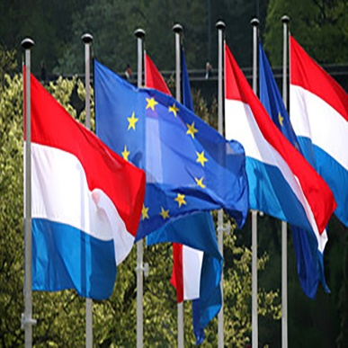
Luxembourg: implementation of the New Copyright Directive
On 1 April 2022, bill no. 7847 implementing Directive (EU) 2019/790 on copyright and related rights in the Digital Single Market was finally adopted after being exempted from a second constitutional vote.
The New Copyright Directive is intended to modernise certain aspects of the legal framework for copyright and neighbouring rights, in particular, to account for rapid technological developments that are continually transforming how protected works are created, produced, distributed and used and the emergence of new business models and actors. The New Copyright Directive reduces uncertainty for right holders and users with respect to certain usage, including the cross-border use of works and other subject matter in the digital environment.
The Bill introduces:
- new exceptions and limitations for author’s rights
- the possibility for cultural heritage institutions to use out-of-commerce works subject to the agreement of a non-exclusive licence for non-commercial purposes with a collective management organisation, under certain conditions.
- neighbouring rights for press publishers covering online uses of their press publications by information society service providers
- a new liability regime for online content-sharing platforms. From now on, online content-sharing platforms will have to obtain authorisation from right holders for the content uploaded on their websites.
- a principle of appropriate and proportionate remuneration in the utilisation agreements of authors and performers, as well as the possibility to ask for additional compensation.

Lithuania: implementation of DSM and Directive 2019/789
The Lithuanian Parliament adopted the law implementing both the DSM Directive and Directive (EU) 2019/789 on online transmissions of broadcasting organisations and retransmissions of television and radio programmes.
Transposing press publishers’ right in Article 15 of the Directive, the Lithuanian law states that very short extracts are those which ‘consist of 125 digits or less, excluding the headers and spaces between text’, so this bold text long. However, it is not indeed clear whether a quantitative definition of ‘very short extracts’ complies with the DSM Directive because it might limit the effectiveness of the press publishers’ rights granted under Article 15. Setting up a lump 125-digits’ limit might also be problematic from the perspective of balancing Article 15 with the rights of users of press publications, especially in the context of the freedom to receive and impart information. Moreover, sometimes longer extracts which even include graphics or video/audio recordings might need to be used to appropriately inform the public. The quantitative definition of a ‘very short extract’ seems to limit the spread of such information. Most probably, the Court of Justice of the European Union (CJEU) will have to consider and decide on whether a quantitative definition of a ‘very short extract’ appropriately implements Article 15 of the DSM Directive.
The Lithuanian law implements strictly article 18 provision by establishing a compulsory collective management mechanism.
The Court of Justice declares Article 17 of the Copyright Directive valid
On the 26th of April, the European Court of Justice dismissed (C-401/19) the action brought by Poland against Article 17 of the Copyright Directive, claiming that the article infringed the freedom of expression and information. Poland tried to strike down rules that force YouTube and Facebook to check for pirated content uploaded by users.
The Court considered that Brussels had achieved a “fair balance” between the right to intellectual property and freedom of expression and thus, rejected Poland’s arguments that Article 17 infringed on freedom of expression and information enshrined in the EU’s Charter of Fundamental Rights.
Article 17 establishes the principle that providers of online content-sharing services are directly liable when the protected subject matter is illegally uploaded by users of their services. The providers may be exempted from the liability if they actively monitor the content uploaded, in order to prevent the uploading of protected subject matter.
The Court stated then that the EU legislature excludes measures filtering and blocking lawful content when uploading, as a filtering system might not distinguish adequately between lawful and unlawful content, resulting in the blocking of lawful communications, which would be in violation of the right to freedom of expression and information.
It follows that Article 17 may not impose the use of filters that block legal content, and that platforms cannot be expected to define the technical parameters under which upload filters may be used, either. The question of what constitutes a manifest infringement in the eyes of a filtering algorithm must be answered by the legislator, not by platforms or private-sector vendors of filtering technologies. National implementations that diverge from the text of the Directive may be in violation of the Charter, but the statement by the Court could indicate that even the approach of simply re-stating the provisions of Article 17 in national law, employed by a large number of Member States, is insufficient, as it fails to include specific ex-ante safeguards that limit the application of upload filters to situations where the danger of over-blocking is minimal.

Digital Services Act and platform regulation

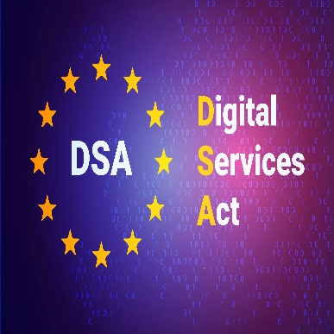
CEPI joins Industry efforts prior to the last DSA Trialogue
On 13 April, CEPI cosigned the joint industry letter addressed to trialogue negotiators in order to push the EU institutions to frame a more futureproof regulation for rightholders. Sent via our CW! Coalition, the letter stressed once again on the main points of interest por the cultural and creative industries.
The letter includes the industry recommendations for negotiators to:
- Extend Know Your Business Customer (KYBC) obligations to all hosting services
- Maintain the legal incentive for search engines to act against illegal content
- Not to weaken current law and practices on Notice and Action
- Allow all entities with expertise and a track record of accurate notices to be awarded the Trusted Flagger Status
- Maintain existing tools to tackle illegal content online
Please find here the letter


DSA last trialogue
On Friday 22 April, the last trialogue on the Digital Services Act took place. Co-legislators agreed on the remaining crucial issues during a sixteen-hour negotiation. EVP Vestager said that there is now “a better proposal than what we tabled”.
While the final agreement’s specificities haven’t yet been made public, that some of the issues dear to CEPI’s advocacy have been dealt with during the final trialogue:
Trusted Flaggers: private entities will be able to be awarded the status of trusted flaggers. Despite the removal of the criteria requiring the representation of collective interests as a condition to access the trusted flagger status, it has been introduced an obligation for trusted flaggers to report all the notices submitted which might be burdensome for smaller entities.
General monitoring: automated tools will NOT be prohibited. Hence illegal content can be detected via automated content recognition.
Search Engines: As you might remember, liability rules for search engines were unclear and could have possibly caused loopholes for notice and action obligations. Recital 27 and recital 27a clarify that search engines will fall under the same liability regime of caching or hosting services according to a case-by-case assessment.
KYBC: Despite long discussions on the possible expansion of the scope of KYBC to all intermediary services, negotiators opted to maintain its application only to online marketplaces.
In the coming weeks we will be able to find out more of the final agreement as we expect that the final text will be made public or leaked.

CEPI meets the European Council Secretariat during CW! Plenary
On 25 April, CEPI participated in the plenary meeting of the Creativity Works! Coalition where all coalition members had the opportunity to exchange with Mr. Raoul Ueberecken, Director at the European Council Secretariat and directly involved in the trialogue negotiations on DSA.
All rightholders from the Cultural and Creative Industries asked for clarifications on the way negotiators foresee the way Liability and Notice and Action obligations will apply to Online Search Engines.
The group stressed on the importance of preventing light obligations for these online services. Antipiracy organisations and rightholders have always collaborated with Search Engines to delist websites proposing copyright infringing content hence allowing for a weaker obligation package might allow these services to escape liability and interrupt their cooperation with rightholders.
Mr. Ueberecken reassured that the rules applicable to Online search engines will be clarified and strengthened during the DSA technical revision.
On another note, the group expressed regrets for the decision of the negotiators to maintain the KYBC principle as applicable exclusively to online market-places. Expanding this provision’s scope to intermediary services was supported in trialogue by Italy, Spain, Germany, Austria, Portugal and Latvia hence we suggested for the regulation to explicit that the provision within DSA could be considered as de minimis leaving the possibility for member states to expand its scope at national level.
Mr. Ueberecken responded that this subject was long debated in trialogue and that member states agreed with the limited scope.
Final steps for the DMA: what about ancillary services?
After 4 month of trialogue negotiation, a compromise has been reached on the Digital Markets Act Regulation, meant to tackle the stronghold of so-called gatekeepers over digital markets. The text remains to be formally voted on by the European parliament (likely in July) and adopted by the Council of ministers. Once adopted, the European Commission will start the process of designating the companies qualifying as gatekeepers.CEPI’s interest in the DMA has lied in the opportunity to access audience data of certain streaming services owned by gatekeeper (I.e. Amazon Prime and Apple TV) if they were to fall in the scope of the regulation, by qualifying as ancillary services. The final text is not as clear as we would have hoped. The term ancillary services has been replaced by “services offered together with or in support of core platform services”, and the recitals describing ancillary services have been removed from the text. Nonetheless, the latest version of the text continues to require gatekeeper to provide business users with high quality, continuous and real time access to users data.Guidance and interpretation will be needed to practically implement this new Regulation to come, including the terms “services offered together with or in support of core platform services” and business users, to understand whether this new provision could be of use in the audio-visual sector. In any case, data sharing and access to data has become a big issue for legislators, which most likely won’t stop with the DMA.

Territoriality

CEPI joint statement calls for the conclusion of the Stakeholder Dialogue on Cross-border Availability and Circulation of Works
CEPI, together with key stakeholders in the film and audiovisual creation, production and distribution value chain, welcomed the findings of the latest European Audiovisual Observatory (EAO)study on the “Circulation of European films on VOD and in cinemas”.
The report of the EAO highlights the wide availability of European content across the EU 27 showing that:
- European audiences have access to over 8 500 European films on VOD in their countries on average. Of these, 82% (~7000) originate in other European countries. This confirms that the increase in European non-national online distribution services operating outside their country of establishment in the EU-27 has now reached a point where any potential demand for European non-national titles is well-met through the diversity of titles and services on offer in-territory.
- VOD roll-out increased by 71% the availability of European non-national films. Of these, 63% of films were available in more than 10 countries on VOD, 31% in 3 to 9 countries, and only 6% were available in 1 or 2 countries.
- 60% of all EU content available on TVOD services is EU non-national. For SVOD services, the share of EU non-national content among all EU content is 76%.
This data contributes to the CEPI narrative brought to the attention of the European commission during the Stakeholder Dialogue, calling for a halt of the current dialogue which was asking the industry to take on commitments to increase availability and circulation of content.
CEPI reminded that these commitments or possible initiatives the commission asked for the industry support, should not be detrimental to the industry’s business model which relies on territorial exclusivity. For this reason, CEPI called for the implementation of support mechanisms to enhance coproduction, support promotion of titles, increase the awareness around online legal content discoverability tools and their development.
While the commission didn’t comment on the industry statement, informal sources informed us that the commission will likely organise a last meeting of the stakeholder dialogue after the conclusions of the DSA negotiations.
Please find here our Joint statement.

AVMSD


European Audiovisual Observatory: AVMS directive tracking table updated
The European Audiovisual Observatory (EAO) released on 26 April an updated webpage of their AVMS directive tracking table. The table presents a purely informative overview of the process of implementation of the Audiovisual Media Services Directive 2018/1808 into the national legal systems of the 27-EU member states and in the UK.
The legal texts listed in the table include final adopted laws and decrees, as well as draft proposals published as part of national consultations, presented or currently debated by the member states' legislative bodies.
In addition, the EAO also provides country by country tailored spreadsheets reporting the official legal text of the national transposition by article of the directive as well as a summary infosheet with the main information of the rules implemented by country.

Piracy


The fight against password sharing of streaming platforms
The proliferation of online marketplaces where passwords are being sold illegally at bargain-basement prices has increased dramatically. Such illicit marketplaces have sprouted in response to the popularity of password sharing — which has become a growing headache for streamers that rely on subscription revenue to finance the rising cost of producing content.
The losses are steep. Account sharing and piracy cost streamers and pay TV providers $9.1 billion in lost revenue in 2019. That’s expected to grow to $12.5 billion in lost revenue by 2024, according to market research and consulting firm Parks Associates. Instead, Citi analysts estimated streaming services lose roughly $25 billion a year due to password sharing, with Netflix representing 25% of that amount.
In facing the recent difficulties, Netflix took a major step to crack down on password sharing among people who don’t live in the same home. The Los Gatos, Calif.-based streamer said it was testing features that would allow its subscribers in Chile, Costa Rica and Peru to add up to two users outside of their household, for an additional $2 or $3 per account.
The study said that 36% of Netflix subscribers share their password with at least one relative outside of their household, while 13% share their password with a friend outside of their household. By comparison, 32% of Disney+ subscribers share their password with a relative outside of their household, followed by 13% who share it with at least one friend who does not live with them, the study said. That’s compared to just 16% of ESPN+ subscribers sharing their password with a relative who did not live with them and 7% with a friend, according to the study.

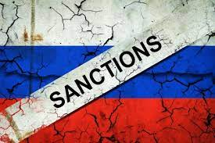
Russia: the legalization of piracy as a way to circumvent sanctions
The film industry from all over the world has dislodged Russia after the attack to Ukraine. The largest American film studios: Disney, Warner Bros., Universal, Paramount, Sony and also Netflix suspended the theatrical distribution of their films in the Russian Federation in March. However, it appears that the Kremlin has responded by allowing illegal streaming in the cinemas.
E1.ru reports that the illegal streaming of “Batman” by Matt Reeves was shown for the first time since the beginning of the sanctions in Yekaterinburg.
The Non-Stop Cinema is planning more pirate shows, while, recently, even RuTracker, the largest Russian BitTorrent tracker, has been unlocked.
The legalization of piracy has thus became a way to circumvent the sanction and no one will be able to stop them since it is not possible to completely cut them off from the Internet.

BUSINESS NEWS: VOD

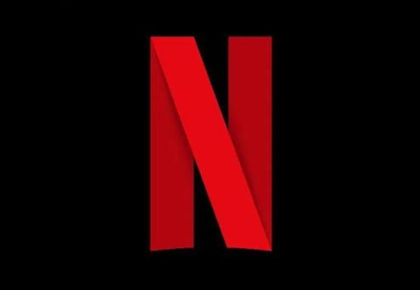
Netflix's loss of subscribers and following actions
Netflix's share price initially fell close to 20% on news that ​​it had lost 200,000 subscribers globally during the first quarter. Wall Street had been expecting the company to add 2.5 million subscribers. Netflix expects to lose 2 million global subscribers in the current quarter.
The main reasons for subscribers' drop are the rise of new important competitors, the release of Covid-restrictions worldwide and the large number of people who share their Netflix accounts with non-paying households. The decision to close up shop in Russia also cost the company 700,000 new additions.
In order to address these problems, in a surprise move, Netflix executives said they were now open to adding advertising to the service – in return for a lower-priced subscription.

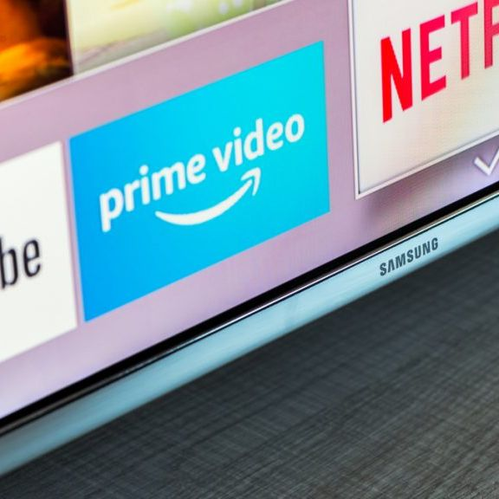
45% of US internet households subscribed to Amazon Prime Video
A report of Parks Associates reveals that Amazon Prime Video subscriber penetration reached 45% of U.S. internet households as of third-quarter in 2021.
About 71% of the 77.3 million Amazon Prime members as of Q1 2021 watched Prime Video, according to the firm’s OTT Video Market Tracker. Despite the increase of the price of Prime membership by $20 (to $139), Parks thinks this won’t affect the video service, given the broader context.

Netflix: the launch of the “Two thumbs up” content rating
Netflix is ready to launch a new ratings option: two thumbs up. In this way, customers will be able to express a deeper affection for TV shows or movies that they love. According to Netflix, the new feature will give the streamer a valuable signal into user preferences that will let it further refine content recommendations.
It’s the biggest change for Netflix’s user content ratings in five years, when the streamer discontinued the five-star content rating system in favor of the thumbs up/down paradigm, saying that the binary options provided a more reliable data set on which to base recommendations. The new “two thumbs up” option will appear next to the thumbs up and down buttons across all platforms.
Right now, Netflix doesn’t expect to intro a “two thumbs down” rating. The current single thumb down is not very widely used, so Netflix doesn’t see much incremental value in two thumbs down. Indeed, data show that if people don’t like a show, they generally just stop watching it.
Distribution agreement between Salto and Amazon Prime Video
The French streaming service Salto and Amazon Prime Video signed a distribution agreement. From May, Amazon subscribers will be able to subscribe to Salto directly from Prime video. The service, which brings together the content of M6, TF1 and France Télévisions, will be integrated into Prime Video library. Salto assured that both the content and the price (6.99€ per month) will be the same.

Cinema & TV

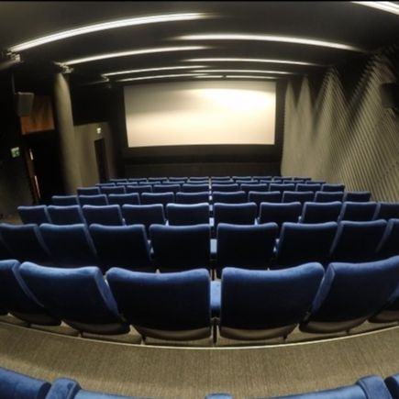
UK and Ireland box office: results of the 2021 and projections for 2022
UK distributors and exhibitors generally expressed their relief by the outcomes achieved in 2021, after cinemas were permitted to reopen in mid-May that year. The total UK and Ireland box office of £597m ($778m) for the year was 85% up on the 2020 figure, and two 2021 titles — Universal’s No Time To Die and Sony Pictures’ Spider-Man: No Way Home — both exceeded £90m ($117.3m). What was missing in 2021, however, was a consistent tier of films achieving blockbuster numbers, and no other title achieved as much as £25m ($32.6m). Warner Bros’ Dune, with £22.1m ($28.8m) to date, was the third biggest hit of the year in the UK and Ireland.
The total UK and Ireland box office for the first quarter of 2022 is £203.7m ($265.5m). According to Gower Street Analytics projections, UK and Ireland should achieve £948m ($1.24bn) for 2022.
The UKCA CEO says that the truncated window is a particular challenge for smaller cinemas playing titles off-date. When films were released into homes on videocassette and then DVD, communication was transparent and it was clear what was going to happen. Smaller operators do not have a strong bargaining position in negotiation with distributors.


Sony Pictures Television expanding on European production
Wayne Garvie, Sony Pictures Television International chief, said that SPTV International had almost accomplished its goal of becoming “the biggest drama studio in Britain” and was now setting its sights on European production.
During a keynote discussion at MipTV on the 4th of April, Garvie and Tranter, Bad Wolf co-founder, also discussed why SPTV International and Bad Wolf were a good fit for each other. Tranter explained that what had ultimately persuaded Bad Wolf to join SPTV’s stable of high-end production companies was the fact they “would be stronger in partnership rather than doing it on our own but [we] wanted to maintain the sense of signature and independence.”
Both also discussed the streaming landscape, with Tranter saying that despite having a strong relationship with HBO she approaches streamers on a project by project basis. She also explained that on a potential adaptation she is looking to option, she is considering hand-selling it to territories one by one rather than relinquishing worldwide rights to a streamer, which she described in an analogy as driving against the traffic. Tranter explained: “I like the idea of hand-rearing a piece in that way.”

Sony and Paramount's success
Sony and Paramount are responsible for seven of the 10 highest-grossing films of 2022 and currently represent more than 46% of all domestic revenues. This represents an incredible turnaround since at this point Paramount and Sony represented roughly 5% of domestic revenues last year.
While rivals such as Disney, Warner Bros. and Universal choose to hold off many of their major tentpoles until summer or the holiday season, the two studios pushed many of their top titles to the first half of the year. Sony’s blockbuster success with “Spider-Man: No Way Home” and “Venom: Let There Be Carnage” late last year has continued with the video game adaptation “Uncharted,” while Paramount has recently found favour with films including “Sonic the Hedgehog 2” and “The Lost City.” Moreover, both companies have adopted the strategy of releasing their films exclusively in theatres, and they both kept those movies in theatres for a long time.
Despite of this, Disney will probably retain its box office crown in 2022, thanks to upcoming blockbuster-hopefuls such as “Doctor Strange in the Multiverse of Madness,” “Black Panther: Wakanda Forever” and the “Toy Story” spinoff “Lightyear.”
CinemaCon: considerations of Fithian and Rivkin
CinemaCon launches Monday at Caesars Palace in Las Vegas, the second in-person gathering of theatre owners and Hollywood studios since August, and Covid. Domestic attendance at the confab, including a full complement of studio heads, is at a pre-pandemic level (international still a bit softer given challenges in some markets). John Fithian, NATO President & CEO, considered this moment as a takeoff point for the resurgence of the industry.
Charles Rivkin, MPA Chairman-CEO, shared his optimism on the future of audiovisual production, considering how the data (2021 global box office was $21.3 billion, up 81% over 2020) are very promising.
Concerning the piracy threat, Rivkin referred to the progress made by Motion Picture Association and our global anti-piracy coalition, the Alliance for Creativity and Entertainment (ACE).
About streaming, Fithian does not agree with the popular description of streaming services as cannibalistic at the core, considering instead how, theoretically, streaming and theatrical support each other.

Festivals


Exclusive offer for CEPI members to join Monte-Carlo Television Festival, Business Content on June 18 - 20, 2022
The Monte-Carlo Television Festival is the ideal venue to meet, exchange, and network with television and streaming industry professionals.
Join us in a convivial setting for the Business Content and hear from an exceptional line up of legendary showrunners, international producers and executives on the latest industry and production trends. Mix and mingle during lunch and a VIP Festival Party and expand your network through the Festival Connect.
The Festival and CEPI are partnering to offer members a 15% discount on the Festival’s PASS PRO (500 € instead of 590€ incl. taxes).
For more information and bookings contact: passpro@tvfestival.com and ref. code: PASSPRO15

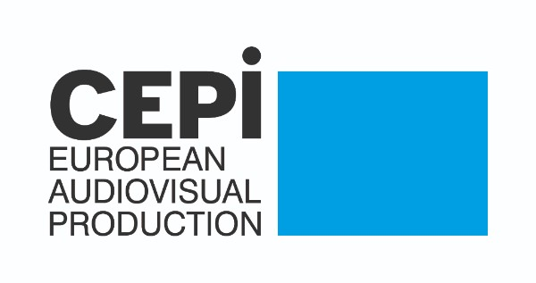
Save the Date: CEPI General Assembly Cannes – 22nd of May 2022
We are looking forward to seeing you in Cannes this year for the next CEPI General Assembly on Sunday 22nd May 2022. We will be kindly hosted by Le SPI, directly in the Village du Festival.
In addition to the General Assembly, CEPI will also be organising an afternoon event, open to all CEPI members and your producers present at the festival on that day. More information will follow rapidly.
Save the date:
CEPI General Assembly - 22nd May from 10h30 to 12h30 - Registration here.
CEPI event - 22nd May from 15h00 to 17h00 - more information will follow.
Both will take place at the Cannes Festival, Le SPI stand, village du festival Pantiero
In order to access the Village du festival, you will need to apply for a FILM PROFESSIONAL accreditation (24€). ( you do not need an accreditation to the marché du film). You can access the accreditation process here.

Constant Gardeners: The Realities of Today's Film Sector in Europe
CEPI, together with FIAD, IVF, Eurocinema, UNIC, Europa International, FIAPF, FSE, Europa Distribution and FERA will host a conference within the official programme of the Cannes Film Festival on 23 May | 14:00 - 16:00 at the Riviera, Palais des Festival.
The conference will explore:
What has been the impact of COVID-19 on the film sector in Europe? Where are we today? How do we build back better? How do we continue to celebrate what makes Europe’s film culture so unique – its diversity? How do we inspire audiences to watch a variety of films, including independent and arthouse, at the cinema?
Please note that you will need an access badge to the Palais des Festivals in order to attend the conference in person. The event will also be livestreamed.
RSVP at filmincannes2022@europe-analytica.com
Call for Projects - Venice Gap-Financing Market 2022
The Venice Gap-Financing Market is a platform for selected projects that aims to support the european and international producers to secure financing for their projects (Fiction Films, Documentaries and Immersive Projects) through one-to-one meetings with potential and pertinent international professionals (producers, sales agents, distributors, financiers, broadcasters and funds). All the invited professionals are decision-makers.
This call is open to European and International projects for the following categories:
- Fiction feature and Documentary film projects: up to 27/33 feature films and international narrative or creative feature documentaries, including 3 Biennale College Cinema Projects, from all over the world will be selected. There is no genre limitation and it's open to animation feature films;
- Immersive Projects: up to 10/12 VR projects from all over the world will be selected.
The deadline for project submission is on the 7th May 2022.
For additional information please visit the Venice Gap-Financing Market website.

Future events
May
- Beldocs International Documentary Film Festival, Serbia – May 11-18, in-person
- Cannes Film Festival, France – May 17-28, in-person
- Nippon Connection Film Festival, Germany – May 24-29, in-person
- Docaviv, Israel – May 26-June 5, in-person
- Krakow Film Festival, Poland – May 29-June 5, in-person; June 3-12, online
- Monaco Streaming Film Festival, Monaco – May 31-June 2, in-person
June
- Sundance Film Festival London, UK – June 9-12, in-person
- Ramsgate International Film & TV Festival, UK – June 9-12, in-person
- Annecy International Animation Film Festival and Market, France – June 13-18, in-person
- Transilvania International Film Festival, Romania – June 17-26, in-person
- Monte Carlo Television Festival, Monaco – June 17-21, in-person
- CineEurope, Spain – June 20-23, in-person
- Munich Film Festival, Germany – June 23-July 2, in-person
- Brussels International Film Festival, Belgium – June 23-July 2, in-person
- Kingston International Film Festival, UK - June 24-26, in-person
- Taormina Film Fest, Italy - June 26-July 2, in-person

Recent studies

European Audiovisual Observatory: Most European VOD content is non-national
The latest report by the European Audiovisual Observatory finds that most content in European VOD catalogues is still non-national. The UK is by far the largest exporter of European content found on VOD services, according to the EAB.
Transactional Video on Demand (TVOD) has a higher share of national film and TV content than SVOD services. On TVOD, British film and TV titles are the most exported titles of EU produced content (getting 32% and 48% of the EU market respectively), followed by French film titles and German TV titles.


TV fiction production in Europe dropped with 600 hours in 2020
The European Audiovisual Observatory saw a decrease of 600 hours in the production of TV fiction. The Observatory announced these results in a study in which they analysed the impact of COVID-19 on TV production in Europe.
The study can be accessed here.

Report: OTT trends in 2022
A Parks Associates report on ‘OTT streaming trends to watch in 2022’ reveals that streaming services such as Roku, Amazon Prime Video and others that distribute premium OTT apps, continue to see strong downloads of big OTT premium apps. The percentage of households subscribing directly from OTT providers’ websites declined to 29% from 41% between first-quarter 2020 and third-quarter 2021 -- with downloads rising from "OTT aggregators."

