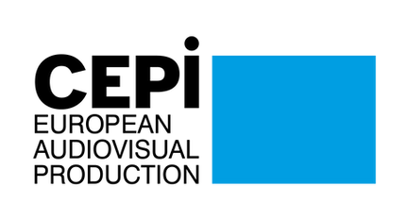
CEPI Newsletter
May 2022

Dear CEPI Members,
We have been thrilled to see many of you in Cannes 10 days ago for the CEPI General Assembly. The meeting has been informative and a great reunion opportunity, under the sun no less! CEPI has been experimenting with this new format: a general assembly session for our members followed by sessions open to members and producers, on various topics. On this occasion, we organised a European roundtable on media chronology, following the agreement reached in France. We had the opportunity to hear from experts about the situation in France, Italy and Ireland and compare and contrast national situations. For more details, see the article in this newsletter.
In order to strengthen CEPI’s presence, we have had the opportunity to participate in 2 events in the festival programme. On Saturday the 21st, CEPI was the voice of independent producers at an event of the European Audiovisual Observatory on circulation of European films. In front of representatives, we have had the opportunity to defend the principle of territoriality. CEPI together with other trade associations also organised a joint event: Constant Gardeners: The Realities of Today's Film Sector in Europe, gathering producers, distributors, film fund representatives and other experts to discuss the state of our sector, sending strong signals to the European Commission of our need. Find more on both events in this newsletter.
The next CEPI General Assembly will take place in Poland during the Polish Film Festival in Gdynia, on the 16th and 17th of September 2022. Stay tuned for more information rapidly.
CEPI also had the opportunity to meet the European Commission for an exchange on Policy in Cannes. More details in this newsletter, but the most important is that the Commission will resume the Stakeholder dialogue on access and circulation of audiovisual content in September. We will spend the summer gathering ammunition for this next meeting. This summer, the European Commission is also meant to start its media outlook, to which CEPI will be feeding information.
Finally, this summer, we will also be starting our new survey on the implementation of the copyright directive. We are now in the process of designing the questionnaire. If you have any specific questions included, don’t hesitate to reach out. Otherwise, we will be looking forward to reading your answers.
We hope you will find this newsletter informative.
All the best,
The CEPI secretariat

Sections in this newsletter:
- EU News
- CEPI events in May and Cannes 2022
- Copyright
- Digital Services Act (DSA)
- AVMSD
- Territoriality

- Piracy
- Business News: VOD
- Business News: Cinema and TV
- Festivals
- Interesting studies
- Events and opportunities

EU News

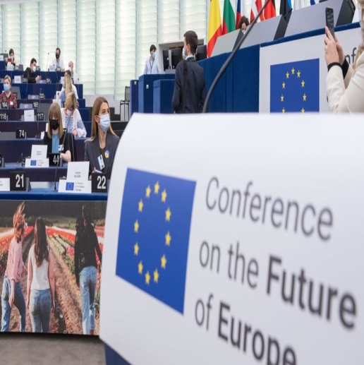
The Conference on the Future of Europe concluded its work
On 29 and 30 April, the Conference on the Future of Europe Plenary session agreed to a set of 49 detailed proposals covering a wide range of subjects from climate change to health, migration and the EU in the world. On 9 May 2022, the Conference concluded its work. After a one-year journey of discussion, debate and collaboration between citizens and politicians, a final report composed of 49 proposals and more than 320 measures for the EU institutions to follow up has been presented (see the report here).

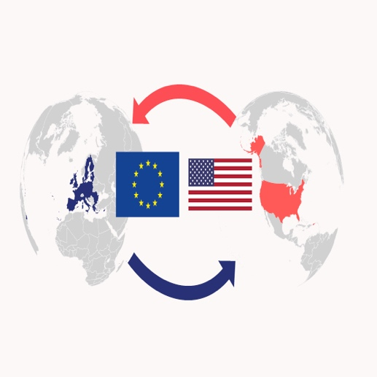
EU-U.S. Trade and Tech Council statement
On 16 May, the United States and European Union agreed to launch a new sub-group on artificial intelligence, a taskforce for funding IT infrastructure and supply chains in third countries, a “policy dialogue” on dealing with big tech and mechanisms to more easily collaborate on standards and more quickly react to trade crises.
“Russia’s war of aggression against Ukraine has further underlined the key importance of our cooperation with the U.S. on economic and technology issues,” Margrethe Vestager, the European Commission executive vice president said in a statement. “This cooperation goes beyond our reaction to the war.”
Please find the final statement here.

IMCO visits Silicon Valley tech companies
From 23 to 27 May, a delegation from the Internal Market Committee (IMCO) met with leading tech companies including Google, Meta, Apple, Airbnb, eBay, Paypal and Uber. The goal of this visit is to look into the latest digital market advances in the United States, particularly in relation to the development and use of e-commerce, artificial intelligence, consumer protection, online platforms and the gig economy. It will also provide a key opportunity to get a closer insight into US legislative work on e-commerce and platforms and to exchange views on the EU’s digital policy agenda, especially the recently agreed EU rules on online platforms - the Digital Services Act (DSA) and Digital Markets Act(DMA).
Right of authorship in Europe: international brochure
The Society of Audiovisual Authors has published brochure explaining the concept of authorship, royalties, collective management and European legislation.
What audiovisual authors all over the world need is an “author” status, with all its consequences: authorship, royalties, and collective management. Good legislation in this regard should ensure the right with 4 components: a remuneration right; making author right undeniable and invaluable; paid by end-distributors; collectively negotiated and enforced.
FERA General Assembly: protection of artistic freedom and unity of the filmmaking community
Members of the Federation of European Screen Directors from 23 countries met in Frankfurt, Germany from May 11 to 13 for its General Assembly annual conference and came together in the acknowledgement that artistic freedom is never a given and that the filmmaking community must stand united to protect its own.
Culture, as an essential part of democracy, and the freedom of artistic expression require the cultural and creative sectors to be independent and free of any governmental censorship, political interference or pressure from non-state actors.
As some talked about their experiences of filmmaking during and about military conflict, the urgent need for the filmmaking community to support filmmakers at war became apparent.
Artistic freedom and cultural diversity must remain cornerstones of meaningful European filmmaking politics.

CEPI events in May and Cannes 2022

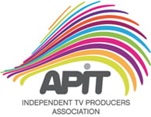
European production meets in Lisbon at the 7th meeting of Independent TV producers of the APIT
On 17 May, CEPI joined APIT on the 7th meeting of Independent TV producers in Lisbon organised on the occasion of the 25th anniversary of our Portuguese member.
During the conference, Mathilde Fiquet, CEPI’s Secretary General highlighted the challenges of European independent producers in a constantly evolving audiovisual landscape. It is indeed a challenging time for European producers said Ms. Fiquet. It is certain that the Covid 19 pandemic had a huge impact on both content consumption changing content, industry dynamics, and players prominence in Europe.
While reminding that the arrival of Global streamers represents a unique opportunity for European producers, their presence in the European market invites to a reflection on what will be the role of independent producers which fatigue to maintain an independent and creative role and more and more often working on commissioned productions.
Accompanying this trend there is also the question of IP ownership and European cultural sovereignty. When is content considered European? Shouldn’t IP ownership be an essential criterion to decide the Europeanity of content?
CEPI is working on these essential issues for European producers via its coordination between national associations, framing common challenges and developing European strategies to shape European regulatory intervention and industry model.
Following CEPI’s intervention, representatives of the Czech, Danish, Irish and Polish producer’s associations participated in a panel entitled: Present and Future of Independent Production.
Alicja Grawon-Jaksik – President of the Polish Audiovisual Producers Alliance KIPA, Søren Henrik Jørgensen – Chief Legal Officer at the Danish Producers' Association Pro-F.DK, Filip Bobinsky – Board of the Czech Audiovisual Producers´ Association APA and Anthony Muldoon - Policy and Communications Manager at Screen Producers Ireland, presented the challenges and the role of their associations in their respective countries.
Their presentations showed that despite the different approaches taken across Europe, common market and regulatory issues can be identified such as the questions of the definition of independent production, impact of global VOD entering the market, IP retention, copyright law and more.
Following the debate, Ms. Susana Gato, president of CEPI and Executive President of APIT highlighted the need for collaboration between national associations in order to share experience and best practices: “The challenges we experience are similar but not simultaneous. Knowing what happens in one territory can help anticipate future challenges already solved somewhere else. In this context, CEPI has an essential role in coordinating cooperation and best practices sharing”
CEPI’s Secretariat wish to thank the entire team of APIT for the invitation to participate in this extraordinary event.


Media Chronology: what is it changing for Films in Europe
On 22 May, CEPI hosted a roundtable on windowing entitled: Media Chronology – What has changed for Films in Europe.
The discussion focused on the differences on the windowing system across Europe and an analysis of the latest developments in France and Italy.
Edouard Mauriat (Mille et une Productions) and Vice-president of the Film section of le SPI presented the outcomes and goals of the recently agreed Media Chronology system in France.
The agreement reached in France, Edouard explained, aimed at finding a viable system for production, audiences and broadcasters following the arrival of online players. Negotiations have been driven by the logic that there is no more a strict border between linear and non-linear services considering that traditional broadcasters are providing more than catch-up services online hence, rather than establishing windows based on the type of provider, the proportion of investment will secure faster access to content after the theatrical release.
Producers were in the best position at the end of the negotiations, he added, since the result brought an increased level of investment in production (+25% from Canal Plus and Netflix now investing 40 million euros).
Barbara Bettelli, legal advisor of the Italian Audiovisual Producers Association – APA, explained the status of the current negotiations in Italy. The theatrical window is regulated by law. The most recent change consisted in shortening the theatrical window from 105 to 90 days in 2015 then no window during the pandemic and now again to a blanket 90-day theatrical window for all films (Italian and non-Italian) that received state backing.
Barbara added that new demands are coming from distributors in particular Italian public and commercial broadcasters that are suggesting a 180 days window applicable to 3rd countries productions as well.
Patrik O’neill Managing Director Wildcard Distribution presented a different picture from the Irish system where there is no regulation organising theatrical release and film exploitation in other windows. The traditional agreement would see films be exclusively in cinema theatres for 16 weeks, then 3 weeks on TVOD followed by Pay TV and FreeTV. This system disappeared during and post covid where Day and Date release, a system he said much more convenient for distributors who take advantage of their promotion strategy in a single moment.
Antoine Simkine, founder of Les Films d’Antoine and president of ACE producers, confirmed that the french Media Chronology has the advantage of creating a cascading effect that is viable in the French ecosystem but also saying little possibilities for an expansion in other european markets. In a diverse region like Europe, were rules apply in different ways, if there at all in the case of windowing, the idea of a European single market for films might be a good idea! he stressed.
Panelists highlighted how the different systems in Europe will not necessarily converge toward a similar one but certainly there is a need to adapt to the new opportunities brought by the online players. While it is true that theatrical release is still the main exploitation venue in terms of financing generation, AVOD seems to be a model that will be explored in the coming years and Europe should be ready to have the capabilities to favour innovation in the audiovisual sector.

Constant Gardeners: The Realities of Today's Film Sector in Europe
On 23 May, CEPI together with Eurocinema, Europa Distribution, Europa International, the International Federation of Film Producers Associations (FIAPF), the International Federation of Film Distributors' and Publishers' Association (FIAD), the Federation of European Screen Directors (FERA), the Federation of Screenwriters in Europe (FSE), the International Video Federation (IVF) and the International Union of Cinemas (UNIC), co-organised a conference within the official programme of the Cannes Film Festival 2022. The conference aimed at presenting the current challenges of the European Film industry following the Covid 19 pandemic. Everyone’s focus is now on how best to adapt to the “new normal” and how to sustain a holistic recovery for the entire value chain, to the benefit of European audiences and industry alike. All the speakers agreed on the importance of increasing collaboration within the audiovisual value chain and strengthening the funds available to support the film industry. During the panel “How to re-establish a creatively and economically sustainable film sector in Europe?”,guest panellists discussed the fundamental role of cinemas in order to maintain a financially viable film industry in Europe.
Eduardo Escudero, Business Manager at AContraCorriente Films reminded that the recovery for theatres never took place as on average in Europe, admissions remain 50% lower than pre pandemic 2019. Day and Date releases, he continued, played certainly an essential role during the series of lockdown but this experience demonstrated that online release cannot compete with theatrical releases when it comes to secure a viable financing for Films: “Day and Date kills the cost effective value of Films”. .
Jaime Tarrazon, CEO, Cines Filmax Gran Via & Co-Founder ACEC, put the emphasis on the question of recovery. In his opinion, recovering isn’t enough as not only the pre-pandemic levels should be reestablished but also the same goals and ambitions the Film industry had during 2019, a record year for cinemas in Europe. An important question is now to understand audiences preferences highlighting the role of education and film literacy.
The second panel “For the many, not the few - it is all about choice” highlighted the need to protect European diversity. Funds are needed to allow European companies to express their European voices. The young generation represents the targeted audience: young people need to be educated to watch movies.
Panellists agreed that independence is essential to preserve diversity however, there is a balance to maintain between commercial ambitions and artistic choice. These two aspects can coexist since the commercially viable titles can serve to finance the creation of less audience attractive titles with high artistic value.
The debate of Monday 23 May showed that the core concept to be promoted by European, national and regional decision-makers remains freedom of choice to take risks on diverse stories and their production models, their diverse and tailor-made promotion and distribution strategies, with cinemas as an essential part of the ecology. This is an essential factor for preserving the art of cinema as well as the plurality of the players involved in the creation, production, distribution and exhibition of films in Europe.
• Freedom to create, produce, and distribute new film stories in Europe. Cinema is the art of putting on screen stories that we did not know we wanted or needed, but which continue to move us, inform us, entertain us, opening windows on new worlds and echoing existing ones.
• Freedom to take artistic and economic risks, working together in a very interconnected value chain, and to pursue business strategies compatible with the DNA of individual film sector players, whether small, medium or large-sized companies or individuals.
• Freedom to deploy tailor-made business plans, including as regards financing and the path to meet future audiences, dependent on each individual film title and its specific requirements.
• Freedom to market, distribute and exhibit films territory by territory, audience by audience, according to local tastes, societal debates, and other preferences of each local and/or specific audience group.
This will allow the film sector to continue to make a significant contribution to the economy of, and employment in, Europe. It is essential for the European, national and regional public authorities to uphold cinema as one of the most important democratic, cultural and civic tools for emancipation, dialogue and international influence.
Please find a joint press release by the organising associations here.
The Art of Educating Youth on Respect for Intellectual Property in Italy, Netherlands, Spain, UK, USA
On 20th of May, Cinecittà for DGCA-MiC in collaboration with MPA organized the event: The Art of Educating Youth on Respect for Intellectual Property in Italy, Netherlands, Spain, UK, USA. After the introduction of Roberto Stabile – Head of Special Projects MiC-Cinecittà; Federico Bagnoli Rossi, Secretary-General, FAPAV; Estela Artacho Garcia-Moreno – President and Director General FEDICINE; Liz Bales – Chief Executive Industry Trust for IP Awareness and DEG International; Paul Solleveld – General Secretary Dutch Copyright Foundation joined the discussion.
The fight against piracy has experienced an evolution over the years. In the 90s, the focus was to let people understand that piracy represented something illegal. Once this idea has been accepted, the fight against piracy moved to demonstrate that it is useless to access illegal content. Today, the fight against piracy is also by means of offering easily accessible content at competitive prices.
Fighting privacy is composed of 3 legs: educate and empower consumers to make good choices; provide a great legal offer; protect and enforce rights. Panellists believe that, despite the seriousness of the piracy problem, a shift in attitude toward majority unacceptability would help to further marginalise illegal behaviour. According to a Spanish study, 54% of the users consider that the most effective measure against illegal access is to develop social awareness campaigns. Education and campaigns constitute an added value in combating piracy.
Finally, since piracy represents a global problem, coordination and international collaboration represent a fundamental tool in this fight.
Find a record of the debate here.
The trends in the film sector post-pandemic
During the 75th edition of the Cannes Festival, the European Audiovisual Observatory organised a conference with people from across the film sector to talk about the recovery process in the film industry after the COVID crisis.
According to the European Audiovisual Observatory's Department for Market Information, in 2021, despite the safety measures being lifted in cinemas, only 400 million admissions were registered in the EU and the UK, a number still 60% below the pre-pandemic average (find the report here).
One of the reasons advanced is a growing production of US films meant for exclusive distribution on online platforms. Another reason is the lack of big independent arthouse movies coming out in theatres so far, whether European or American.
For Michael Ryan, Director of GFM Animation, it might take another year, but the levels will get back to normal.
In 2020, the admissions to US movies dropped by almost 80%, whereas admissions to European movies only dropped 56%, as they benefited from the lack of competition from US movies that were rescheduled and not released.
In 2021, as US movies came back in cinemas, the admissions to European films declined significantly from year-to-year.
According to Michael Ryan, before the pandemic, there were too many local movies that were made, their quality was dropping, and they didn’t catch enough attention. For both him and Peter Fornstam, Founder and Director of Svenska Bio, in the last 2 years, independent and local content was discovered because it was the only thing offered to them. There is now an opportunity to make those local stories appealing to a theatrical audience.
For Laurent Dutoit, CEO of Agora Films, the problem is that, as Europe is raising more films, they are competing with each other, they don’t stay long in theatres because they are pushing each other out.
Talking about European concentration in the film industry from Laurent Dutoit’s distribution point of view, consolidation will not help the diversity and the circulation of European content. It’s a dream of the Commission to have big European players to compete with the Americans, but within those big chains, there is not the best diversity.
Find the recorded conference here.
Fostering Europe’s cultural autonomy and diversity through private investment and IP exploitation
Taking place during the 75th edition of the Cannes Film Festival, the European Film Forum focused on how to secure European audiovisual competitiveness at global level, in particular through private investment in the sector, in a context of profound changes for the industry.
In the first part of the conference, the program Media Invest was officially launched by Commissioner Thierry Breton and then discussed by the panel.
Media Invest is a new financing tool launched by the Commission to boost Europe’s audiovisual industry. It’s expected to leverage 400 million euros of investment over a 7-year period. It belongs to the InvestEU Equity Program, managed by the Commission and implemented by the European Investment Fund.
While presenting it, Commissioner Breton underlined that it mobilises private investors to preserve cultural independence by maintaining a distance between governments and the world of creation.
Media Invest can help reinforce producers and production companies and be another player with industry expertise, other than producers and investors.
In the second part of the conference, IP exploitation and more diversified investment strategies were discussed by producers.
Especially with the growing number of streamers, producers expressed their need to have their IP rights protected. Alexandra Lebret, Managing Director at European Producers Club, called for a legislative framework introducing terms of trade that protect the rights of producers.
The panel also expressed a need to support and trigger more coproduction in Europe, not only between countries, but also between different medias, like the press for instance.
Find the recorded conference here.
Europa Cinema makes a review of its cinema attendances in 2021 and their engagement in contemporary issues
Despite the reopening of cinemas, 2021 cinema attendances failed to reach their 2019 level, showing the extent of the COVID crisis. The possible reasons advanced are the face-mask requirements, a lack of big arthouse films on screens, and a limited return of cinemagoers in the 50-plus age group.
In 2021, admissions in cinemas supported by the Creative Europe network showed only a 1.7% growth. The market share of American films, which had reached a historic low in 2020, rose slightly. European films also grew year by year, thanks to the strength of national cinema in numerous European countries.
Marking the comeback of European filmmakers, the top two European films, “Another Round” and “The Father” exceeded 700 000 admissions, while the third-ranked film, “Parallel Mothers” came close to 500 000 admissions.
The Danish film “Another Round” also showed the strength of Northern Europe’s film industries; in 2021, the cumulative market share of Northern European films was the second European largest within the Europa Cinemas network.
Only surpassed by American cinema, French films accounted for the second largest market share within the Europa Cinemas network. The success of “Annette” and “Titane” must be noted as they may help bring new audiences through the doors of arthouse cinemas.
Network cinemas are also shown to engage in contemporary issues. More than 20% have entered the digital arena, notably through virtual screening, cooperation with VOD platforms and podcasts. Almost 60% have set up inclusive community-oriented initiatives, like the establishment of ticket donation schemes. Finally, 42% of network cinemas are committed to the environment, in particular in relation to the issue of mobility within their cities; many are adopting environmentally responsible practices, as well as showing socially engaged films that aim to raise awareness.

Copyright


Discussion in the Communia Salon on the implications of the CJEU judgement of Article 17 of the Copyright Directive
On 28 April, Communia hosted a debate to discuss the implications of the CJEU judgement rejecting Poland’s request to annual Article 17 of the Copyright Directive by confirming that it can be reconciled with the right to freedom of expression provided that certain safeguards are in place.
The discussion started with João Pedro Quintais, Assistant Professor at the Institute for Information Law, Amsterdam University, presenting the judgement and underlining that it makes it clear that the ex-post procedural safeguards are insufficient to take care of overblocking, meaning that ex-ante safeguards are also required to protected users’ rights or freedoms.
Marco Giorello, Head of the European Commission’s Copyright Unit at DG CONNECT, said that the Commission was satisfied with the judgement, and highlighted that the Commission’s guidelines for the implementation of Article 17 (which Giorello could not yet confirm if the Commission would revise in light of the judgement) could help legislators, courts and market players.
Felix Reda, former MEP and project lead at the Society for Civil Rights, noted that the Court set specific requirements for upload filters: they cannot be used unless they can ensure that lawful content does not get blocked. He continued by pointing out that the platforms cannot be the only ones defining the technical parameters of the upload filters, as they cannot be required to make an independent assessment of the lawfulness of the content uploaded. Hence, the Member States will need to define ex-ante safeguards in the law.
Finally, Eliška Pírková, Global Freedom of Expression Lead at Access Now, recalled that the civil society has for many years challenged the deployment of upload filters as they impose ex-ante restrictions on the freedom of expression. She welcomed that the filtering system must be able to recognize, and not automatically block, lawful content.


How Member States should transpose and implement Article 17 of the Copyright Directive after the CJEU decision
On 26 April, the CJEU held that Article 17 of the Copyright Directive was compatible with the freedom of expression and information, and considered the internal safeguards enough. Those safeguards must be considered by the Member States when implementing the Article.
To comply with EU law, the safest transposition and application of Article 17 would be a minimalistic one (a “copy-and-paste” solution).
First, the provision sets very specific obligations relating to autonomous concepts of EU law, meaning they must receive a uniform interpretation and application across the EU. Second, the Court expressly acknowledges that Article 17 contains the appropriate safeguards, meaning that it should be transposed in a way that its normative content, including those safeguards, is not altered.
As the goal is to create a digital single market, the Member States should not remove or add provisions while transposing the Directive.
As the use of automatic recognition and filtering tools is unavoidable, such tools have to comply with EU law, with its principle of proportionality, and strike a fair balance of rights and interests.
The online content sharing services providers are required to adopt “strictly targeted” measures that may distinguish adequately between unlawful and lawful content. What is required is not a 100% error-free tool, but that when an error occurs, a complaint and redress mechanism, like the one in Article 17(9), is readily available.

The Commission sent reasoned opinions to Member States over their failure to transpose the Copyright Directive
On the 19 May, the Commission sent reasoned opinions to 13 Member States over their failure to implement the Copyright Directive.
The Directive entered into force in June 2019 and had to be transposed by the 7f June 2021. On 23July 2021, the Commission opened infringement procedures by sending letters of formal notice to the 23 Member States that didn’t communicate complete transposition of the Directive.
The Directive aims to modernise copyright rules for consumers and creators. It protects rightholders from different sectors, stimulating the creation and circulation of more high-value content. It brings greater choice of content for users by lowering transaction costs and facilitating the distribution of radio and television programmes across the EU.
The Member States have two months to adopt national transposition measures for the Directive; otherwise, the Commission can refer them to the CJEU.
Read the press release by the European Commission here.

Digital Services Act


Digital Markets Act: IMCO approves the text
On 16 May, the IMCO committee approved the final text of the Digital Markets Act (DMA). Members of the committee voted 43-1 in favour of the text, with one abstention.
The text still needs to be approved by Parliament’s plenary meeting, which plans to vote on it the week of July 4.

AVMSD

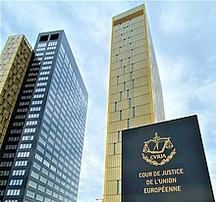
5 EU countries before the Court of Justice for failing to transpose EU audiovisual law
The European Commission has activated the infringement procedure against 5 EU Member States (Czech Republic, Ireland, Romania, Slovakia and Spain) for failing to transpose the Audiovisual Media Services Directive (AVMSD) in time.
EU countries had until September 2020 to add the EU rules for broadcasters and platforms like YouTube and Netflix to their national laws. The Commission said the five countries hadn’t shared the reasons why they were delayed and that citizens and businesses were left behind.
Due to the delayed transposition, citizens and businesses in Czechia, Ireland, Romania, Slovakia and Spain may not be able to rely on all the provisions of the AVMSD, which:
- Create a level playing field for different types of audio-visual media services;
- Guarantee the independence of national media regulators;
- Preserve cultural diversity by, for example, requiring video on demand services to have at least 30% of European works in their catalogues;
- Protect children and consumers in general, by laying down rules for instance for the protection of minors against harmful content in the online world, including protection on video-on-demand services and reinforcing their protection regarding audiovisual commercial communications; and
- Combat racial, religious and other types of hatred by having reinforced rules to combat the incitement to violence or hatred, and the public provocation to commit terrorist offences.
Read the press release by the European Commission here.

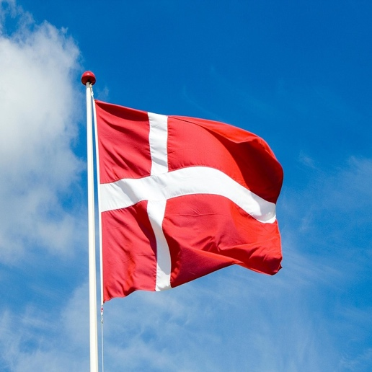
Successful agreement reached in denmark for 6% levy to fuel production
On Saturday, 21 May 2022, a new media agreement for the period 2022-2025 was announced in Denmark. The media agreement encompasses and regulates a wide array of subjects including some important aspects of the political regulation of films in Denmark.
Below is a summary of the main points regarding films and series in the media agreement:
- A 6% levy on the revenue in Denmark of national and international streaming services will be established.
- The profit from the levy will be split evenly between films and the Danish Public Service Fund, a production scheme that supports mainly TV series and documentaries.
- The distribution of the profit from the levy will be administered by the Danish Film Institute.
In addition to the above, the agreement also specifies that the public broadcasters DR and TV 2 shall increase their engagement in the production of Danish feature and documentary films.
See more in the original text of the Media Agreement 2022-2025 (in Danish).

Territoriality


CEPI meets DG Connect to discuss the next steps of the Stakeholder dialogue
On 19 May CEPI was invited to participate in a stakeholders meeting with Giuseppe Abbamonte - Deputy Director General in charge of media policy at DG Connect. The meeting has been an occasion to continue the discussion with the Commission on Circulation of European works started during the stakeholder dialogue in December 2021.
Mr. Abbamonte shared that the commission is not happy with the conclusion of the stakeholder dialogue which will need to bring forward an effective solution or at least a step forward to enable cross-border access to content.
The commission suggested to start considering the option for passive sales on transactional bases for content not available in a specific territory. CEPI is against this option as it would be detrimental to content value and rightholders.
The dialogue will restart in September 2022. CEPI will prepare a position in the coming months and provide data to clarify the impact that cross border access to content can have on the financing system of the entire Audiovisual value chain.


CEPI intervenes at the European Audiovisual Observatory panel on circulation: “Is availability enough?”
On 21st May, Mathilde Fiquet intervened during a panel organised by the European Audiovisual Observatory (EAO) entitled Circulation of European films: is availability enough?
The EAO presented the results of their latest report on circulation of films in Cinemas and on VOD.
- European audiences have access to over 8 500 European films on VOD in their countries on average. Of these, 82% (~7000) originate in other European countries. This confirms that the increase in European non-national online distribution services operating outside their country of establishment in the EU-27 has now reached a point where any potential demand for European non-national titles is well-met through the diversity of titles and services on offer in-territory.
- VOD roll-out increased by 71% the availability of European non-national films. Of these, 63% of films were available in more than 10 countries on VOD, 31% in 3 to 9 countries, and only 6% were available in 1 or 2 countries.
- 60% of all EU content available on TVOD services is EU non-national. For SVOD services, the share of EU non-national content among all EU content is 76%.
During the panel discussions, Sabine Chemaly, Executive Vice-President for International Distribution in TF1 Studio and board member of Europa International, Edith Sepp, Vice-President of EFAD, Mathilde Fiquet, Secretary General, European Audiovisual Production Association (CEPI), Giuseppe Abbamonte, Director of the Media and Data Directorate, European Commission, Marc Smit, Co-CEO of Cinéart and Joan Sala, Head of Programming at Filmin and Festival Manager at Atlàntida Film Fest, exchanged on what conditions facilitate circulation of european films in Europe.
Panelists agreed on the basic principle that circulation doesn’t mean having content available in each territory but rather having each specific title promoted and brought to the public in ways that can create an interest. This is indeed a question that brought the conversation to see promotion and curation at the centre of audience building. Territorial licensing is essential, not only for the related financial value generating for each title but also from a cultural point of view.
Marc Smit, Co-CEO of Cinéart explained that curating a release means to take into consideration a large number of variables: festivals, national holidays and particularities unique to the market.
When discussing audience data, prominence and discoverability, Mathilde Fiquet explained that transparency on audience data is fundamental for the production of titles that have more capacities to circulate in different territories. Traditional exploitation channels provide data enabling producers to better plan their potential audiences but with the increased importance of VOD services in the market, this audience data is not accessible which also gives a competitive advantage to those platforms producing their own content.
Finally, after a brief discussion on policy at European level with Giuseppe Abbamonte - Deputy Director General in charge of media policy at DG Connect, the panel concluded with a discussion on Film education and diversity.
Please find here the recorded video of the event.

Piracy

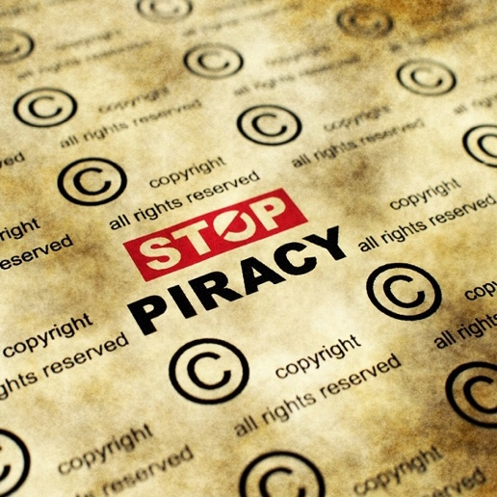
The new alliance between the MPA, Fedicine and FECE to fight piracy and protect creative content
The Motion Picture Association (MPA), the Federation of Film Distributors (Fedicine) and the Federation of Film Entrepreneurs of Spain (FECE) announced the formation of a multi-level alliance to protect intellectual property rights and fight against digital piracy.
It’s a result of the collaboration with the National Police, manifested in several recent successful operations in Madrid, which led to the arrest of different members of organised crime networks.
This alliance has made the anti-taping initiative a priority as illegal camrecording (recordings in movie theatres) puts innovation, creativity and investment at risk. The public service announcement campaign will be seen in cinemas across Spain to educate the public about the dangers of piracy and its economic impact on creative communities.


Illegally pirated movies are shown in Russian cinemas
Following the decision of some US and EU studios to suspend new movie releases in Russia, some Russian cinemas have been taking drastic actions to put people in seats.
Starting in the middle of April, some Russian cinemas started showing Hollywood films that shouldn’t be available, such as The Batman (Warner Bros.), Don’t Look Up (Netflix) or I’m Blushing (Pixar), coming from pirated copies downloaded from an unnamed torrent site.
Given that movie piracy is illegal in Russia, some cinemas are attempting to distance themselves from it; the Grinvich Cinema notes for example that The Batman was “compiled and posted” by organisers of a private event renting three of its screens.
It appears that mass piracy is now firmly back on the public agenda and it seems unlikely that Western companies will be able to do much about it. Many social media posts express support for piracy, arguing that if Western movie companies hadn’t pulled out, there would be no need for illegal screenings.

BUSINESS NEWS: VOD

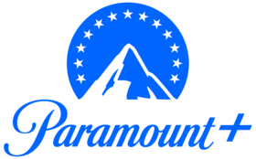
Paramount + new openings worldwide
Paramount+ will launch in the UK and South Korea next month and will be in India next year. Launches in Italy, Germany, France and Austria will follow in the second half of this year. As a result, by the end of 2022, the streamer will be based in more than 60 markets worldwide.
In the UK, Paramount+ will cost £6.99 ($8.77) per month or £69.90 ($87.71) per year, featuring on Sky as part of a multi-platform distribution agreement that also includes the extended carriage of Paramount’s portfolio of pay TV channels.
India’s opening will be incremental to the 100 million sub guidance (comprised of subs to all Paramount’s streaming services, not just Paramount+).

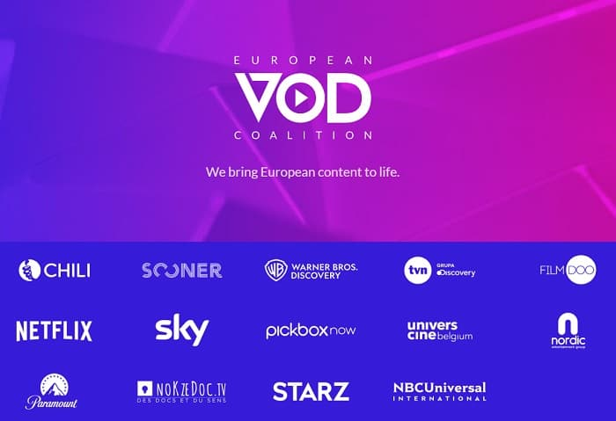
European VOD Coalition
On 10 May, Video-on-demand (VOD) companies officially inaugurated the European VOD Coalition.
The European VOD Coalition, bringing together video-on-demand (VOD) and digital entertainment companies, gives a voice to the European audiovisual streaming sector. By engaging with policymakers and regulators across Europe, it will represent companies that invest in and distribute audiovisual content in Europe as part of their core commercial activities.
Members include CHILI, FilmDoo, NBCUniversal, Netflix, Nokzedoc, Nordic Entertainment Group AG, Paramount, Pickbox, Sky, Sooner, StarzPlay, TVN, Univerciné Belgium and Warner Bros Discovery.
Find the press release here.

Switzerland: international streaming services required to invest in local filmmaking
Swiss voters have backed proposals to make international streaming services invest some of the revenues they generate in Switzerland into local filmmaking.
Switzerland held a national referendum on an amendment to the Federal Act on Film Production and Film Culture (FiG). 58.4% of voters backed the amendment requiring streaming services to invest 4% of their annual Swiss revenue from 2024 into local film and TV production (the streamers will have up to four years to hit the 4% target). In order to do so, they can either participate directly in the production of Swiss films and TV series or acquire completed titles. In addition, they will be required to promote diversity in their programming by ensuring that at least 30% of the films shown are titles produced in Europe.
According to Switzerland’s Federal Office for Culture (BAK), the investment obligation will generate an additional CHF 18m (£14.5m, $18m) annually for the local film and TV industry (supplementing the current CHF 21m ($16.9m, $21.1m) in support each year from BAK).
Opponents to the amendment had argued that the investment obligation could lead to the streamers increasing subscription charges for their services.
Disney: international expansion may not represent a financial success
The quarterly results of Walt Disney Co's (DIS.N) show a path for signing up a quarter billion subscribers. However, the market is concerned about the combination of subscriber guidance and rising costs to compete more broadly with non-Disney brands. Disney+ ended March with 138 million subscribers, up 7.9 million from the previous quarter. The service is poised to launch in 42 countries this summer, expanding its global reach to 106 countries. It will produce roughly 500 shows in local languages around the world to attract subscribers in these markets.
But more than half of its quarterly subscriber gains came from Disney+ Hotstar in India, where subscribers pay an average of 76 cents a month. In the United States, customers pay $6.32 on average. However, spending on programming is expected to increase by more than $900 million in the third quarter, as the company invests more deeply in original content and sports rights.
According to predictions, Disney+ will continue to grow as it expands to new markets and offers enticing content to stream, but that may not be a financial success.

Business News: Cinema and TV


Europe’s movie production levels rebounds after the pandemic, but the box office lags behind
The first details from the annual report prepared for Cannes Marché du Film by the European Audiovisual Observatory were released.
It shows that the film production levels in Europe in 2021 bounced back to pre-pandemic levels; however, the limited box office recovery is stark, accounting for 42% of the pre-pandemic levels. This can be explained by the fact that cinemas remained closed for a substantial part of 2021 and by a possible hesitancy among audiences to return to cinemas (with cinema attendance up only 31.5% year on year in 2021), but also by the return of US studio blockbusters and by the differing of strength of local films (with a drop of European films market share from 39.5% to 26.5% as US blockbusters returned to European cinemas).
Indeed, US movies monopolised Europe’s top 20 of most-watched movies in theatres, starting with “No Time to Die” (34.3 million admissions in the EU and UK), “Spider-Man: No Way Home” (26.8 million), “Dune” (14.3 million) and “Venom: Let There Be Carnage” (10.5 million); whereas as top performing European movies in Europe were led by France’s “Kaamelott: First Instalment” (2.8 million admissions), “The Father” (2.4 million), “BAC Nord” (2.2 million) and “Another Round” (2.0 million).

The launch of a Beta Group Film-TV Production and Distribution in Spain
Beta Group, an independent film and television group, is launching Beta Fiction Spain, a TV-movie production house, offering production services and running a theatrical distribution operation.
Beta Fiction Spain will be led by Mercedes Gamero, former head of Atresmedia Cine, and Pablo Nogueroles, former SVP at Warner Bros. Pictures International España.
This launch comes as Spain is consolidating its international power in a new platform-driven environment; eight of the Top 10 non-English language TV shows and movies released on Netflix are Spanish.
Christian Gockel, responsible for all Beta Group’s Spanish activities, noted that Spain had a need for more strong independent distribution companies.
The firsts projects or buys have not been announced yet, but it might be films as they are faster to develop.
Beta Fiction Spain will join another Spanish subsidiary of Beta Group, Beta Entertainment Spain, headed by Javier Pérez de Silva, which focuses on creating and adapting international unscripted entertainment formats.

“Top Gun: Maverick”: standing ovation for its premiere in Cannes
Tom Cruise received a roaring ovation as he was awarded the prestigious Palme d’Or at this year’s Cannes Film Festival for the movie “Top Gun: Maverick”. This was followed by 8 fighter jets bellowing red, white and blue smoke as he and his castmates were on the red carpet.
The screening of the movie was punctuated by many cheering and gasping from the festival crowd, and an overwhelming response when Val Kilmer, who starred as Cruise nemesis Iceman in the original film, appeared on the screen. The movie projection ended with a five-minute standing ovation from the public.
The movie is already scoring rapturous reviews and is expected to be among this summer’s biggest blockbusters.
The impact of the market crash on streaming platforms
On May 18th, as the market crashed in Wall Street, Disney, Netflix, Warner Bros. Discovery and Comcast have seen tens of billions of dollars in market capitalization wiped out over the first five months of the year.
Netflix has taken the biggest hit of all, losing nearly 50% of its equity value in four weeks, and even more since the start of the year. This is viewed as a sign that the entire sector will hit a speed bump, particularly in the US, where consumers are overwhelmed with choices but also as platforms like Paramount’s Pluto TV offer free content.
It seems this would force each company to re-estimate their spending plans and their own long-term estimates of their total addressable market.
As for Disney, it recently outlined its plans to increase local-language production, with some 500 projects in the works for territories in Asia, Europe, Africa and Latin America.

Festivals

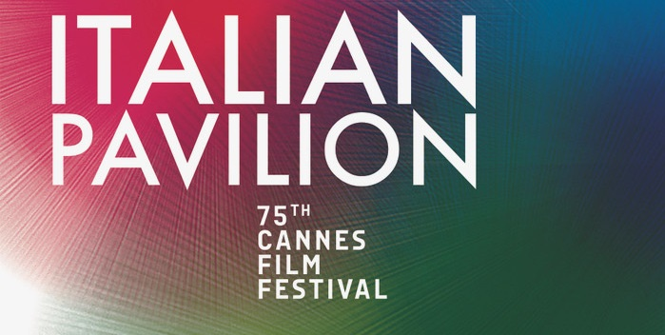
The Italian Pavilion in Cannes shows its commitment to collaborate with Israel, Ukraine and the UK
As European collaborations are rising to assure shared success, the Italian Pavilion hosted a number of international initiatives and activities during the 2022 Cannes Film Festival. With the aim of creating more opportunities and exchanges, the following three commitments are the most noteworthy.
The Roma Lazio Film Commission presented the second edition of Crossing Script, an initiative in collaboration with the Rabinovich Foundation’s Israel Cinema Project dedicated to the development of screenplays set in the Lazio region and in Israel.
A “Rome-Kyiv: development and opportunities” meeting was organised by the Italian Pavilion to support Ukraine’ audiovisual sector. The Roma Lazio Film Commission spoke about opportunities arising with the Ukrainian State Film Agency and the Ukrainian Motion Picture Association, and its commitment to organise creative residencies in the Lazio region for Ukrainian talent.
Finally, the Italian Film Commissions signed on May 20 a memorandum of understanding with the British Film Commission, which aims at incentivising cultural, commercial and creative exchanges between Italy and the UK, as well as bolstering investments and the development of new, high-end productions in both territories.

Future festivals
June
- Sundance Film Festival London, UK – June 9-12, in-person
- Ramsgate International Film & TV Festival, UK – June 9-12, in-person
- Annecy International Animation Film Festival and Market, France – June 13-18, in-person
- Transilvania International Film Festival, Romania – June 17-26, in-person
- Monte Carlo Television Festival, Monaco – June 17-21, in-person
- CineEurope, Spain – June 20-23, in-person
- Munich Film Festival, Germany – June 23-July 2, in-person
- Brussels International Film Festival, Belgium – June 23-July 2, in-person
- Kingston International Film Festival, UK - June 24-26, in-person
- Taormina Film Fest, Italy - June 26-July 2, in-person
July
- arlovy Vary International Film Festival, Czech Republic – July 1-9, in-person
- Galway Film Fleadh, Ireland - July 5-10, in-person
- New Horizons International Film Festival, Poland – July 21-31, in-person
- Jerusalem Film Festival, Israel – July 21-31, in-person
- Prishtina International Film Festival, Kosovo – July 26-31, in-person

Interesting studies

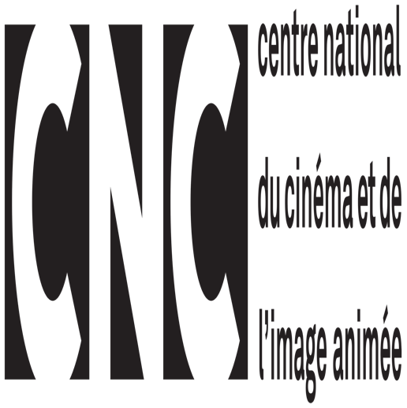
CNC: 2021 performances of the French audiovisual industries
The French CNC (the National Centre for Cinema and the Moving Image) released a study of the 2021 performances of the French audiovisual industries.
It enlightens that despite the reopening of cinemas and a growth of cinema attendances by 46,3% compared to 2020, the year 2021 has the second lowest level of cinema attendances since 1917. Indeed, the cinemas were only open for 138 days in 2021, with curfews and an obligation to have a COVID sanitary pass to access them.
The attendances of European films other than the French ones were up by 121% compared to 2020, with market shares up by 4,7 points, reaching 14%. This growth is notably due to British films, especially with James Bond’s “No Time to Die”, second-ranked film of the year in French cinemas.
In 2021, 51,4% of the French population went to the cinema; the 25-49 and 50-and-more age groups representing each around one third of the attendances. 55% of the public for French films were persons of 50 years old and more.


Investing in European works: the obligations on VOD providers
On 24 May, the European Audioviusal Observatory published a new study gathering the newly introduced investment obligations levels for VOD providers across the countries that implemented article 13 of the AVMS directive.
This new report by the European Audiovisual Observatory describes the rules concerning financial obligations for VOD services in the EU responding the following questions:
- What is the current legal framework for promoting the production of European works in the EU?
- What are the resulting obligations on VOD services operating at national and cross-border level?
- What form do these financial obligations take (investment in production, acquisition of rights, levies etc.)?
Please find the full report here.

Events and opportunities


Conscious Content: The Shift Towards Sustainable Production (Monday 20th June,18:00 - 18:50)
Audiovisual industries are not necessarily setting global environmental issues aside. Current climate crisis compels productions to adopt greener practices, reduce their carbon footprint and increase recycling on sets.
How can producers get help to make their productions environmentally sustainable? Panelists will detail the tools available around the globe to implement the shift toward sustainable production. Going "Green" on productions does not have to mean more costs. To the contrary, utilizing sustainable resources can save production costs. Participants will provide some current examples of cost-saving efforts.
· Mathilde FIQUET General Secretary CEPI
· Paloma A. URRUTIA Co-Founder & Consultant Sustainable Productions MRS GREENFILM
· Leif HOLST JENSEN CEO OSLO FILM FOND
· Matt DEANER CEO SCREEN PRODUCERS ASSOCIATION OF AUSTRALIA
Moderator: Vance VAN PETTEN Adjunct Professor Hollywood Campus COLUMBIA COLLEGE CHICAGO
See all sessions:https://www.tvfestival.com/en/professionals/programme
Exclusive offer for CEPI members of 15% discount on the Festival’s PASS PRO (500 € instead of 590€ incl. taxes)
For more information and bookings contact: passpro@tvfestival.com and ref. code: PASSPRO15

