CEPI Newsletter December 2023 - January 2024



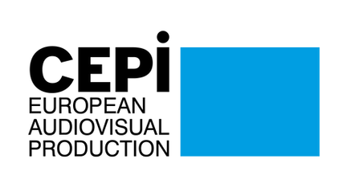
Dear CEPI Members,
Happy New Year! As we welcome 2024, we hope this newsletter finds you well-rested after a festive holiday season.

Before the institutions adjourned for the December break, significant developments occurred. Firstly, we’ve concluded the series of roundtables with the Commission for the stakeholder dialogue on the future of the AV industry. In mid-December, the European Commission organised the final two stakeholder meetings. The first one focused on technological innovation, emphasizing the need for sustainable, accessible, and inclusive practices in AV, particularly in green production and AI technology. Key points included the necessity for European AV solutions, greater accessibility to generative AI models and data, and a focus on audience experience and development. The following day, a second meeting addressed talent and skills development, stressing the importance of digital literacy and proposing innovative training methods, such as sessions in the Metaverse and continuous updates to online courses, to adapt to the rapidly changing digital landscape.
Following these discussions and the previous ones, CEPI submitted a written contribution to the Commission highlighting the contraction in AV sector investments and the need for more transparent access to consumption data for producers. We re-emphasized the importance of IP ownership for financial stability and funding new projects. We also recommended policies to retain IP rights within the EU for cultural sovereignty and economic benefits. Additionally, we addressed the need for equitable development and use of AI technology, advocating for transparency, wider access, and responsible deployment in the industry.
On the Parliament’s front, the Geoblocking implementation report was adopted in the December Plenary session. In the weeks leading up to the vote, the AV sector and CEPI actively worked to amend it and remove the most concerning wordings, railing support from MEPs. The report, which is not legally binding, was adopted, removing the most problematic parts, maintaining the exemption for copyrighted services and recognizing the importance of territorial exclusivity in the audiovisual sector. This outcome represents a significant victory for the sector, reflecting the collective advocacy's effectiveness. We thank everyone involved for their support in this endeavor. You can find more information on the CEPI website and the “Territoriality” section

After extensive negotiations, the European Parliament and Council reached a provisional agreement on the Artificial Intelligence Act, which mandates the classification of AI systems by risk level, with corresponding obligations. Key provisions include transparency requirements for general-purpose AI systems, such as creating technical documentation and adhering to EU copyright laws. Additionally, new articles outline obligations for AI model providers, focusing on respecting copyright through identification and policy implementation. The final text is still under technical review, with further details pending finalization before confirmation by both Parliament and Council. Find more information in the “Digital Policy” section.
On December 15th, the Parliament and Council also reached a provisional agreementon the EMFA, which proposes a unified framework for EU media services, addressing media politicisation and ownership transparency. A significant development includes replacing ERGA with the European Board for Media Services, an independent advisory body to assist the Commission. Awaiting formal approval, the final adoption of the EMFA is expected in spring 2024. We will share further details upon publication of the finalised text. Find more information in the “Digital Policy” section. You can find out more in the “Digital Policy” section.
Looking into 2024, CEPI is working on its Vision Paper, aiming to address pivotal issues confronting independent producers, outline strategic objectives, and offer actionable policy recommendations for guiding the European Commission in its forthcoming mandate. Your feedback over recent months has been instrumental in refining an updated version of the document, which will be presented to the Board in Berlin come February.
As we embark on this new year, which includes the European elections, we eagerly anticipate the opportunities it presents. We would like to take this opportunity to thank you all for your continued support and commitment
We hope you will find this newsletter informative,
Best regards,
The CEPI Secretariat

Sections in this newsletter

- Latest from the EU
- Digital Policy
- Territoriality
- Creative Europe
- Copyright
- Piracy

- Recovery and growth of the AV sector
- Business News: VOD
- Business News: Film and TV
- Festivals
- Interesting studies
- Interesting links
- Events and opportunities

Latest from the EU


Parliament’s survey shows rising voter interest in the upcoming European elections
The European Parliament has released a survey that shows that 57% of EU citizens are interested in the upcoming European elections, which is 6% higher than the level of interest before the 2019 elections. If the election were held next week, 68% of respondents said they would vote, which is 9% higher than in 2019.
The survey found that interest in the election is uneven across the EU, with interest being particularly high in the Netherlands and low in the Czech Republic. The likelihood to vote is also uneven, with Danes being the most likely to vote and Cypriots being the least likely.
The survey also found that 61% of Europeans believe that EU membership is a good thing. This is slightly higher than the level of support before the 2019 elections and significantly higher than the low of 47% in May 2011.
A European Parliament spokesperson Jaume Duch said that the EU's future path is especially critical for young voters and added that there is a lot of uncertainty about the future of the EU. He said that a lot can change in politics in six months and that the results of the 2024 European elections will be very important.

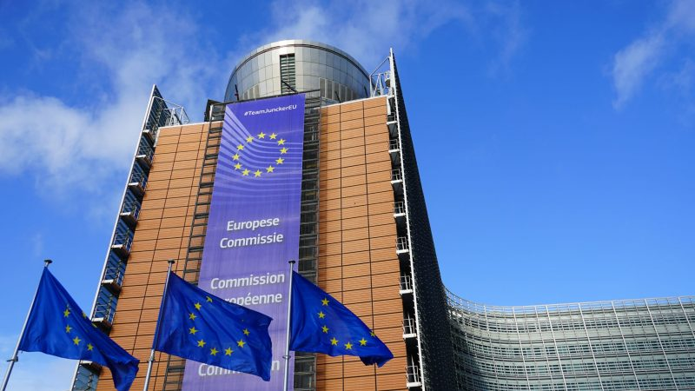
2024 will bring shifts in political agendas and changes in national and EU-level politics
2024 will bring several changes to the European Union, including a new composition of the European Parliament, a new President of the European Council, and a new Commission President.
The new President of the European Commission is expected to be Ursula von der Leyen, but her reappointment is not guaranteed. Former Italian Prime Minister and head of the European Bank Mario Draghi could be a contender for the position if she is not reappointed.
There are many potential ideological compositions for the upcoming European political term. One possibility is a right-wing majority coalition excluding Socialists but including Liberals, as a recent projection foresees a surge in support for far-right parties in the new Parliament’s composition. Another possibility is a centre-right coalition of EPP, Socialists (S&D) and Liberals. A third possibility is a Green & Centre-Right Europe coalition that incorporates the Greens, solidifying its position as the largest voting majority in the European Parliament. Finally, the existing coalition of EPP, Socialists and Liberals is also a possibility.
The European political landscape is set for a number of changes in 2024. The European Parliament is expected to move towards the right, and the European Council is also expected to be more fragmented. This could make it difficult for the EPP to maintain its current position as the leading party in the European Parliament.
MEPs want to have a greater say in the election of the European Commission president
In December, the European Parliament voted in favour of a proposal that would ensure that European political parties and parliamentary groups begin negotiations with the 27 EU national leaders to choose who will lead the next European Commission. The proposal would give the leading candidate of the European political party that gets the most seats in Parliament a greater role in the negotiations, as well as creating a "legislature agreement" that would have to be agreed upon by the Parliament, Commission, and Council.
The proposal is still under discussion, but it is seen as a step towards giving the European Parliament a greater role in the election of the European Commission president.
The current system for electing the European Commission president is based on the Lisbon Treaty, which provides that the heads of state can "take into account" the leading candidate of the European party which got the most seats. However, this system has been criticized for being undemocratic, as it gives the European Parliament very little say in the process. Such changes would give the European Parliament a greater role in the process, but it would still not have a majority vote; the European Council, representing the heads of states or governments, would still have the final word on who becomes the European Commission president.
The proposed changes are being seen as a compromise between the European Parliament and the European Council. The European Parliament wants to have a greater role in the process, while the European Council wants to maintain its current powers. The outcome is uncertain, but the changes are seen as a sign that the European Parliament is seeking to increase its power in the EU.
EU elections: the Parliament proposes reforms to strengthen democratic process in 2024
The European Parliament has adopted proposals to strengthen the democratic dimension of the 2024 elections and to reform the lead candidate system. The proposals include measures to increase voter turnout, to ensure that the choice made by voters is reflected in the election of the Commission President, and to safeguard the right to vote for all EU citizens. The Parliament also calls for a binding agreement between the Council and the Parliament on the lead candidate system to ensure that the process is transparent and democratic. Here are some of the key points:
- The Parliament wants a clear link between the choice made by voters and the election of the Commission President, meaning that the candidate who is elected President should be the lead candidate of the political party with the most seats in the Parliament.
- The Parliament also wants measures to ensure that all EU citizens have the opportunity to vote, including those who are mobile or who have disabilities.
- The Parliament is calling for a swift adoption of the new European electoral law and new rules for European political parties and foundations.
The Parliament's proposals are a response to the concerns of many EU citizens about the democratic legitimacy of the EU's institutions. The Parliament hopes that the reforms will help to increase voter turnout and make the EU more transparent and accountable.

Digital Policy


The AI Act and its implications for copyright and transparency
Following almost 40 hours of negotiations at the final trialogue meeting, the European Parliament and the Council reached a provisional political agreement on the widely discussed Artificial Intelligence Act (AI Act) on Friday 9th December, marking a historic moment as the first comprehensive legal framework on AI globally.
Proposed by the European Commission in 2021, this legislation mandates the analysis and classification of AI systems based on the risks they pose to users, with varying levels of regulation corresponding to different risk levels. The AI Act would apply two years after its entry into force, with some exceptions for specific measures.
The final compromise includes two provisions relevant to copyright. There was a risk that language that has been introduced and supported by the European Parliament would not make it to the final text, given the opposition of AI companies and several powerful Member States, including France, Germany and Italy. Despite all that, concerning general purpose AI (GPAI) systems, it was agreed that such systems would have to adhere to transparency requirements, which would include drawing up technical documentation, complying with EU copyright law, and disseminating summaries about the content used for training purposes. A recital in the text makes it clear that the “summary should be comprehensive in its scope instead of technically detailed, for example by listing the main data collections or sets that went into training the model, such as large private or public databases or data archives, and by providing a narrative explanation about other data sources used”. This relatively light requirement to publish high-level descriptions should be sufficient to allow third parties to determine whether model providers have trained their models on lawfully accessible data sources, as required by Article 4(1) of the Copyright DSM Directive, and therefore in compliance with EU copyright rules.
Secondly, a newly introduced article on “Obligations for providers of general-purpose AI models” includes two distinct requirements related to copyright. Section 1(c) requires providers of GPAI models to “put in place a policy to respect Union copyright law in particular to identify and respect, including through state of the art technologies where applicable, the reservations of rights expressed pursuant to Article 4(3) of Directive (EU) 2019/790”, which provides rightsholder with the right to opt-out to text and data mining (TDM).
(There is currently no consolidated text of the AI Act; the article numbers are taken from a compromise proposal published by POLITICO on December, 6th.)
Work continued at technical level for a couple of weeks to finalise the details of the new regulation before the Spanish presidency informed Member States that the definite text had been agreed between Council staffers and European Parliament advisers. However, the Belgium presidency, in place since January 1rst, will have to hold more technical meetings with Parliament experts to write the recitals; the first of these meetings is on January 8th. The entire text will then need to be confirmed by both the Parliament and the Council.


The Council and the European Parliament reached an agreement on the Media Freedom Act
On December 15th, the Council and the European Parliament reached a provisional agreement on the European Media Freedom Act (EMFA), a new law to safeguard media freedom, pluralism, and editorial independence within the EU.
The EMFA establishes a common framework for media services in the EU's internal market, addressing concerns about media politicization and transparency of media ownership. The agreement emphasizes member states' responsibility to ensure plurality, independence, and proper functioning of public media providers. While we do not have the final version of the text yet, a notable change is the creation of the European Board for Media Services to replace ERGA, the European Regulators Group for Audiovisual Media Services, as an independent advisory group of national regulators, aiding the Commission in applying the EMFA consistently. It will issue non-binding opinions to assist in this task.
The provisional agreement awaits formal endorsement by the Council and the Parliament, with final adoption expected in spring 2024. The European Commission, having proposed this file in September 2022, also welcomed the political agreement in a public statement. We will keep you posted on the most relevant articles once the text is published.
Commission launches public consultation on transparency reporting under the DSA
The European Commission has launched a public consultation on the templates for transparency reports under the Digital Services Act (DSA). The DSA mandates intermediary services and online platforms to release periodic transparency reports on content moderation, covering data such as orders from authorities, human resources for moderation, voluntary content removal, and the accuracy of automated moderation systems. Following the initial reports from Very Large Online Platforms and Search Engines in November 2023, the Commission aims to enhance report quality and standardization through an implementing regulation. This regulation, scheduled for adoption in early 2024, will specify mandatory report templates and harmonize reporting periods. Stakeholders are invited to offer their feedback until 24 January 2024.
Commission publishes DMA gatekeepers template and public consultation responses
In December, the European Commission released a reporting template for gatekeepers under Article 15 of the Digital Markets Act (DMA) to fulfil their obligations regarding consumer profiling techniques. Gatekeepers must provide detailed and transparent information on all profiling techniques across core platform services. These reports are subject to independent audits, and the auditor's assessment of completeness and accuracy should be included. For gatekeepers identified by 5 September 2023, the inaugural reports, along with non-confidential overviews, must be submitted by 7 March 2024. In addition, the Commission has made public the non-confidential responses received during the public consultation phase on the draft template meant for independently audited descriptions, enhancing transparency in this regulatory process.

Territoriality

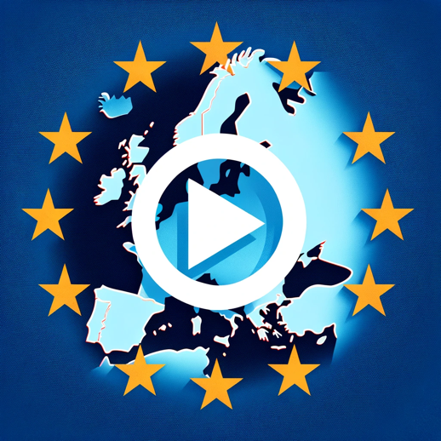The European Parliament amends the Geo-Blocking Report to keep AV out of the Regulation
The European Parliament’s report on the implementation of the 2018 Geo-blocking Regulation was voted on in the Plenary session on December 13th. You can find the complete report here, where the Parliament voted to remove the most problematic parts of the report and rejected the call to extend the Geo-Blocking Regulation to AV services. The favourable outcome of the vote underscores CEPI's commitment to defend the audiovisual industry business model and preserve cultural diversity across Europe.
The Report received significant support, being adopted with 376 votes in favour, 111 against, and 107 abstentions. A majority of the amendments put forth by CEPI and other stakeholders in the audiovisual sector received endorsement, with up to 62% of MEPs voting in favour.
In its amended form, the Report adopts a more balanced approach and rejects the wording asking for a lift of the exemption for copyrighted services. In turn, it now expressly acknowledges the critical role of territorial exclusivity in the audiovisual sector.While the report still mentions the “negative effect of geo-blocking practices on citizens living in cross-border regions or belonging to linguistic minorities”, it now explicitly states that "maintaining geo-blocking for copyrighted works and protected subject matter is a vital tool in upholding cultural diversity”.
It is essential to note that this report is not legally binding. While this marks a significant victory for the audiovisual sector, we know that this is one battle in a more extended campaign. Nonetheless, the vote underscores the majority support from MEPs for our sector and their rejection of the inclusion of AV services in the Regulation.
We take the opportunity to thank you for all your efforts in this endeavour. The positive outcome of the vote is a testament to our collective dedication and advocacy.You can find CEPI’s press release on the vote here, and a recording of our efforts in Screen Daily here.

Creative Europe


EU-supported films score big at European Film Awards
The European Film Awards of 2023, which took place on December 9th, saw a remarkable success for EU co-funded works, with five films grabbing a total of seven awards. This achievement underscores the impact of the EU's Creative Europe MEDIA Programme in fostering cinematic talent.
The award-winning films that benefited from the MEDIA funding are:
- "The Promised Land" (Bastarden), directed by Nikolaj Arcel, took home awards for Best Cinematography, Best Costume Design, and Best Actor for Mads Mikkelsen..
- Anna Hints's "Smoke Sauna Sisterhood" (Savvusanna sõsarad) was named Best Documentary.
- "Robot Dreams" by Pablo Berger won Best Feature Film.
- The Best Original Score went to "Club Zero" by Jessica Hausner.
- Alice Rohrwacher's "La Chimera" received the award for Best Production Design.
These wins at the 36th European Film Awards, held in Berlin on 9 December 2023, highlight once again the significant role of EU support in the film industry's success stories.
European Cinema Night 2023 showcases diversity in film across 85 cinemas
The sixth edition of European Cinema Night, held from the 4th to the 8th of December, celebrated European cinema's diversity with free screenings across the continent. This initiative, a collaboration between Creative Europe MEDIA and the Europa Cinemas network, attracted significant attention, with 85 cinemas participating.
The event offered a mix of European films, including family-friendly and classic movies, tailored to local audiences. Engaging activities like Q&A sessions with film industry professionals complemented the screenings, enhancing the cinematic experience. Since its debut in 2018, the initiative has grown significantly. Starting with 34 theatres, it has now reached 85, connecting over 10,000 cinemagoers and strengthening the sense of a shared European cultural identity.

Copyright


Disney accused of unlawful tech use in Beauty and the Beast
Jurors will soon decide the trial's outcome regarding Disney's alleged use of a San Francisco tech company's facial motion-capture technology for the lead character in the 2017 film "Beauty and the Beast."
Rearden MOVA claims unauthorized copies of its MOVA Contour software, made by another company, DD3, were used to create the Beast. Disney denies copyright infringement, asserting it is not responsible for DD3's actions.
Closing arguments were presented after Disney witnesses testified. Rearden argues a former employee, Greg LaSalle, took the MOVA tech, used by DD3, benefiting Disney. Rearden pays taxes and legal fees for pending MOVA Contour patents, indicating ownership. Disney allegedly used MOVA software for Beast but did not compensate Rearden. Disney argues that it cannot be liable for DD3's copyright infringement and questions if it did enough to ensure DD3 had a license for MOVA. A motion for judgment as a matter of law was filed by Disney.
The trial, presided over by U.S. District Judge Jon Tigar, involves jurors weighing copyright factors. Concerns about trial duration were raised due to conflicting evidence and the approaching holidays.

Piracy


France’s online content consumption and piracy trends in 2023
The 2023 edition of the French telecoms regulator Arcom's report on online content consumption highlights both legal and illegal digital content habits in France.
According to the report, 87% of internet users aged 15 and over consumed digital cultural and sporting content in 2023, a slight increase from 2022. While movies, music, and TV series remained the most consumed content types, spending on legal digital content rose significantly to an average of €38.00 per month.
The overall piracy rate remained static at 24% in 2023, indicating a levelling off in illegal content consumption. Piracy rates are notably higher among younger demographics and lower in older age groups. Illegal consumption of films and music saw a slight decrease, while TV series piracy rates stayed stable. Meanwhile, the popularity of illegal streaming and direct downloading methods has declined, suggesting a positive impact of anti-piracy measures. However, there's a notable rise in the use of Usenet, newsgroups, and Cloud services for accessing content, potentially due to their improved privacy features. Arcom's findings indicate a stabilization in illegal live sports broadcast consumption, with the overall trend showing a shift in how users access illegal content, perhaps in response to anti-piracy efforts.
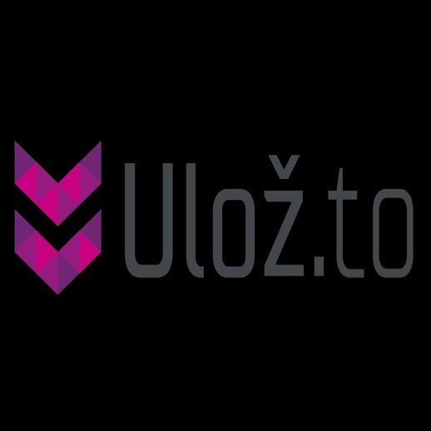Czech file-sharing giant Ulož shifts its model to adapt to the EU’s DSA provisions
Ulož, a prominent file-sharing and hosting platform based in the Czech Republic, is undergoing a significant shift in its business model, moving away from file-sharing to a private, cloud-based storage system starting December 2023.
The decision is attributed to the stringent conditions imposed by the EU's Digital Services Act (DSA). Despite being labelled a 'notorious market' by the MPA, Ulož had resisted implementing upload filters, expressing concerns about potential over-blocking and conflicts with EU law. The impending changes mean users can only download files they uploaded, ending public file-sharing and link-based sharing. Ulož assures users their files will be preserved, offering options to terminate accounts or switch to a free package. The move aligns with the DSA's requirements for intermediaries, mitigating risks associated with illegal content. The transition, deemed fundamental, is seen as a response to legal obligations and potential challenges from Hollywood and rights holders.

Recovery and growth of the AV industry


European cinema dominated domestic box offices in December
In the last quarter of 2023, European cinema made a remarkable stand in domestic markets, showcasing its vitality and appeal amidst international competition. Films like "The Peasants" in Poland and "The Riot" in Norway are not only holding their ground but also outperforming global hits like "Barbie" and "Napoleon" in various regions.
In Poland, "The Peasants" by DK Welchman and Hugh Welchman, an animated feature and the country’s Oscar candidate, has impressively earned over €8.16 million, overtaking Agnieszka Holland’s "Green Border." Meanwhile, in France, the latest "Asterix & Obelix" installment didn't make a huge impact, yet "3211," a music documentary about Stefan Djurić Rasta, surprisingly outshone major international releases in its opening weekend.
Bulgaria's "Dyad" is competing strongly against "Napoleon," with earnings of €301,856, while in the Czech Republic, Rudolf Merkner’s romantic comedy "Jak přežít svého muže" has garnered €1.27 million, following the success of Kamil Bartosek's "ONEMANSHOW: The Movie."
Romania reports strong performances with films like "Miami Bici 2" and Paul-Răzvan Macovei's "Romina VTM" entering the top ten, alongside the sequel to the hit "Mirciulică." In Hungary, Lajos Koltai’s "Semmelweis" has earned around €706,962, while Nils Gaup’s "The Riot" in Norway and Jalmari Helander’s Finnish war film "Sisu" have achieved notable success, with "Sisu" earning over €2.43 million domestically and €13.06 million worldwide.


International co-productions advertise Italian series and films, new study finds
Presented in December in Rome, the new study by ANICA (Italian National Association of Audiovisual and Digital Film Industries) and APA (Italian Association of Audiovisual Producers), one of CEPI’s members, has found that international co-productions are driving the foreign circulation of Italian audiovisual titles.
The study found that the number of co-productions between Italy and other countries has increased by 51% between 2017 and 2022, and that the amount of foreign funding for Italian film and TV projects has also increased. The study also found that the number of Italian titles being exported has increased by 28% between 2017 and 2022. The study concluded that the rise in foreign circulation of Italian audiovisual titles is due to a number of factors, including a growing demand for Italian content from global audiences, the entry of global VoD operators into the market, the Italian Tax Credit initiative, and the entry of foreign capital into the Italian film industry. The study warned that the impact of these factors may lessen in the coming years, and that further measures are needed to support the export of Italian audiovisual titles. The study also emphasized the economic importance of the creative industries in Italy, and called for continued support for the sector. As of 2022, 120,000 people are directly employed by the creative industries in Italy.
Screen production is growing in Poland, as the KIPA Summit highlights
The screen production industry in Poland is booming, with a significant increase in investment from broadcasters, SVoD providers and studios. The industry is also creating jobs and contributing to the Polish economy.
The study by OSPI, in collaboration with the Polish Producers Alliance (KIPA), one of CEPI’s members, found that the total spend on-screen production in Poland in 2022 was approximately PLN 2.5 billion (€576 million), which resulted in substantial economic output of nearly PLN 8.7 billion (€2 billion), GVA of over PLN 3.4 billion (€783.4 million) and the creation of approximately 21,000 full-time equivalent jobs. The report also found that over 60% of the budget expenditure on high-budget comedy and thriller series transcended the confines of the screen-production sector, funnelling into various sectors across the Polish economy, from healthcare to construction, fashion and beyond.
The Polish production incentive introduced in 2019 has boosted the sector's financial viability, with around 75% of producers highlighting the incentive's crucial role in making their productions financially feasible. In conclusion, the screen production industry in Poland is a significant economic force that is creating jobs and contributing to the country's economic growth. By making strategic investments and refining policies, the Polish government can further develop this industry and unlock its full potential.

Business News: VOD

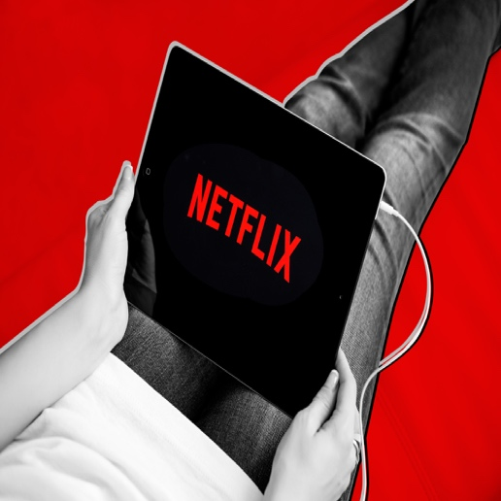
Netflix owns less than 25% of its European works’ IP rights, says its EMEA Director
In a discussion at Content London in December, Lina Brounéus, Netflix's Director of Acquisitions Strategy for EMEA, shared insights into the streaming giant's evolving approach to content ownership in Europe. Brounéus revealed that Netflix now owns less than 25% of the intellectual property (IP) rights for its European content, marking a significant shift in its business model.
Previously, Netflix aimed to own as much of its library as possible. However, the company has transitioned towards a more flexible strategy, embracing various content ownership models. Brounéus highlighted that Netflix is now open to targeted acquisitions for local markets, co-productions, and other acquisition models to build "win-win" relationships.
The shift in strategy is reflected in the diversity of content partnerships, including local acquisitions such as Channel 4's "Derry Girls” and the co-commissioning of "Borgen" with Denmark’s DR. Regarding European content quotas, Brounéus acknowledged that Netflix had previously met its 30% target in most European countries. However, there are discussions about redefining 'European works,' potentially excluding shows from non-EU countries like the UK and Turkey. Brounéus expressed Netflix's commitment to the EMEA region and emphasized the importance of fair policies that allow room for innovation.


Big VOD platforms are re-evaluating licensing strategies
The streaming industry is re-evaluating its strategies for licensing TV series and movies. With an end to the era of unlimited spending, platforms like Netflix are rediscovering the benefits of licensing content from other outlets. Licensed shows, such as "Suits" on Netflix, have become among the most watched on streaming services, with high episode counts contributing significantly to keeping users engaged.
Despite concerns over content removals for cost savings, data reveals that most major streaming services, except Amazon Prime Video, have increased their catalogues since January 2021. However, these figures don't fully capture the nuanced strategies, like Paramount+ almost tripling its content offerings before cutting back nearly half within a year.
A recent analysis by media consultant Mitch Metcalf showed that almost three-fourths of streaming time is spent on licensed shows and movies. Interestingly, the top 1,000 titles, less than 5% of available content in the U.S., account for about 70% of all streaming viewership, while nearly half of the titles register minimal viewing.
Amidst this, ad-supported services like Tubi, The Roku Channel, and Pluto TV are thriving by offering more niche programming with lower licensing fees. As the industry evolves, even Netflix is now licensing from others, like sharing rights for legacy HBO shows, reflecting a shift back to earlier industry practices.
Netflix’s new engagement report shares viewing numbers for more than 18,000 titles
For the first time in its history, Netflix released an engagement report of the most-watched movies and TV shows on its platform in the first half of 2023, including more than 18,000 titles and accounts for about 99% of all viewing on Netflix.
About 55% of viewing was for originals and 45% was for licensed shows and films. Suits, which dominated the Nielsen U.S. streaming charts for much of the summer and fall, had a combined 599 million hours of viewing worldwide on Netflix across all nine seasons. At the other end, a little more than 20% of the titles on Netflix’s list (3,813 in all) had very little viewing. The company rounded them to 100,000 hours, but they would fall between 50,000 and 149,999 hours.
The Night Agent was the most-watched title, with 812.1 million hours of viewing. Season two of Ginny & Georgia was second, with 665.1 million hours. Korean drama The Glory was third, with 622.8 million hours. Wednesday ranked fourth, with 507.7 million hours, despite being released in November 2022. As for the timing of the data release, Netflix co-CEO Ted Sarandos said the company has been on a “continuum” of becoming more transparent as its streaming business has matured.
French Audiovisual strike ensues after stalled salary negotiations
The French audiovisual industry experienced a significant disruption with a nationwide strike on December 19. This followed weeks of mobilization by technicians demanding a substantial salary increase, citing a decline in purchasing power and escalating inflation.
The strike, which included protests and work stoppages, was a response to stalled wage negotiations. It affected a wide range of industry professionals, from wardrobe staff to directors of photography and filmmakers. Demonstrations were notably held in front of the Ministry of Culture in Paris. "Since 2007, wages have plummeted, particularly over the last three years with galloping inflation," explained to Libération Laurent Blois, general delegate of Spiac-CGT.
This unrest has impacted over 70 productions, including popular series and documentaries. High-profile projects like TF1's "HPI" and Canal+'s "Marie-Antoinette" were among those disrupted. The strike underlines ongoing challenges in the sector regarding fair compensation and working conditions.
StudioCanal and M7 expand collaboration by launching streamer app ArtHaus+
StudioCanal, a Canal+-owned production arm, has launched a new standalone app for its streaming service, StudioCanal Presents: ArtHaus+. The app is available on smart TVs, mobile devices, and the web. It offers over 400 titles from the specialist ArtHaus label that will be regularly expanded and curated. The app is available for Samsung, LG, Sony, and other smart TVs and will soon be expanded to Amazon Fire TV. It can also be accessed on mobile devices and tablets via the Apple App Store or Google Play Store. The app is a strategic step into direct end customer business for the company and offers film lovers another tailor-made, well-curated offer. The app was developed by Eviso Germany GmbH, a business partner of M7, and was created with the goal of expanding the market leadership of the company in the content area with regard to outstanding VOD offerings.
Netflix's compensation offered to Polish filmmakers and its controversy
Netflix's offer of extra compensation to Polish creators is criticized by the Association of Polish Filmmakers (SFP). The SFP is concerned about unfavourable conditions for film crew members and the conditional nature of the proposed compensation, linked to high viewership. Key points of contention include creators waiving claims, reduced information sharing by Netflix, and worries about waiving statutory royalties. The SFP sees Netflix's offer as an abuse of its dominant position, dividing the Polish film community. The industry awaits further developments and considers potential impacts on the Netflix-creator relationship and fair compensation discussions.

Business News: Film & TV

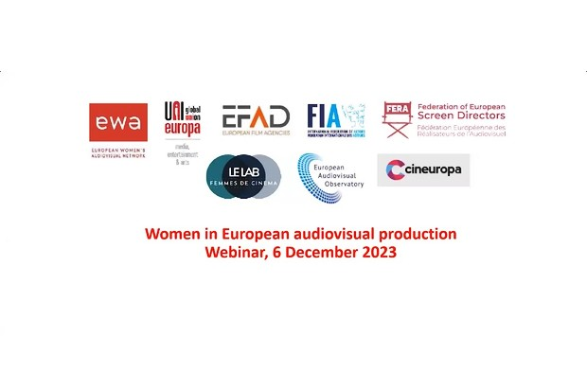
Women in the audiovisual industry: latest statistics from the European Audiovisual Observatory
A group of organisations and research bodies in the European audiovisual sector hosted on the 6th of December a webinar to discuss the place of women in audiovisual production.
The webinar featured presentations from the European Audiovisual Observatory (EAO) and the Lab Femmes de Cinéma, as well as discussions from a number of speakers. During the presentation of the latest gender statistics of the European Audiovisual Observatory, Patrizia Simone presented her key findings. According to the findings, women are significantly underrepresented in the European film industry, comprising just 26% of the workforce. This marks a modest increase from 21% in 2013 to 25% in 2022, indicating a slow but positive trend towards greater equality. However, the representation of women is particularly low in specific roles such as directors and cinematographers. It was also noted that female directors often encounter challenges in directing a second feature film after their debut.
The situation varies across the European Union, with Austria having the highest average representation of women in the industry at 34%. In terms of genres, documentaries have the highest share of female professionals in all categories, except for cinematographers. Furthermore, films directed by women tend to have a higher percentage of women in other key roles compared to films directed by men. However, a disparity exists in terms of production budgets, with films by female directors typically having lower budgets than those directed by men. The gender pay gap in the film industry was reported to be 12.7%.
There are several challenges to closing the gender pay gap, including the fact that many women in the industry are freelancers and that there is a lack of pay transparency. The EU Directive on Pay Transparency is helping to address the issue of pay discrimination. Despite the slow and steady progress, there is still a need for more concrete actions to address gender inequality in the film industry.


Rome Lazio Film Commission hosted a panel on the new professional opportunities in the audiovisual sector
The audiovisual sector is undergoing a period of transformation, including the emergence of new professional roles such as green manager, intimacy coordinator, brand manager, diversity and inclusion manager, VFX supervisor, post-production supervisor, sound designer. The Rome Lazio Film Commission has organized a panel discussion to discuss these new roles and to develop a strategy for training new generations for these jobs.
The panel featured experts from different areas of the audiovisual sector, including Carla Bernardin, green and sustainability manager at Fremantle; Luisa Lazzaro, intimacy coordinator; Laura Corbetta, chair of OBE Osservatorio Branded Entertainment; Giuseppe Musci, diversity and inclusion manager at SKY; Francesco Mastrofini, co-founder and CEO of Rainbow CGI; Monica Verzolini, post-production supervisor; Fabio Cerrito of frame by frame; Mirko Perri, sound designer; Federico Basso, film director and creative director of ETT; Raoul Carbone, chair of the Video Game Museum of Rome Foundation; and Fabio Viola, game designer and curator of the gaming area at Turin's National Film Museum.
The panel discussion highlighted the importance of these new roles and the need for training programs to prepare for them. The participants also discussed the future of the audiovisual sector, with a focus on the growth of the videogame industry.
Nordic digital surge and the rise of unlimited cinema access
The Nordic TV and video market, as reported by Stockholm-based consultancy Mediavision, is on an upward trajectory, expected to generate €9.8 billion in 2023 with projections to exceed €10 billion the following year. This growth is primarily driven by a burgeoning digital services sector, with paid streaming subscriptions nearing 20 million and online viewing taking precedence over traditional TV. Despite a weaker economy and sluggish advertising, the region's video market has seen a 10% annual growth in digital video services like SVOD, TVOD, and AVOD, compensating for the decline in traditional broadcast revenues.
In response to these evolving market dynamics and to further boost cinema attendance, Nordisk Film Cinemas in Denmark has introduced Bioplus Unlimited. This new subscription service, priced at 229 Danish crowns (€30,7) per month, offers unlimited access to regular screenings across its 23 theaters, excluding special events. Initially tested in Aalborg, the service has been successful in attracting frequent movie-goers and younger audiences. Alongside encouraging regular cinema visits, the subscription provides discounts on additional tickets, fostering a culture of diverse film consumption. Despite its early success, Nordisk Film Cinemas is committed to continually evaluating and refining Bioplus Unlimited to adapt to changing consumer needs and market conditions, aiming to contribute positively to the thriving Nordic cinema and digital entertainment landscape.
France Télévisions, the French Screenwriters Guild, the SACD, the SPI, the USPA and the U2R have signed an Annex to the 2011 Fiction Development Charter
France Télévisions, the French Screenwriters Guild, the SACD, the SPI, the USPA and the U2R have signed an Annex to the Fiction Development Charter to extend the Charter's system to all fiction pre-financed by France Télévisions: international co-productions, young adult fiction, youth fiction. It sets up a precise and formalized procedure for welcoming and developing projects, unique in the audiovisual landscape, promoting dialogue between France Télévisions, authors and producers while making development processes more flexible.
Its objective is to encourage the development of more projects and thus support the ambition of France Télévisions in the implementation of its “Creation Plan” of which fiction represents an essential part. The Charter has allowed France Télévisions fiction to undergo profound renewal since 2017, and to achieve numerous successes. The new Annex provides that developments financed by France Télévisions which have not been put into production may be transferred to a third party broadcaster, with reimbursement, on the first day of filming, to France Télévisions of the sums it has invested.
The signing of this new Annex to the Charter for the Development of Fiction involving authors, producers and France Télévisions - which today represents more than 50% of investments in French creation - is an opportunity to strengthen dynamism and renewal of creation, increase the volume of production and employment in the sector, accelerate the diversification of fiction and support talent.

The Netherlands signs new Memorandum of Understanding on the dissemination of Audiovisual content
The Netherlands has signed a new Memorandum of Understanding facilitating the online, cost-free dissemination of non-commercially circulating audiovisual heritage. The agreement involves major heritage and broadcasting organizations like StOPnl, NPO, NOS, EYE Filmmuseum, Beeld & Geluid, and KVAN, covering almost all out-of-commerce audiovisual works produced in Europe. StOPnl is recognized as the representative CMO for such works, allowing publication of certain broadcast materials without a license. The MoU stipulates that works over 25 years old are deemed out-of-commerce unless actively traded, and outlines presentation standards for non-commercial use, including technical protections and crediting of all relevant parties. These works can be published on all non-commercial Dutch heritage websites.

Festivals


Winners of the 2023 European Film Awards
The 2023 European Film Awards, held on December 9 in Berlin, showcased the diversity and talent in European cinema. The night's standout was the French drama "Anatomy of a Fall" by Justine Triet, sweeping the awards for Best Film, Director, Actress, Screenwriter, Editing, and the European University Film Award. The full list of winners is available at this link.
During his acceptance speech, the producer of "Anatomy of a Fall," David Thion, referred to the European Parliament’s vote of 13 December and emphasized the importance of preserving territorial exclusivity. He stated that including audiovisual services in the Geo-blocking Directive would represent the threat to cultural diversity in Europe, advocating for the preservation of geoblocking to support the unique cinematic heritage of the continent. Thion's remarks resonate with the EU's principle of unity in diversity, underscoring the need to nurture and protect Europe's cultural exception.
The European Film Academy has already announced that the 2024 edition of the awards will be held in Lucerne, Switzerland. This event continues to be a pivotal platform for celebrating and promoting European cinema's richness and variety, fostering a deeper appreciation for the continent's unique cultural tapestry.

Marché du Film 2024: spotlight on Swiss cinema in Cannes
Switzerland is set to be the "Country of Honour" at the Marché du Film, the film industry event held alongside the Cannes Film Festival in May 2024. This will be a great opportunity for Switzerland to showcase its rich and diverse film industry, and to connect with international partners.
This news comes alongside Greta Gerwig’s upcoming Cannes Presidency of the Jury, as she stated: “I am stunned and thrilled and humbled to be serving as the president of the Cannes Film Festival Jury. I cannot wait to see what journeys are in store for all of us”. Beyond being the first American female director to be appointed as Cannes Jury President, Gerwig, at the age of 40, is also the youngest person to take on the task since Sofia Loren headed the jury in 1966 at age 31.
Switzerland has a strong track record of producing high-quality films, and has won numerous awards at major international festivals. The country is also home to a number of prestigious film festivals, and has a strong reputation for innovation and new technology. The Marché du Film's deputy director Guillaume Esmiol is excited about Switzerland's participation in the event. He believes that Switzerland's innovative spirit and commitment to high-quality filmmaking will be a great fit for the Marché du Film.
Festival Calendar
January
- FIPADOC Documentary Film Festival, France - January 19-27
- International Film Festival Rotterdam, Netherlands - January 25-February 4
- Goteborg Film Festival, Sweden - January 26-February 4
- Ostend Film Festival, Belgium - January 26-February 3
- DocPoint Helsinki Documentary Film Festival, Finland - January 30-February 4
February
- Berlin International Film Festival, Germany - February 15-25
- European Film Market, Germany - February 15-21
- Dublin International Film Festival, Ireland - February 22-March 2
- Glasgow Film Festival, UK - February 28-March 10

Interesting studies


European Audiovisual Observatory’s AVMSDigest to overview AVMSD legislation
This November the European Audiovisual Observatoryintroduced its latest publication series titled AVMSDigest.
This series aims to provide a concise comparative overview of European and national legislation stemming from the Audiovisual Media Services Directive (AVMSD). Its first publication in particular incorporates both text and explanatory graphics, offering a condensed perspective on the regulatory framework, coupled with market insights. Readers can independently assess the impact of various policy choices. AVMSDigest is structured to be visually accessible and informative, adopting a more compact format than typical publications. In this inaugural edition, findings on the implementation of AVMSD Articles 13, 16, and 17, along with relevant market figures, are compiled across EU member states, EEA, EFTA countries, and the UK. The information is based on publicly available data as of July 31, 2023, with subsequent developments not considered in this publication.
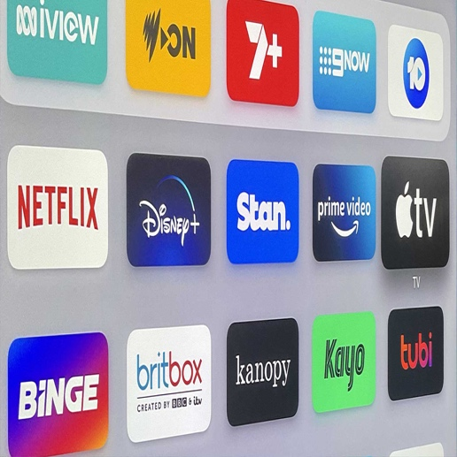
Streamers double down on content investment amid surging SVOD subscriptions
Streaming giants, defying calls for cuts, will invest billions in content, anticipating a boost in viewership and revenue.
Notably, 85% of recent Netflix content is from the last three years, and nearly 90% of global streaming from Feb 27 to Mar 19, 2023, is from 2021 or later. Engagement, key for higher revenue, explains 92% of ARPU variance. Despite subscriber growth slowdown expectations, Netflix plans a $17 billion content spend in 2024; Disney, $25 billion. In line with this, research carried out by Digital TV predicts global SVOD subscriptions will hit 1.79 billion by 2029, growing by 321 million from 2023. Six US platforms are set to have 946 million SVOD subscribers by 2029, led by Netflix's addition of 44 million. Amazon Prime Video aims for 296 million subscribers. Disney+ forecasts 192 million by 2029, facing Asia Pacific challenges. China emerges as a key market, with 391 million subscribers projected by 2029. Platforms now gauge success by profitability, favouring Netflix over its US-based peers, notes Simon Murray of Digital TV Research.
EAO study points to the dominance of Low and Mid-Tier films in 2022 admissions
In December, the European Audiovisual Observatory released its new report, "An Analysis of European Box Office Structure 2010-2022”, delving into the composition of the European box office with a particular focus on four film categories: blockbusters, high-grossing films, mid-tier films, and low-grossing films. In 2022, fewer than 100 films sold over one million tickets across Europe, despite a diverse offering of over 12,000 films. Notably, 96% of these films were classified as low-grossing.
The concentration of the European box office is evident, with the top 10 and top 20 films contributing to 34% and 48% of total admissions, respectively. US blockbusters play a crucial role, constituting 32% of all cinema tickets sold in Europe in 2022. However, variations exist among European markets, with the UK and Ireland leading at 51% of total admissions for US blockbusters, while in France it stands only at 31%. The decline in US mid-tier films affects overall admissions to this category, as the industry increasingly focuses on blockbusters. Notably, nearly 70% of admissions to European films come from low-grossing and mid-tier films. Furthermore, 75% of cumulative admissions to European films occur in their home markets, with the remaining 25% in non-national European markets.
EAO publication on fair remuneration in the digital AV sector
In the digital era, the fair remuneration of audiovisual creators has become a pressing issue, drawing attention from industry stakeholders and policymakers alike. The European Audiovisual Observatory's (EAO) latest study delves into this complex landscape, offering a comprehensive analysis of the current challenges and emerging solutions.
The study begins by contextualizing the issue within the broader framework of the European Union's digital market. It highlights the pivotal role of the DSM Copyright Directive. A significant portion of the study is dedicated to examining the varied responses of these member states. It outlines how different countries are navigating the legislative changes, adapting their national laws, and impacting the audiovisual sector. This comparative analysis not only underscores the diversity in approaches but also sheds light on best practices and areas needing improvement.
Following detailed case studies and legal frameworks, the study concludes by reflecting on the future directions in the field of fair remuneration. It underscores the importance of ongoing dialogue and adaptation in legislation to keep pace with the rapidly evolving digital landscape. The study emphasizes the need for collaborative efforts among creators, industry stakeholders, and policymakers to ensure a balanced and fair remuneration system that recognizes the value of creative contributions in the audiovisual industry.

Interesting links

- PRIVATE CREDIT FINANCING FOR FILM & TV WILL ONLY GROW AFTER STRIKES by Variety
- FIFDH Impact Days announces its 2024 selection by Cineuropa
- Overview of national funds to support cinema and audiovisual sectors in 17 selected European countries by Cullen International
- Netflix Streaming Success Not Just From Top Shows: Analyst by MediaPost

Events and Opportunities


CIMIx 2024: Creative Industries meet Industry - The Crossover Edition #CIMIx2024
Mark your calendars for CIMIx | The Crossover Edition in Vienna, January 18, 2024.
Expanding upon the successful debut of the CIMIx format in January 2023, the upcoming edition will continue to highlight relevant current subjects, uniting companies from the creative industries. CIMIx | The Crossover Edition aims to establish connections among the film, TV, music, audio, and games industries, emphasizing collaborative efforts in production and distribution formats, alongside the exploration of cross-sector issues like artificial intelligence, licensing, and export. Facilitating an even more global reach, the event will provide simultaneous German/English translations.Find out more about the event and register to participate here.


35th Edition of FIDMarseille: Call for Film Submissions
Film submissions are now open for the 35th edition of FIDMarseille. Eligible films include those produced after January 1, 2023.
Deadline for films produced in 2023: January 15, 2024
Deadline for films produced in 2024: March 15, 2024.
Find more information here.
Join the 2024 Oxbelly Writers' Retreat in Greece
Apply now for the Oxbelly Retreat (June 22-30, Costa Navarino, Greece), a unique gathering for screenwriters, episodic writers, and fiction writers. The retreat offers workshops and one-on-one sessions led by industry experts, aiming to deepen craft and foster intercultural dialogue. All fellow expenses are covered, with no application fee. Programs focus on various aspects of writing, led by Nicole Perlman, Jörg Winger, and Chigozie Obioma. Don't miss this chance to elevate your storytelling in an inspiring setting.
Deadline for applications: January 19, 2024.
Join dok.incubator 2024: Elevate Your Documentary
Applications are now open for the 2024 dok.incubator workshop. Targeting feature-length documentaries at the rough-cut stage, this eight-month program offers intensive mentorship from industry experts in editing, distribution, and audience engagement. Teams of a producer, director, and editor will work to refine their films for a global audience.
The workshop culminates in three residential sessions throughout 2024, aiming for a picture lock by early autumn. Participants will receive tailored feedback and develop marketing strategies to ensure their films reach the widest audience possible. Dok.incubator alumni have gone on to feature in major festivals and receive numerous awards, showcasing the program's impact.
Deadline for submissions is 25 January 2024. Apply now to transform your project into an international success story.
Call for Submission - Barcelona Film Festival 2024
Barcelona Film Festival (BCN) 2024 opened its call for film entries. Directed by journalist Conxita Casanovas this year, the 8th edition of the festival is taking place from April 18th to 26th.
In the spirit of Saint George's Day, and International Book Day, the festival is expected to showcase remarkable World, European and/or Spanish works with a focus on art, especially on book adaptation and history.
Moreover, the festival is divided into three selection areas, the Official Selection pays attention to Saint George’s Day, culture and history, the Cinema amb Gràcia section which focuses on comedies, and the Zona Oberta section for other films of interest to organizations or the festival.
The call to submit film projects is open to international sales agents, distributors and producers. You can register your entry using this link. The deadline for submissions is February 2nd, 2024.
Before applying, make sure to read more about the regulations and conditions here.
Eurimages' E-Learning Platform Call for Sustainable Film Production
Eurimages is accepting proposals for an e-learning platform to boost sustainable practices among film professionals. This initiative targets improving skills in international co-production for all film genres. It offers modular training, culminating in a certificate of participation, and emphasizes the exchange of best practices. The project seeks partners for content creation, technical development, and platform maintenance. Collaborate with Eurimages to shape sustainable film production's future.
Find more information here and submit your proposal by 12 February 2024, 10 AM.
2024 Golden Nymph Awards: Celebrating Excellence in Television
The Monte-Carlo Television Festival announced the 63rd edition of the Golden Nymph Awards, from 14th to 18th June 2024 at the Grimaldi Forum Monaco. Celebrating TV Films, Mini-Series, TV Series, Documentaries, and News Programs, the competition highlights original creations for television or SVOD platforms.
Entries are free and open to broadcasters, distributors, and producers, with programs broadcast for the first time after January 1st, 2024, eligible. Categories include Fiction, News & Documentaries, and the Prince Rainier III Special Prize. Notable awards include Best Film, Best Series, and a Jury Special Prize among others.
Submit your entries between February 1st and March 21st, 2024. Ensure programs are submitted with English subtitles and meet the specified technical requirements.
For detailed rules, registration, and submission, click here.

