CEPI Newsletter October 2023


Dear CEPI Members,
This month has seen significant activity within the EU institutions.

First, CEPI responded to the Commission’s consultation process, launched after the publication of the Media Outlook, aiming to gather industry insights and formulating recommendations for the next Commission. In our response, we emphasized several critical points: the necessity to strengthen European IP rights to have a common understanding and recognition; the need to clarify the producer’s role and contributions in project development; the importance of creating a more balanced environment for European producers; the enhancement of quotas and investment obligations in the AVMS Directive; and finally addressing the complexities of AI in the AV sector, lawful content access and transparency obligations. We are expecting the Commission to hold a technical roundtable in Brussels to further discuss the different responses they’ve received from stakeholders.
In parallel, the Commission held a meeting with AV stakeholders on October 24th, to discuss AI and the text and data mining (TDM) exception, present in the 2019 Copyright Directive. During the meeting, several stakeholders raised concerns about the practicality of the opt-out mechanism, including how authors and producers can express reservations. Challenges associated with applying the opt-out to pre-existing works were discussed. And, all stakeholders stressed the importance of transparency obligations to ensure AI developers respect the opt-out option. The Commission is now requesting written feedback on this topic by the end of November. To contribute your views, please answer this Google Formbefore the 24th.
This month, the Parliament’s Internal Market (IMCO) Committee adopted its report on the implementation of the Geo-blocking Regulation. Despite coordinated efforts from the AV sector, the final report asks the Commission to propose solutions that will “allow consumers, in particular citizens living in cross-border regions or belonging to linguistic minorities, legal access to varying cross-catalogue content across borders”. As we move forward, the CEPI remain dedicated to actively engaging in the upcoming debates and advocating for amendments that align with the interests of our sector.

The Plenary session vote on the text is scheduled for the end of November or early December. You can find more information in the “Territoriality” section of this newsletter.
On a different policy file, CEPI supported the position adopted by the Parliament on article 20 of the European Media Freedom Act (EMFA), which clarifications are vital in safeguarding ambitious cultural policies of Member States that promote European audiovisual creation. These clarifications address concerns raised in a joint letter, signed by CEPI and 73 other European and national organizations, regarding the potential impact of the Commission's proposal for Article 20. The improved text now confines Article 20 to media pluralism and the editorial independence of media service providers, ensuring it does not impede national measures for promoting European works or those governed by State aid rules. The negotiations with the Council of the EU, which agreed on its position in June 2023, will now begin to decide on the final shape of the law.
The European Parliament also adopted its position on the 2024 draft EU budget, in which it emphasized “the key role that Creative Europe plays in supporting the cultural and
creative sectors”, and asked to “increase financing for the Creative Europe programme by EUR 25 million above DB, with EUR 15 million for the Culture strand and EUR 10 million for the Cross-Sectoral”.
Looking ahead, on the 9th and 10th of November, CEPI will hold its Annual General Assembly, which will take place in Lisbon this year. This year's assembly will include Board elections, insightful discussions on various policy matters, as well as updates on AI, national updates from our members, and discussions related to the next European elections. We look forward to seeing you in Lisbon in a couple of weeks!
We hope you will find this newsletter informative,
Best regards,
The CEPI team

SAVE THE DATE!
CEPI General Assembly: 9-10 November, in Lisbon
We look forward to seeing you there!



Sections in this newsletter

- Latest from the EU
- AV industry starting up again
- Copyright
- Creative Europe
- Digital Policy
- Territoriality
- Piracy

- Business News: VOD
- Film and TV
- Festivals
- Interesting studies
- Interesting links
- Events and opportunities

Latest from the EU

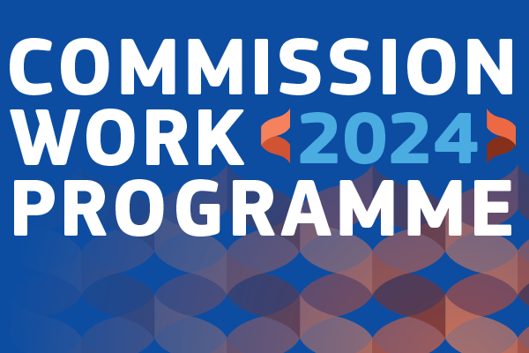
“A Europe fit for the digital age” as part of the Commission work programme 2024
The European Commission has published its 2024 Work Programme, called “delivering today and preparing for tomorrow”.
Pursuant to the 2020s Digital Decade with clear digital targets, the EU and its Member States “have set a course to improve digital skills, digitalise administration and businesses, boost research and innovation, close the digital gap and upgrade our digital infrastructure. At the same time, the EU is leading the way in managing the risks of our digital future.”
The DMA and the DSA have paved the way for a more competitive and safe digital market, as well as the AI Act proposal could further ensure safeguards in the application of such a fast-evolving technology. The Digital Decade targets for 2030 will call for further major investments in digital networks. Following the recent exploratory consultation, the Commission is set to prepare the ground for possible policy and regulatory actions regarding Digital Networks and infrastructure, notably “to facilitate cross-border infrastructure operators in the Single Market, accelerate deployment of technologies and attract more capital into networks.”

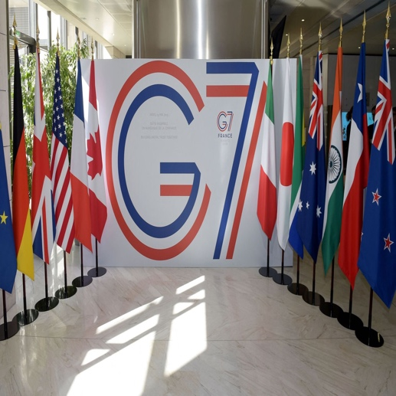
European Commission is opening up to stakeholders’ views after G7 agreement on formulating guidelines for AI
The European Commission has launched a stakeholder survey on draft International Guiding Principles for organisations developing advanced AI systems, which have been agreed by G7 ministers for stakeholder consultation.
“We want to join forces with partners, like the United States, Canada, Japan and other G7 countries, to develop the first set of serious rules for AI, such as generative AI,” said Commission Vice President Jourová during the G7 meeting.
The eleven draft guiding principles, which cover advanced AI systems such as foundational models and generative AI, aim to promote safety and trustworthiness of the technology. On this basis, G7 members compiled a Code of Conduct that provides guidance for organisations developing AI tools.The G7 guiding principles and voluntary Code of Conduct will complement at a global level the legally binding rules that the EU co-legislators are currently finalising under the AI Act.
Why Europe Needs a Cultural Deal and the upcoming elections’ chance to make a difference
In an article published on the Parliament Magazine, Isabelle Schwarz, the Head of Public Policy at the European Cultural Foundation, highlights the significance of culture in addressing Europe's pressing issues. As the European Parliament elections approach, there's an opportunity to redefine the continent's priorities, focusing on culture, people, and the climate. Culture plays a pivotal role in dealing with challenges such as populism, climate change, social disparities, and geopolitical conflicts. In response to the cultural and creative sectors' struggles during the pandemic, the Cultural Deal for Europe campaign was launched. It seeks to integrate culture into all relevant EU policies and actions. The campaign successfully secured a €12 billion investment in culture through Member States' National Recovery and Resilience Plans, but there's more to be done in making culture a central aspect of EU policies. Schwarz recalls that culture is indispensable for democracy, freedom, and peace, and it is under threat in regions like Ukraine, emphasizing its critical role in preserving Europe's identity and future.
The European Parliament is contemplating major Committee restructuring
The European Parliament is considering a major reform of its committee structure, with a 'reflection paper', which was seen by Euractiv, proposing significant changes. Currently organized into 20 permanent committees and four sub-committees, the proposal aims to halve the number of committees in an effort to streamline the legislative process and reduce conflicts of competencies between committees. While simplifying committee attributions, the changes may also concentrate legislative power among fewer Members of the European Parliament. Additionally, five horizontal committees would be established, called ‘special committees’ on the rule of procedure, immunities, and legal matters, EU constitutional affairs, relations with citizens, gender equality and gender mainstreaming, and human rights and democracy.

AV industry starting up? & COVID impact on the sector


New Madrid Audiovisual Cluster aims to promote growth and boost industry
At the beginning of the month, a panel of founding executives of the newly formed Madrid Audiovisual Cluster discussed the opportunities of the new initiative at the Iberseries & Platino Industria forum in Madrid.
The cluster is a new initiative launched in March this year, aiming to boost the audiovisual sector in the Spanish capital; it’s made up of 67 private and public companies and is led by industry veterans such as Raúl Berdonés, CEO of Secuoya Content Group and president of the cluster.
During the panel, the cluster's founding executives, highlighted the city's advantages, including its tax breaks, geographical location, and connectivity. They also called for the development of more post-production companies to attract more big-budget international productions. The cluster is expected to play a key role in helping Madrid achieve its goal of becoming a global audiovisual hub. It will also help the sector keep up with the latest trends, such as augmented reality and AI.
Overall, the Madrid Audiovisual Cluster is seen as a positive development for the Spanish audiovisual sector. The cluster has the potential to help the sector grow and thrive and to make Madrid a leading global production hub.
International film production surge in Italy, but local audience interest decline
On the first day of Rome's MIA – International Audiovisual Market (October 9-13), a panel discussion titled "Italian Film and Audiovisual Industry Numbers - 2022" was held, during which experts discussed the most recent data on Italian film and audiovisual production, published in the report of the same name by Italy's national Film and Audiovisual Department.
Reported data found that the number of international films shot in Italy in 2022 exceeded the total number of films shot there between 2016 and 2021, and grew by 60% on 2021. However, the report also found that the reception of Italian films in domestic cinemas has declined. In 2022, Italian films had a market share of just 18%, down from 37% in 2021, which suggests that Italian audiences are not interested in seeing Italian films.
The panellists pointed out the decline in the market share of Italian films in domestic cinemas and they argued that in response, the industry needs to focus on producing films that audiences want to see, rather than focusing only on production incentives. They also suggested that the government needs to revise its support systems for the industry, as to encourage the production of high-quality films.
French box office bouncing back amid challenging September
The French box office faced a challenging September with just 8.8 million ticket sales and a total gross of approximately €63.2 million, marking a 21.1% decline compared to the pre-pandemic 2017-2019 average.
While this is the lowest figure since 2005, it does show a 16.1% increase from last year's dismal 7.6 million admissions. The French box office has been gradually recovering throughout the year, with July and August figures even surpassing pre-pandemic averages.
Distributors have adapted to the traditional September slump by releasing smaller films during this period. The biggest film of the month was Sony's "The Equalizer 3" with 787,000 admissions. An exception to the September trend was Justine Triet's "Anatomy Of A Fall," which has been performing consistently since its August release, totaling 1.1 million admissions.
Despite the September setback, the annual outlook for the French box office remains positive, with expectations to surpass 2022's 152 million in annual ticket sales. October and November are seen as critical months, with anticipated releases like "The Trolls 3," Martin Scorsese's "Killers Of The Flower Moon," and more. The industry is optimistic about continued growth, even if it might not reach the peak admissions of previous years.

Copyright

Google to support generative AI users against copyright violations
Google officially announced that it will defend users of its generative AI systems in its Google Cloud and Workspace platforms if they are accused of intellectual property violations.
Generative AI systems are trained on massive amounts of data, including text, code, and images, and can be used to create new content, such as text, images, and music. However, some copyright owners have argued that the use of their work to train these systems and the content the systems create violates their rights. Google's new policy applies to software, including its Vertex AI development platform and Duet AI system, which generates text and images in Google Workspace and Cloud programs. However, the policy does not apply if users "intentionally create or use generated output to infringe the rights of others."
Google is the first major tech company to offer a comprehensive, two-pronged approach to indemnity for generative AI users, covering both the cost of defending users against intellectual property lawsuits and any damages that are awarded against them.


Balancing copyright law in the Digital Age: a broader construct of consent for creative reuse
In an article by Georgia Jenkins from the University of Kent, the role of exploiters in European copyright law and their impact on creativity is explored. Specifically, the article delves into the implications of the Information Society Directive and how it has favoured online business models over creativity.
The introduction of Article 17 of the Copyright in the Digital Single Market Directive is discussed as a regulatory instrument that solidifies the role of exploiters, who often lack artistic contributions, in the creative process. The burden on platforms to police vast amounts of content has led to the use of algorithmic decision-making to identify potential copyright infringement. The article emphasises the importance of striking a balance between authors, users, platforms, and exploiters. It suggests that a broad construction of consent can be achieved by considering both authorship and the doctrine of exhaustion. This construct defines the boundaries of authorial consent over future creative reuses and explores the extent to which authors can rebut the exhaustion of consent. A practical framework for creative reuse online is proposed, focusing on the exhaustion of authorial consent once authors are compensated. It also considers the possibility of artistic reputational harm and when authors may withdraw their consent from future creative reuses.
The article concludes by highlighting the need for a balanced approach to copyright law that supports and fosters various forms of creativity online. It also references the German implementation of the DSM Directive as a potential way forward, emphasizing the importance of a broad approach to consent in protecting and facilitating all types of creativity in the digital age.

“AI Hub” on Discord servers faces legal actions in the US for copyright infringement
Over just a few months, Discord server AI Hub - a server for fan-created AI songs and the creation of AI voice models - gained more than 500,000 members. On the server, AI enthusiasts are called upon to share the latest tips, tricks, and developments, as well as complete models. Some of these models included voice models of popular musicians, such as Bruno Mars and Frank Sinatra.
AI Hub was aware of copyright infringement and its sensitivities and prohibited its members from sharing copyrighted content, however not all of them.
RIAA, a trade association that represents American music companies, is closely monitoring the development of artificial intelligence. When they noticed copyrighted content being shared on the AI Hub, they took legal action.
The RIAA used a DMCA subpoena to get the names of several users who are accused of sharing copyrighted content. As part of its efforts, RIAA asked Discord to shut down AI Hub, which at that time had reached approximately 80,000 members. By the first week of October, AI Hub completely shut down, presumably following more copyright-related allegations.
This is however unlikely the end of it. Given the success of AI Hub, several new servers are lined up to take its place; while Discord is shutting down one server, another one will be popping up. AI can eventually fix this problem by developing better ways to detect and remove copyrighted content, however, until then, it is a problem that is likely to persist.

Creative Europe


Creative Europe Program: TV and online content call is open
An exciting funding opportunity from the Creative Europe Program (CREA) is open, the 2024 TV and Online Content call.
Its objectives include strengthening the independence of European producers from broadcasters and digital platforms, increasing collaboration between operators from different countries participating in the MEDIA strand, and producing high-quality programming aimed at wide international distribution. To submit your project, please follow this link.
The deadline for project delivery is December 7th - 17:00 CET
The negotiations with the Council of the EU, which agreed on its position in June 2023, will now begin to decide on the final shape of the law.
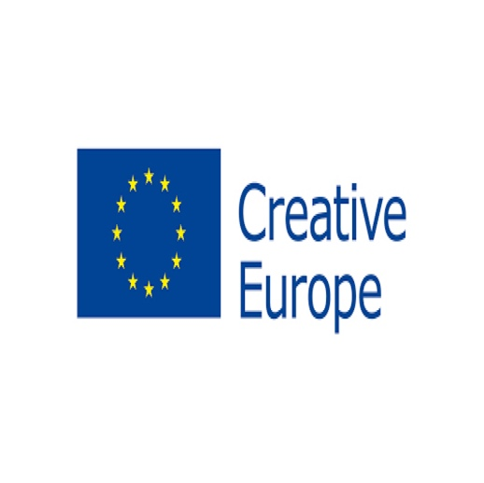
European Union adopts 2024 General Budget with emphasis on Creative Europe Program
The European Union has formally adopted its General Budget for the financial year 2024, and among the notable highlights is a strong emphasis on the Creative Europe program.
This budget, which outlines the financial allocations and priorities for the coming year, recognizes the “key role that Creative Europe plays in supporting the cultural and creative sectors, promoting media literacy, combating disinformation, and upholding media freedom and pluralism as essential elements of a functioning democracy”.
To support and bolster the cultural and creative sectors, the General Budget for 2024 proposes an increase in funding for the Creative Europe program. An additional EUR 25 million is allocated above the Draft Budget, with EUR 15 million designated for the Culture strand and EUR 10 million for the Cross-Sectoral strand. This boost in funding aims to empower the creative industry, enabling it to navigate the challenges posed by recent economic fluctuations.
This financial boost is expected to have a positive impact on artists, cultural organizations, and creative projects across the European Union, ultimately contributing to the vitality and diversity of the European cultural and creative scene. It highlights the European Union's dedication to upholding cultural values and supporting the cultural and creative sectors in these challenging times.
Creative Europe Programme 2021-2027: a comprehensive study reveals early insights and recommendations
In a comprehensive study commissioned by the Committee on Culture and Education (CULT), the European Union's funding programs for the period 2021-2027 have been meticulously examined, providing a neutral and informative perspective on the strengths, weaknesses, and potential improvements of the program.
The study reveals that since the inception of the program, 69 calls for proposals have been published, with the first few years marked by external factors that influenced its development. The report suggests that the initial implementation phase of the program has reached an acceptable level of effectiveness. The number of funded projects, according to the Tenders & Funding portal, aligns with observations made during the transitional year of 2021, indicating that the program is now fully operational.
A key strength of the current program is the substantial budget allocation, which represents a 68% increase compared to the previous period. Stakeholders have welcomed this boost, but the study notes that further allocations are necessary to enhance the cultural strand within the program.
The study also emphasizes the need for greater support, improved IT tools, and increased clarity in the application process. It highlights that many individuals and small organizations depend on support when submitting project proposals. The recommendations offered in the study encompass areas such as providing more support and information through Q&A sessions, improving IT tools, and addressing the impact of the UK's departure from the EU.

Digital Policy


CEPI supports the European Parliament's position on article 20 EMFA
During the Plenary week at the beginning of the month, the European Parliament adopted its position on the European Media Freedom Act (EMFA). CEPI, along with other European audiovisual and cultural organizations, issued a press releaseexpressing support for the Parliament's clarifications regarding Article 20.
These clarifications are crucial in preventing this article from being used to challenge or weaken ambitious cultural policies set out by Member States to promote European audiovisual creation.
In June, CEPI joined a broad coalition of 73 European and national organizations from the audiovisual and cultural sectors in addressing the Commission, Council, and Parliament through ajoint letter. The letter expressed concerns about the Commission's proposal for Article 20, which would embed national cultural policies into internal market rules. Such embedment could end up disrupting key policies implemented by Member States to support film and TV creation and local ecosystems.
We are now pleased to see improved text, with Article 20 now restricted to measures liable to affect media pluralism and the editorial independence of media service providers and recital 38 clarifying that the provision “does not aim to affect national measures implementing Directive 2010/13/EU, in so far as they do not affect media pluralism and editorial independence, national measures taken pursuant to Article 167 TFEU, national measures taken for the purpose of promoting European works or national measures which are otherwise governed by State aid rules.”
The negotiations with the Council of the EU, which agreed on its position in June 2023, will now begin to decide on the final shape of the law.|END:IF|*
French cultural organisations advocate for ethical AI development
In a collective effort, 73 French cultural organizations, including 2 of CEPI’s members, the SPI and USPA, have joined forces to address the growing concern of artificial intelligence (AI) and its impact on intellectual property.
In a letter penned to Prime Minister Elisabeth Borne, these organizations are pushing for the development of AI that not only excels on a global scale but also respects literary and artistic property rights.
Generative AI (GAI) has been a source of anxiety among creators and copyright holders for years. These AI systems rely on a vast array of protected works, encompassing music, images, literature, audiovisual materials, and more, to train their algorithms and produce new content. While this innovative technology generates alternative content that can sometimes rival original works, it often bypasses the investments and efforts that go into traditional artistic creation. The problem lies in the secrecy surrounding GAI operations, as they essentially operate as "black boxes," leaving authors, assignees, and rights holders in the dark about the use of their works. This lack of transparency raises concerns about whether intellectual property rights are being respected. Shockingly, GAI training may have been carried out for more than a decade without the consent of the rightful copyright owners.
To address these concerns, the signatories of the letter are advocating for greater transparency and regulation in the realm of generative AI. While they appreciate the steps taken by the European Parliament in May to introduce transparency obligations in the AI Act, they find them to be somewhat timid. The cultural organizations are pushing for a more stringent principle of total transparency, demanding a comprehensive list of works utilized by GAI systems and their sources. This detailed list should be made available to rights holders to ensure their interests are safeguarded. The organizations are keen to establish a balanced regulatory framework for these emerging AI services through the AI draft regulation. They also welcome the European Parliament's specific provisions on generative AI, signalling a step in the right direction.
Transparency reports and independent audits: the DSA’s road to transparency
*|IF:ARCHIVE_PAGE|*Amazon, LinkedIn, Pinterest, Snapchat, Zalando, TikTok, and Bing are among the firms that have shared these reports. These reports offer new insights into how these platforms function within the EU.
The Commission also outlined that the designated companies are now obligated to undergo annual audits conducted by independent auditors. These audits will assess the companies' compliance with all DSA obligations, providing a clear opinion on their adherence to the regulations. This DSA Delegated Regulation outlines the steps that VLOPs and VLOSEs must follow to verify the capabilities and independence of their auditors. It also specifies the main principles that auditors should apply when conducting DSA audits. To ensure consistency in reporting, VLOPs and VLOSEs will use templates to produce audits and implementation reports. The first audits of these designated services must be completed within 16 months of their designation, by the end of August 2024. Subsequently, the audit reports will be submitted to the European Commission and the competent authority in the company's Member State of establishment. Additionally, the reports must be published within three months of completing the audit implementation report. The DSA Delegated Regulation has been sent to the European Parliament and Council for consideration. If no objections are raised, these rules will come into force within three months, marking a significant step toward ensuring transparency and compliance within the digital services landscape.

Territoriality


The Geo-Blocking Report has been adopted, the Parliament will finalize its position in a month
The European Parliament is currently working on a non-legally binding report to review the implementation of the 2018 Geo-Blocking Regulation in the Digital Single Market.
The purpose of this report is to assess whether the Regulation has effectively achieved its intended goals and to provide recommendations. The Internal Market Committee (IMCO) is the lead Committee on this file, and will take into consideration the opinions of the Culture and Education Committee (CULT) and the Legal Affairs Committee (JURI) when drafting its report.
The CULT Committee adopted its very positive opinion before the summer break, emphasising the essential economic and cultural role of the film and AV sectors and the importance of territorial and exclusive licensing rights.
The JURI Committee adopted its opinion on October 24th; after many efforts from the AV sector and discussion with MEPs, the opinion does recognise that “the system of exclusive territorial licencing ensures the sustainable financing of films and audiovisual content, and is crucial to ensuring both content diversity and a wide range of distribution business models”; however it “underlines that exceptions to this model can be justified in certain cases to improve cross-border access to and availability of audiovisual content in the EU for linguistic minorities”.
Finally, the IMCO report was adopted on October 25th. Despite the coordinated efforts of the sector, the final report calls for a re-evaluation of the Regulation and underscores the importance of considering the “potential benefits of extending the scope of the Regulation to new areas”. Although some worrying wording was removed thanks to efforts for the AV sector, the final report also asks the Commission to propose solutions that will “allow consumers, in particular citizens living in cross-border regions or belonging to linguistic minorities, legal access to varying cross-catalogue content across borders”.
Throughout the discussion, the AV sector came together. At the beginning of October, the Creativity Works! Coalition, of which CEPI is a part, sent a letter to MEPs, strongly opposing the extension of the Geo-blocking Regulation to include AV services. It underscores that “territorial exclusivity and commercial freedom are essential for the creation, financing, production and distribution of creative content across the EU”. The letter also emphasizes that “cultural diversity is under threat if our sectors can no longer geo-enable the distribution of their content”. It highlights the consequences of ending justified geo-blocking, including higher prices for citizens and consumers, threats to the artistic and financial viability of smaller players in Europe, and a concentration of content production and distribution among a few major market players.
Now that the IMCO report has been adopted, a vote by the European Parliament in a Plenary session is expected to take place at the end of November or beginning of December. CEPI and other associations will follow closely the debates and propose to table amendments to the report. *|END:IF|*

Piracy


MUSO study finds that movie piracy is linked to box office revenue
A new study by data company MUSO has unveiled a correlation between movie piracy and box office revenues.The study examined the link between piracy trends and the demand for movies in theatres.
Surprisingly, when piracy activity experienced peaks or declines, a similar trend was observed in movie theatre attendance. This intriguing correlation suggests that public interest in new movie releases tends to surge initially and gradually diminishes over time. The study analyzed data from 98 film releases, including popular titles such as "The Lion King" (2019), "Shang-Chi and the Legend of the Ten Rings" (2021), and "Spider-man: No Way Home" (2021).
While the findings highlight a robust correlation between authorized and unauthorized demand, it's important to remember that correlation doesn't imply causation. This relationship could merely signify a higher demand for content right after its release, a pattern that may also apply to other media like book sales. The study utilized a rank comparison for this correlation, making it a less precise proxy measurement.
In conclusion, the research underscores that there is indeed a link between piracy trends and box office revenues, but the relationship is more intricate than it may appear at first glance. This insight can potentially help content creators and rightsholders better understand and utilize piracy data to their advantage, ensuring that movies are legally available in regions where they are popular on pirate sites.


Operating the French Hadopi anti-piracy program: Advocate General opinions claiming non-alignment with EU privacy laws
The European Union's copyright landscape is witnessing a significant legal battle related to online privacy and intellectual property rights, with France's anti-piracy agency, Hadopi, which has been monitoring and storing data on users suspected of copyright infringements, at the centre of this controversy.
Digital rights group La Quadrature du Net, along with internet service providers and supporters, has taken legal action, arguing that Hadopi's data collection breaches EU data protection laws. The case has now reached the Court of Justice of the European Union (CJEU).
In a non-binding opinion delivered by CJEU Advocate General Maciej Szpunar, the Advocate General found that the retention and disclosure of suspected pirates' identifying information is compatible with EU privacy laws, provided that it is strictly necessary and proportionate to the objective pursued. He noted that the IP address may be the only means of investigation enabling a suspected infringer to be identified, particularly in cases of offences committed exclusively online. If the CJEU upholds the Advocate General's opinion, it would be a significant victory for rightsholders and would set a precedent for other EU member states. The Judges of the Court are now starting their deliberations in this case, delivering their full judgment at a later date.
The MPA reports piracy sites to US Trade Representative
The Motion Picture Association (MPA) has submitted an overview of some of the most problematic pirate sites and services to the U.S. Trade Representative (USTR), calling on all stakeholders in the Internet ecosystem to help out in the fight against piracy.
The key problem which MPA highlighted in the report is that pirate sites use third-party intermediaries to 'hide' the true location of their servers, which complicates enforcement efforts. MPA mentions proxy services and CDN providers as the main culprits. The MPA also suggests a variety of problematic sites and services, including the usual torrent sites such as The Pirate Bay and 1337x. However, plenty of other targets remain. The IPTV turnkey solution 'WHMCS Smarters' is a key example, serving as the priority target in this category. Operated from India, it offers a software solution that allows third parties to administer IPTV services.
Finally, MPA's overview mostly highlights third-party intermediaries, including hosting providers, advertising services, and domain name registries. Although these are not the source of any piracy activity, they admittedly play a crucial role in keeping services afloat, the anti-piracy group argues.

BUSINESS NEWS: VOD

Northern European broadcasters form a new collaboration in response to viral US streamers
Eight European public broadcasters have agreed to come together this year and form a new collaboration called New8, with the aim to co-produce and distribute high-end drama series.
The collaboration is a response to the increasing competition in the European TV market from US streamers like Netflix and Amazon Prime Video.
The New8 partners are ZDF (Germany), NPO (Netherlands), VRT (Belgium), SVT (Sweden), DR (Denmark), YLE (Finland), RÚV (Iceland), and NRK (Norway). The partnership builds on an existing Nordic pubcasters collaboration that has seen an exchange of dramas like NRK's Exit and the Swedish police procedural drama The Thin Blue Line. Both dramas have had wide global audience success outside of the Nordic region.
The New8 partnership will see its first collaborative series greenlit this year and rolled out in 2024. The future series will broadly run in German-speaking territories, Flemish-speaking territories, and the Nordics.

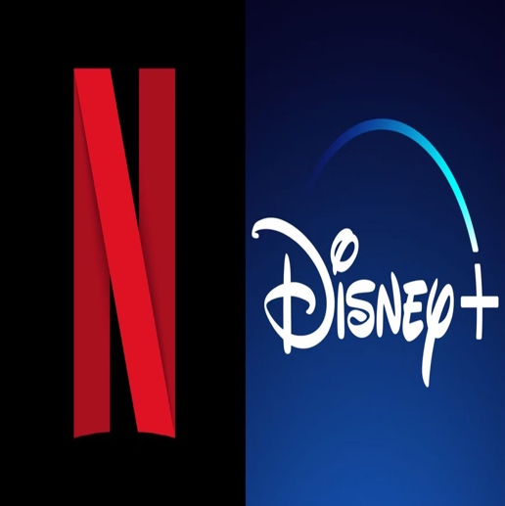
Password sharing prohibitions as enshittification of streaming grows: Disney and Netflix leading the race
The streaming sector is becoming increasingly similar to the traditional cable industry it disrupted, with rising prices, declining product quality, pointless mergers, and new restrictive efforts to nickel-and-dime customers - a transition also termed by many as “enshittification”.
This includes Netflix's recent crackdown on password sharing, which it had previously encouraged as a form of free advertising. However, as the streaming market has matured, Netflix has developed more creative ways to improve its quarterly returns for Wall Street, even if it means sacrificing product quality or customer satisfaction. For example, Netflix is now charging users more money for something it already monetized, meaning users were already paying more for more simultaneous streams.
However, despite the claims of Netflix and Disney, both companies do not consider password sharing as some significant threat to their financial well-being. This is partly because there is no guarantee that the "freeloaders" they are harassing will sign up for their own accounts.
Analysts have noted that many of the companies' predictions about how much money they will make from crackdowns are unrealistic.
Young Horizons 2023 experts discussing the status quo of European cinema in the streaming age
On the first day of the Young Horizons Event 2023 in Warsaw, at the beginning of the month, several experts were called to provide their insights during a panel discussion on the matter of European cinema in today’s age of streaming.
Some key points were made by David Kleeman, a strategist and analyst at Dubit, who initiated the conversation on the growing success of European cinema particularly in children’s and family-oriented content, despite facing numerous economic challenges and shifting consumer preferences. Susan Wendt, managing director at TrustNordisk, shared her ideas on the importance of big franchises in keeping cinemas afloat, but also the difficulty of getting European children's content into theatres.
Panellists then exchanged views on the role of streamers in content distribution, noting that streamers are now offering longer theatrical windows to distributors, recognising the value of local content.
Finally, the experts delved into the challenges and strategies for marketing and distributing films, particularly targeting young audiences. They considered the potential of implementing promotional and extension strategies on gaming platforms and media, including TikTok and YouTube.
Netflix on streaming the first live sports event and opening the first ‘Netflix houses
Netflix hosted its first live sports event, the Netflix Cup, during the week of the Formula 1 Heineken Silver Las Vegas Grand Prix.
The event featured four pairs of players, each consisting of a Formula 1 driver and a PGA TOUR professional. The players played an eight-hole match, with the two leading teams advancing to the final hole. The Netflix Cup is a classic sports crossover and showcases two of Netflix's sports programming breakouts: 'Formula 1: Drive to Survive' and 'Full Swing'.
That’s not the only novelty that Netflix aims to pursue in the near future. Netflix announced that it is currently planning to open new physical locations where fans can immerse themselves in the worlds of their favourite TV shows. These venues, called Netflix Houses, will offer a mix of shopping, dining, and interactive experiences. Netflix has already experimented with pop-up fan experiences, such as The Queen's Ball: A Bridgerton Experience in Los Angeles. The company strives to open the first two physical locations in 2025.
YouTube’s new Primetime Channels service launched in the UK
On October 10, YouTube launched its new Primetime Channels product in the UK. This service allows users to browse, subscribe to, and watch premium content from streaming services within YouTube.
YouTube Primetime Channels aims to make it easier for users to find and watch the content they want without having to switch between different apps. It also allows users to discover new content through official trailers, cast interviews, and user-generated content from their favorite TV shows.
Richard Lewis, director of partnerships at YouTube UK & Ireland, said: “Primetime Channels give users access to official TV, movies or streaming service content all in one place.”

Film & TV

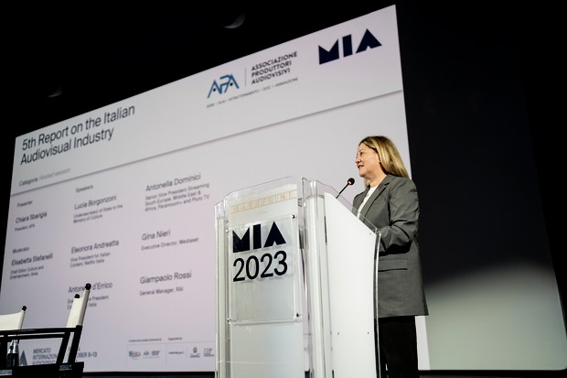
Audiovisual Producers Association (APA) presents new report at MIA
The 5th Report on National Audiovisual Production for the 2022/2023 season was presented by Chiara Sbarigia, President of the Audiovisual Producers Association (APA), one of CEPI’s members, at the MIA - Mercato Internazionale dell’Audiovisivo di Roma. The report found that the total value of investments into original Italian productions amounted to €1.8 billion, with investments in linear platforms (free or requiring payment) at around €1 billion.
Fiction films and series for TV and VOD constitute the main genre per volume of investment (55%), but documentaries and animation are also growing in importance, mainly in the VOD segment.
As for entertainment, the data revealed growth of +7% in the 2022/2023 period, compared to the 2021/2022 season. OTT services also showed good growth, in terms of hours (+5%) and titles (+9%), "rewarding in particular the independent production model (+24% in titles and +30% in hours)."
Almost 117,000 workers are involved in the audiovisual sector. Compared to the 2021 data, an overall dynamic of +4.7% was recorded. Self-employment is the item that registered the highest result (+9,8%), followed by outside employees (+8,6%), administrators (+2,4%), employees (+0,6%), in contrast to the substantial stagnation of entrepreneurs.
The Report was completed by APA in collaboration with various research institutes, amongst them eMedia, Ce.R.T.A - Centro di Ricerca sulla Televisione e gli Audiovisivi dell’Università del Sacro Cuore di Milano, and Symbola.

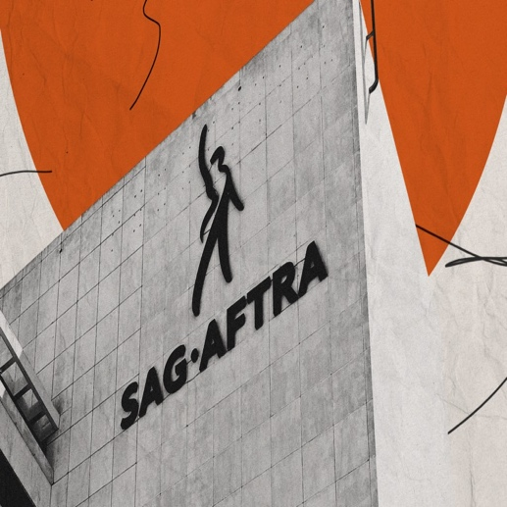
SAG-AFTRA and Studios resume talks
Four CEOs of major media companies returned to SAG-AFTRA headquarters on Tuesday 24 and Wednesday 25 October with a new offer in the hopes of breaking the stalemate in the 102-day actors’ strike.
The key obstacle remains SAG-AFTRA's demand for a cut of streaming revenue, as the union is seeking an 11% increase in basic minimums and artificial intelligence protections. Studios have already agreed to increase the amount of money actors receive in residuals from streaming, but the union says it is far too low. Talks have been suspended for nearly two weeks, but the two sides have still been working on elements of the contract. The studio side is hopeful but not optimistic that a deal can be reached soon. They are frustrated with SAG-AFTRA president Fran Drescher, who has talked in the negotiating room about income disparities and her ambition to transform actors' lives. The upbeat mood in the actors' camp marked a change from last week when leadership was facing pressure from George Clooney and other high-profile members to make a deal.
Negotiations on a new SAG-AFTRA contract continued, with the studios aiming to salvage the 2024 summer box office. The union resumed bargaining for the first time in almost two weeks, with the studios delivering a new offer on streaming residuals that they hope will break the deadlock. SAG-AFTRA’s leadership has urged members to stay together and support each other, saying that solidarity is the only way to get what they are asking for in the negotiation.*|END:IF|*
Irish government is raising tax incentives in 2024
The Irish government is set to boost its support for the Irish film and TV industry in its 2024 budget, with film and TV productions able to claim a 32% tax break on eligible expenditure up to €125m, raised from €70m, per project.
Screen Ireland, the national agency for the Irish screen industry, has welcomed the update to the Section 481 tax incentive and also outlined plans to support new initiatives to facilitate production across the breadth of the country. It is also aiming to launch a Creative Clusters programme for 2024, targeting emerging screen talent and communities across the country, with a pilot scheme proposed for County Cork.
This follows consultation with stakeholders as part of the Counterculture Audiovisual Policy report. The Creative Clusters programme will provide company development and leadership support to build creative screen ecosystems.
Susan Bergin, chair of the board of Screen Ireland, stated how the increase in the eligible expenditure cap will allow Ireland to attract a wider range of high-quality, larger-scale production, create opportunities in the growing area of VFX and post-production, whilst maintaining our well-regarded global reputation. This in turn will allow Ireland to drive increased cultural and economic opportunities for screen tourism.
Désirée Finnegan, Screen Ireland's chief executive, added that “the national development of the industry, beyond the existing production hubs, is a critical priority for Screen Ireland to ensure the sustainability of the industry into the future.”
Austria boosts film incentive model budget for 2024
The Austrian federal government is increasing the budget for the film incentive model in 2024, which will support both cinema films and TV and streaming productions. In particular, the government budget for ÖFI+, which supports cinema films, will increase from €15.5 million to €40 million, while the budget for FISA+, which supports TV and streaming productions, will increase from €22 million to €94 million.
The chairman of the film and music industry in the Austrian Chamber of Commerce (WKO), Alexander Dumreicher-Ivanceanu, welcomed the increase in funding, considering it a "clear signal" that Austria as a film location is "worth investing in." He also affirmed that the increase in funding will help to achieve the goals of the incentive model, which includes strengthening Austrian creativity and added value, creating sustainable jobs, as well as promoting European anchoring, climate-friendly transformation, and gender equality in the broader film industry.
French CNC President on the triumph of French cinema
Amid recent debates over public support for French cinema, Dominique Boutonnat, President of the CNC (Centre National du Cinéma et de l'Image Animée), has reiterated the significance and success of the "French cultural exception" in the world of film.
Boutonnat, in a piece published in Le Monde, emphasizes the CNC's commitment to maintaining the delicate balance between art and industry within the cinema. He cites statistics, such as French cinema's substantial 41% market share, and proudly points out the numerous awards received by French films at international festivals, showcasing the country's cinematic prowess.
One of the pivotal strengths Boutonnat highlights is the unique and virtuous funding system, where CNC's financial resources are derived from taxes within the film industry itself, rather than being sourced from the general state budget. This distinctive approach effectively harmonizes the artistic and economic aspects of filmmaking.
While acknowledging the challenge of some French films drawing limited audiences, Boutonnat defends the CNC's supportive measures, particularly nurturing emerging talent. He contends that these films neither hinder other productions nor substantially impact the CNC's budget.
In response to the global growth of film production, Boutonnat aspires to position France as a sectoral benchmark by endorsing initiatives like the France 2030 plan, which promotes open-access film studios and educational institutions across the nation. He concludes by highlighting that safeguarding the cultural exception doesn't entail preserving an unchanging model but rather adapting to the constantly evolving challenges of the industry, such as ecological transition and artificial intelligence.
Unscripted formats in a new era: innovations and strategies
As the international formats business faces tightening commissioning budgets and economic pressures on content powerhouses, there's a growing need to think innovatively. The Format Recognition and Protection Association (FRAPA) is urging producers to reevaluate their business models. Jan Salling, co-chairman of FRAPA and head of BBC Studios Nordic, emphasizes that the old distribution model is no longer effective. All players are now looking for returns on their investments and adjusting to the evolving market situation.
Despite these challenges, Mipcom offers a wide array of content in unscripted genres like reality, game shows, and dating shows. There's renewed interest in unscripted formats, with broadcasters willing to back new and original ideas. For instance, the success of shows like "The Traitors" has sparked a mini-boom in adventure reality formats.
Broadcasters are exploring both heritage formats and newer shows to meet audience demands for value for money, including game shows. Interactive, studio-based formats and reality shows are increasingly popular, with feel-good, family-oriented reality programs gaining traction.
In a competitive marketplace, the key to success is creating formats with a unique selling point, making them distinctive in a crowded field, and being adaptable within tight budgets. This approach allows producers to stay relevant and attract audiences and advertisers at scale.

Festivals

European entries for the Oscars
European countries are starting to reveal their titles submitted for the Best International Feature Film Award at the 96th Academy Awards ceremony, which will take place in Hollywood on March 10, 2024.
For this edition, submitted films must have been released in their respective countries between the dates of December 1, 2022 and October 31, 2023.
The deadline for submissions was October 2, 2023. Fifteen finalists will be selected from the total number of submissions and announced at the end of 2023. The Academy will then whittle that number down to five, which it will announce as the final nominees at the beginning of 2024. Last year, a total of 92 submissions were accepted, with 40 of them coming from a European country. Germany's submission, Edward Berger's Netflix title All Quiet on the Western Front, ended up winning the coveted trophy.
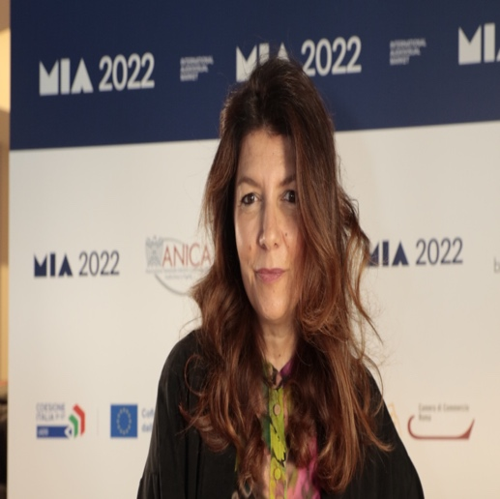
You can find here the lists of European and non-European movies (with European production) that have been submitted.
MIA chief Gaia Tridente lays out this year’s progress in terms of diversity
MIA, the International Audiovisual Market, is an innovative event that aims to boost the Italian industry by strengthening its international ties. It featured 62 projects of all shapes and sizes from 36 countries with an accent on “inclusion and diversity.”
As stated by MIA Chief Gaia Tridente, this year, the event has expanded its focus to include all formats, including animation and extended reality content. It has also seen a 30% increase in the number of countries that submitted projects to the co-production market, slightly getting away from its Eurocentric foundation.
Increased geographic diversity is visible across the entire project selection, including content showcases that this year, for the first time, are open to global – not just Italian – content. MIA is proud to be supporting Ukraine TV as well as some MENA Countries Film Industries.
Co-productions are more crucial than ever, as production budgets are being slashed across the board. MIA plays an important role in supporting co-productions by bringing together producers, distributors, and other players around the table. MIA has also worked to bolster its role as a market for finished theatrical products. It has introduced a new section called Comin'up, where buyers can discover work-in-progress feature films, as well as the See U Soon showcase section for finished titles seeking an international distributor.*|END:IF|*
Streamers and Broadcasters discuss TV series market tendencies at Cadiz South Series Festival
The South International Series Festival in Cadiz, Spain, was held from October 6-12. One of the major talking points at the festival was the challenges of financing series at a time of rising production costs and reduced spending by streamers and broadcasters.
Buyers are interested in local dramas that might resonate globally, rather than big-budget international shows. Many said that local shows have the best chance of becoming break-out hits, citing series such as Spain’s Money Heist and South Korea’s Squid Game. Co-production is more in vogue than ever before as producers seek to make up budgets. Laura Minarro, VP of international business and co-production at Spain’s Buendia Estudios, said: “The budgets of productions are diminishing a little right now, so for us it makes sense to come into co-productions, mainly with Europe but also with Latin America.”
Streamers are moving away from only commissioning expensive originals and will instead look to save money by licensing more content or by taking territory-specific rights for originals, bringing about both opportunities and challenges. Interestingly, UK execs, are willing to diversify away from reliance on the US market and to work more with European partners. Europe was repeatedly cited as a territory that can produce increasingly high-quality content, but for a much cheaper price than the United States, currently affected by strikes and market contractions.*|END:IF|*
EIF: An Icebreaker for European Audiovisual Production
At Rome’s Mercato Internazionale Audiovisivo (MIA), Logical Picture’s president Frédéric Fiore hosted a discussion on the role played by the European Investment Fund (EIF) in carrying out projects.
EIF, a financial intermediary and investor in private equity funds, is aimed at bringing new financing to sectors that are considered to be strategic and vital, such as the audiovisual sector. EIF is currently investing in funds focused on content production and distribution, including films, series, and other audiovisual works. Its partners must be SMEs or mid-caps whose workforce does not exceed 500 employees.
EIF recently started investing in the Logical Content Ventures fund, which is regulated by France's financial authorities and managed by Logical Pictures. One of the main obstacles faced when it comes to intercepting investors outside of the audiovisual industry is that they find putting money into films to be too dangerous. EIF is willing to convince investors that funding films is not risky as Europe’s soft money could further mitigate risks.
EIF's investment in the audiovisual sector is motivated by the belief that the sector is facing a number of challenges, including difficulty attracting investors, lack of internationalization, and the struggle to finance larger projects reasonably fast. EIF internal investment analysis and discussions follow due diligence checks until the investment is eventually signed. The Fund aims to build long-term relationships, set to last at least ten years.*|END:IF|*
Festival Calendar
November
- Thessaloniki International Film Festival, Greece - November 2-12
- Tallinn Black Nights Film Festival, Estonia - November 3-19
- Geneva International Film Festival, Switzerland – November 3-12
- Stockholm International Film Festival, Sweden – November 8-19
- Camerimage, Poland – November 11-18
- Industry@Tallinn & Baltic Event, Estonia - November 13-17
- Marrakech International Film Festival, Morocco - November 24-Decembe
December
- NFMLA Monthly Film Festival: Middle Eastern & Arab Cinema, US - December 9
- Les Arcs Film Festival, France - December 16-23

Interesting studies

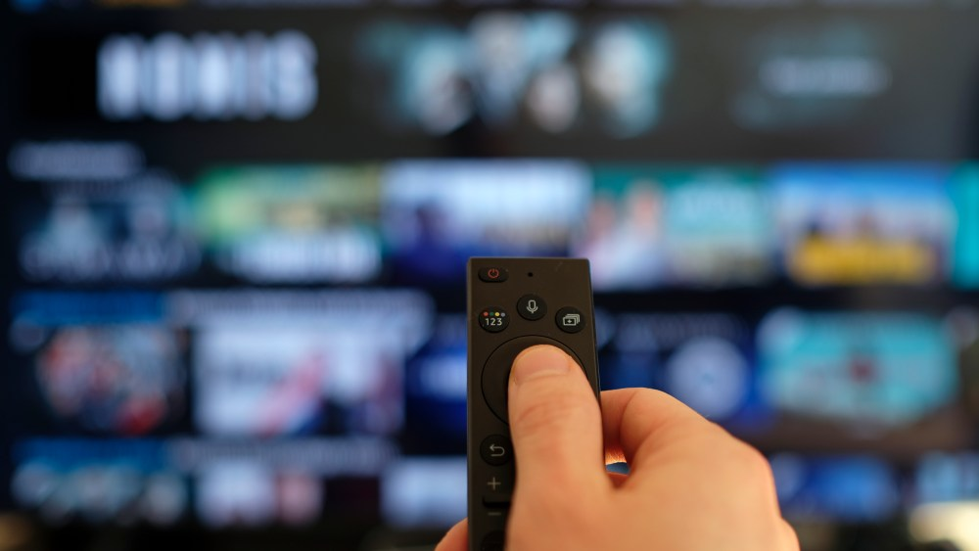HBO Max marks best streamer for consumer satisfaction sending Netflix to sixth place, survey reveals
Warner Bros. Discovery's HBO Max is the most satisfying streaming service in the US, with a score of 88%, Whip Media’s newest survey reveals.
While remarkably Disney's Hulu and Disney+ rank second and third, Netflix has seen its satisfaction score decline for the third year in a row and now ranks sixth. Netflix remains the most popular streaming service, however, the survey showcases that it is now starting to lose significant ground to its competitors. Specifically, in 2023, 27% of respondents said they would keep Netflix if they could only have one streaming subscription, down from 41% in 2021.
Moreover, mid-tier services such as Apple TV+, Peacock, Amazon Prime Video, and Paramount+ have all seen their satisfaction scores increase. Apple TV+ is the top-ranked mid-tier service, with a score of 81%. Peacock showed the largest gain in satisfaction, increasing 6 points to 74%, bolstered by the subscriber's strong reception to the quality of its original content. Still, Peacock is tied with Prime Video for the lowest-ranked position in overall satisfaction, as both services showcase a score of 74%.

Streaming giants and public film 2022 report predicts European film industry challenges and US streamers success
At the start of 2022, Michael Gubbins published the report titled Streaming giants and public film funding.
Commissioned by Swedish Film i Väst, one of Europe’s leading regional film financer, the study focuses on the challenges for European funding in markets and the effects of US streaming giants’ domination on the European film industry.
Streaming services are now a major player in the European film ecosystem. The report considers the policy choices facing public funds in relation to this trend. The report predicts that subscription streaming giants will become increasingly powerful in the film market. The report further argues that these giants are different from previous media giants, such as DVD and pay-TV companies, because of their scale, exclusive content ownership, and control over distribution and audience engagement. In 2020, the top three streaming giants had 80% of the market in 21 of 28 EU countries.
Today, much of the change predicted in the report is already happening, and new factors, such as the Ukraine War, inflation, and a cost of living crisis, are accelerating this change. However, the report's main argument remains timely: streaming giants are a powerful force in the media industry, with a strong potential to wield monopolistic power.

Interesting links

- If Google suddenly had real competition in search, how would news publishers’ world change?, by NiemanLab
- No need to send it back: Netflix posts its final DVDs to customers, by The Guardian
- Fremantle Spain Boss Heads To ITV Studios To Head Up Iberia Production Unit, by Deadline
- Execs at Cadiz’s South Series festival discuss the challenge of financing TV series, by
- ScreenDailyAdobe previews AI dubbing & generative fill for video, by BroadcastNow
- How AI is reshaping filmmaking: Insights from UNESCO’s conference in Paris, by EuroNews

Events and Opportunities

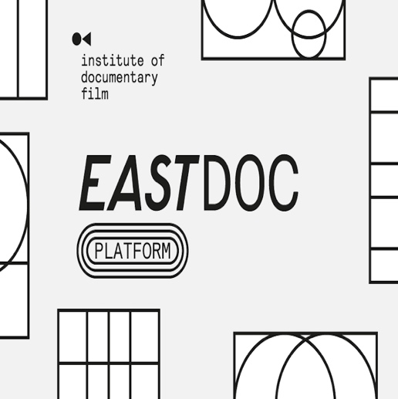
Call for Submissions - East Doc Platform
The 13th edition of East Doc Platform (EDP), the foremost co-production, funding and distribution platform exclusively dedicated to Central and Eastern European documentaries, is gearing up for its 2024 event, which will take place from 22-28 March in Prague. EDP is organised by the Institute of Documentary Film in partnership with the One World International Human Rights Documentary Film Festival.
The call for project submissions is now open, with a deadline set for 14 November. EDP is on the lookout for innovative feature-length documentary films with a strong narrative or character focus, factual series, and non-fiction transmedia projects (including interactive factual, VR/AR) at various stages of development, production or post-production. Additionally, EDP welcomes international projects with thematic ties to the Central and Eastern European region.


Call for Submission - SeriesMania Co-Pro Pitching Sessions
The Co-Pro Pitching Sessions are Series Mania Forum’s founding premise and the most anticipated part of the Forum. Each year, 15 series projects seeking international financing are selected and their producers are invited to come to Lille to pitch their series to an audience of key industry decision-makers (producers, broadcasters, financiers, etc.).
Any producer with a drama series seeking international financing and co-production partners can apply. The same company can submit up to 2 projects.
The deadline to apply is Thursday, November 30 2023, at 11.59 pm (CET).
You can find more information about the call for projects here.
Call for Submission - Series Accelerator Programme
The European Women’s Audiovisual Network (EWA Network) is teaming up with Netflix to launch the Series Accelerator Programme. The programme will bring together women film producers who want to expand their creative range by deepening their knowledge of series production.
EWA will curate three industry-led workshops supported by Netflix’s Creative Equity Fund, offering emerging and mid-career women film producers practical insight and upskilling tailored to the European series production landscape. Participants must have a minimum of one feature film credit in film and apply with a series project in early development. They will also each receive a €5,000 grant to further develop their work.
The deadline to apply is November 30.
Call for Submissions - BUFF Film Festival
The BUFF Festival, an international children and youth film festival held in Malmö, Sweden from the 9 March to the 15 March 2024, is open for submissions. Since 1984, BUFF Film Festival has been the most important screening venue for films for children and young people in the Nordic countries. The festival offers three awards:
- The Children’s Film Award
- The Young People Film Award
- The Short Film Award
The deadline for submissions is November, 15th. You can find more information here.
The European Writers Club announces BOOSTING IMPACT: an effort to bolster collaboration between the world of writers and producers
The European Writers Club (EWC), a network of European creators, writers, producers and broadcasters announced the launch of a pilot session: Boosting Impact, From Facts to Fiction. It aims to foster collaboration between the world of journalists, scientists, documentarists, etc. and storytellers of scripted TV series, with the objective to create societally significant and engaging stories rooted in actual events.
Participants are called to make up concept teams, composed of a creator/writer, a producer, and a journalist, scientist, or documentarist. The EWC will select 6 concepts in early development for TV series that are based on or inspired by thoroughly researched true events conducted by journalists, scientists, anthropologists, documentarists, etc. These stories should offer something new or reveal previously unknown aspects of a topic. They should profoundly impact a wide European audience, addressing topics that significantly influence European lives.
Across three immersive camps in Hamburg (April), Madrid (June), and Copenhagen (September) 2024, the EWC will welcome the six teams to refine, develop, and boost their concepts in collaboration with EWC's network of consultant writers, broadcasters, and sales professionals. The EWC's goal is to see all 6 selected projects commissioned for script development after the final presentation conference in Copenhagen in September 2024.
The call is now open, and the deadline for applications is 31 December 2023. For more information, visit www.europeanwriters.club
Call for Submission - Barcelona Film Festival 2024
Barcelona Film festival (BCN) 2024 just opened its call for film entries. Directed by journalist Conxita Casanovas this year, the 8th edition of the festival is taking place on April 18th to 26th.
In spirit of Saint George Day, and International Book Day, the festival is expected to showcase remarkable World, European and/or Spanish works with a focus on art, especially on book adaptation and history.
Moreover, the festival is divided into three selection areas, the Official Selection paying attention to Saint George’s day, culture and history, the Cinema amb Gràcia section focusing on comedies, and the Zona Oberta section for other films of interest of organizations or the festival.
The call to submit film projects is open to international sales agents, distributors and producers. You can register your entry using this link. Deadline for submissions is February 2nd, 2024.
Before applying, make sure to read more about the regulations and conditions here.







Copyright © 2023 CEPI, All rights reserved.

