CEPI Newsletter November 2023

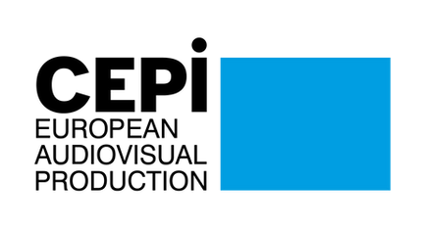
Dear CEPI Members,
We’ve had a great time seeing you in Lisbon this month!

Indeed, CEPI held its General Assembly, in Lisbon on November 9th and 10th. This was the occasion for the members to elect a new Board of Directors; we give a warm welcome to Mr. Boštjan Ikovic, representing Slovenia, who joins the Board, and we thank Ms. An Jacobs (VOFTP, Belgium) and Ms. Chiara Sbarigia (APA, Italy) for their dedicated service on the Board in the last years. The Assembly also addressed crucial policy issues like Geo-blocking, Artificial Intelligence, EMFA, and AVMSD. It provided a platform to define CEPI's vision for the upcoming Commission mandate, engaging in discussions to prioritize focus areas for the coming years. These debates are pivotal for the industry and CEPI's legitimacy in shaping the future of the European audiovisual and cinematographic industry. Indeed, the General Assembly was the place of discussions of the first draft of the CEPI Vision paper (find it here). This paper aims to tackle key issues for independent producers, establish strategic objectives, and provide policy recommendations for the European Commission's next mandate. Your insights on this draft are crucial for refining the vision paper. Please review the attached draft, considering it a work in progress, and share your feedback by December 15th to margaux.chielle@europe-analytica.com.
As part of the European Commission's stakeholder dialogue on the future of the AV sector, a meeting was organised by the Commission in Brussels on November 21st, following previous sessions in July in Brussels, Venice, and San Sebastian. CEPI's policy advisor Margaux Chielle and Board member Jérôme Dechesne attended. During the meeting, producers emphasized the importance of IP ownership, while also highlighting challenges in obtaining consumption data from broadcasters/streamers. CEPI suggested linking IP to the definition of European works, emphasizing ownership by European companies. The Commission encouraged stakeholders to supplement responses with written feedback through a Google Form, due by December 7th - you’ll find here a link to a Google Form for you to answer the Commission’s questions.
As part of the same dialogue, the Commission organized a targeted meeting in late October specifically addressing AI and the text and data mining (TDM) exception.

Following this meeting, CEPI recently submitted written feedback to the Commission, which includes the input we’ve received from you - you’ll find more information in the “Artificial Intelligence” section.
On November 29th, the European Audiovisual Observatory (EAO) organised a conference on the promotion of European works according to the AVMS Directive. The conference addressed various challenges and opportunities in promoting European works, with insights from panelist and CEPI Board Member Bostjan Ikovic emphasizing Slovenia's role and collaboration in the creative industry. Find more information about this in the “AVMSD” section.
From November 22 to 24, CEPI Policy Advisor Margaux Chielle participated in the second edition of Animar, the European Animation Convention, held in Barcelona. Organized by Animation in Europe, a CEPI member based in Barcelona, the event aimed to enhance the European animation sector, fostering collaboration among EU countries. Discussions covered topics such as AVMS Directive quotas, investment obligations, market financing, equity, IP retention, and the significance of geoblocking, highlighting the need for harmonization and flexibility in contractual relations. You’ll find more information in the “Festivals” section.
Finally, onto policy files, this month we’ve done a lot of work on the Geo-blocking report, set to be voted on December 13th. We’ve asked you for your support in contacting your national MEPs to ensure that amendments deleting the most worrying parts of the report are supported. CEPI has been part of a campaign on social media aimed to grow awareness on the consequences of including AV services into the Geoblocking Regulation. Letters were send by coalitions, which CEPI is a part of, to MEPs to urge them to reject the report, or at least, support the amendments preserving territorial exclusivity. You can find more information on this topic in the “Territoriality” section.
We hope you will find this newsletter informative,
Best regards,
The CEPI team

Sections in this newsletter

- EU News
- Digital Policy
- Artificial Intelligence
- Territoriality
- AVMSD
- Creative Europe
- Copyright

- Piracy
- Recovery and growth of the AV industry
- Business Information: VOD
- Business News: Cinema & TV
- Festivals
- Interesting studies
- Interesting links
- Events and opportunities

EU NEWS


EU institutions are looking into buy-out practices
Both the European Parliament and the Commission are working on studies concerning buy-out practices in the audiovisual sector. Read More

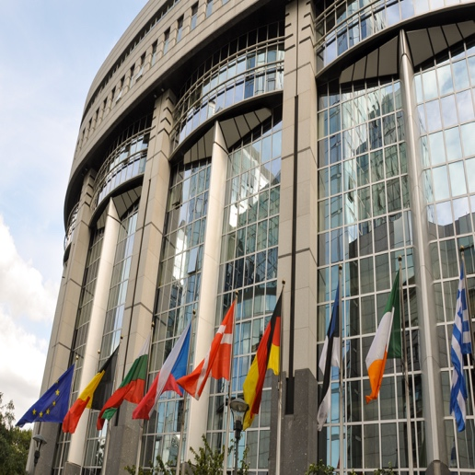
Power shifts in 2024 European elections forecast
The recent seat projections for the 2024 European Parliament, reported by Euractiv, highlight significant changes. Read More
MEPs discuss the role of AI in cultural diversity at European Parliament conference Read More

The LUX Audience Award Nominees' films are set to tour Europe for free screenings organized by the Parliament Read More
European Parliament takes action for artists’ rights and working conditions Read More

Digital Policy


The AI Act at final stage of negotiations in the EU and in France, Germany and Italy
The AI Act is a landmark EU legislation to regulate Artificial Intelligence based on its potential to harm people. Read More
70 French organizations from creative industries sent a letter to the government on the AI Act
Although the AI Act is approaching its final stages of negotiations, its adoption still echoes reactions from the citizens' perspective. 70 organizations representing the creative industries in France, including two of CEPI’s members, the SPI and USPA, have sent an open letter to the French government, expressing their concern over the government's move to weaken transparency requirements in the AI Act for foundational models. Read More
EMFA: the trialogue negotiation started, but no discussion on article 20 yet Read More
Commission signs agreement with Italian media regulator on DSA enforcement Read More

Artificial Intelligence

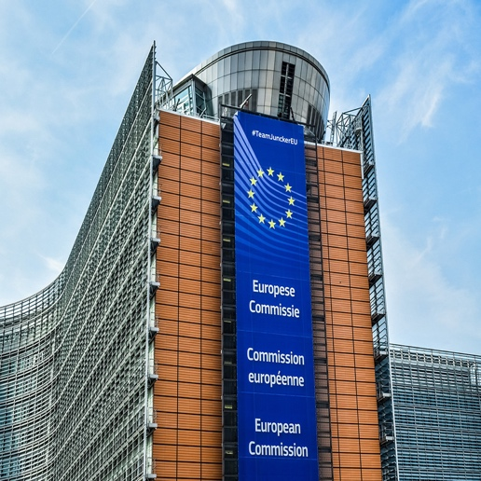
Commission dialogue on AI and TDM: CEPI submitted its response
As part of the stakeholder dialogue the European Commission launched following the publication of the Media Outlook, the Commission organised a meeting dedicated to copyright, artificial intelligence and the text-and-data mining (TDM) exception, introduced by the 2019 Copyright DSM Directive. CEPI participated in the meeting held on October 24th in Brussels. Giuseppe Abbamonte, Director at the European Commission, led the meeting, which primarily discussed the implementation of opt-out mechanisms. The focus was on how these mechanisms are communicated, used, and enforced. Read More
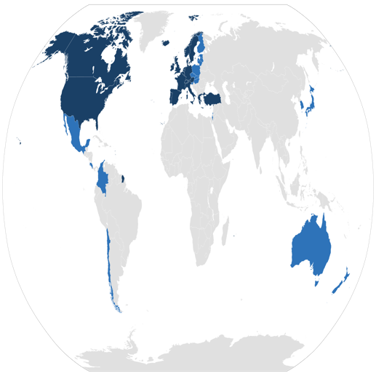
OECD released its first report on “Principles for Trustworthy AI” implementation
The Principles for Trustworthy AI is a set of guidelines that were developed by the Organisation for Economic Co-operation and Development (OECD) in May 2019 to help countries develop and use AI in a responsible and ethical manner. The principles are based on several key values which are applied to AI systems including fairness and transparency. Read More

The EU's AI rulebook might be too late to prevent Big Tech dominance in the AI market
The rise of artificial intelligence in the Internet economy is raising concerns about increased market concentration, primarily due to the significant investments required in computing power and data—resources controlled by a few major tech companies. Read More

Territoriality


CEPI takes action in the face of the geo-blocking notice vote in December
The European Parliament’s report on the implementation of the 2018 Geo-blocking Regulation is getting close to a vote in Plenary session. The lead on the file, the Internal Market Committee (IMCO) has adopted its report at the end of October. Read More
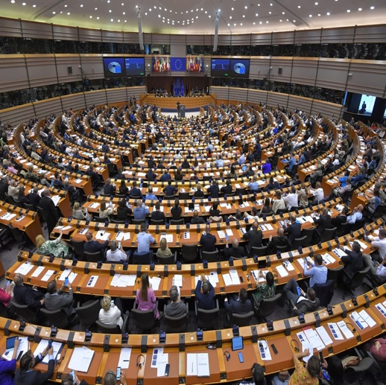
MEPs call for continued support for territorial exclusivity for audiovisual services
On November 29, CEPI attended the Conference “Geoblocking Regulation: Save cultural diversity in Europe's audiovisual sector”, which was organised by the French ARP at the European Parliament and included interventions by Members of the Parliament and representatives of European creators. Read More

AVMSD

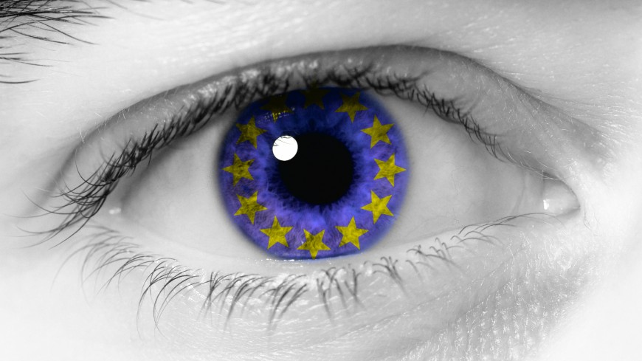
The promotion of European works according to the AVMSD: where do we stand?
In 2019, the European Union introduced the Audiovisual Media Services Directive (AVMSD) to boost European content. The European Audiovisual Observatory, in collaboration with the Council of Europe, organized an in-person event on November 29 in Brussels to assess the AVMSD's implementation across member states. Read More

Creative Europe


2024 EU budget agreement: victory for Creative Europe, with a 3 million increase
The EU budget for 2024 brings good news for Creative Europe, the EU's key program for transnational cultural cooperation, as it will not face funding cuts. Instead, it will receive an increase, raising its budget to 335 million euros, surpassing the European Commission's initial June proposal. Read More
Creative Europe Program: TV and online content call is open
An exciting funding opportunity from the Creative Europe Program (CREA) is open, the 2024 TV and Online Content call.Read More
CULT Committee voted its position on Creative Europe report
On November 28, the CULT committee of the European Parliament voted on the drafted report "Creative Europe programme 2021-2027”. This vote was based on the report drafted by MEP Massimiliano Smeriglio (S&D, IT), which garnered substantial support, indicating a strong consensus on the direction of the program. The final version of the report is currently awaited, with a plenary vote anticipated by January. Read More

Copyright


"Is the EU Copyright Directive still fit for purpose in the age of generative AI?"
On November, 15th CEPI attended Brugel's panel discussion "Is the EU Copyright Directive still fit for purpose in the age of generative AI?". The event delved into the complexities surrounding the training of Generative AI Large Language Models, emphasizing the need for extensive data access and raising concerns among copyright holders about unauthorized use and the potential for AI to produce near-indistinguishable imitations of their creative works. Read More

Insights from ACT’s IP Law Enforcement Conference: Commission’s perspective and industry role 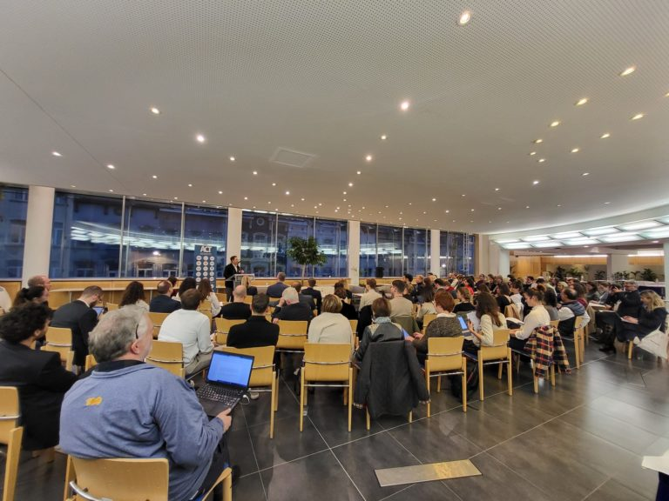
On November 2023, CEPI took part in ACT's Conference on IP Law Enforcement at the European Parliament. Read More
OpenAI and Microsoft face lawsuit over alleged unauthorized use of works in AI training Read More

French AI proposal raises questions on AI ownership and taxation Read More

Piracy


Streaming TV prices have doubled in recent years according to studies
A recent opinion piece from Techdirt discusses the increasing prices and added restrictions in the streaming TV market, a phenomenon described as 'enshittification.' Services like Amazon, Netflix, Apple TV, Disney, Hulu, and ESPN are raising prices and adding more restrictions. This shift is compared to the early days of cable TV, where price hikes and service degradation eventually led to customer dissatisfaction. Read More

StreamSafely launched a new phase of its anti-piracy campaign: What and who

A new phase of the StreamSafely.com anti-piracy campaign is underway, warning visitors that pirate streaming sites are not what they seem and pose risks beyond pirated content. The campaign aims to inform people of the risks associated with pirate streaming sites, such as malware infections, identity theft, and credit card fraud. Read More
MPA praises France, Italy and the Philippines for site-blocking efforts
The Motion Picture Association (MPA), a vocal proponent of website blocking and anti-piracy, recently met with stakeholders at a private "site blocking conference”. Read More

Recovery and growth of the AV
industry


Global film and TV production set to resume in a big way
After six months of strike-related stoppages, global film and TV production is set to resume in a big way. Producers and execs are anticipating an early 2024 surge in production that could last throughout the calendar year, while also being cautious in their optimism, as they are aware that the business is cyclical and that labour uncertainty could still impact production. Read More

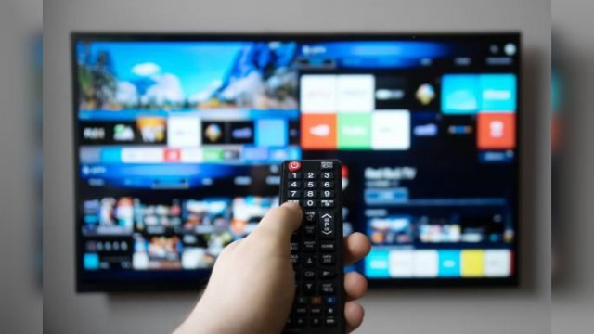
Global streaming revenues set to grow by double digits in 2023
Global streaming revenues are expected to reach $65.7 billion in 2023. Overall, the streaming industry is still growing, but at a lower pace. Read More
Tickets sold out again in German cinemas after pandemic declines
After a year of pandemic restrictions, German cinemas are continuing to bounce back, according to industry figures. Read More

Italian "C'è ancora domani" tops box office amid funding controversy
Director Paola Cortellesi's "C'è ancora domani," a film that delicately addresses domestic violence while celebrating women's resilience, has become a box office sensation in Italy. Read More

BUSINESS NEWS: VOD

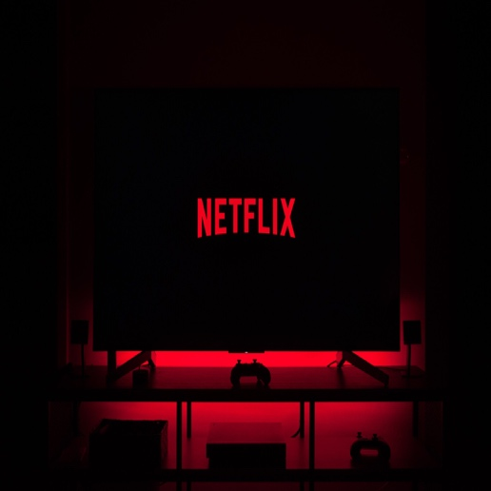
Netflix’s new “quality over quantity” strategy on European films and how it’s going to work
Netflix is making a change to its movie strategy, shifting from producing a large number of films of varying quality to focusing on making fewer, higher-quality films. This change is being driven by several factors, including increased competition from other streaming services, including for example Disney+ and HBO Max, as well as a decline in the overall number of subscribers, and a growing demand for premium content. Read More

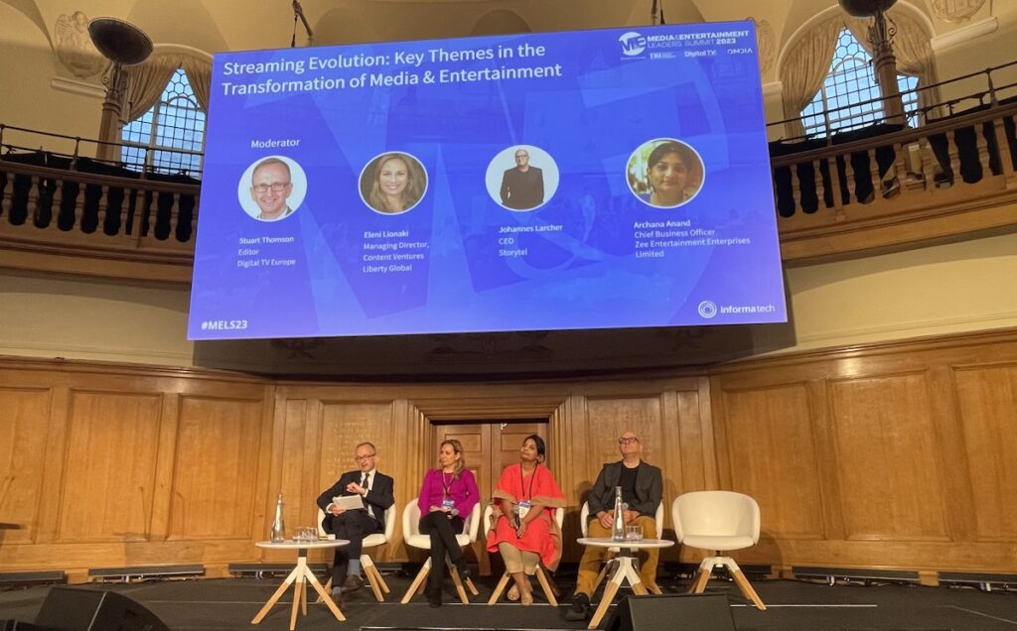
Experts discuss the broken streaming model at MELS in London
The streaming model is "broken" and leading to a "huge devaluing of content," according to execs at the Media & Entertainment Leaders Summit (MELS) which took place in London on November 7th. Read More
Short film streaming platform THIS IS SHORT launched in 2021 but is here to stay Read More
Disney to acquire Hulu’s Comcast stakes and release a joint streamer by the end of next year Read More

Business News: Cinema & TV

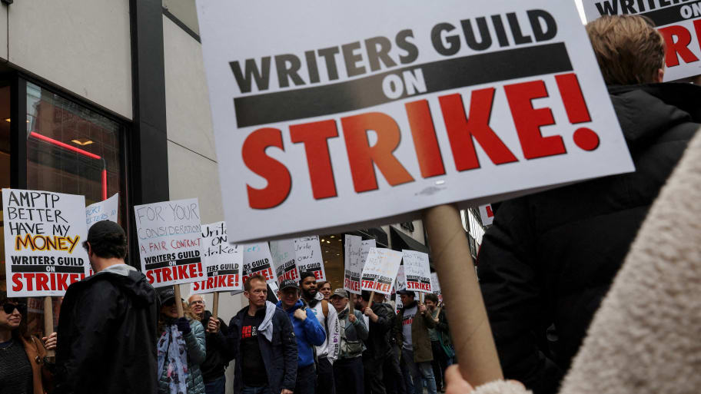
SAG-AFTRA negotiators approve tentative agreement, ending historic strike
After a 118-day strike, SAG-AFTRA negotiators have approved a tentative agreement with the Alliance of Motion Picture and Television Producers (AMPTP). The deal will officially end the strike at 12:01 a.m. on Thursday. The agreement includes a historic pay increase, with most minimums increasing by 7% – two per cent above the increases received by the Writers Guild of America and the Directors Guild of America. The deal also includes a “streaming participation bonus,” increases in pension and health contributions, and the first-ever protections for actors against artificial intelligence. Read More


The French audiovisual technicians rally in Paris, demand 20% salary increase
In a renewed strike in France, hundreds of technicians working on the production and post-production of TV series and shows gathered in Paris on Friday, demanding a "20% for all" salary increase. The protesters, holding banners with slogans like "Audiovisuel +20%, sinon rien sur vos écrans" (Audiovisual +20%, otherwise nothing on your screens), converged in front of the headquarters of Mediawan, a major French audiovisual production company. The demonstrators seek a significant increase in wages. Read More

The Balkan Film Festival encourages Italian-Balkan co-productions and distribution synergies Read More

French Cinema and Animated Image Code amended Read More
Spanish ICAA funding body to provide 30 million euros in grants for a total of 25 films Read More

Festivals

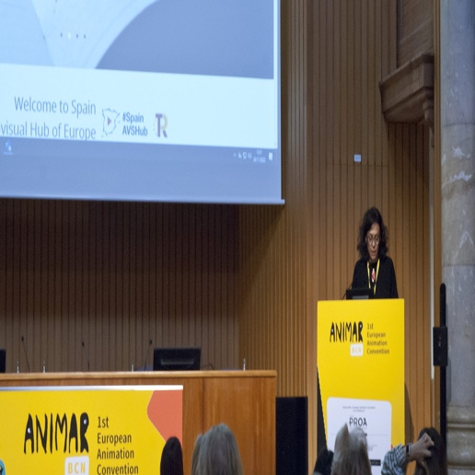
Scaling up European animation: CEPI’s participation to Animar 2023
From the 22nd to the 24th of November, CEPI, represented by Policy Advisor Margaux Chielle, participated in the second edition of Animar, the annual think-tank of the European Animation industry. Animar was organised by Animation in Europe, one of CEPI’s members in Barcelona, and gathered producers, policymakers and other key players to scale up the European animation industry and increase cooperation between different EU countries.
The topics ranged from the quotas and investment obligations of the AVMS Directive, to market financing and equity, by way of dissemination of European animated works in Europe and globally, and were organised in different working groups.
CEPI raised several key points: the need for harmonised investment obligations in Europe, the need for sub-quotas, the crucial importance of producer retaining the IP and of the IP staying in Europe - by linking IP to the definition of “European works”. Debates revolved around the meaning of “ownership” of the IP and what it means to own the majority of the rights. The importance of flexibility was also highlighted in the contractual relations with streamers and broadcasters. The importance of geoblocking was underscored by all participants in the working group.
You can find more information about the conference and the different working groups in this press release.
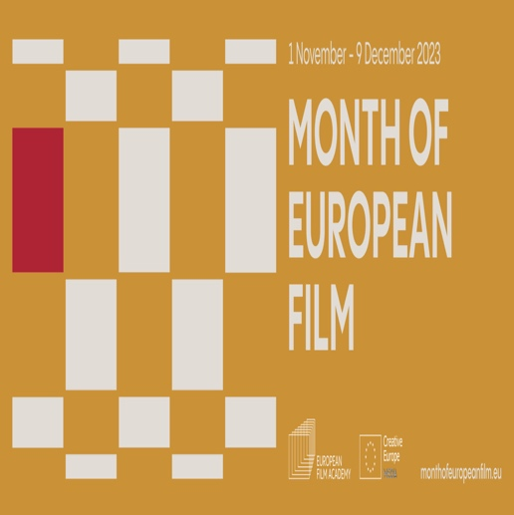
The Month of European Film has been engaging audiences with its events all over Europe
The European Film Academy is celebrating the diversity of European film with the Month of European Film, which is taking place from 1 November to 9 December. The event is being held in partnership with Europa Cinemas, MUBI, and DAFilms, and will feature screenings of European films, special events, and dedicated retrospectives at cinemas across Europe.

One of the highlights of the Month of European Film was the Young Audience Film Weekend, which took place from 4 to 5 November. The Month of European Film will also see the European Arthouse Cinema Day on 12 November, organized by CICAE, the international confederation of arthouse cinemas.
Many of the participating cinemas will focus on younger audiences during the Month of European Film. For example, in Tirana (Albania), young film-lovers from the Tirana Film Club will be involved in every screening and discussion. Audience engagement in general also plays a major role for all participating cinemas. For example, a screening in Frederikssund, Denmark, will be followed by a community dinner and a conversation focusing on brain injury, art, and the struggle to find a way back to life.
All the information on the Month of European Film events can be found on the European Film Academy website.
Festival Calendar
December 23
- NFMLA Monthly Film Festival: Middle Eastern & Arab Cinema, US - December 9
- Les Arcs Film Festival, France - December 16-23
January 24
- FIPADOC Documentary Film Festival, France - January 19-27
- International Film Festival Rotterdam, Netherlands - January 25-February 4
- Goteborg Film Festival, Sweden - January 26-February 4
- Ostend Film Festival, Belgium - January 26-February 3
- DocPoint Helsinki Documentary Film Festival, Finland - January 30-February 4

Interesting studies


European Audiovisual Observatory’s report on spending on content by audiovisual services in Europe
This EAO report analyzes spending on content by audiovisual services in Europe between 2012 and 2022. The report does not include spending by other sources, such as public funding, distributors' minimum guarantees, or fiscal incentives. Read More

Global streamers value the UK and Spain at most, according to EAO report
A new report by the European Audiovisual Observatory finds that the production and release of original TV fiction resumed growth in 2022 after a halt during the COVID-19 crisis. The report also finds that global streamers are increasingly commissioning fiction in Europe, with Spain and the United Kingdom being the most popular production hubs. Read More
European Audiovisual Observatory publishes report on access and findability of public interest content Read More

Interesting links

- Some Pirate Sites Received More Visitors After Being Blocked, by TorrentFreak
- AI companies have all kinds of arguments against paying for copyrighted content, by The Verge
- FILM PIRACY: WHAT AUDIENCES ARE CONSUMING RIGHT NOW, by Muso
- Number Of Female Writers & Directors On British TV Shows Fell Between 2016 & 2022, Diamond Report Reveals, by DEADLINE
- Copyright Exceptions and Digital Exhaustion addressed by the European Court of Human Rights (yes, the one in Strasburg!), by Kluwer Copyright Blog

Events and Opportunities


Call for Submissions - Sunscreen Film Festival
The Sunscreen Film Festival will take place from April 25th to 28th in St-Petersburg, Florida. Apart from participating in workshops and panels, you can also submit a project in various categories, until December 16th. You can find more information here.

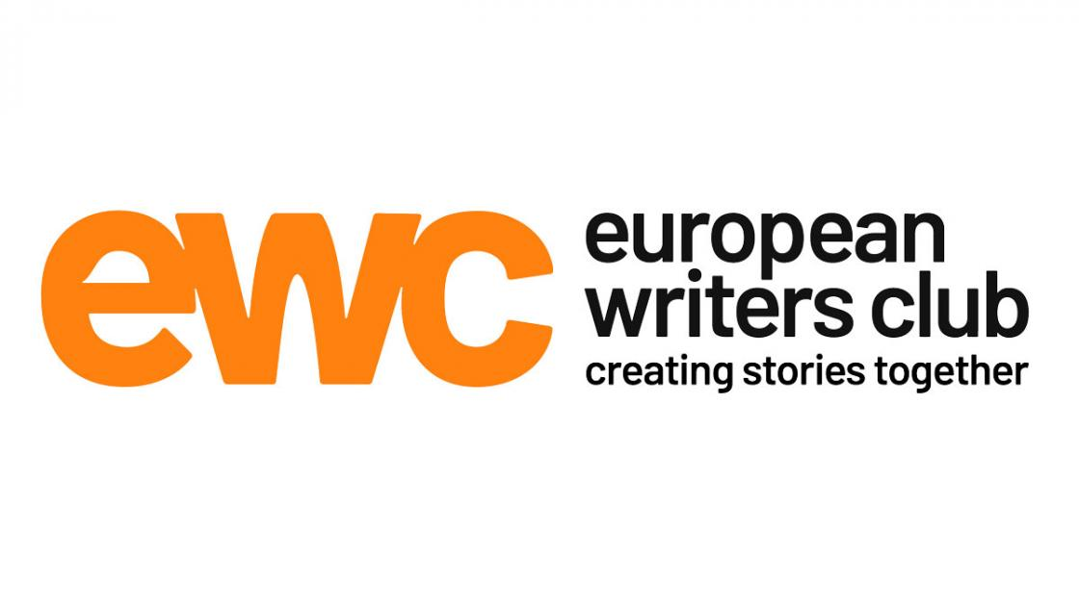
The European Writers Club promotes BOOSTING IMPACT: an effort to bolster collaboration between the world of writers and producers
The European Writers Club (EWC), a network of European creators, writers, producers and broadcasters announced the launch of a pilot session: Boosting Impact, From Facts to Fiction. It aims to foster collaboration between the world of journalists, scientists, documentarists, etc. and storytellers of scripted TV series, with the objective to create societally significant and engaging stories rooted in actual events. Read More
Call for Submission - Barcelona Film Festival 2024 Read More

